SPK Capital Markets Law 7518 Compliance for Log360
Tagline: Meet Turkey's crypto asset platform security requirements under Capital Markets Law 7518 with Log360.

Overview
The SPK Capital Markets Law 7518 Compliance extension for Log360 helps Turkish crypto asset service platforms licensed by the Capital Markets Board (SPK) meet the technology risk management, cybersecurity monitoring, and investor protection obligations under Law 7518.
Log360 monitors logs from crypto asset trading platforms, wallet systems, cloud environments, and identity services, providing security teams with real-time visibility into cyber risk events. Compliance teams can detect threats, maintain audit trails, and generate SPK-ready documentation to demonstrate regulatory compliance.

Key Features
- Generate predefined compliance reports covering SPK Law 7518 technology requirements including platform access monitoring, incident detection, and user authentication events.
- Monitor crypto asset platform activity in real time, detecting unauthorized access, suspicious trading patterns, and data exfiltration indicators.
- Detect threats targeting crypto asset platforms through real-time transaction monitoring integrated with advanced security event correlation.
- Export compliance evidence in PDF and CSV formats for SPK supervisory submissions and internal crypto asset governance reviews.
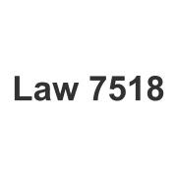
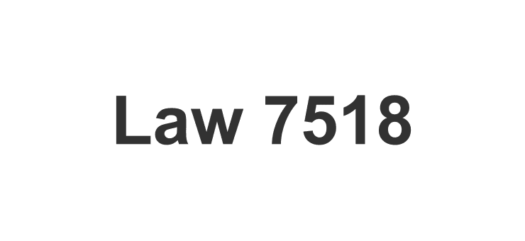

Screenshots
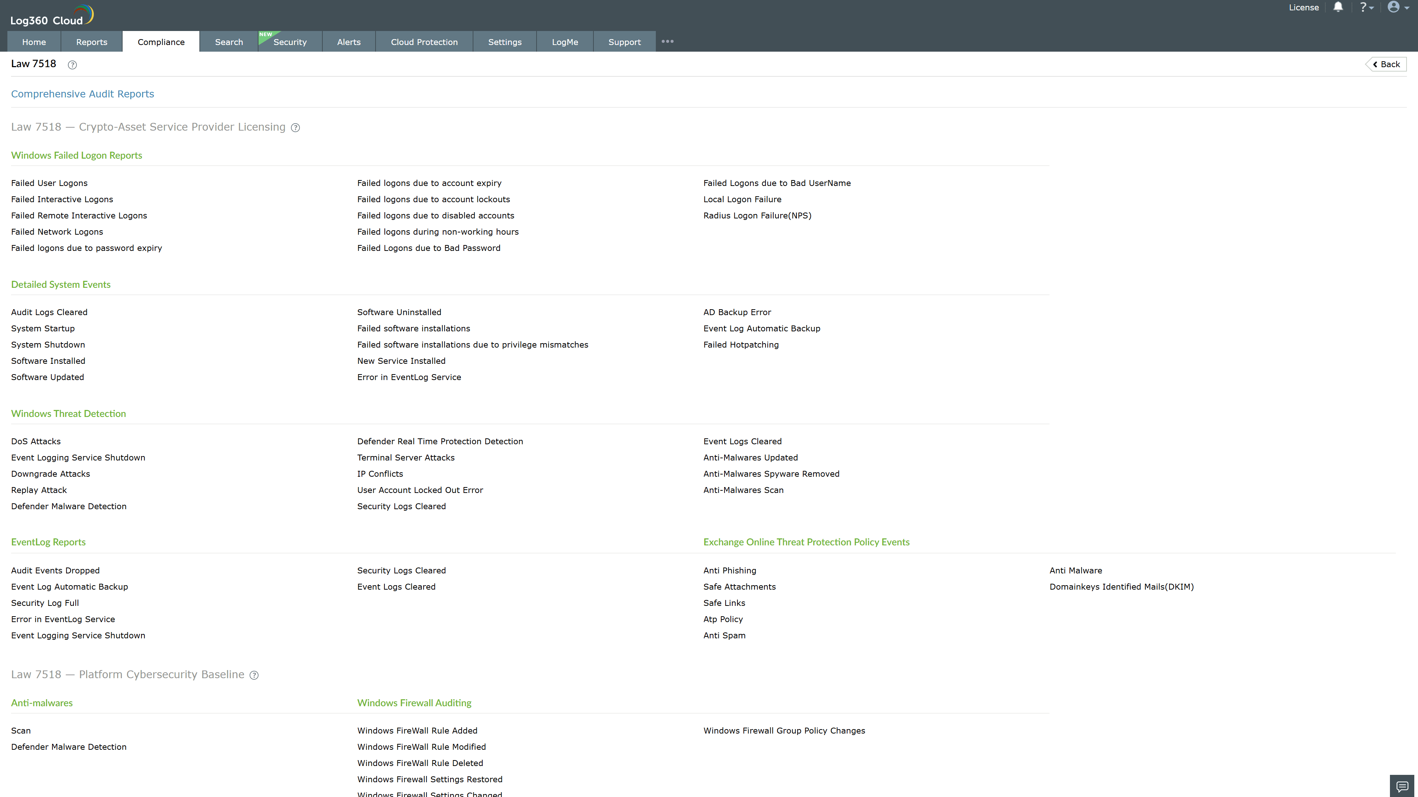
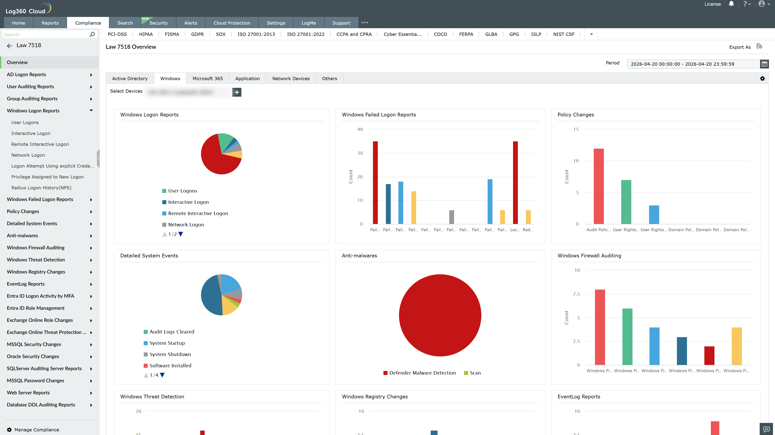
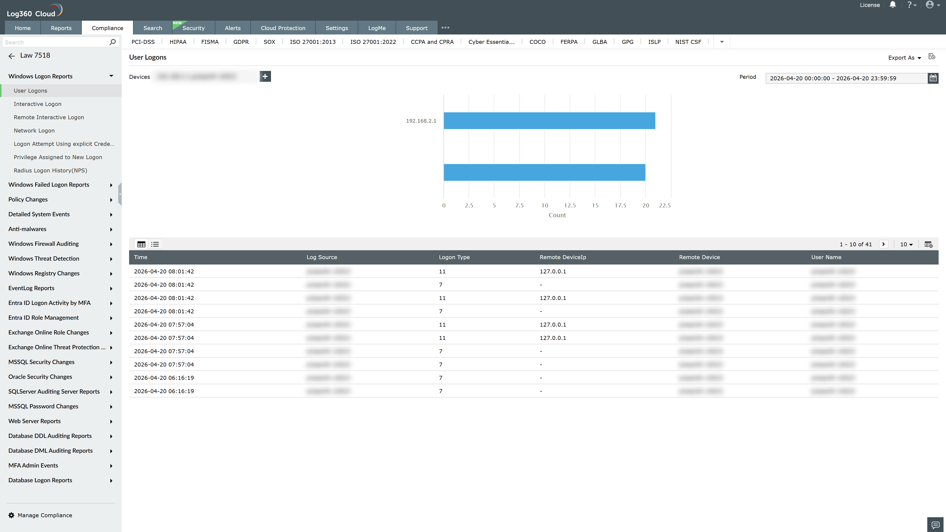
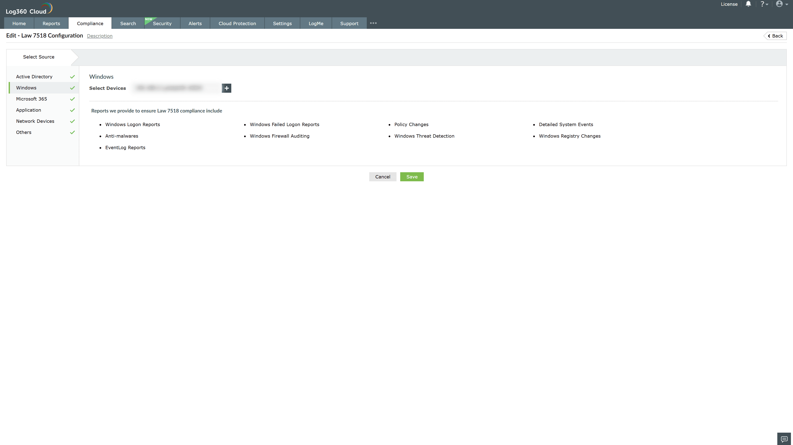
Valid Submission : Yes
Supported Editions : Free, Basic, Standard, Professional, MSSP
Help Document : https://www.manageengine.com/log-management/help/integrations/compliance-extensions.html
Help Video : Not provided
Tags : Log360, Compliance, Privacy monitoring, Data privacy, Regulatory compliance
Supported DCs : US, IN, JP, CA, AU, UK and EU
Privacy Policy:
Terms of Service:
Release Notes:
Predefined reports for the Law 7518 Compliance

