Swiss Cybersecurity Ordinance Compliance for Log360
Tagline: Meet Switzerland's CSO requirements with continuous monitoring from Log360.

Overview
The Swiss Cybersecurity Ordinance (CSO) Compliance extension for Log360 enables Swiss organizations and federal agencies to align with the operational security requirements established under Switzerland's cybersecurity regulatory framework.
Log360 ingests and correlates log data from endpoints, servers, cloud platforms, and network infrastructure, providing security teams with granular visibility into system events, user activities, and threat indicators. With built-in compliance dashboards and automated reporting, organizations can proactively identify security gaps, remediate risks, and demonstrate readiness during CSO audits.

Key Features
- Generate audit-ready compliance reports mapped to CSO requirements, covering log collection, monitoring, and incident notification obligations.
- Detect and alert on anomalous user behavior, unauthorized access patterns, and lateral movement across your IT environment.
- Maintain a centralized, tamper-evident log repository with automated log integrity checks to ensure the completeness and authenticity of audit trails required under CSO monitoring and incident reporting mandates.
- Export compliance evidence in PDF and CSV formats for regulatory submissions, management reviews, and third-party audits.
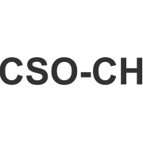
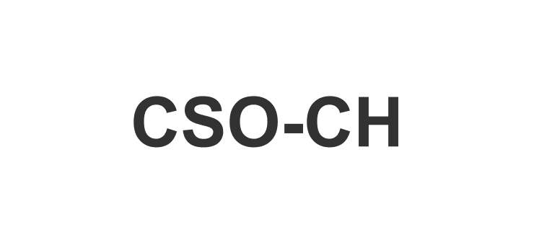

Screenshots
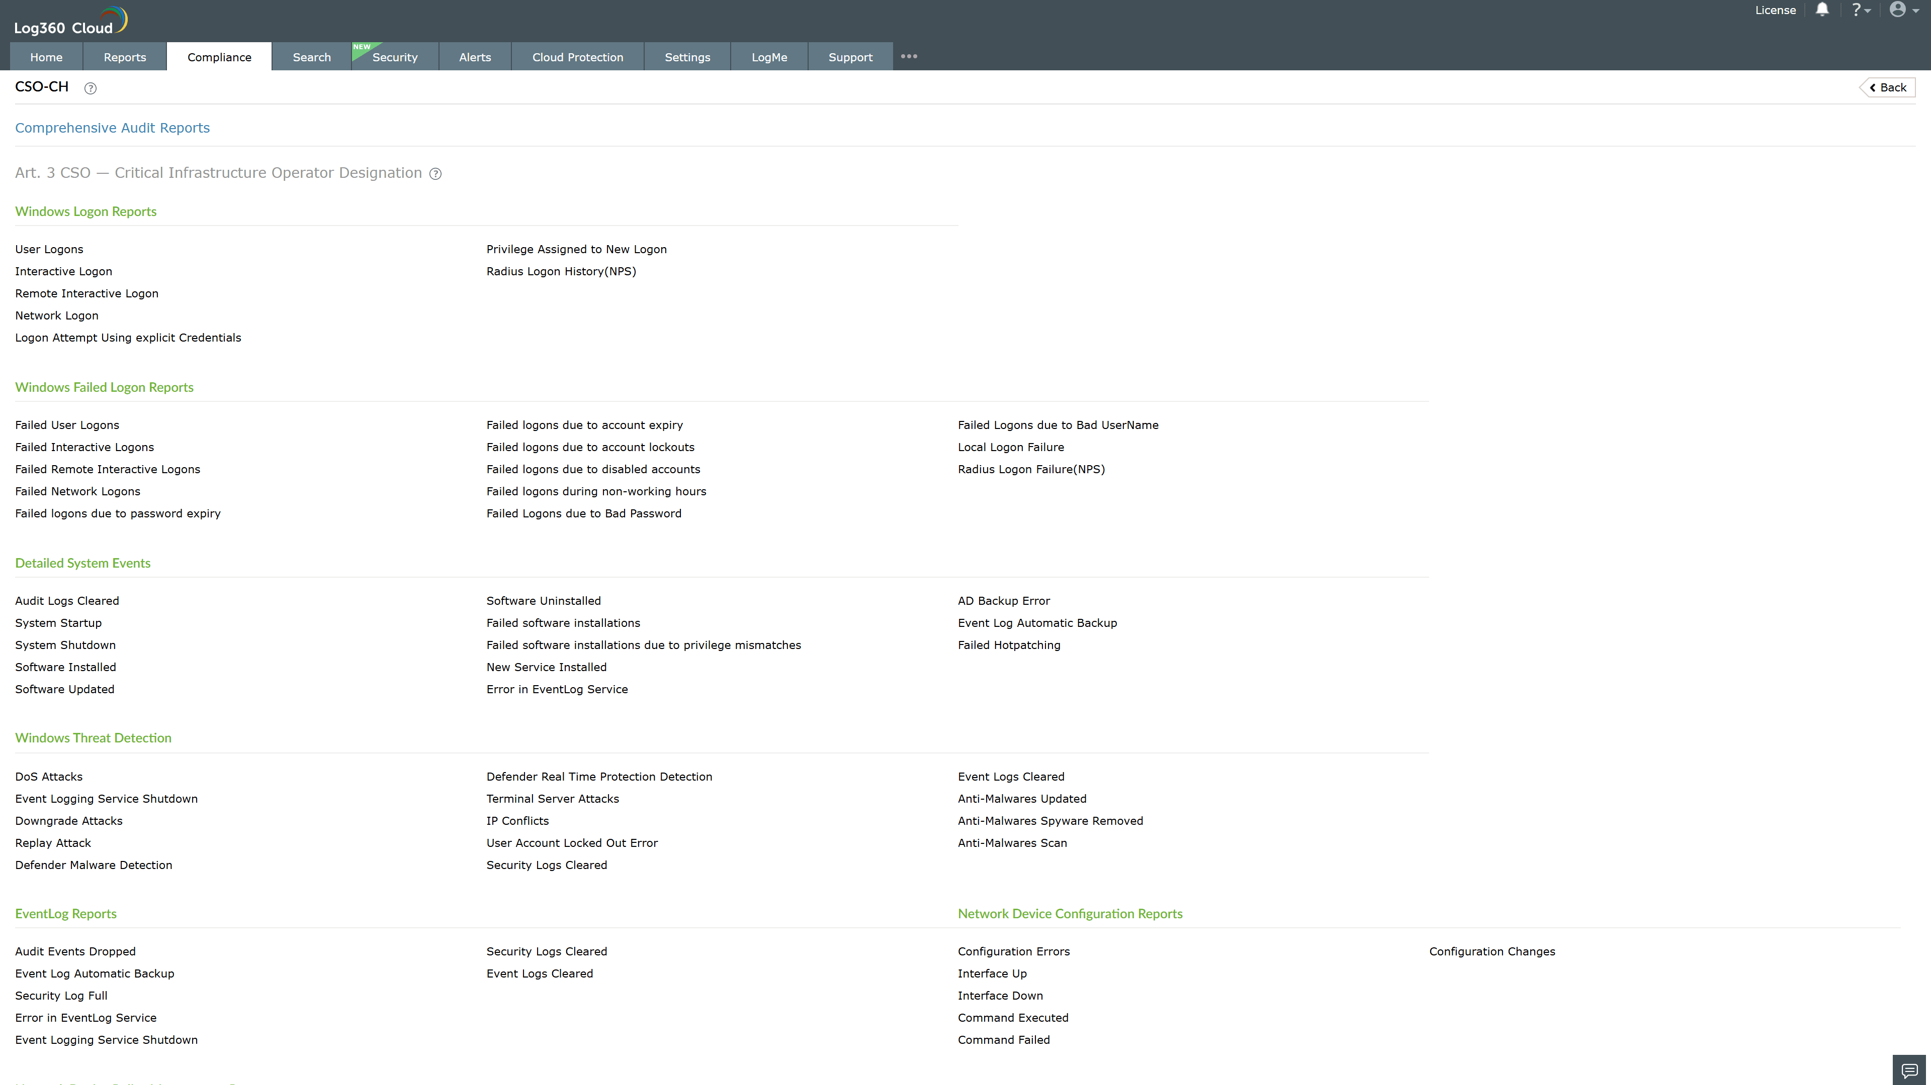
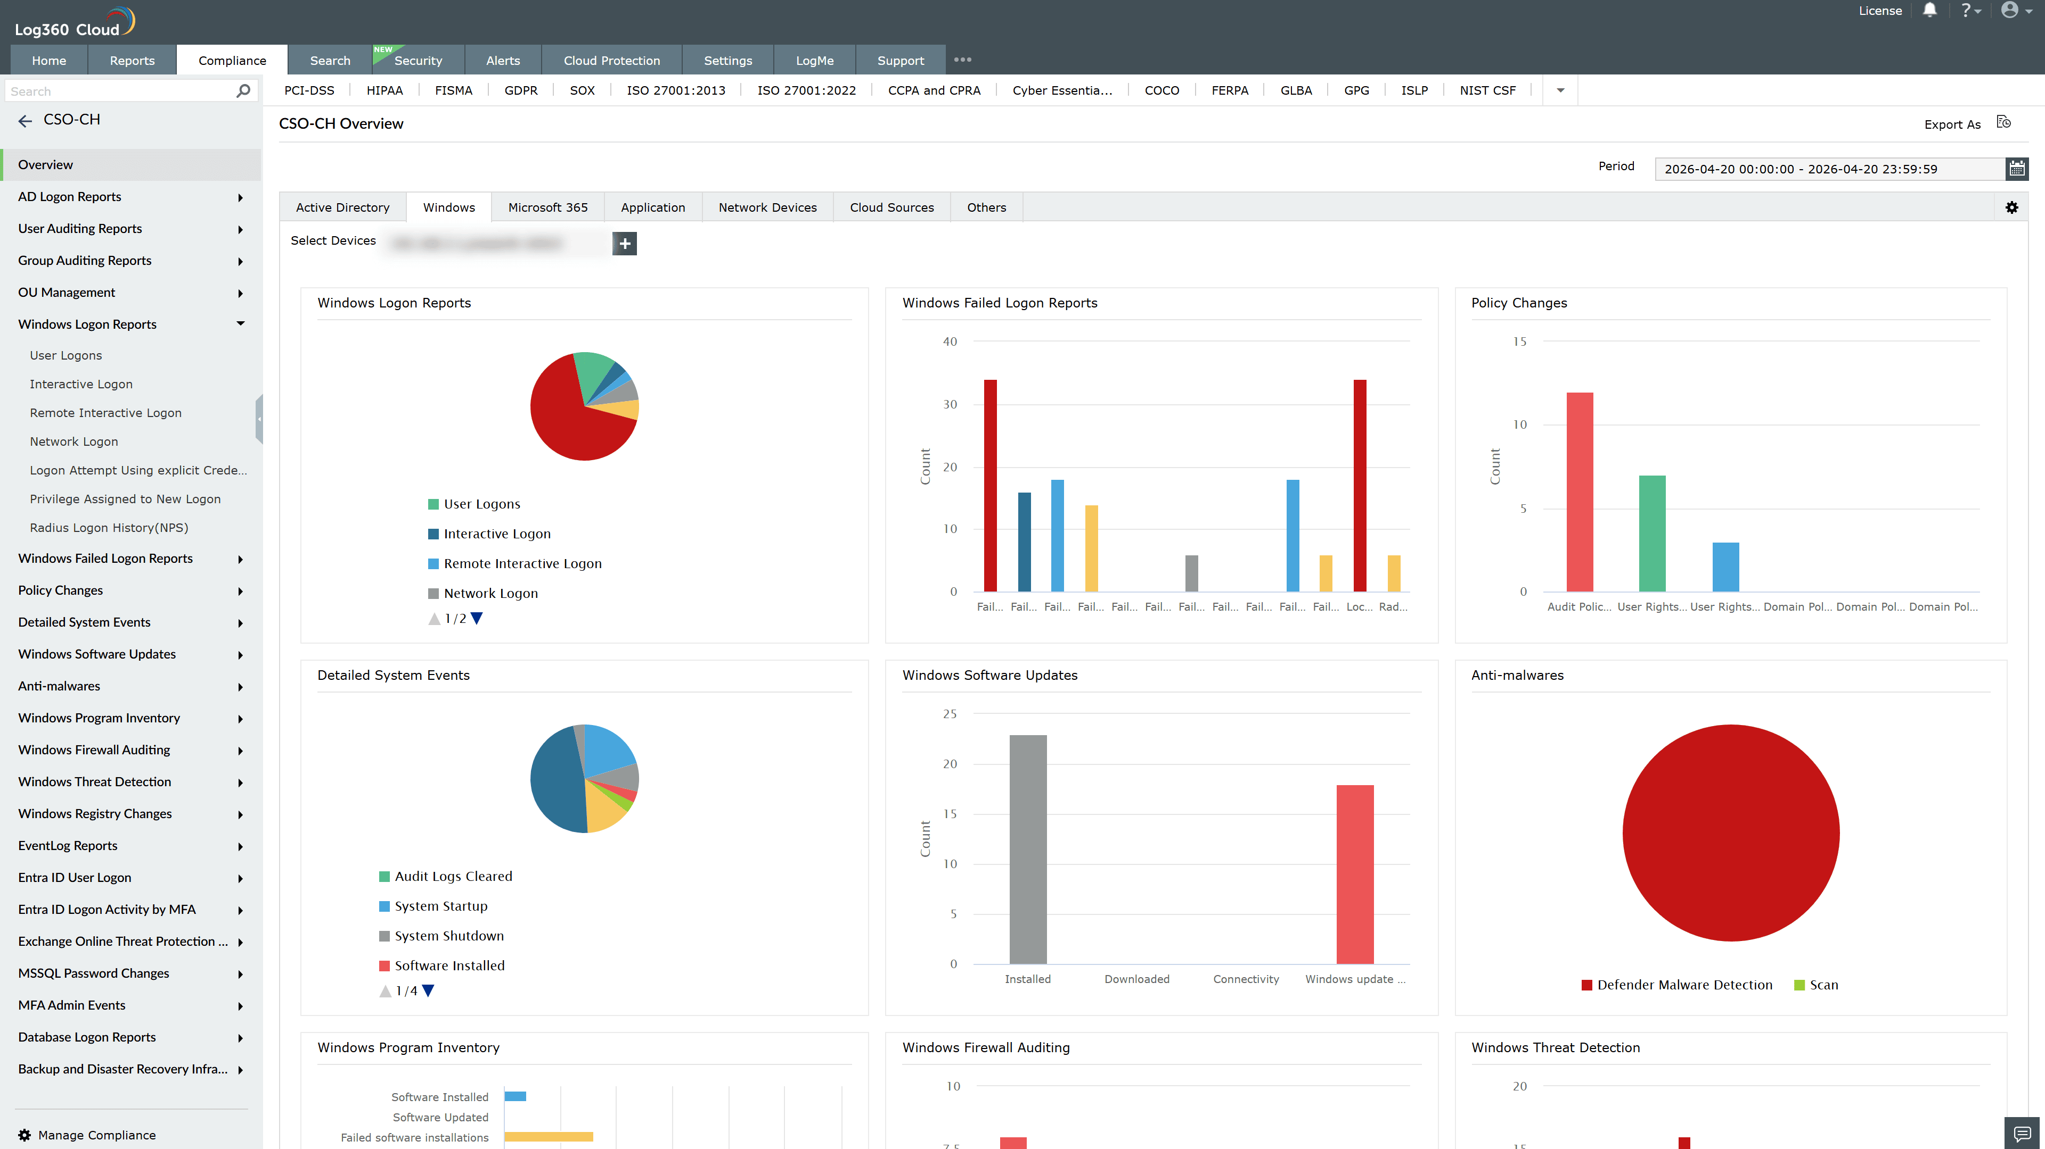
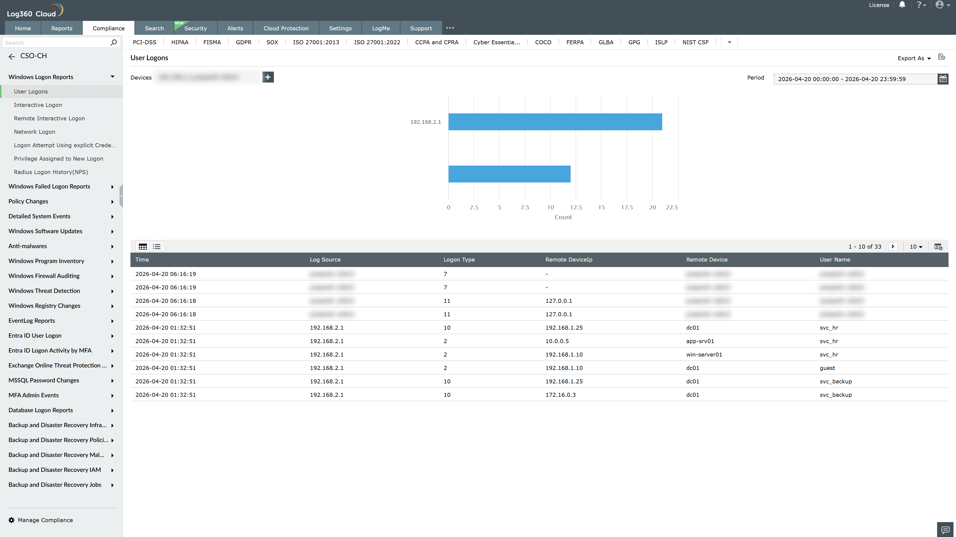
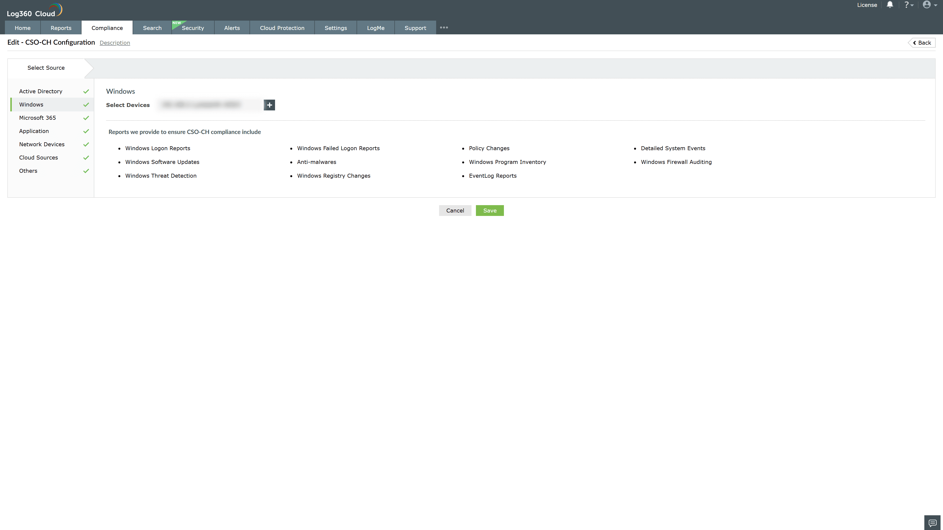
Valid Submission : Yes
Supported Editions : Free, Basic, Standard, Professional, MSSP
Help Document : https://www.manageengine.com/log-management/help/integrations/compliance-extensions.html
Help Video : Not provided
Tags : Log360, Compliance, Privacy monitoring, Data privacy, Regulatory compliance
Supported DCs : US, IN, JP, CA, AU, UK and EU
Privacy Policy:
Terms of Service:
Release Notes:
Predefined reports for the CSO Compliance

