Swiss CySec Rail Directive Compliance for Log360
Tagline: Meet CySec cybersecurity requirements with continuous monitoring from Log360.

Overview
The Swiss CySec Rail Directive Compliance extension for Log360 helps Swiss railway operators and rail infrastructure managers meet the cybersecurity monitoring, incident response, and resilience obligations under Switzerland's CySec Rail Directive.
Log360 ingests and correlates logs from operational technology, signaling systems, IT environments, and access control platforms, providing security teams with visibility into cyber threats targeting rail operations. Compliance teams can detect incidents, maintain forensic audit trails, and generate reports for BAV oversight.

Key Features
- Generate audit reports mapped to CySec Rail Directive requirements covering access control, operational technology monitoring, and cybersecurity incident detection.
- Monitor rail OT environments and IT systems for unauthorized access, anomalous commands, and configuration changes that may impact rail safety and operations.
- Leverage preconfigured correlation rules and threat intelligence to detect advanced threats targeting railway control systems and passenger data.
- Export compliance documentation in PDF and CSV formats for BAV supervisory reporting and internal rail cybersecurity governance.
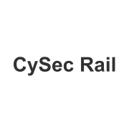
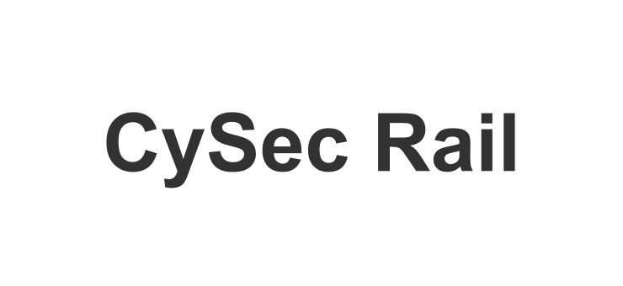

Screenshots
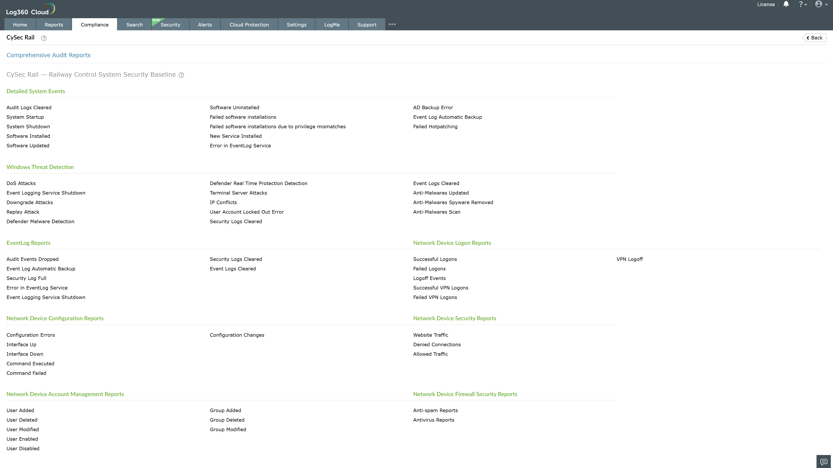
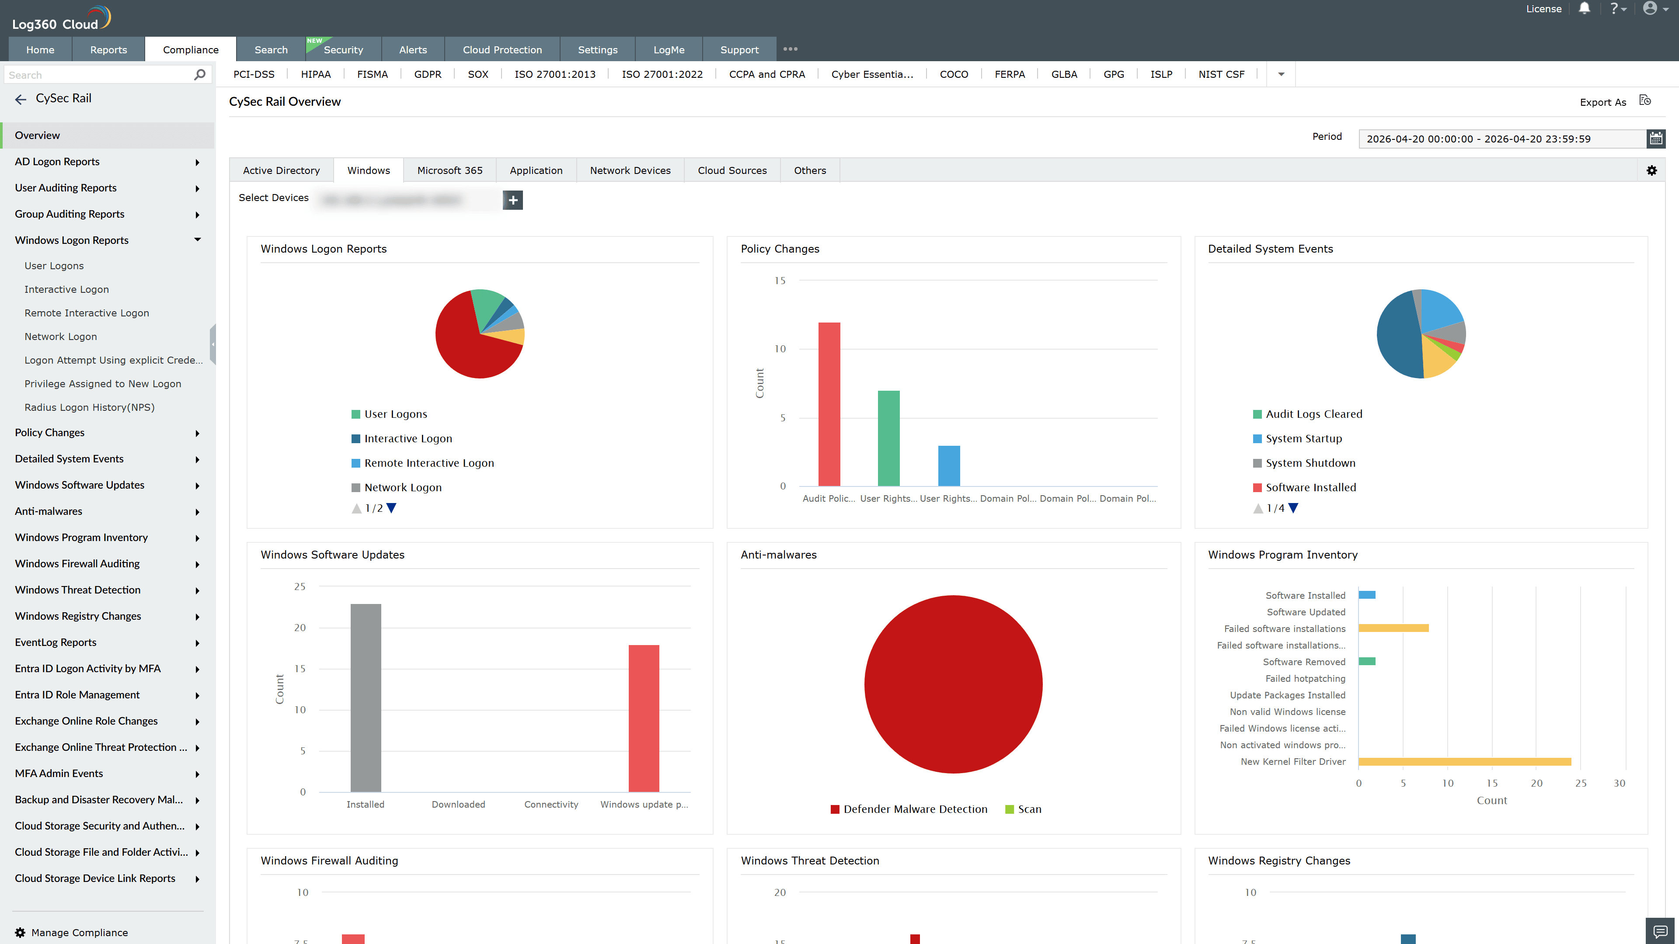
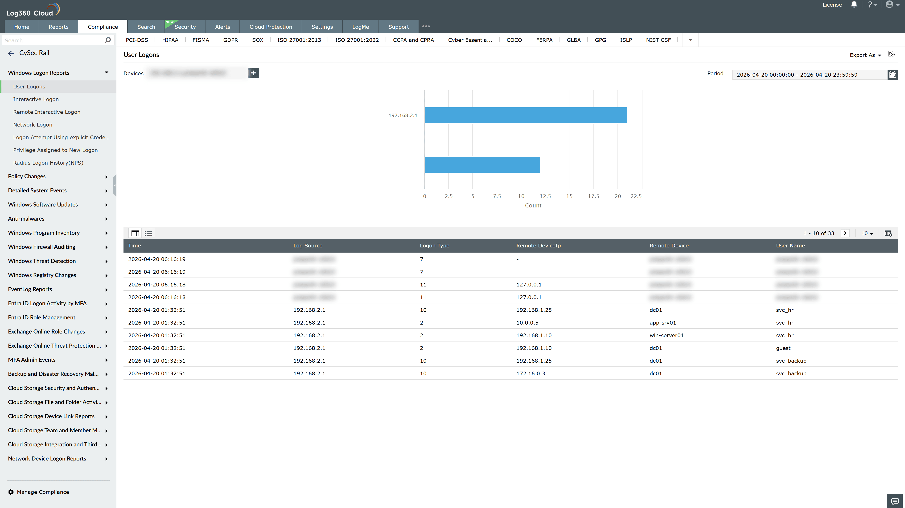
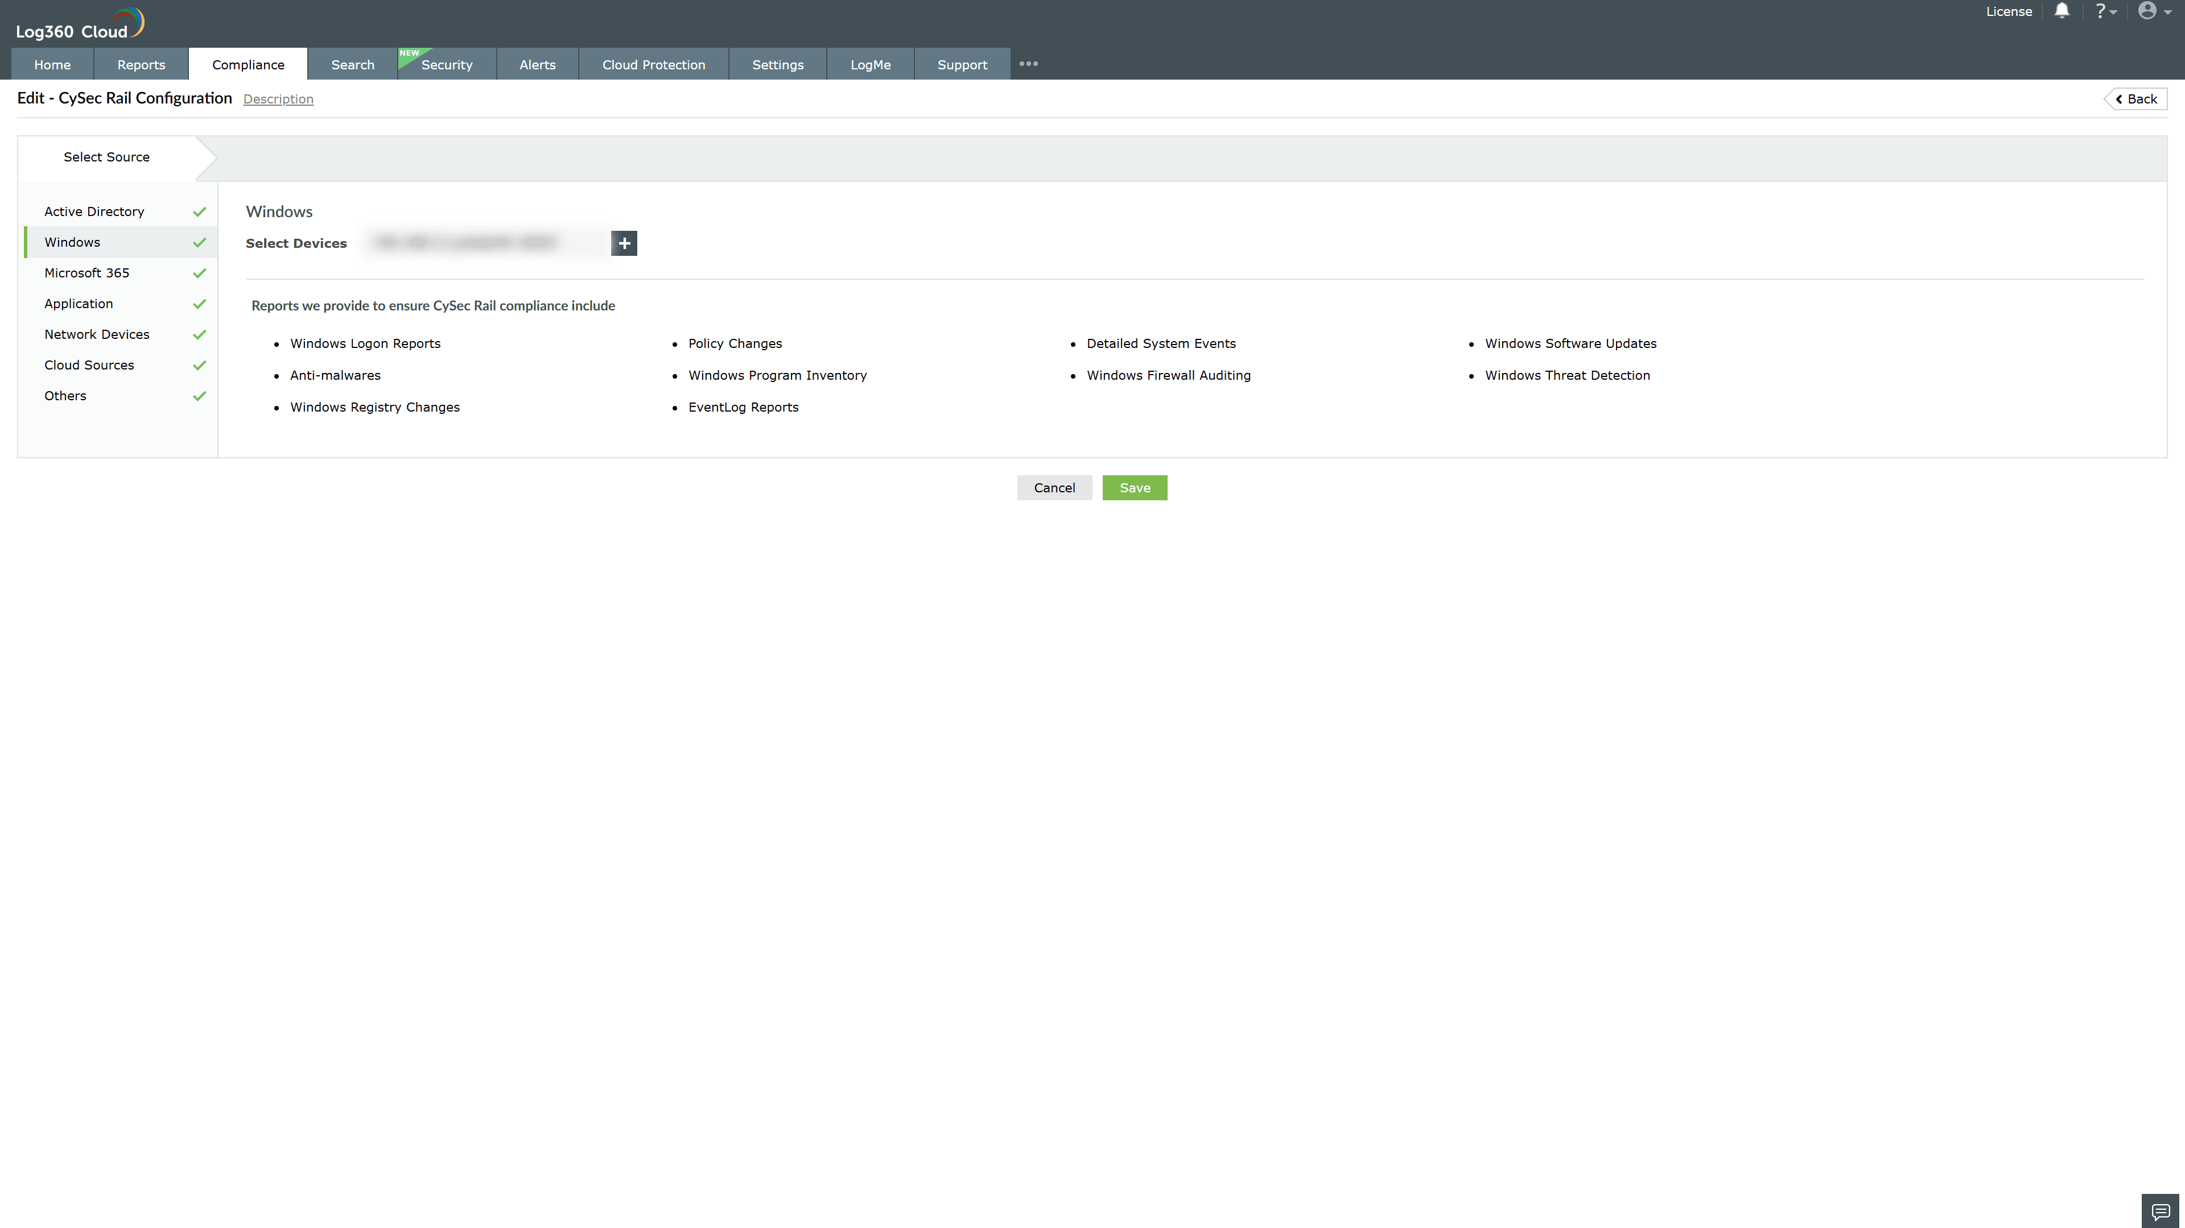
Valid Submission : Yes
Supported Editions : Free, Basic, Standard, Professional, MSSP
Help Document : https://www.manageengine.com/log-management/help/integrations/compliance-extensions.html
Help Video : Not provided
Tags : Log360, Compliance, Privacy monitoring, Data privacy, Regulatory compliance
Supported DCs : US, IN, JP, CA, AU, UK and EU
Privacy Policy:
Terms of Service:
Release Notes:
Predefined reports for the CySec Rail Compliance

