Swiss Electricity Supply Ordinance Cybersecurity Compliance for Log360
Tagline: Protect Swiss electricity infrastructure and meet OApEl Art. 8b cybersecurity requirements with Log360.

Overview
The Swiss Electricity Supply Ordinance (OApEl Art. 8b) Cybersecurity Compliance extension for Log360 supports Swiss electricity network operators and energy suppliers in meeting the mandatory cybersecurity measures for critical energy infrastructure as required by Art. 8b of the OApEl.
Log360 collects and correlates logs from operational technology, SCADA systems, IT environments, and network infrastructure, providing security teams with continuous monitoring of cyber threats to energy systems. Compliance teams can track control effectiveness and generate audit evidence for ELCOM oversight.

Key Features
- Generate predefined audit reports covering OApEl Art. 8b cybersecurity requirements including access control, network monitoring, and incident detection for energy systems.
- Monitor operational technology and IT environments for unauthorized access, unusual commands, and configuration changes that may affect energy supply continuity.
- Configure real-time alerts for cyber events affecting critical electricity infrastructure, including SCADA access anomalies and network intrusion indicators.
- Export compliance evidence in PDF and CSV formats for ELCOM regulatory submissions and internal energy sector security reviews.
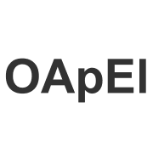
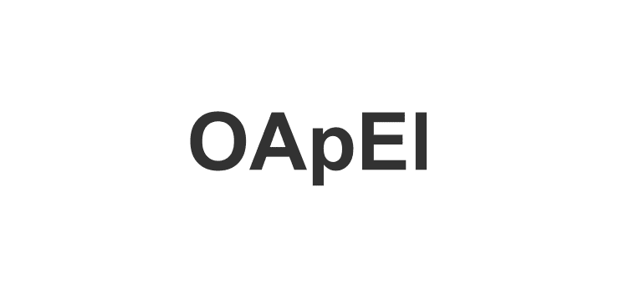

Screenshots
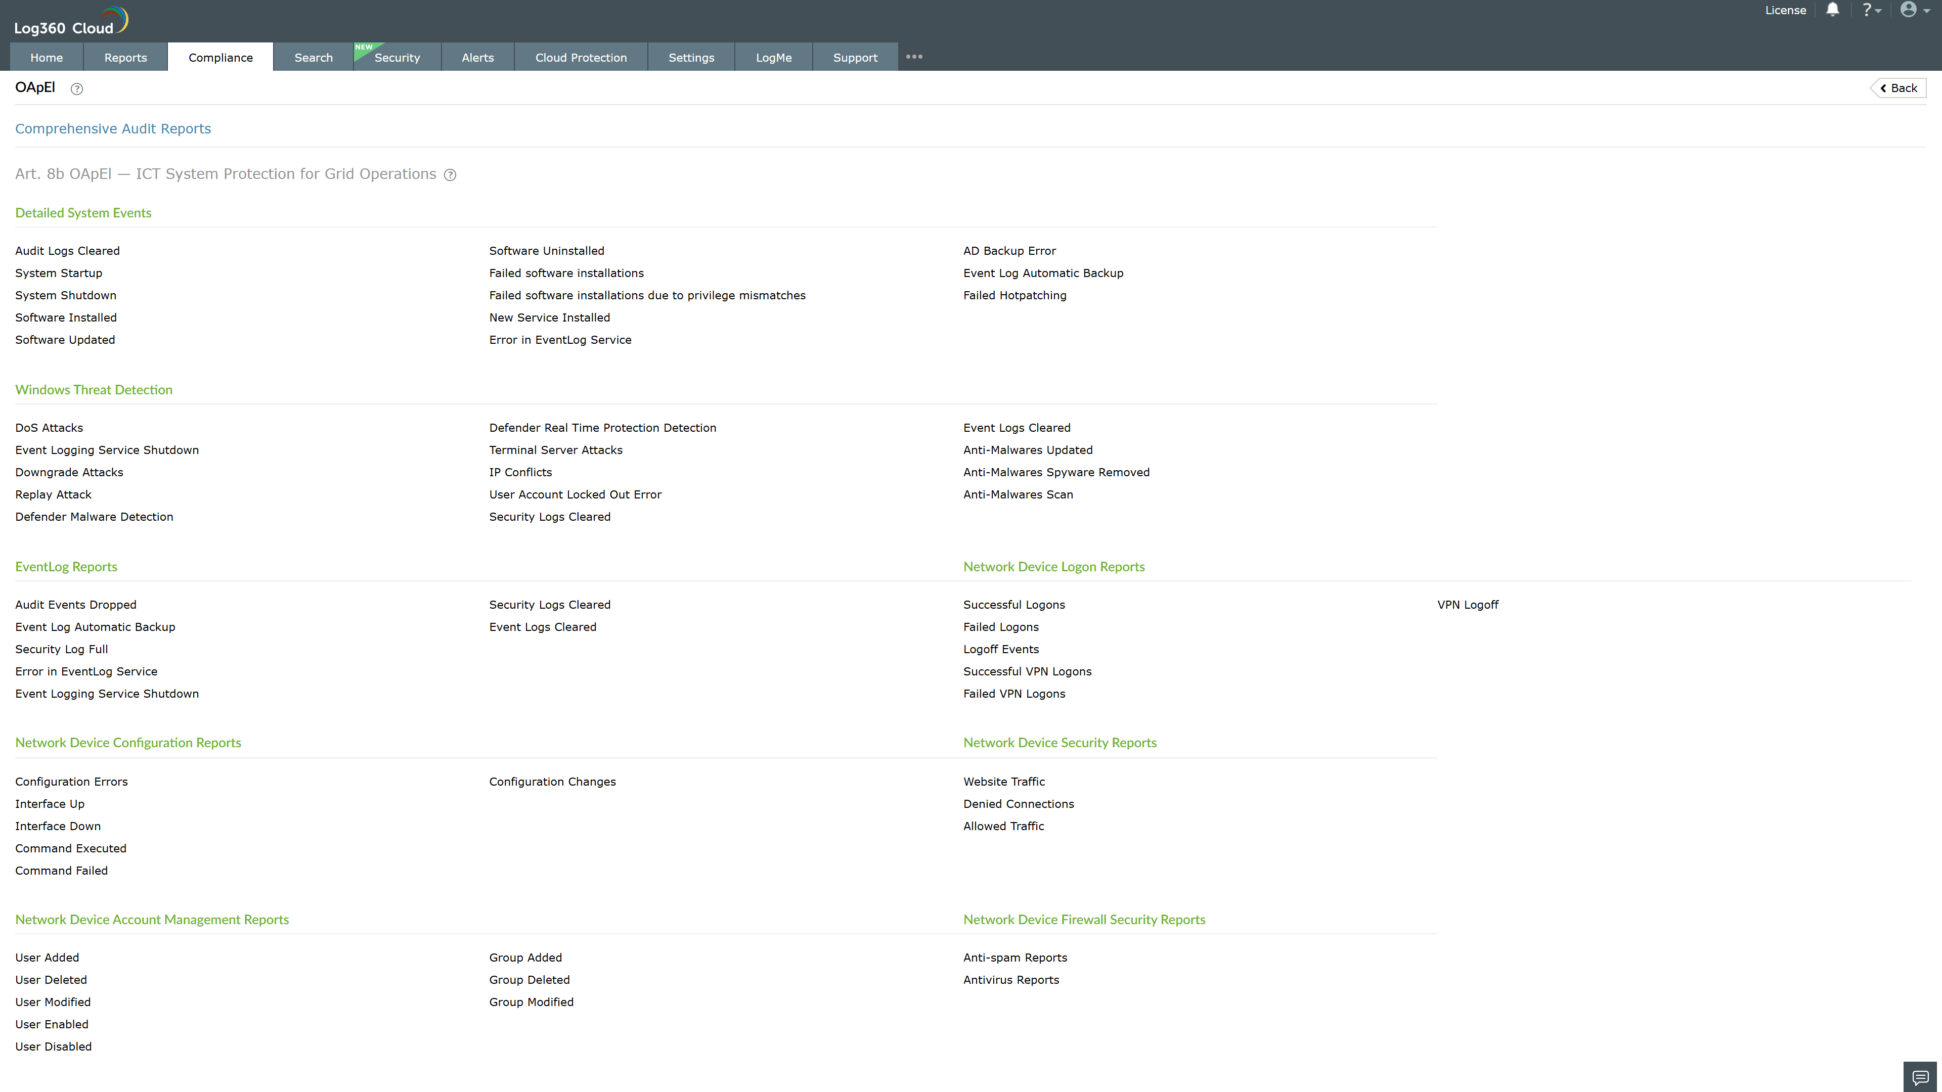
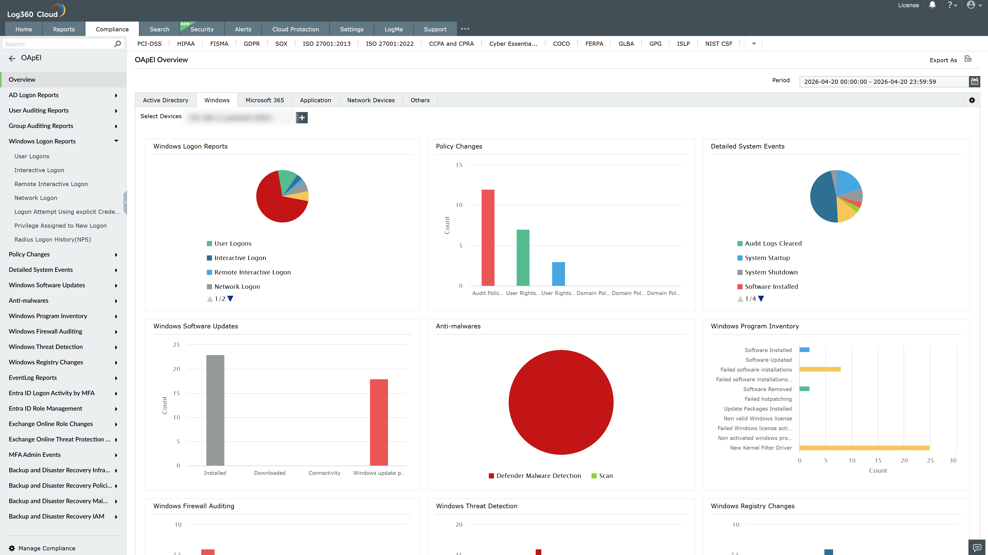
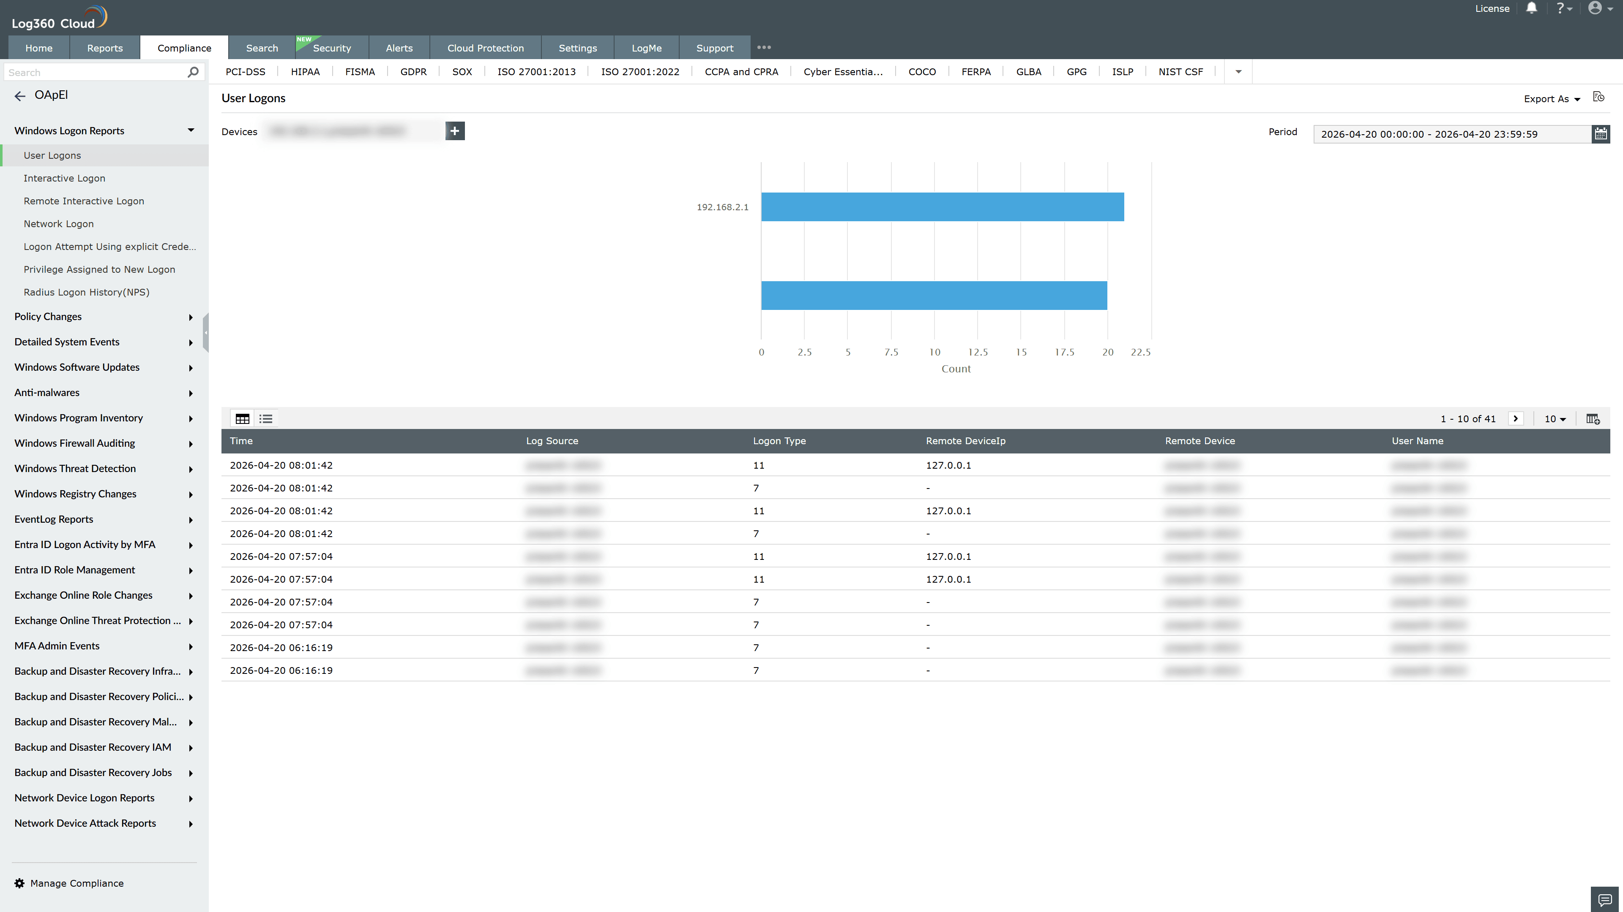
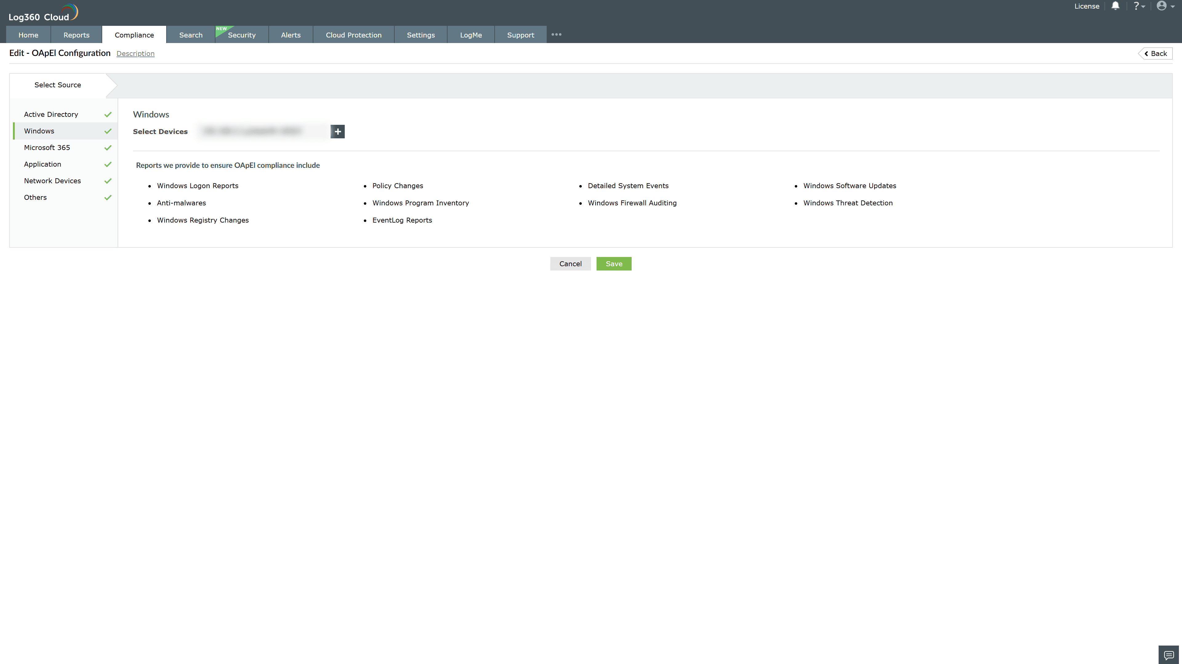
Valid Submission : Yes
Supported Editions : Free, Basic, Standard, Professional, MSSP
Help Document : https://www.manageengine.com/log-management/help/integrations/compliance-extensions.html
Help Video : Not provided
Tags : Log360, Compliance, Privacy monitoring, Data privacy, Regulatory compliance
Supported DCs : US, IN, JP, CA, AU, UK and EU
Privacy Policy:
Terms of Service:
Release Notes:
Predefined reports for the OApEI Compliance

