French CIIP Law 2013 Compliance for Log360
Tagline: Support France’s vital infrastructure security compliance with continuous monitoring from Log360.

Overview
The French CIIP Law 2013 Compliance extension for Log360 supports French Opérateurs d'Importance Vitale (OIV) in meeting their security monitoring, incident reporting, and control implementation obligations under France's critical information infrastructure protection framework.
Log360 ingests and correlates logs from OIV systems, network infrastructure, industrial control systems, and cloud environments, providing security teams with real-time detection capabilities. Compliance teams can document control adherence and generate reports for ANSSI oversight.

Key Features
- Generate audit reports mapped to French CIIP requirements covering security monitoring, incident detection, access control, and network protection for OIVs.
- Detect advanced threats targeting OIV critical infrastructure through behavioral analysis and anomaly detection across industrial control systems and operational technology networks.
- Monitor access to critical systems and operational technology environments to detect unauthorized activity and configuration changes.
- Export ANSSI-aligned compliance documentation in PDF and CSV formats for regulatory submissions and internal security reviews.



Screenshots
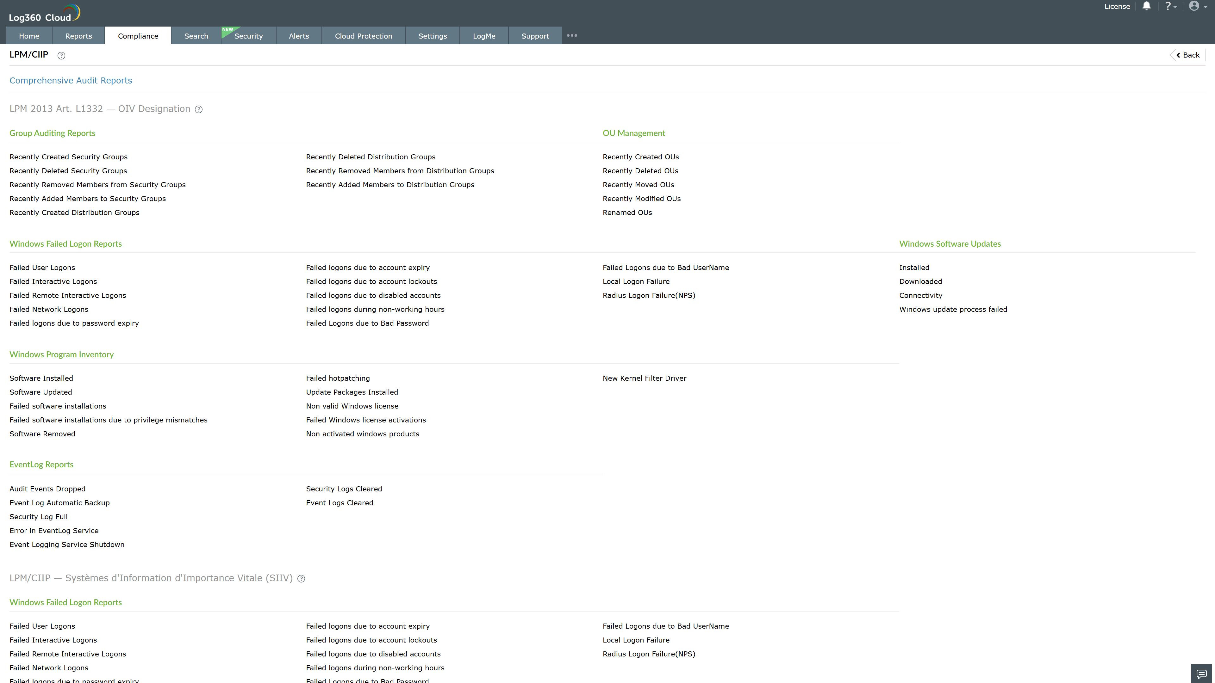
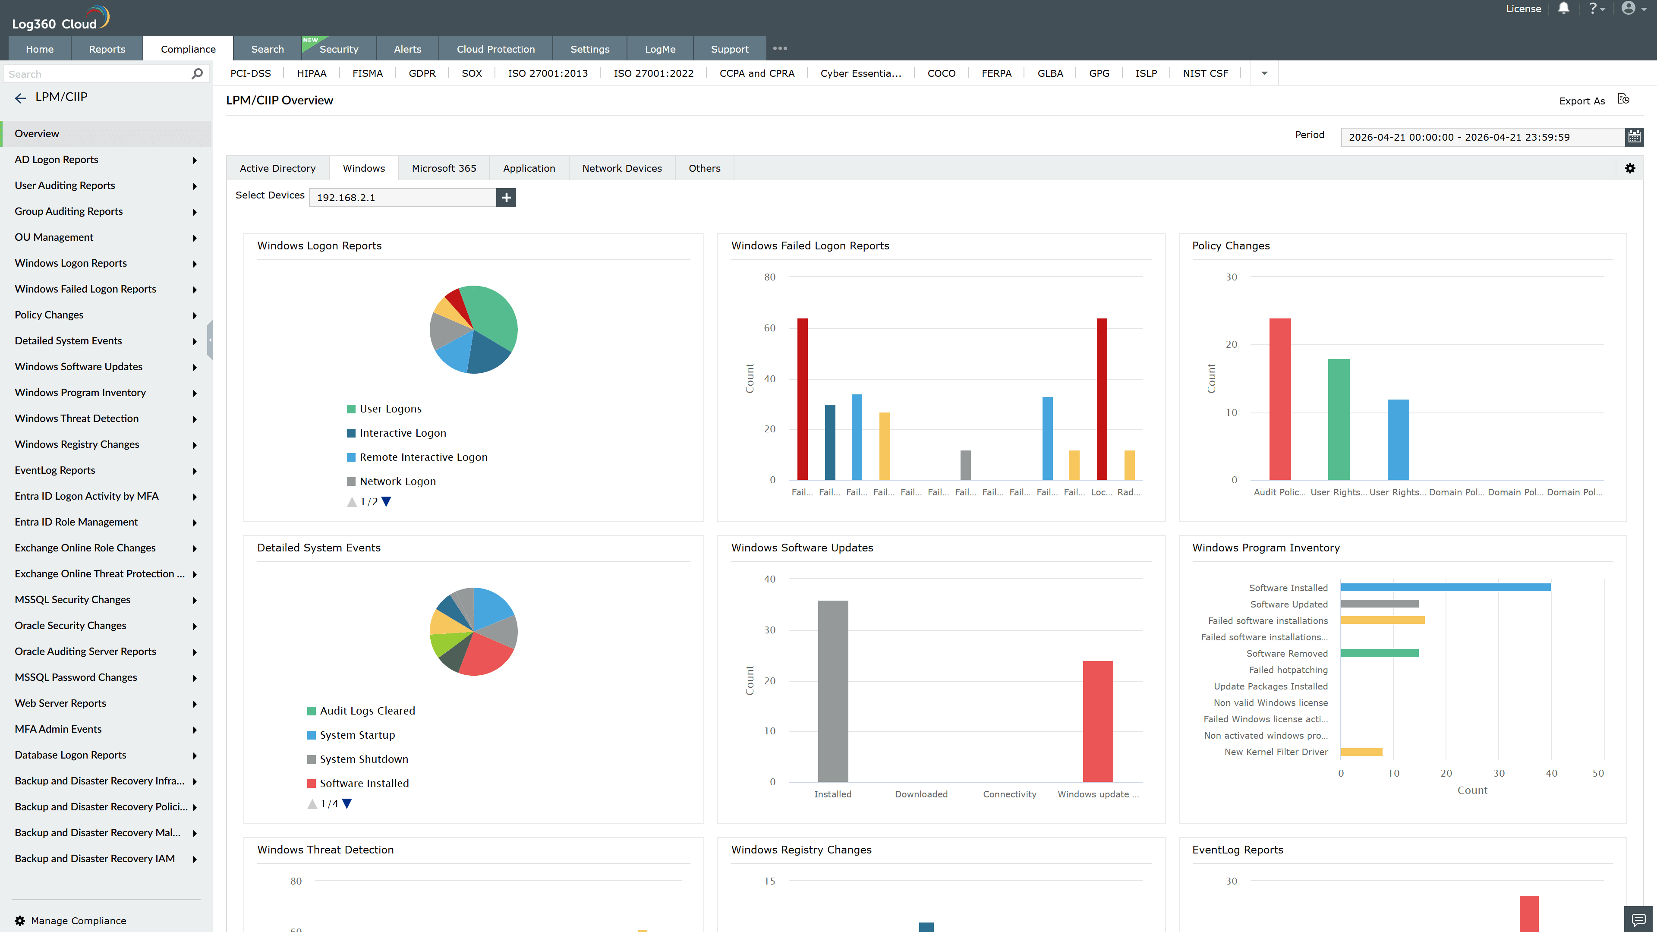
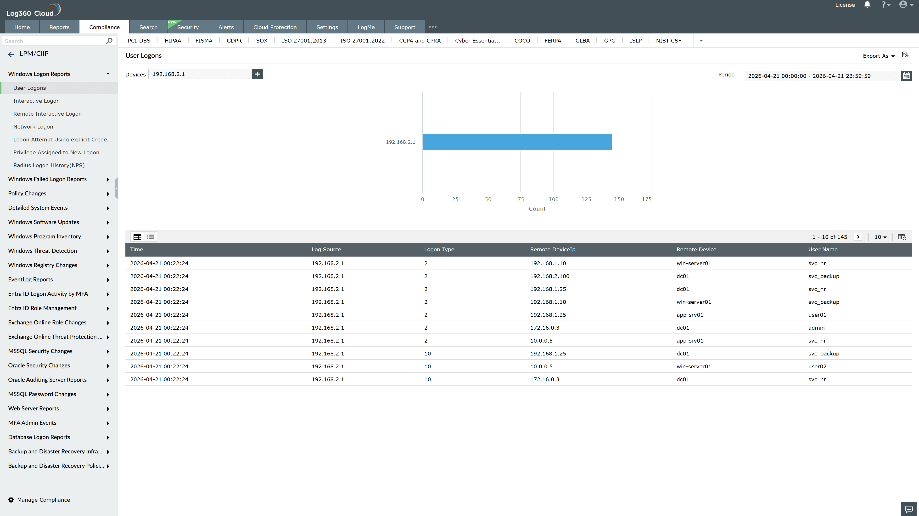
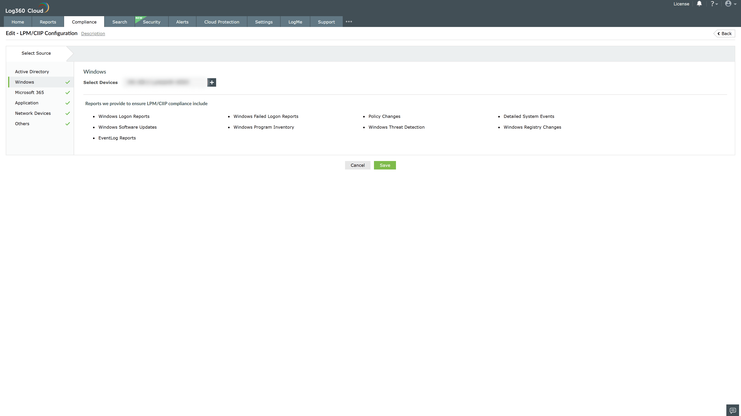
Valid Submission : Yes
Supported Editions : Free, Basic, Standard, Professional, MSSP
Help Document : https://www.manageengine.com/log-management/help/integrations/compliance-extensions.html
Help Video : Not provided
Tags : Log360, Compliance, Privacy monitoring, Data privacy, Regulatory compliance
Supported DCs : US, IN, JP, CA, AU, UK and EU
Privacy Policy:
Terms of Service:
Release Notes:
Predefined reports for the CIIP Law Compliance

