FSRA Cyber Risk Management Framework Compliance for Log360
Tagline: Align with ADGM's FSRA standards using threat detection from Log360.

Overview
The FSRA Cyber Risk Management Framework Compliance extension for Log360 enables ADGM-licensed financial institutions and fintech firms to meet the Financial Services Regulatory Authority's cyber risk management, monitoring, and resilience requirements.
Log360 ingests and correlates security event data from financial applications, cloud platforms, endpoints, and network devices, providing compliance and security teams with a continuous view of their cyber risk posture. Teams can identify control gaps, respond to threats rapidly, and generate FSRA-ready documentation to demonstrate framework adherence.

Key Features
- Generate compliance reports aligned to FSRA Cyber Risk Management Framework controls covering identity security, threat monitoring, and incident response.
- Monitor authentication events, privileged access usage, and critical configuration changes across ADGM financial services environments.
- Correlate security events across ADGM financial services infrastructure to maintain continuous visibility into user activity and access patterns aligned with FSRA Cyber Risk Management Framework monitoring obligations.
- Export audit evidence in PDF and CSV formats for FSRA supervisory reviews and internal risk governance submissions.
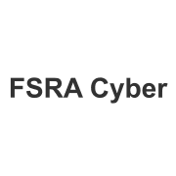
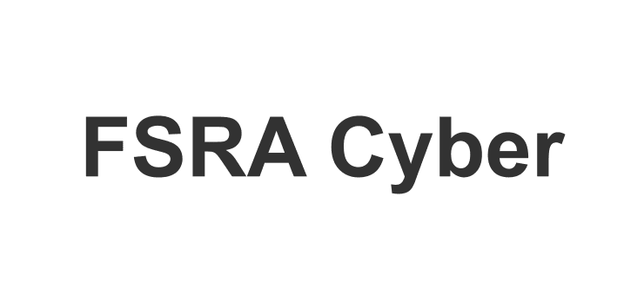

Screenshots
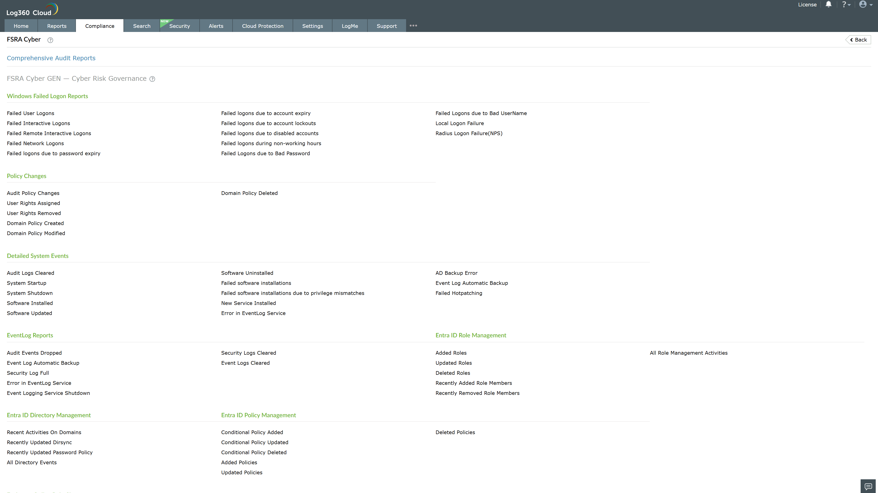
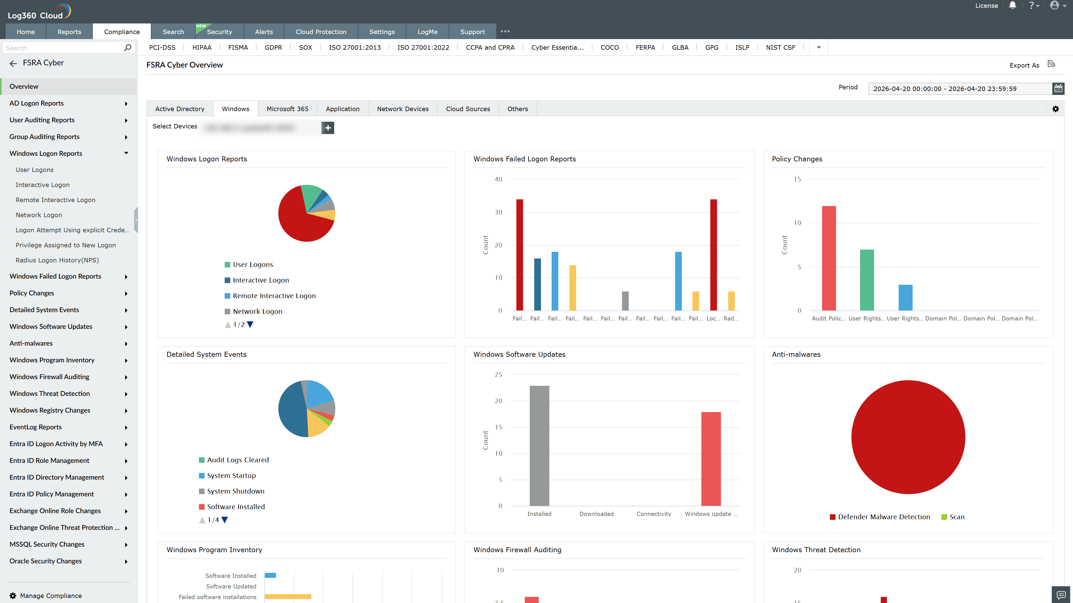
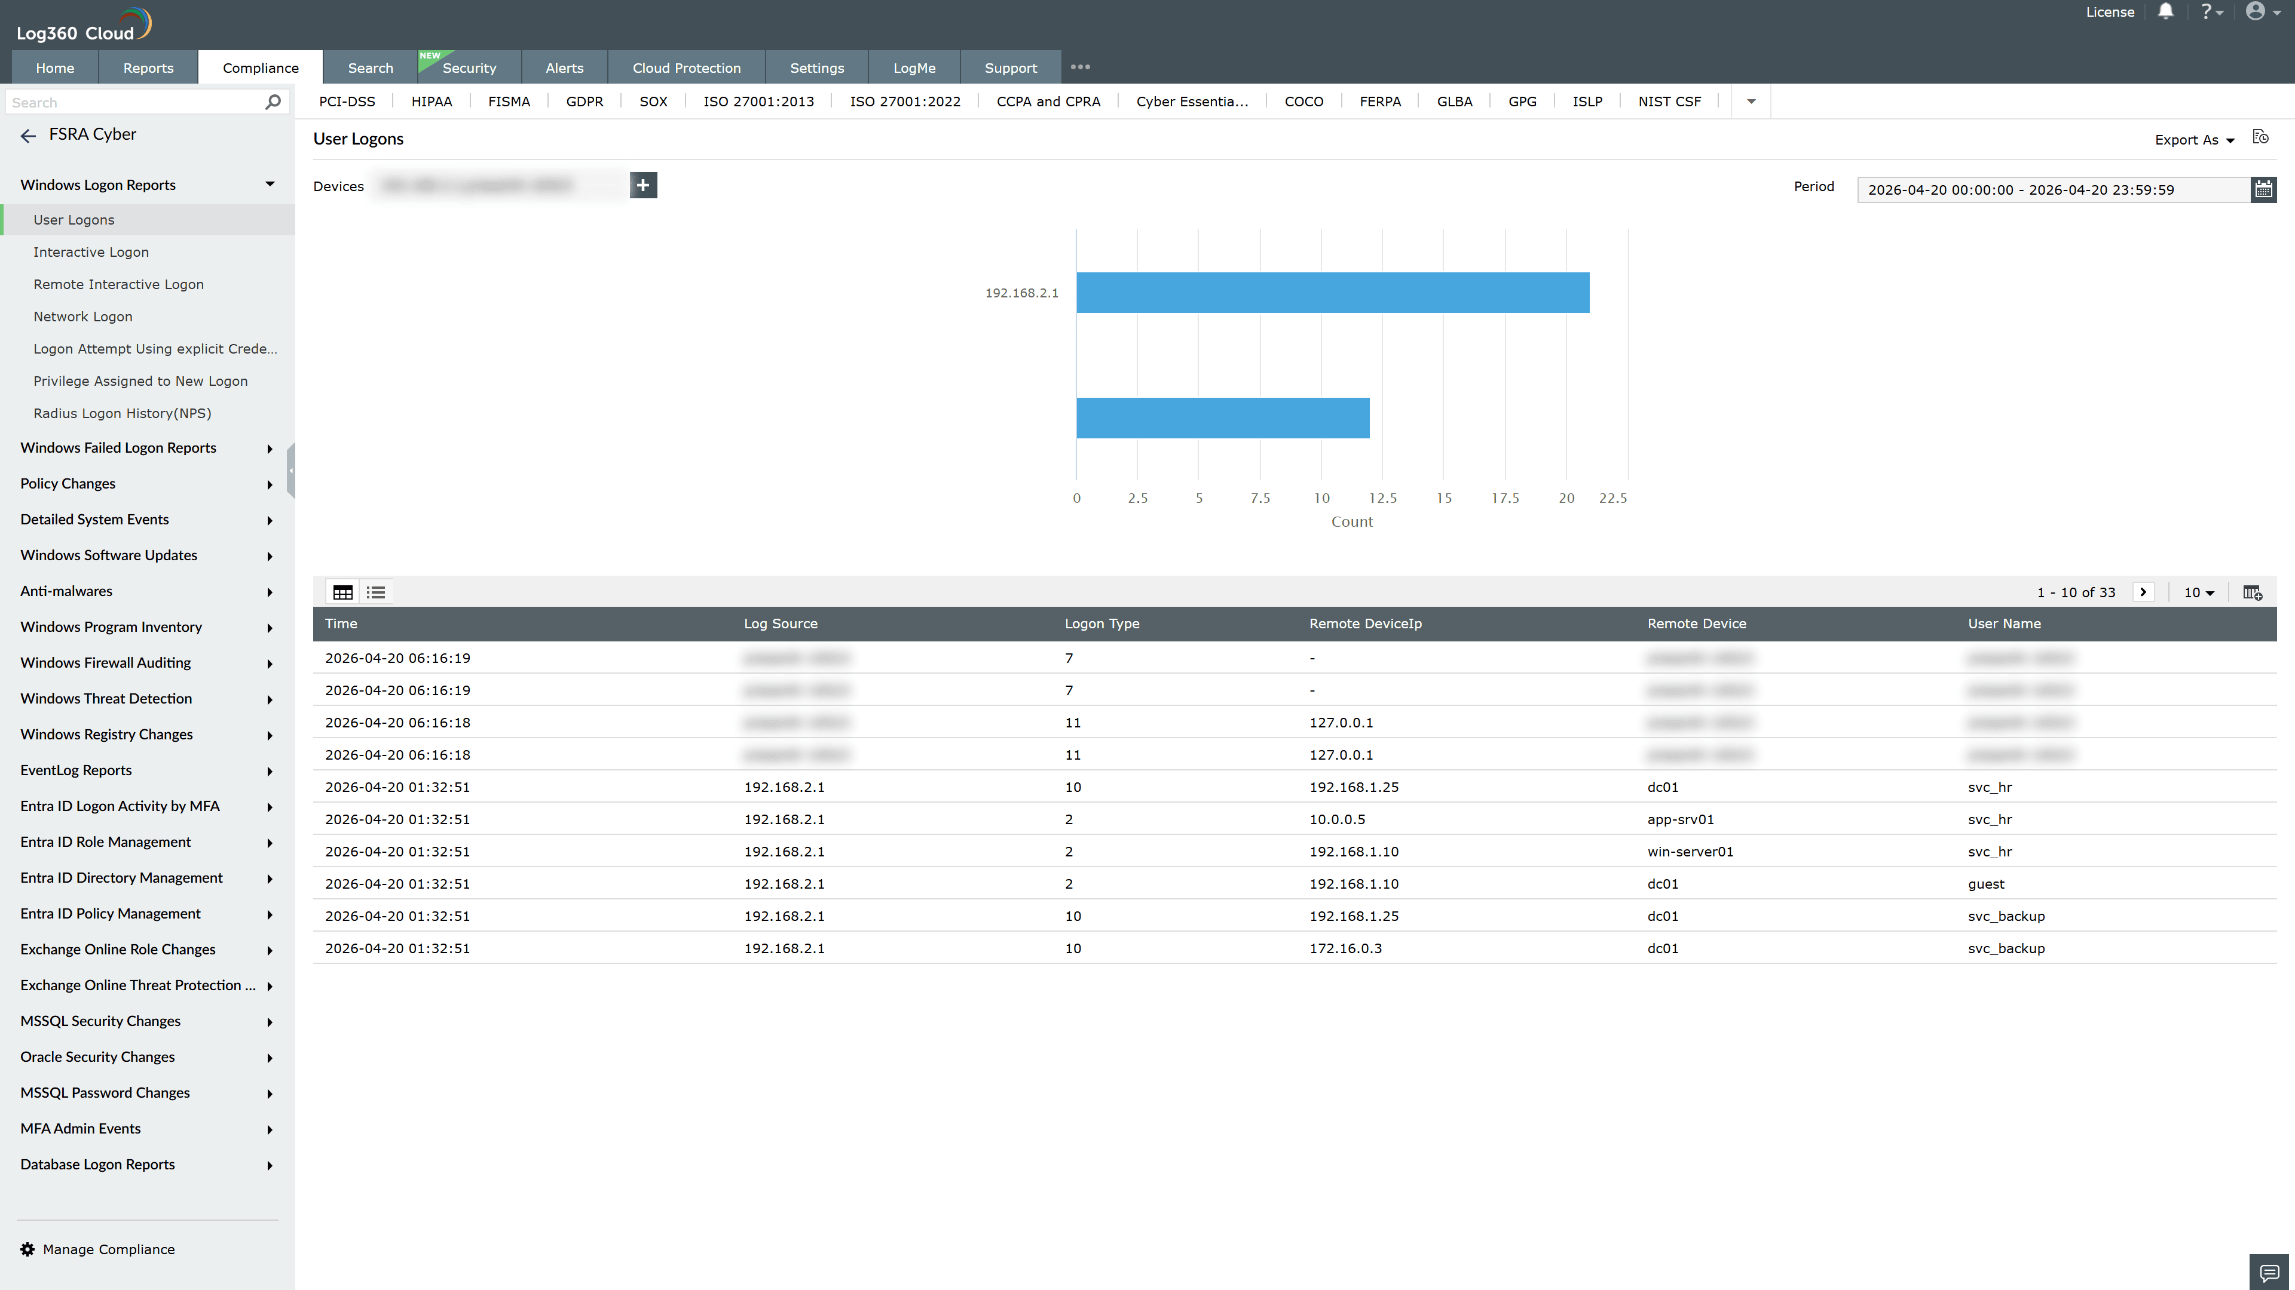
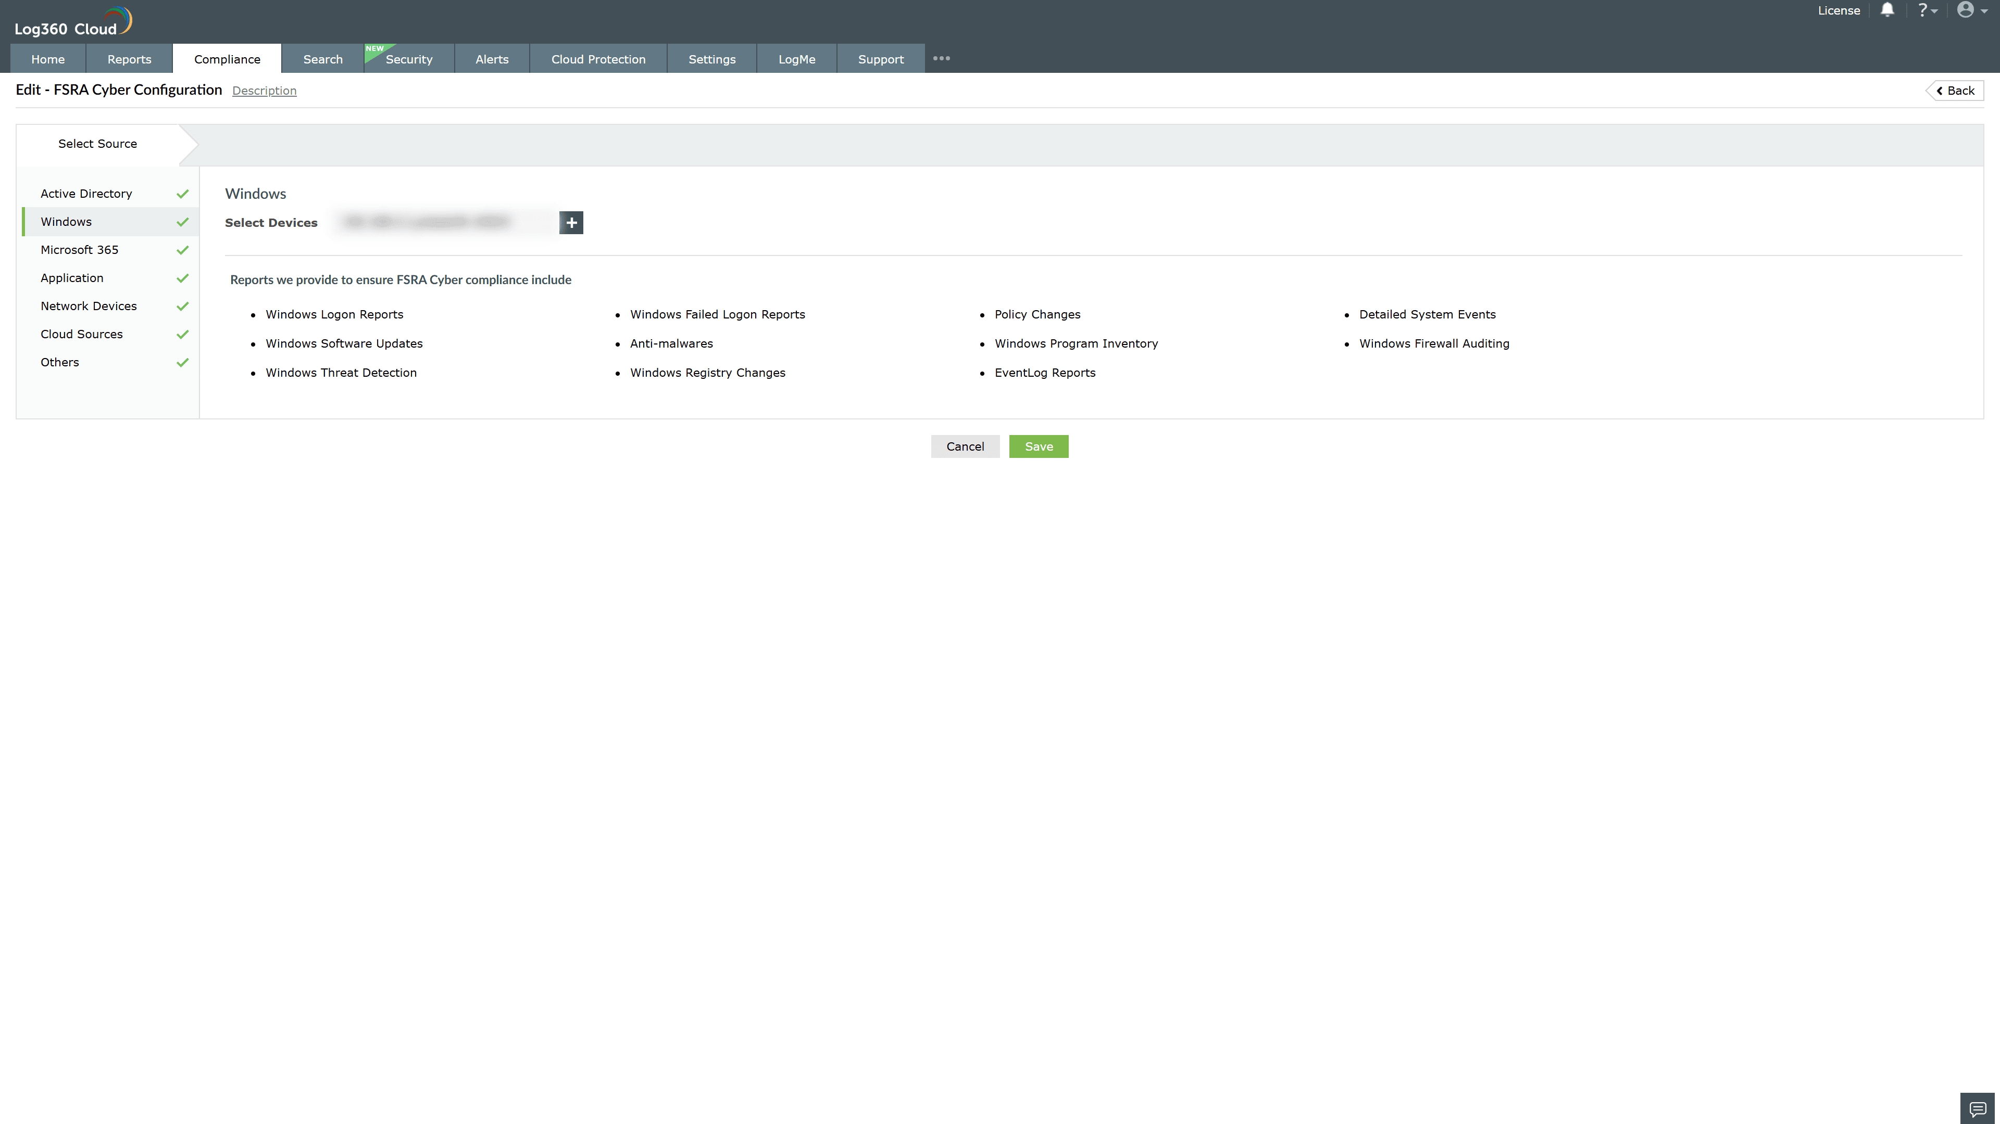
Valid Submission : Yes
Supported Editions : Free, Basic, Standard, Professional, MSSP
Help Document : https://www.manageengine.com/log-management/help/integrations/compliance-extensions.html
Help Video : Not provided
Tags : Log360, Compliance, Privacy monitoring, Data privacy, Regulatory compliance
Supported DCs : US, IN, JP, CA, AU, UK and EU
Privacy Policy:
Terms of Service:
Release Notes:
Predefined reports for the FSRA Compliance

