German Anti-Money Laundering Act Compliance for Log360
Tagline: Support German AML compliance and FIU reporting with centralized log monitoring from Log360.

Overview
The German Anti-Money Laundering Act (GwG) Compliance extension for Log360 helps German obligated entities — including banks, financial service firms, and designated non-financial businesses — meet the IT access control, audit logging, and monitoring obligations relevant to GwG AML compliance.
Log360 collects and correlates logs from financial systems, customer data platforms, cloud environments, and identity services, providing compliance teams with visibility into access events and anomalous behavior associated with financial crime risks. Teams can investigate suspicious activities and generate documentation for BaFin and German Financial Intelligence Unit (FIU) oversight.

Key Features
- Generate compliance reports covering GwG-relevant IT controls including access to customer financial records, authentication logs, and transaction system monitoring.
- Monitor financial system access and detect unusual data queries, privilege escalations, or unauthorized record modifications that may indicate AML control failures.
- Configure real-time alerts for AML-relevant security events such as unauthorized access to customer due diligence records and suspicious administrative actions.
- Export audit evidence in PDF and CSV formats for BaFin examinations, internal AML compliance officer records, and FIU disclosure documentation.

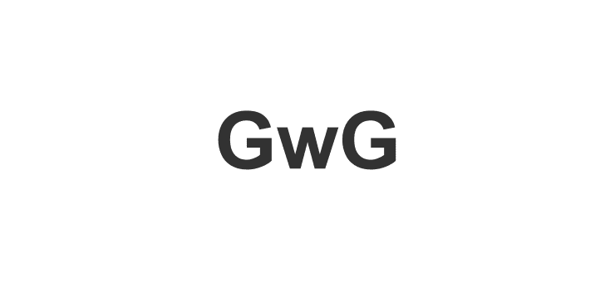

Screenshots
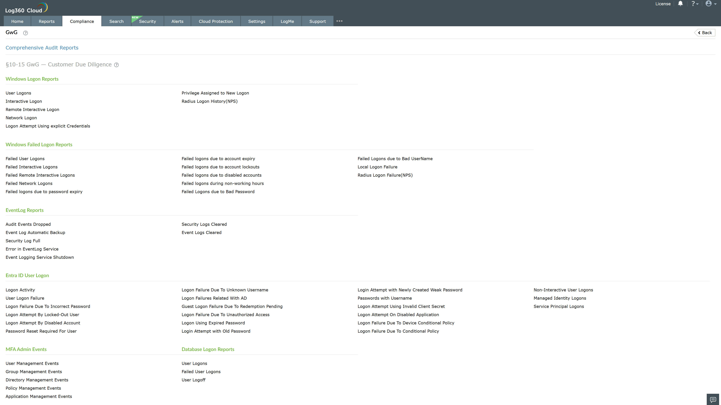
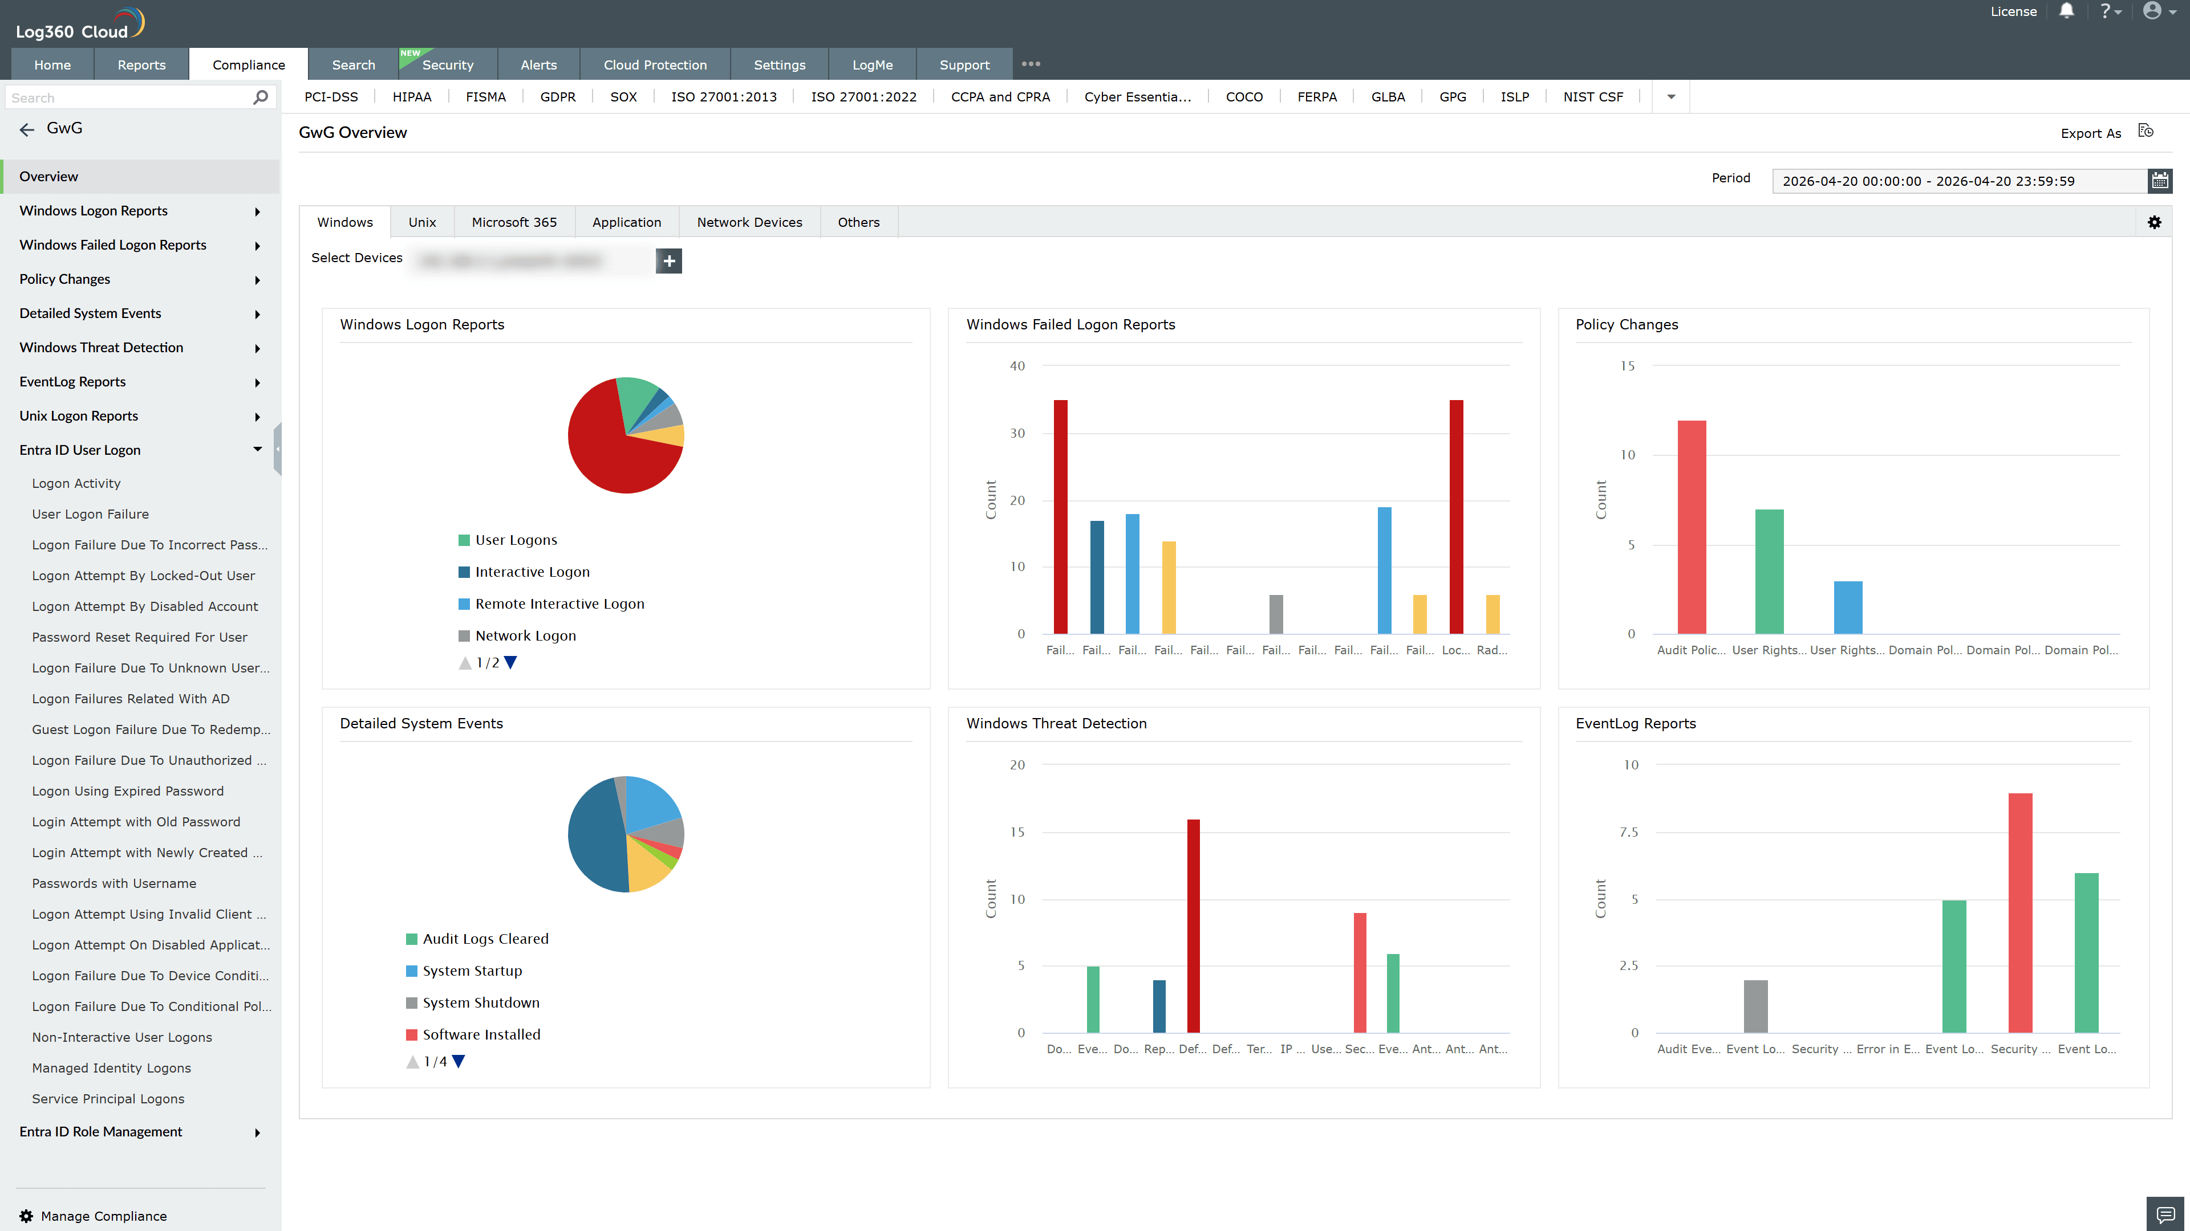
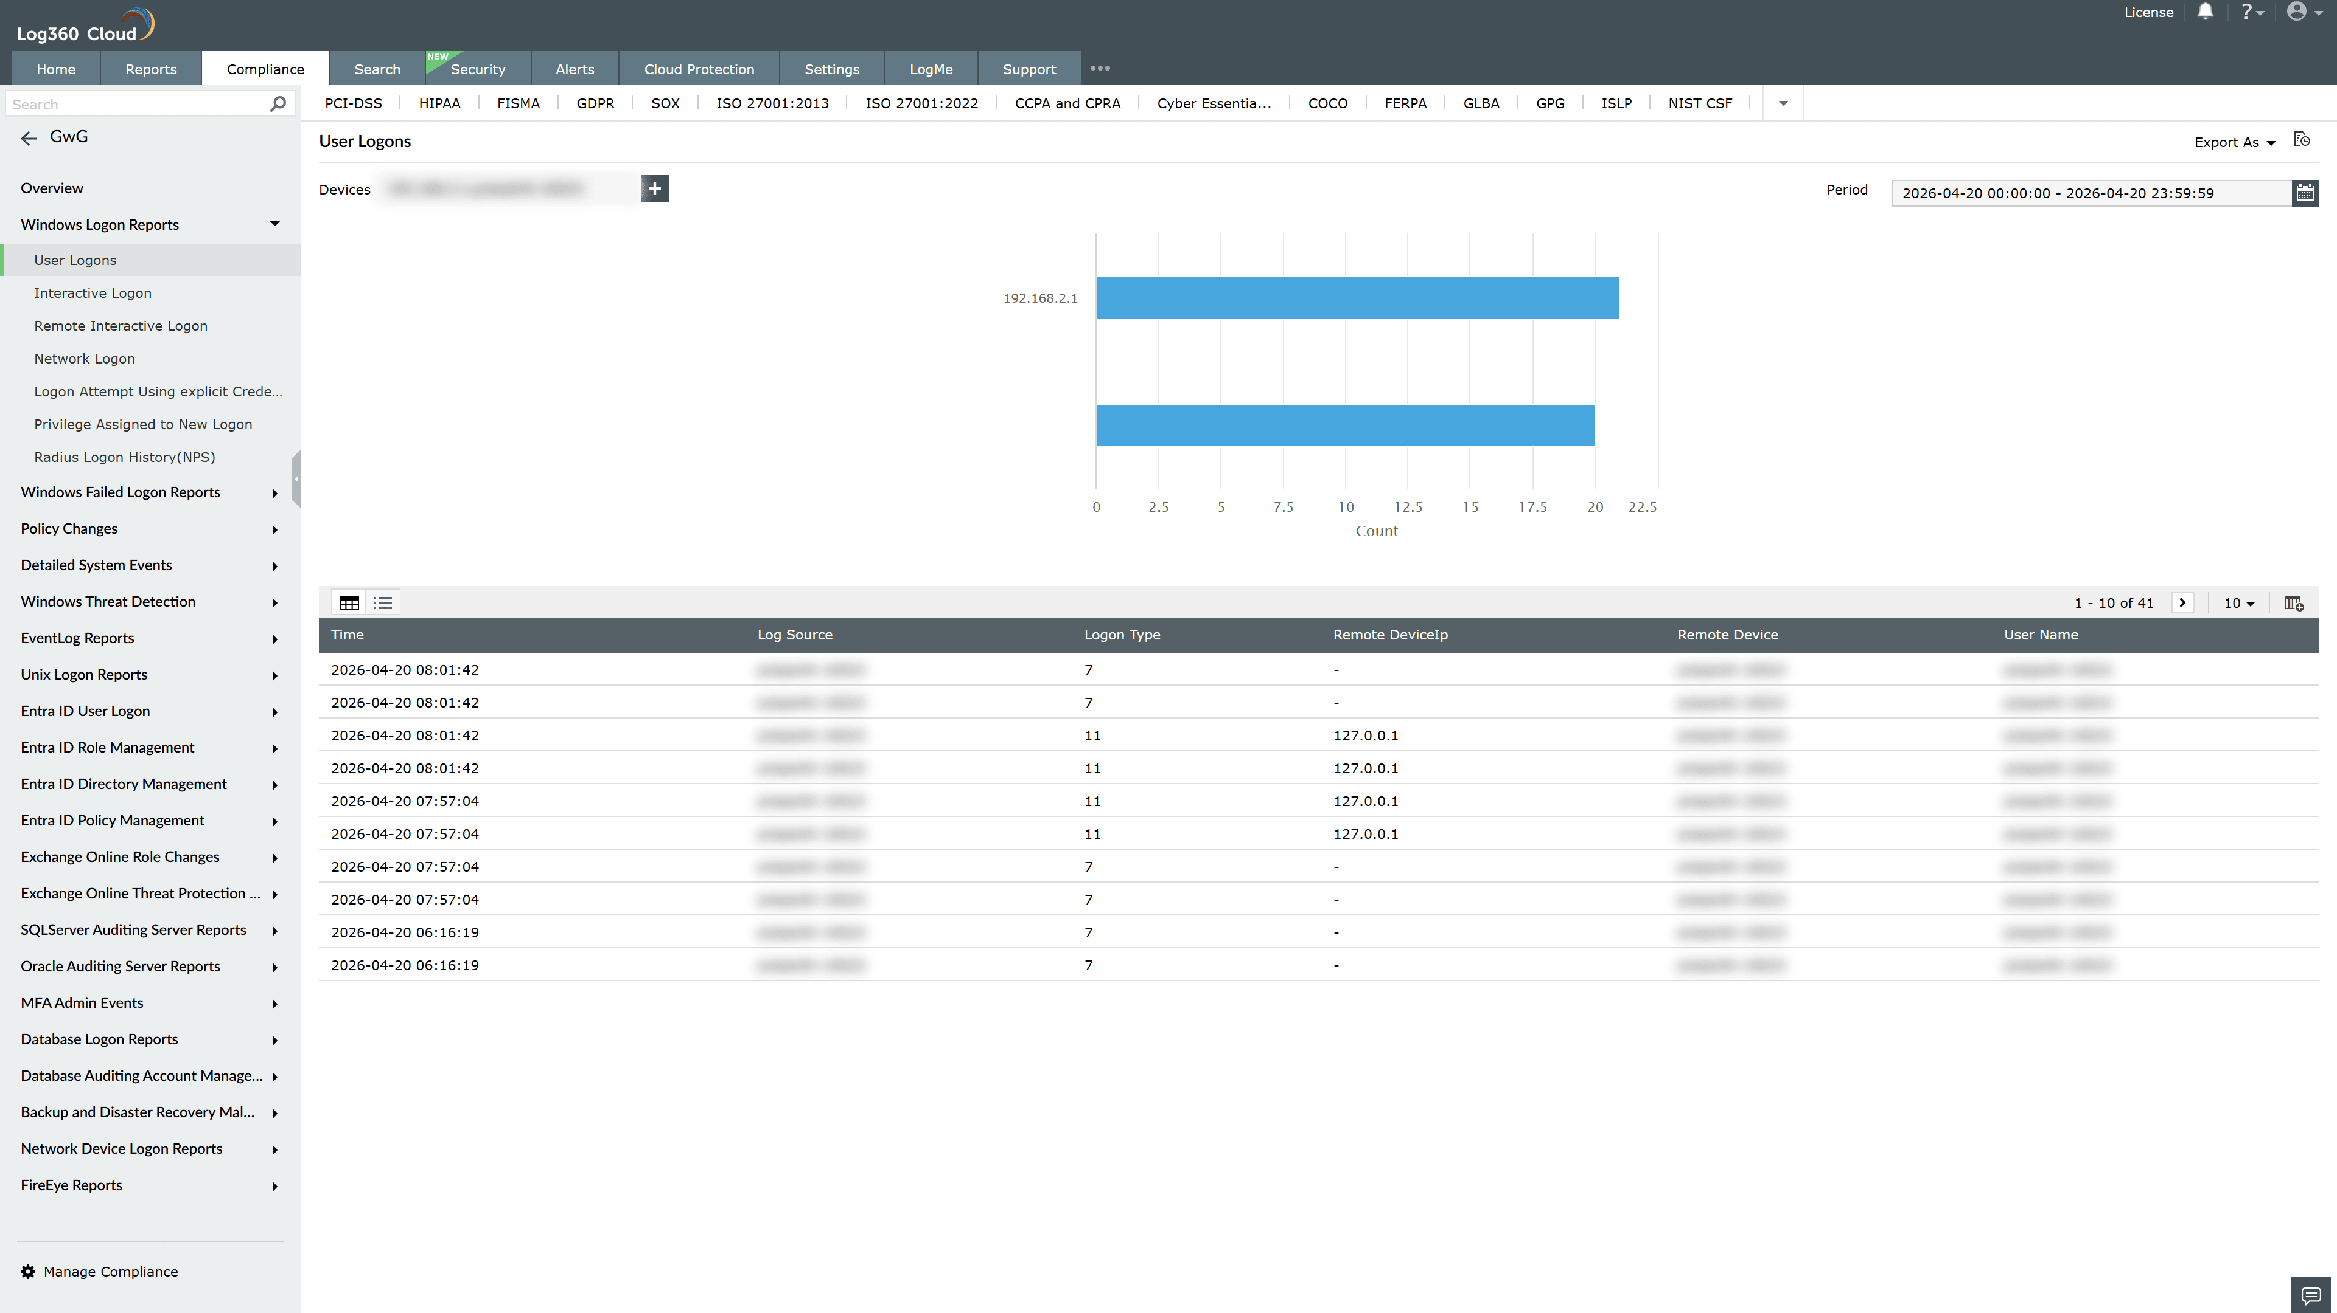
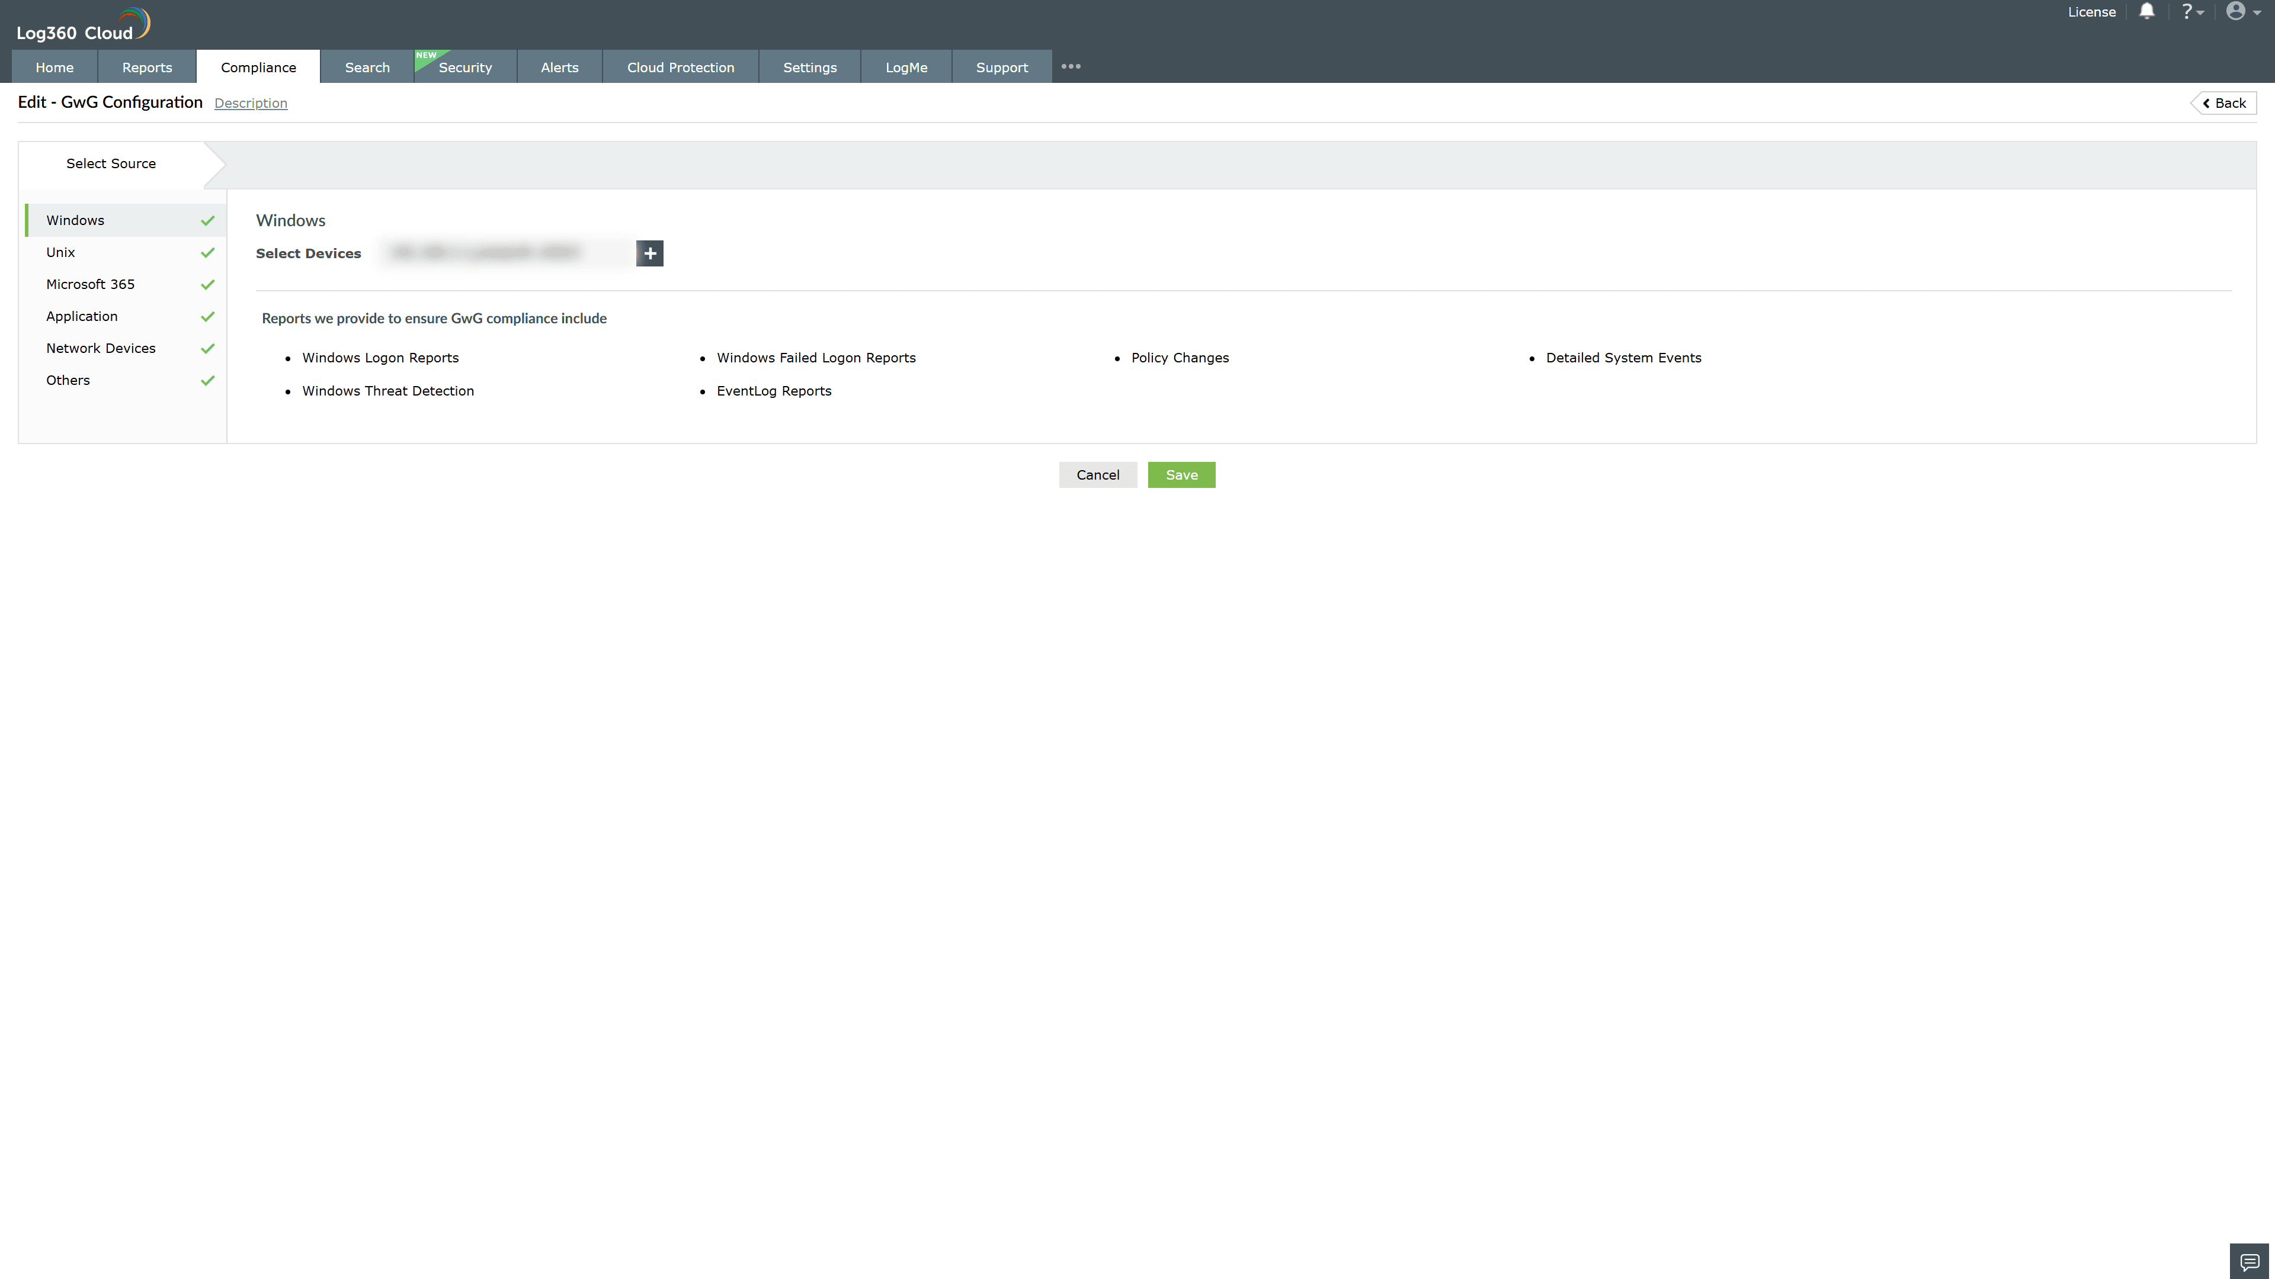
Valid Submission : Yes
Supported Editions : Free, Basic, Standard, Professional, MSSP
Help Document : https://www.manageengine.com/log-management/help/integrations/compliance-extensions.html
Help Video : Not provided
Tags : Log360, Compliance, Privacy monitoring, Data privacy, Regulatory compliance
Supported DCs : US, IN, JP, CA, AU, UK and EU
Privacy Policy:
Terms of Service:
Release Notes:
Predefined reports for the GwG AML Compliance

