German Telecommunications Act and TDDDG Compliance for Log360
Tagline: Meet German telecom security obligations with continuous log monitoring from Log360.

Overview
The German Telecommunications Act (TKG) & TDDDG Compliance extension for Log360 helps German telecommunications service providers and digital platform operators meet security monitoring, data retention, and access control requirements under TKG and the Telecommunications Digital Services Data Protection Act (TDDDG).
Log360 collects and analyzes logs from network infrastructure, communication platforms, and cloud environments, providing security teams with visibility into access events and potential violations. Compliance teams can maintain detailed audit trails and generate reports demonstrating adherence to BNetzA and BSI security requirements.

Key Features
- Generate predefined audit reports covering TKG and TDDDG obligations including network access logging, data handling events, and security incident records.
- Monitor authentication events, network device logs, and user activities across telecommunications infrastructure in real time.
- Configure threshold-based alerts for security events relevant to TKG obligations, including unauthorized access and configuration changes to critical telecom systems.
- Export compliance documentation in PDF and CSV formats for BNetzA submissions and internal data protection officer reviews.
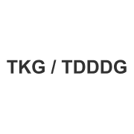
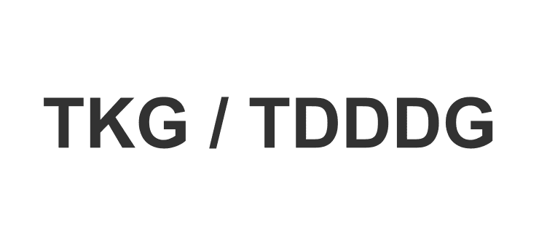

Screenshots
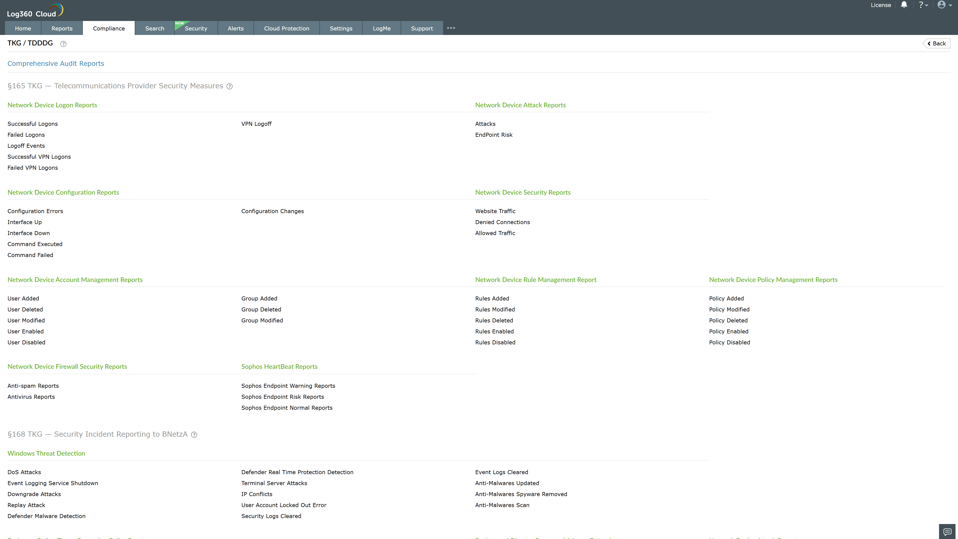
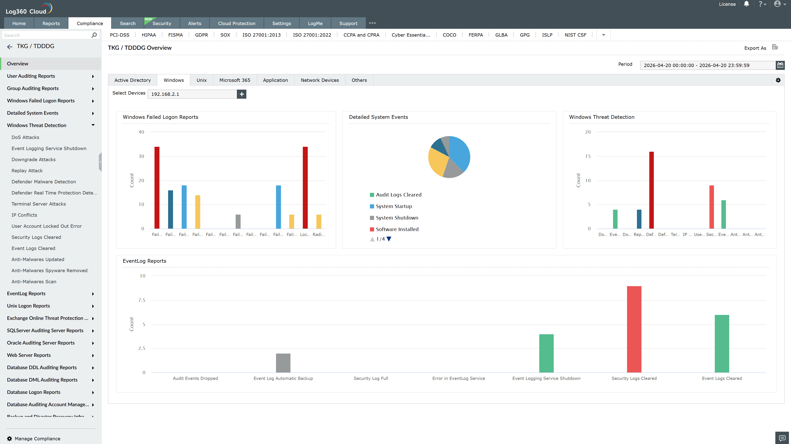
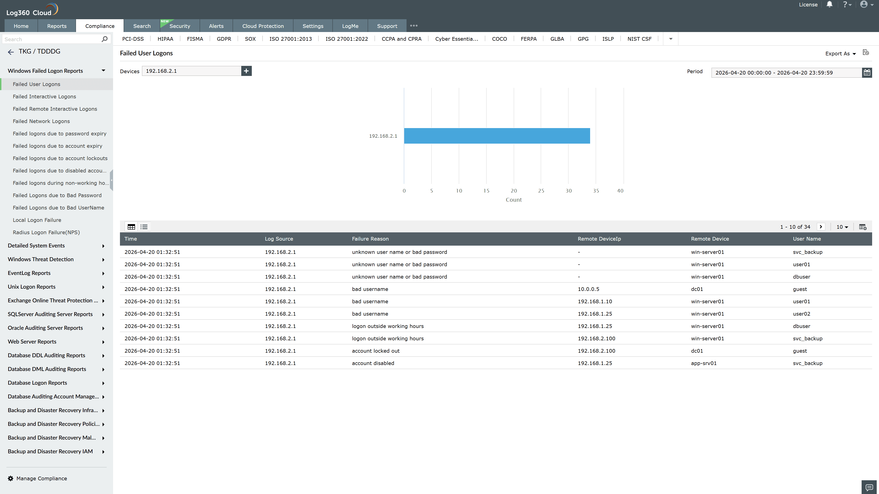
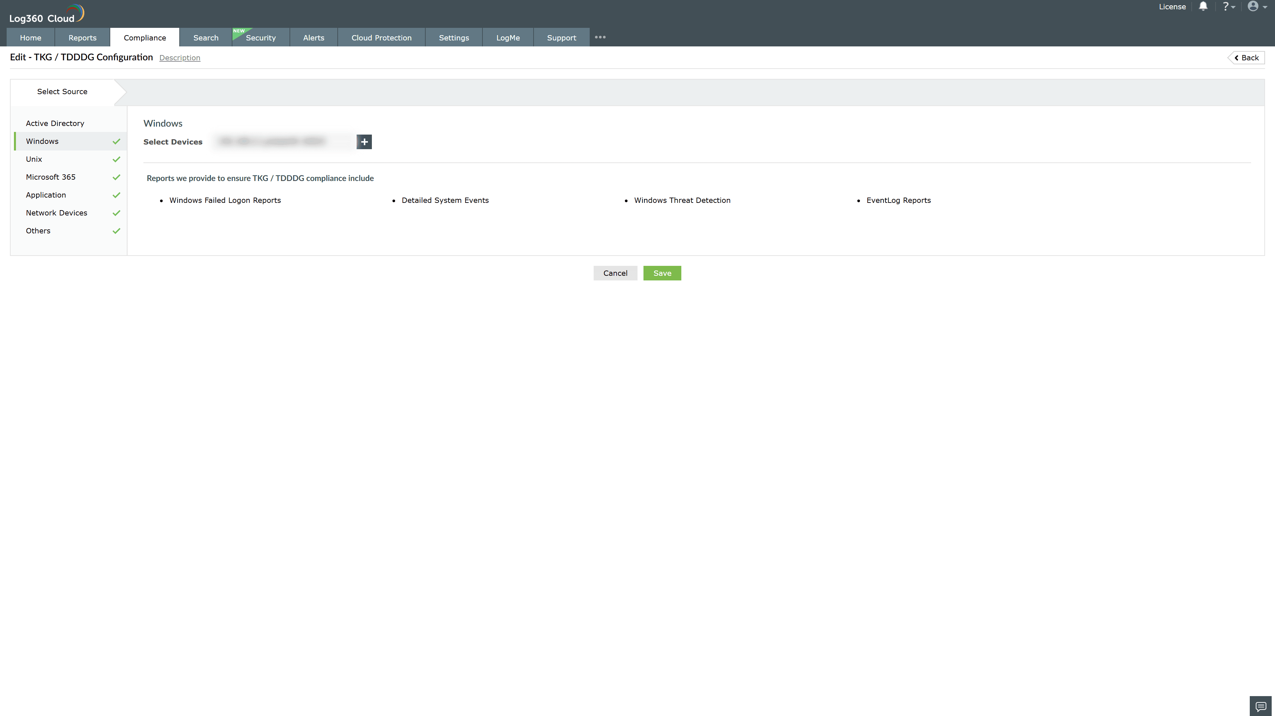
Valid Submission : Yes
Supported Editions : Free, Basic, Standard, Professional, MSSP
Help Document : https://www.manageengine.com/log-management/help/integrations/compliance-extensions.html
Help Video : Not provided
Tags : Log360, Compliance, Privacy monitoring, Data privacy, Regulatory compliance
Supported DCs : US, IN, JP, CA, AU, UK and EU
Privacy Policy:
Terms of Service:
Release Notes:
Predefined reports for the TKG and TDDDG Compliance

