Presidential Information and Communication Security Guide Compliance for Log360
Tagline: Support Turkey’s cybersecurity compliance with centralized monitoring from Log360.

Overview
The Presidential Information and Communication Security Guide Compliance extension for Log360 helps Turkish public institutions and state enterprises meet the cybersecurity controls and information security management requirements prescribed by Turkey's Presidential Cybersecurity Authority.
Log360 collects and correlates logs from government IT systems, cloud environments, network infrastructure, and identity platforms, providing security teams with continuous visibility into security events. Compliance teams can monitor control effectiveness, detect threats, and generate audit documentation for Presidential Cybersecurity Authority reviews.

Key Features
- Generate predefined compliance reports covering Presidential Guide security controls including access management, network monitoring, data protection, and incident detection.
- Monitor authentication events, privileged access activities, and system changes across Turkish public institution IT environments in real time.
- Configure threshold-based alerts for guide-relevant security events such as unauthorized access, account privilege escalations, and audit log tampering.
- Export compliance documentation in PDF and CSV formats for Presidential Cybersecurity Authority submissions and internal government security governance.



Screenshots
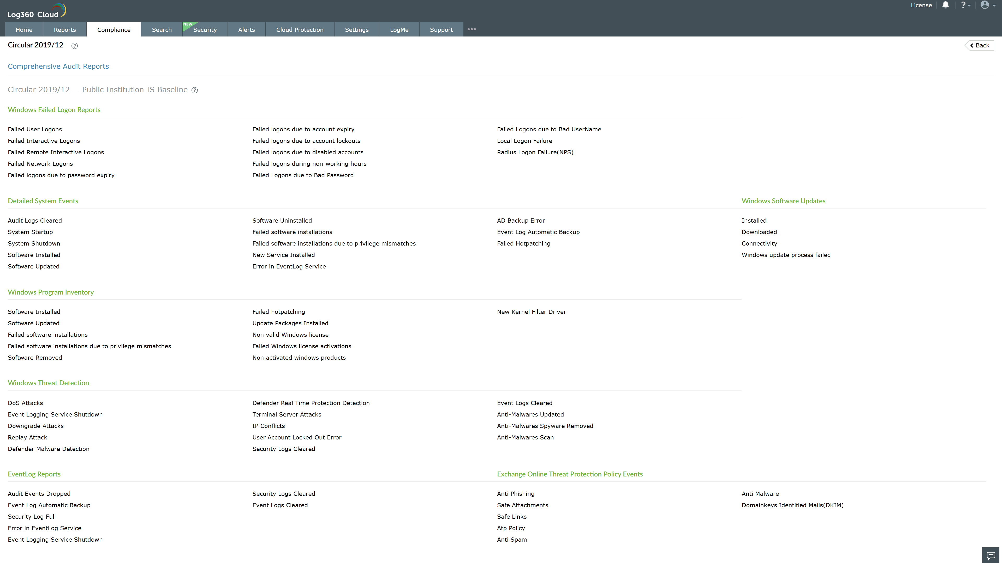
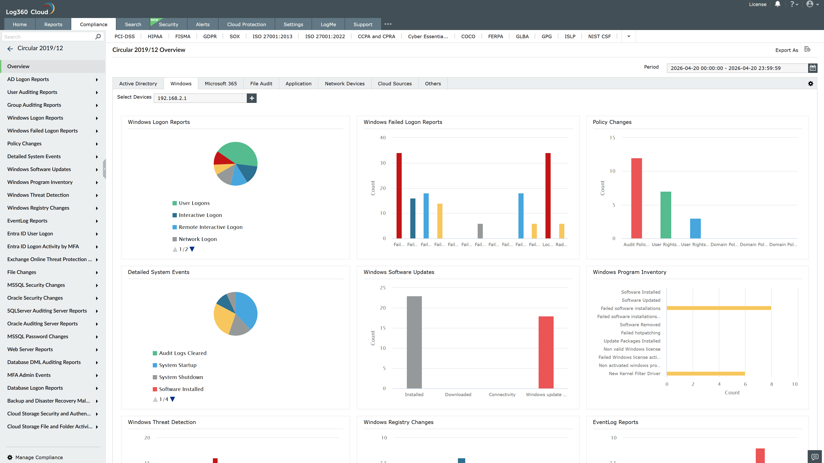
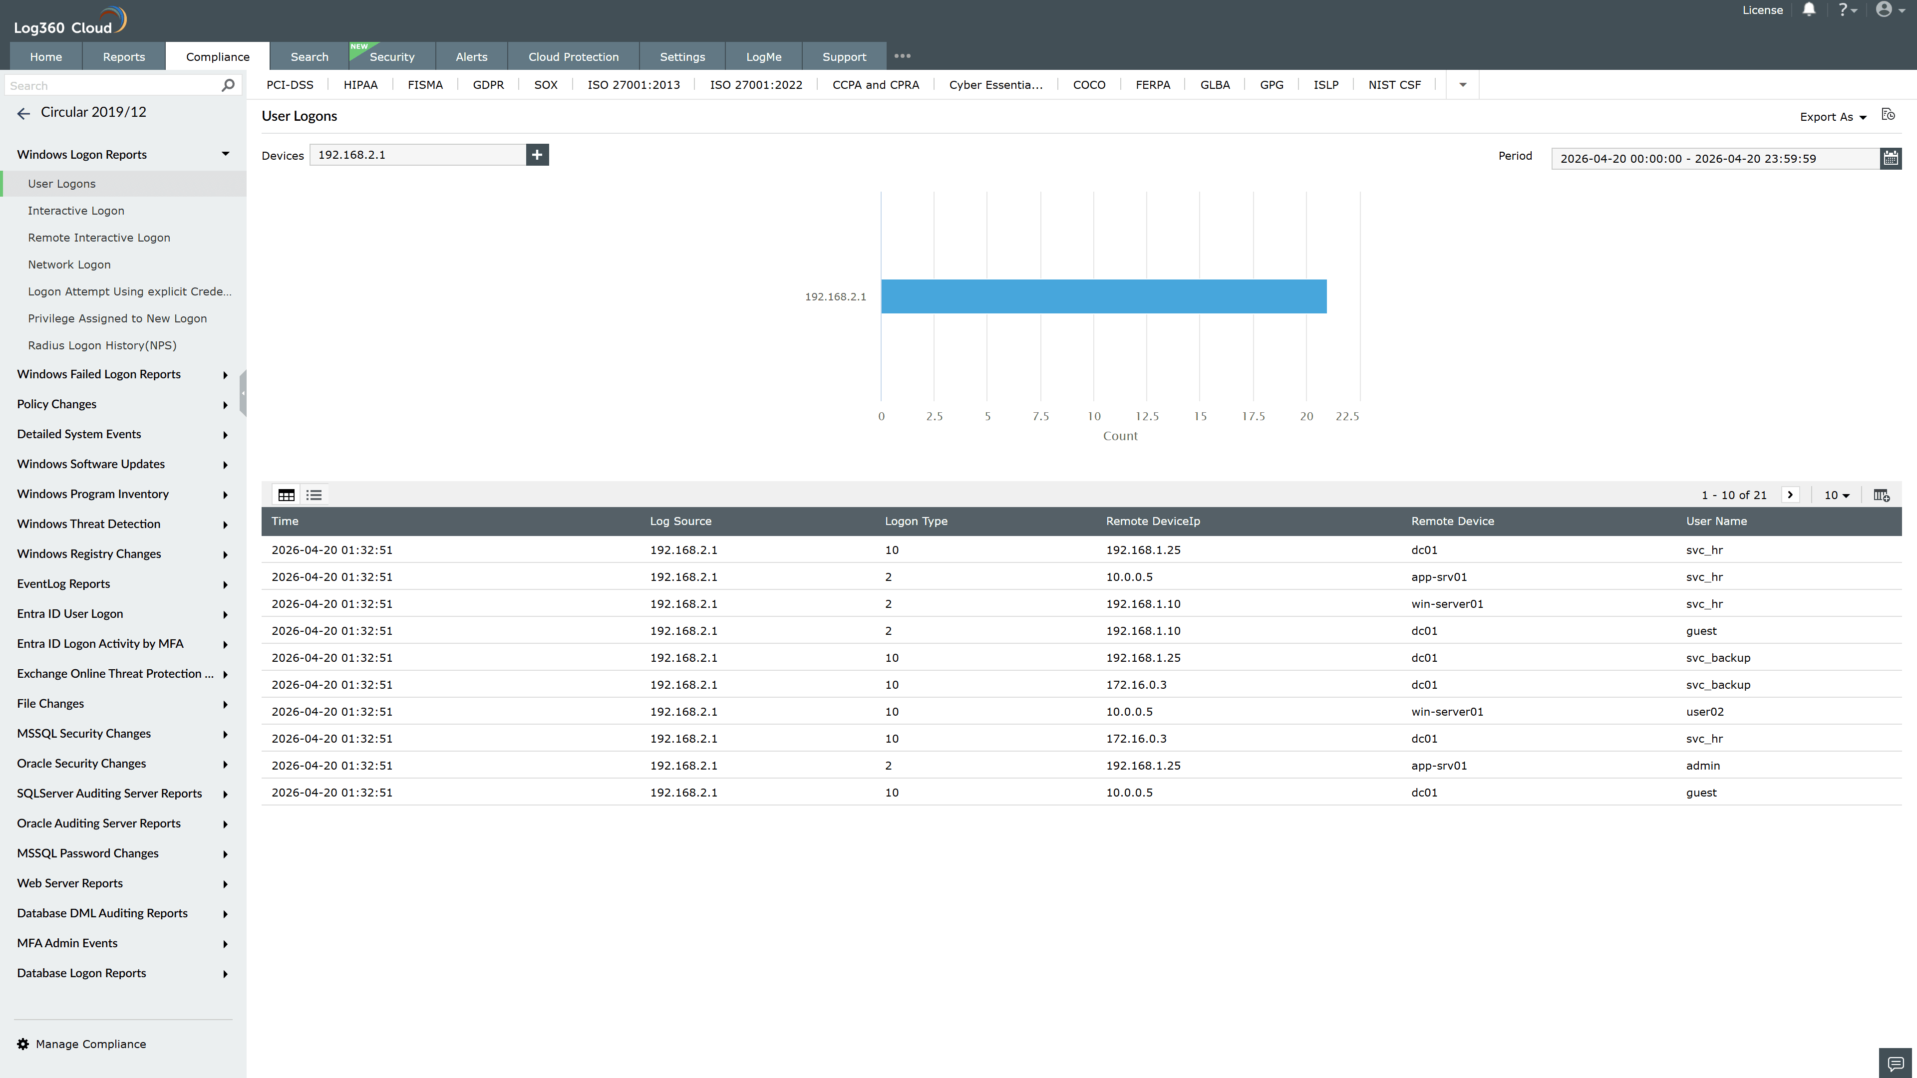
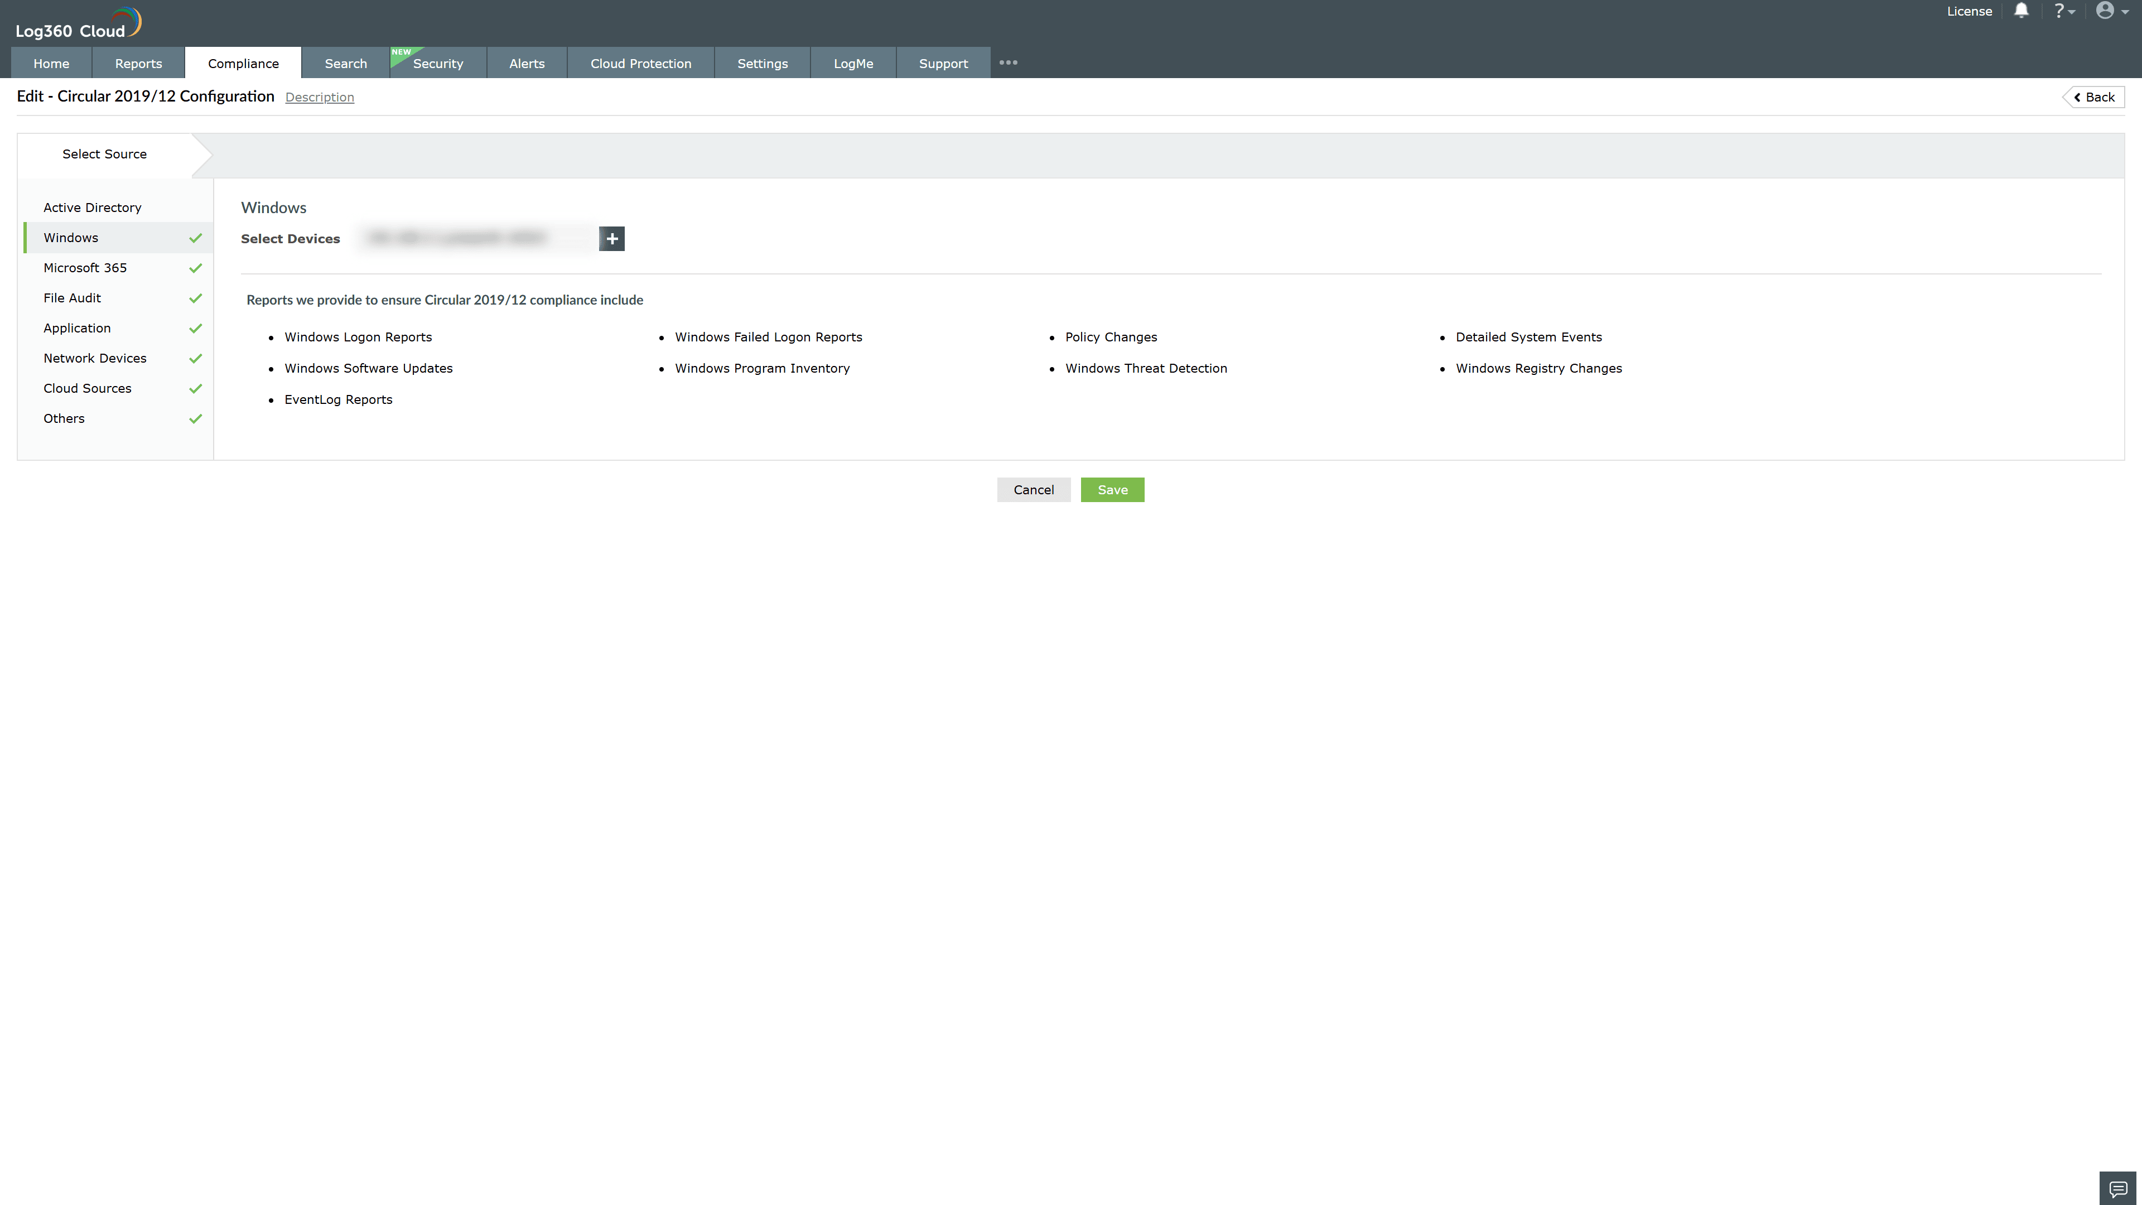
Valid Submission : Yes
Supported Editions : Free, Basic, Standard, Professional, MSSP
Help Document : https://www.manageengine.com/log-management/help/integrations/compliance-extensions.html
Help Video : Not provided
Tags : Log360, Compliance, Privacy monitoring, Data privacy, Regulatory compliance
Supported DCs : US, IN, JP, CA, AU, UK and EU
Privacy Policy:
Terms of Service:
Release Notes:
Predefined reports for the Presidential Information and Communication Security Guide Compliance

