SecNumCloud 3.2 Compliance for Log360
Tagline: Meet ANSSI's trusted cloud qualification requirements and support SecNumCloud 3.2 certification with Log360.

Overview
The SecNumCloud 3.2 Compliance extension for Log360 helps French cloud service providers seeking ANSSI SecNumCloud qualification meet the security monitoring, audit logging, and incident management requirements of the SecNumCloud 3.2 reference framework.
Log360 provides cloud-native log collection and analysis across infrastructure, identity, application, and network layers, enabling continuous monitoring of the security controls required for SecNumCloud certification. Compliance teams can demonstrate logging completeness, detect deviations, and generate audit evidence for ANSSI qualification audits.

Key Features
- Generate SecNumCloud 3.2-aligned audit reports covering log collection, access monitoring, security event detection, and incident management controls for cloud service providers.
- Monitor cloud infrastructure events, user access patterns, and administrative actions in real time across cloud environments.
- Leverage CASB capabilities in Log360 to gain full visibility into cloud application usage and enforce data sovereignty controls relevant to SecNumCloud requirements.
- Export qualification evidence in PDF and CSV formats for ANSSI SecNumCloud certification audits and cloud governance reviews.



Screenshots
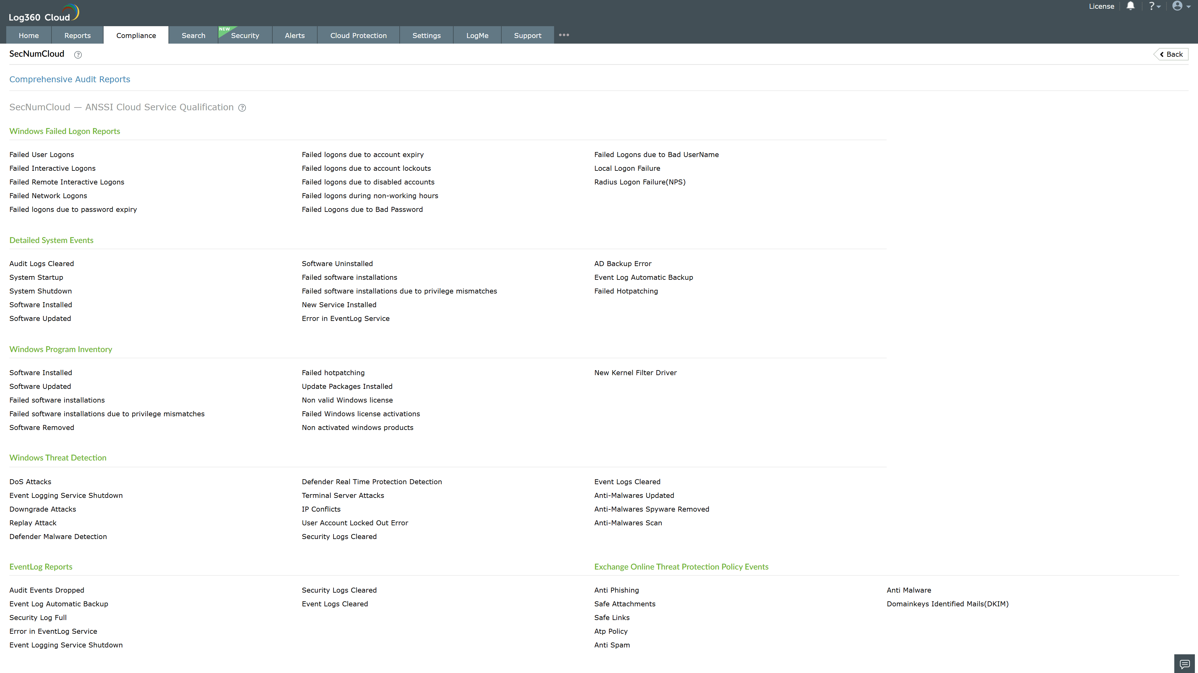
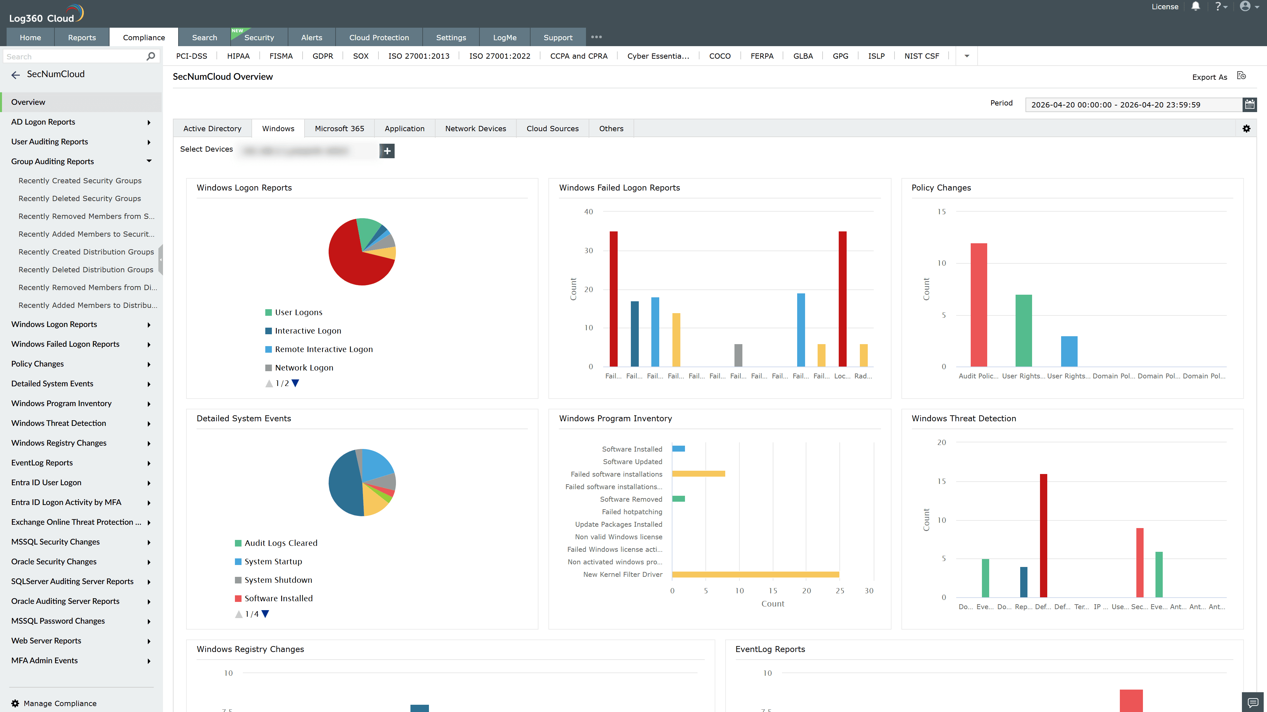
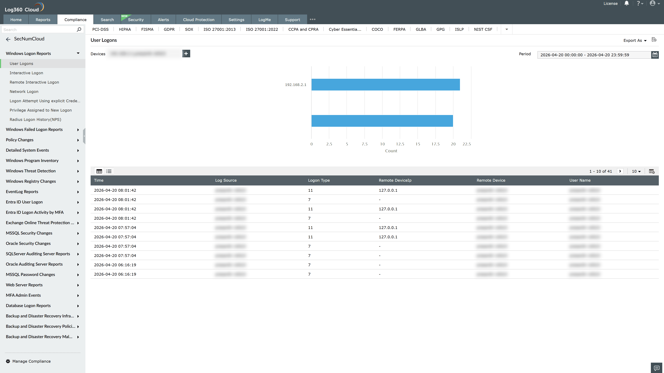
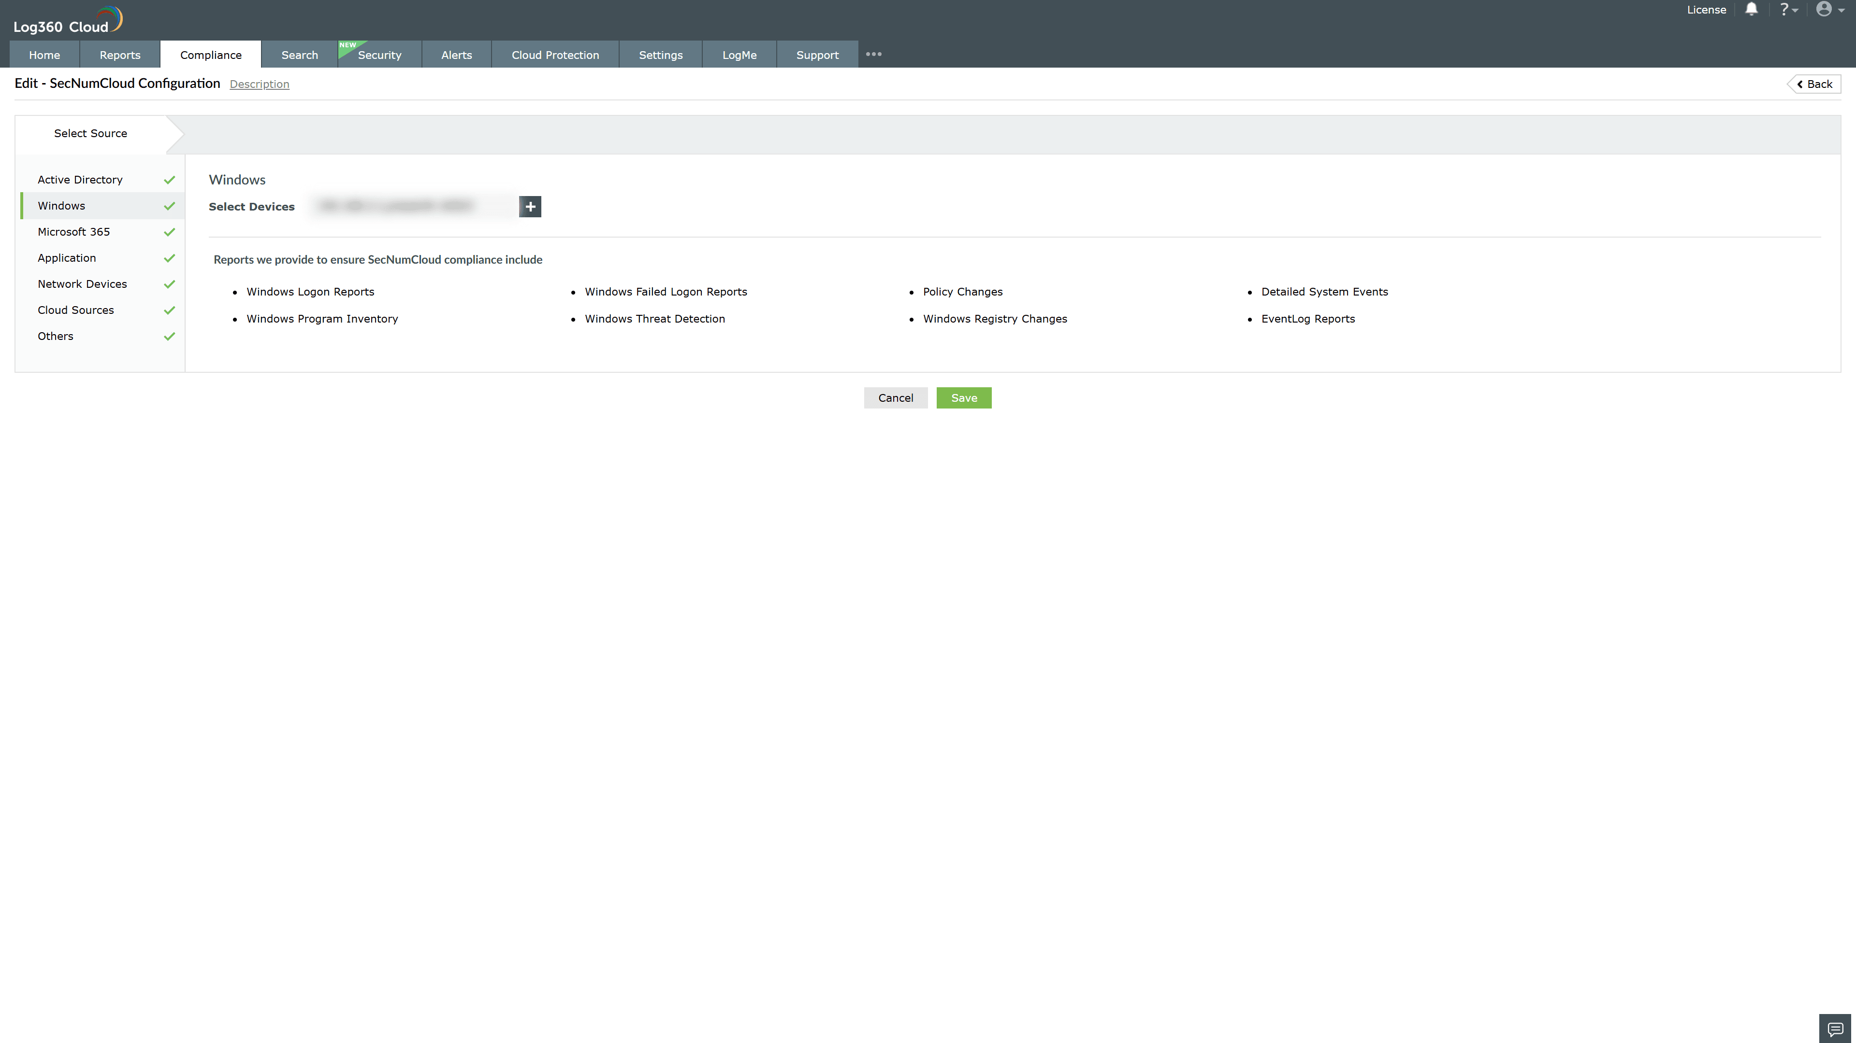
Valid Submission : Yes
Supported Editions : Free, Basic, Standard, Professional, MSSP
Help Document : https://www.manageengine.com/log-management/help/integrations/compliance-extensions.html
Help Video : Not provided
Tags : Log360, Compliance, Privacy monitoring, Data privacy, Regulatory compliance
Supported DCs : US, IN, JP, CA, AU, UK and EU
Privacy Policy:
Terms of Service:
Release Notes:
Predefined reports for the SecNumCloud 3.2 Compliance

