Spanish CIP Law 8-2011 Compliance for Log360
Tagline: Meet Spain's CIP obligations with continuous security monitoring from Log360.

Overview
The Spanish CIP Law 8/2011 compliance extension for Log360 helps Spanish critical infrastructure operators and designated entities meet the cybersecurity monitoring and incident reporting requirements under Spain's Critical Infrastructure Protection Law.
Log360 collects and correlates logs from operational technology, IT systems, cloud platforms, and network infrastructure, providing security teams with continuous visibility into threats targeting critical facilities. Compliance teams can document control implementation and generate audit evidence for CNPIC oversight.

Key Features
- Generate audit reports aligned to CIP Law 8/2011 requirements covering physical and cyber security monitoring, access control, and incident detection for critical infrastructure.
- Monitor IT and OT systems for unauthorized access, anomalous activity, and configuration changes affecting critical services in real time.
- Monitor and alert on threats targeting Spanish critical infrastructure sectors through correlation of IT/OT security events, with specialized detection for supply chain compromise and insider threats.
- Export compliance documentation in PDF and CSV formats for CNPIC reporting and internal critical infrastructure protection governance.



Screenshots
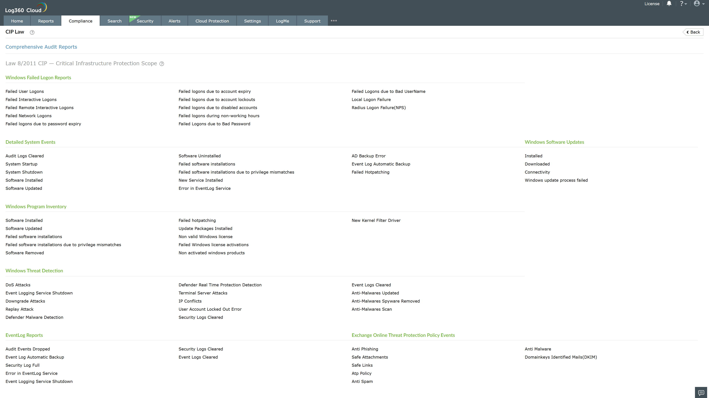
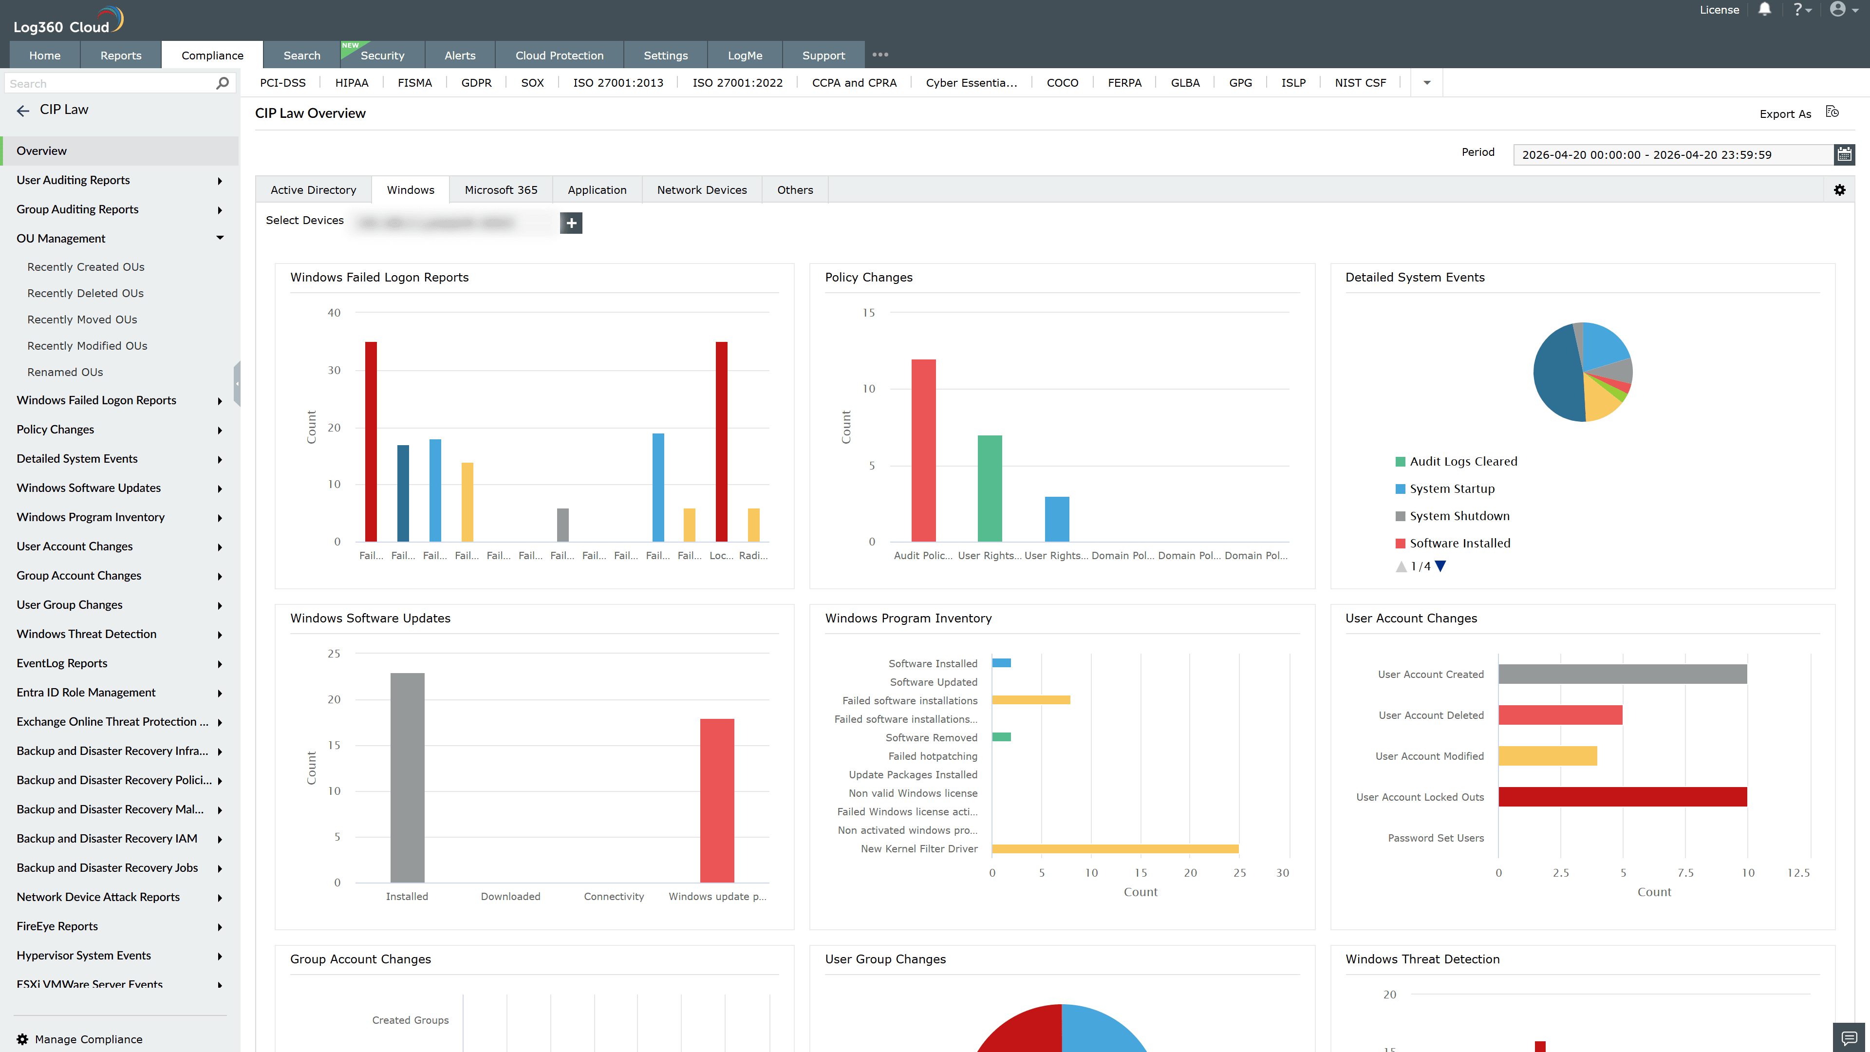
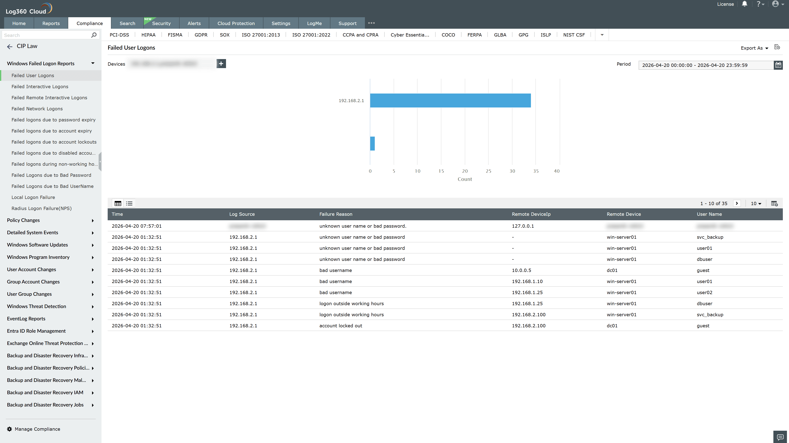
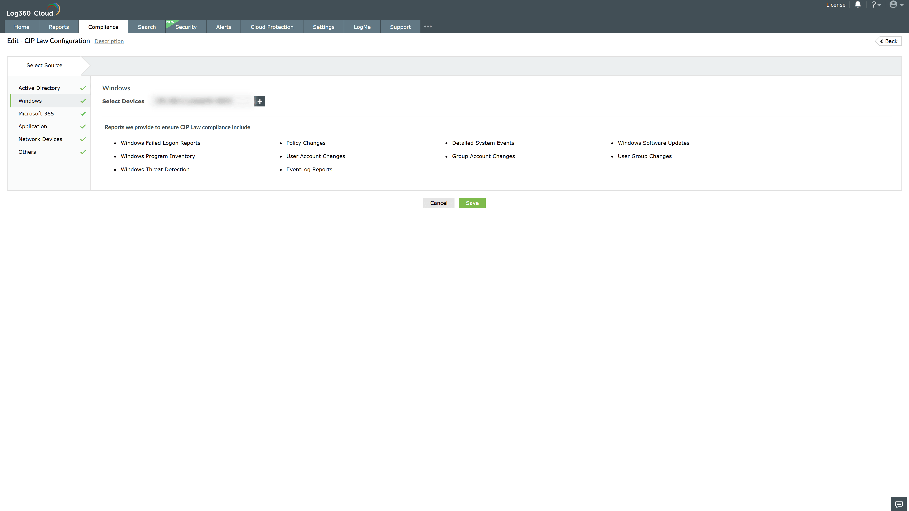
Valid Submission : Yes
Supported Editions : Free, Basic, Standard, Professional, MSSP
Help Document : https://www.manageengine.com/log-management/help/integrations/compliance-extensions.html
Help Video : Not provided
Tags : Log360, Compliance, Privacy monitoring, Data privacy, Regulatory compliance
Supported DCs : US, IN, JP, CA, AU, UK and EU
Privacy Policy:
Terms of Service:
Release Notes:
Predefined reports for the CIP Law Compliance

