Spanish E-Commerce and Cookie Law Compliance for Log360
Tagline: Demonstrate security compliance under Spain's LSSI e-commerce with Log360.

Overview
The Spanish E-Commerce & Cookie Law (LSSI 34/2002) Compliance extension for Log360 helps Spanish information society service providers and e-commerce platforms meet the security monitoring and data handling obligations under the LSSI.
Log360 monitors logs from web applications, databases, cloud environments, and identity systems, providing security teams with visibility into access events and potential data protection violations. Compliance teams can maintain audit trails of user data processing activities and generate documentation aligned to AEPD and SESIAD oversight requirements.

Key Features
- Generate predefined compliance reports covering LSSI security obligations including web application access monitoring, user data processing events, and system security activities.
- Monitor e-commerce platform access logs and detect unauthorized data queries, bulk user data exports, and suspicious account activities.
- Configure threshold-based alerts for LSSI-relevant security events such as unauthorized access to customer data, web application anomalies, and audit log modifications.
- Export compliance evidence in PDF and CSV formats for AEPD investigations, internal DPO records, and e-commerce governance reviews.



Screenshots
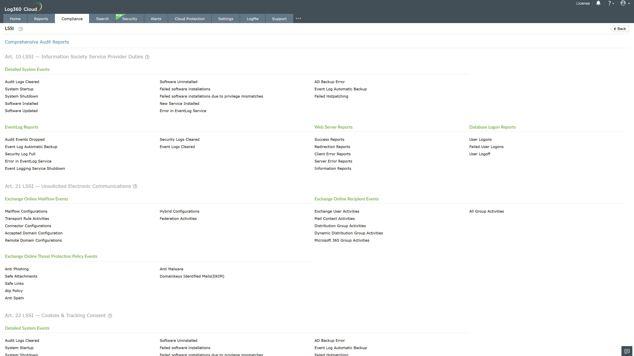
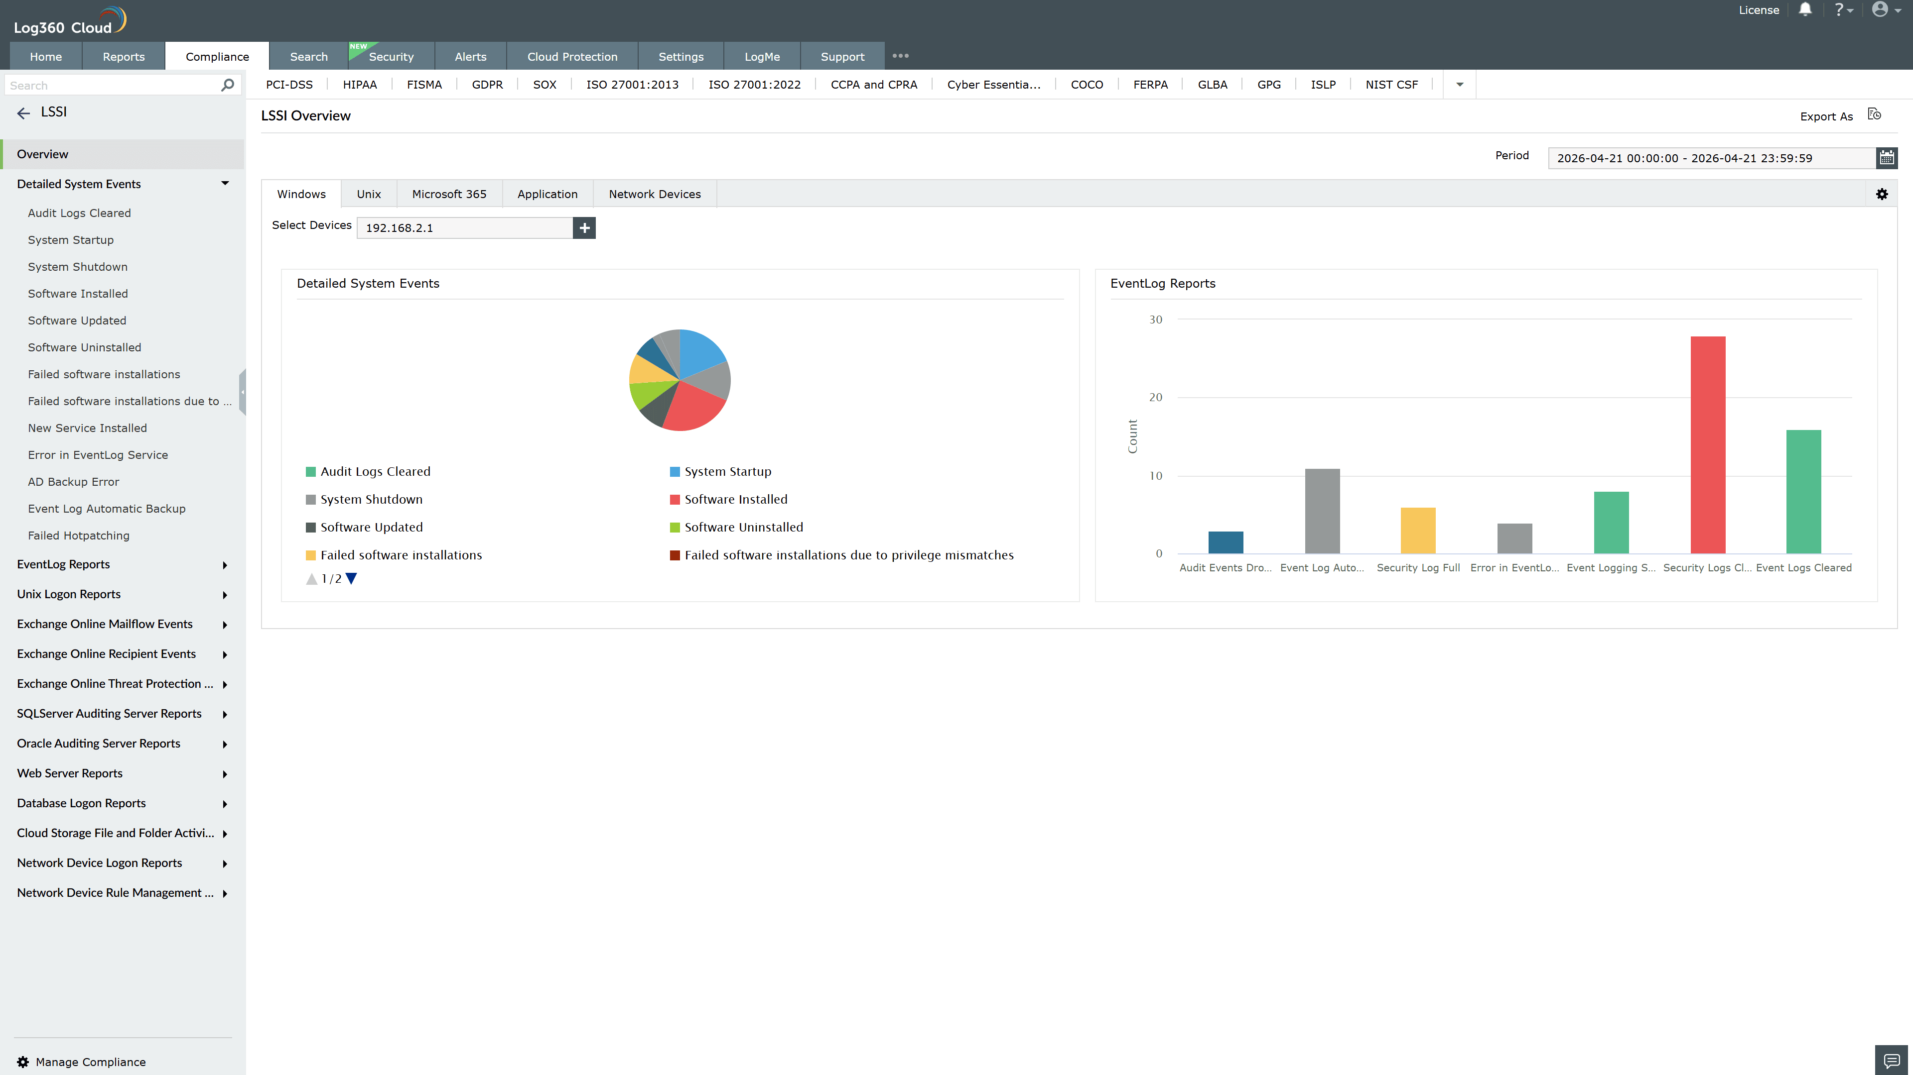
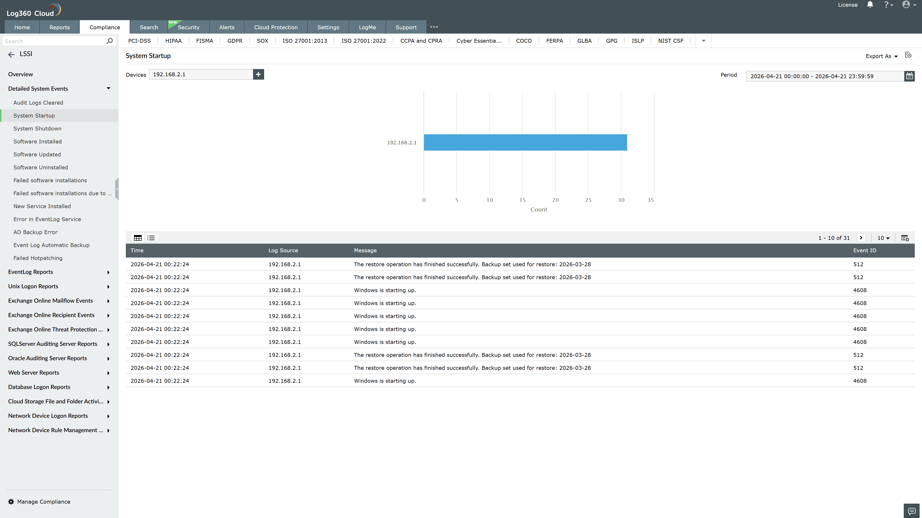
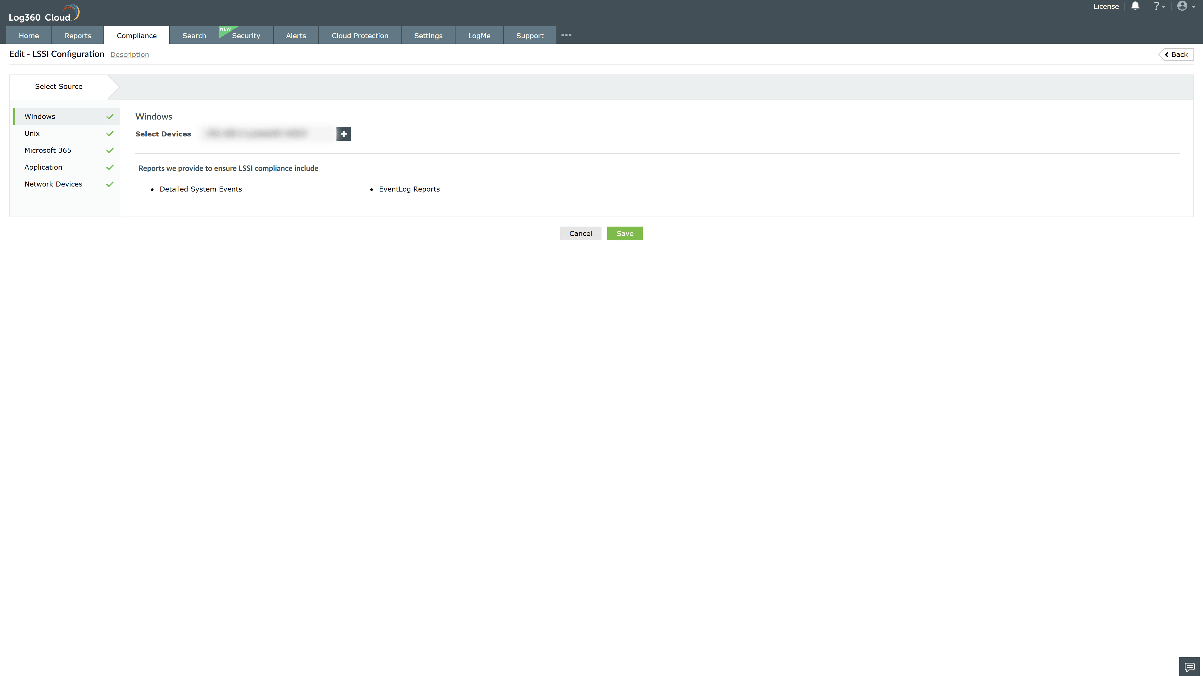
Valid Submission : Yes
Supported Editions : Free, Basic, Standard, Professional, MSSP
Help Document : https://www.manageengine.com/log-management/help/integrations/compliance-extensions.html
Help Video : Not provided
Tags : Log360, Compliance, Privacy monitoring, Data privacy, Regulatory compliance
Supported DCs : US, IN, JP, CA, AU, UK and EU
Privacy Policy:
Terms of Service:
Release Notes:
Predefined reports for the LSSI Compliance

