Spanish Organic Law 3-2018 Compliance for Log360
Tagline: Demonstrate data protection accountability with comprehensive log monitoring from Log360.

Overview
The Spanish Organic Law 3/2018 (LOPDGDD) Compliance extension for Log360 helps Spanish data controllers and processors meet the data security, access audit, and breach notification requirements under Spain's Organic Law on Data Protection and the Guarantee of Digital Rights (LOPDGDD).
Log360 collects and analyzes logs from databases, cloud services, applications, and identity systems, providing visibility into personal data processing activities and potential security violations. Compliance and DPO teams can detect unauthorized access to personal data, investigate incidents, and generate AEPD-ready audit documentation.

Key Features
- Generate predefined LOPDGDD compliance reports covering personal data access events, authentication logs, and system security activities.
- Monitor access to personal data repositories and detect unauthorized queries, bulk exports, and anomalous data movements across cloud and on-premises environments.
- Configure alerts for breach indicators such as unauthorized access to sensitive records, unusual data transfers, and audit log tampering.
- Export compliance evidence in PDF and CSV formats for AEPD investigations, DPO records, and internal data governance reviews.



Screenshots
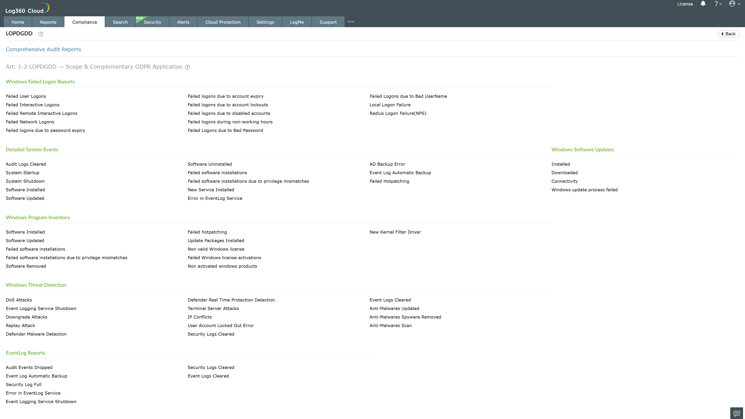
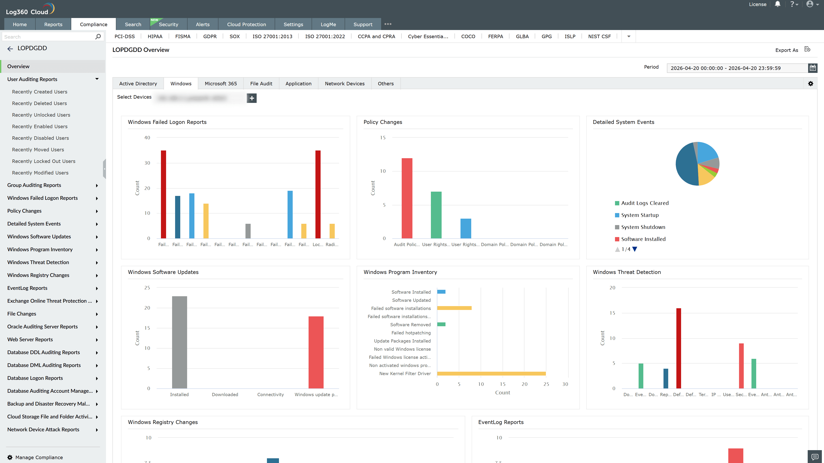
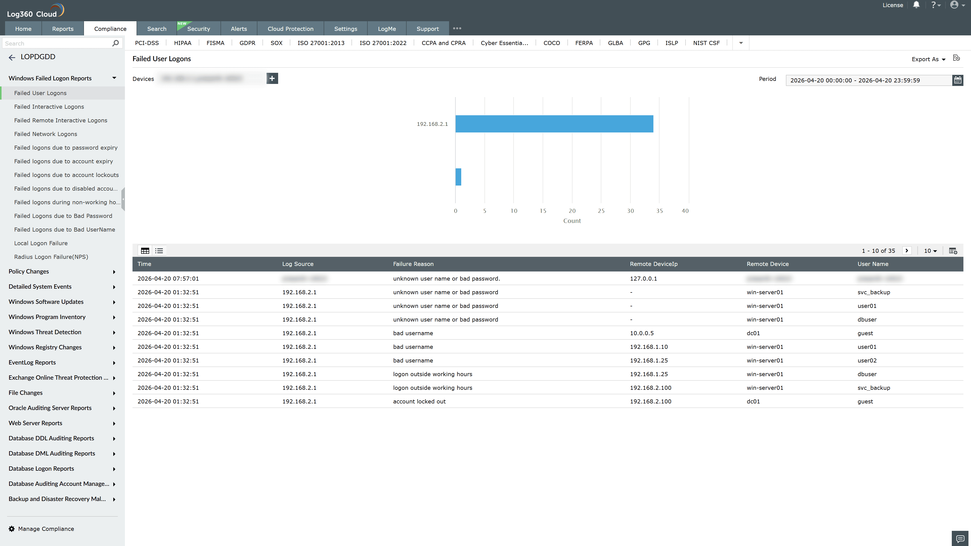
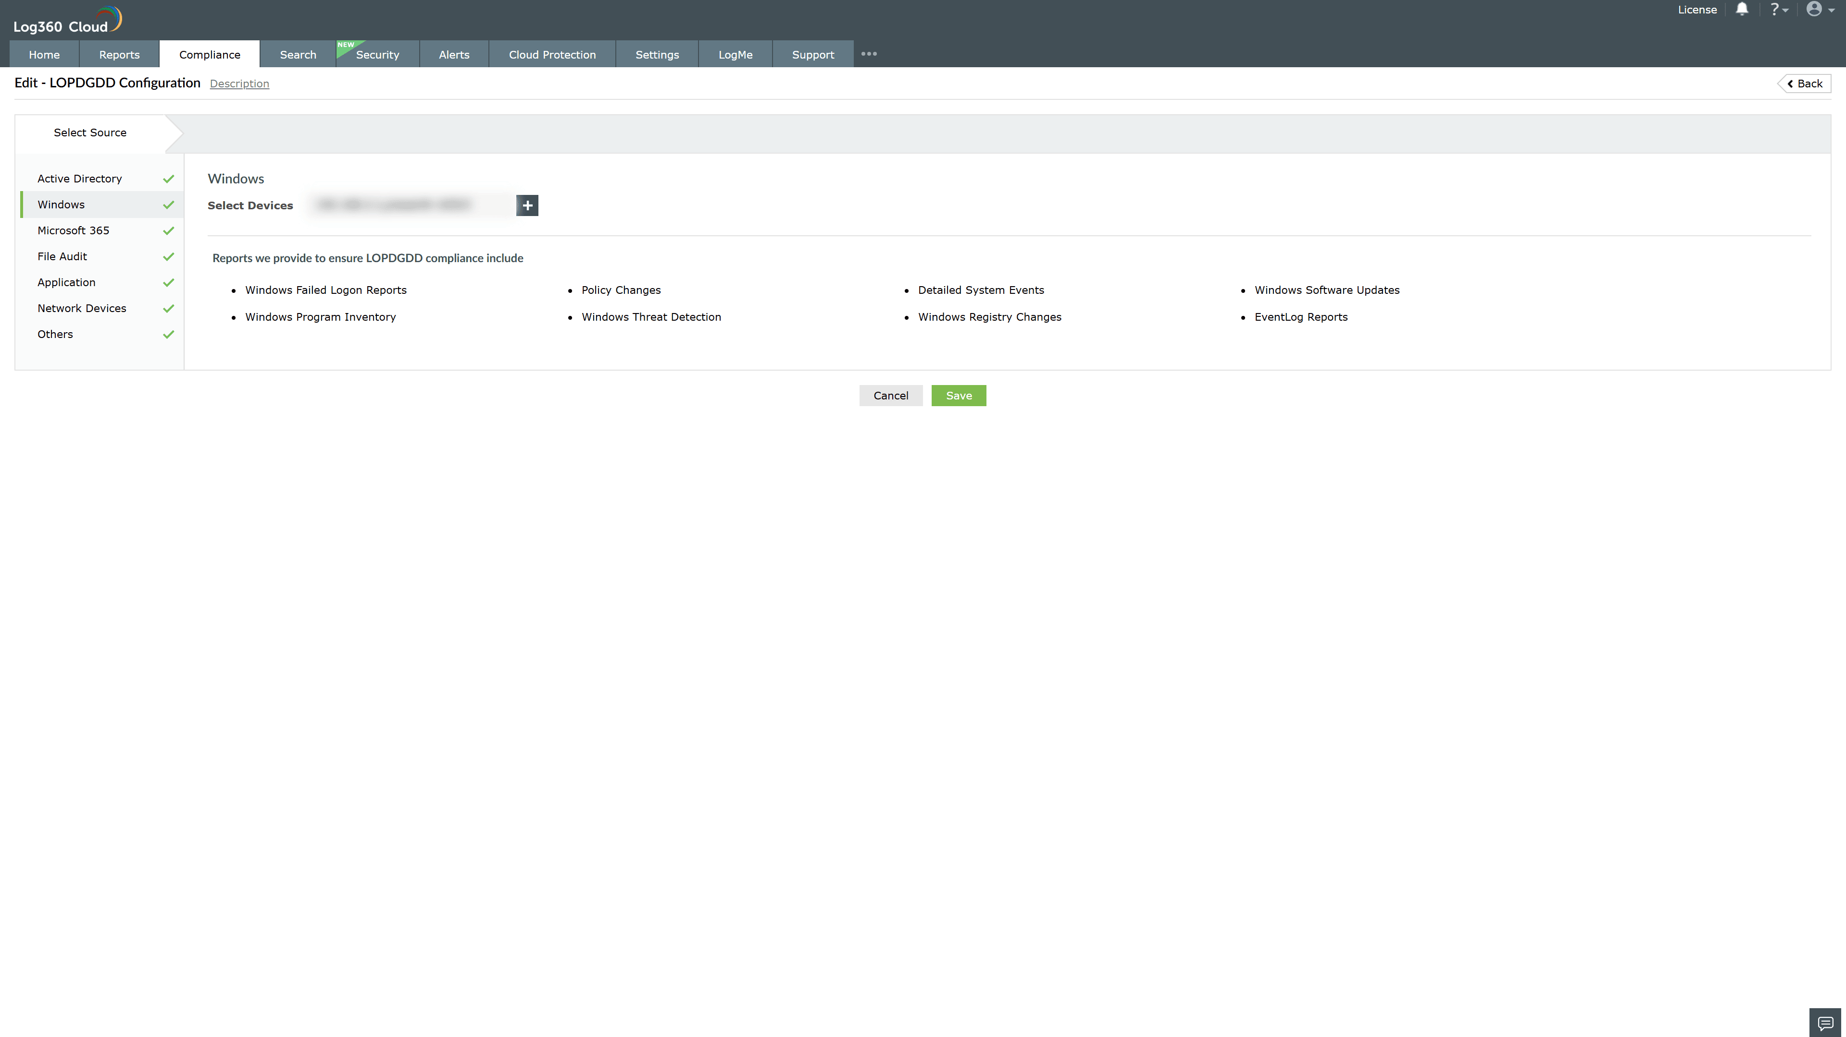
Valid Submission : Yes
Supported Editions : Free, Basic, Standard, Professional, MSSP
Help Document : https://www.manageengine.com/log-management/help/integrations/compliance-extensions.html
Help Video : Not provided
Tags : Log360, Compliance, Privacy monitoring, Data privacy, Regulatory compliance
Supported DCs : US, IN, JP, CA, AU, UK and EU
Privacy Policy:
Terms of Service:
Release Notes:
Predefined reports for the LPODGDD Compliance

