Spanish Trust Services Law Compliance for Log360
Tagline: Meet Spain's qualified trust service provider security requirements under Law 6/2020 with Log360.

Overview
The Spanish Trust Services Law (Law 6/2020) Compliance extension for Log360 helps Spanish qualified trust service providers (QTSPs) and electronic signature service operators meet the security monitoring, incident reporting, and audit logging requirements under Spain's Trust Services Law and the EU eIDAS Regulation.
Log360 collects and analyzes logs from certificate issuance systems, cryptographic modules, cloud platforms, and identity services, providing security teams with visibility into system integrity and access events. Compliance teams can detect anomalies, investigate incidents, and generate documentation for MINECO and ENISA supervisory oversight.

Key Features
- Generate predefined audit reports covering Law 6/2020 trust service security requirements including certificate system access monitoring, key management events, and incident detection.
- Monitor access to trust service infrastructure, detect unauthorized cryptographic operations, and track administrative changes to certificate issuance systems.
- Configure real-time alerts for trust service security events such as unauthorized certificate issuance attempts, key access anomalies, and audit log modifications.
- Export compliance evidence in PDF and CSV formats for MINECO supervisory submissions and internal QTSP security governance reviews.



Screenshots
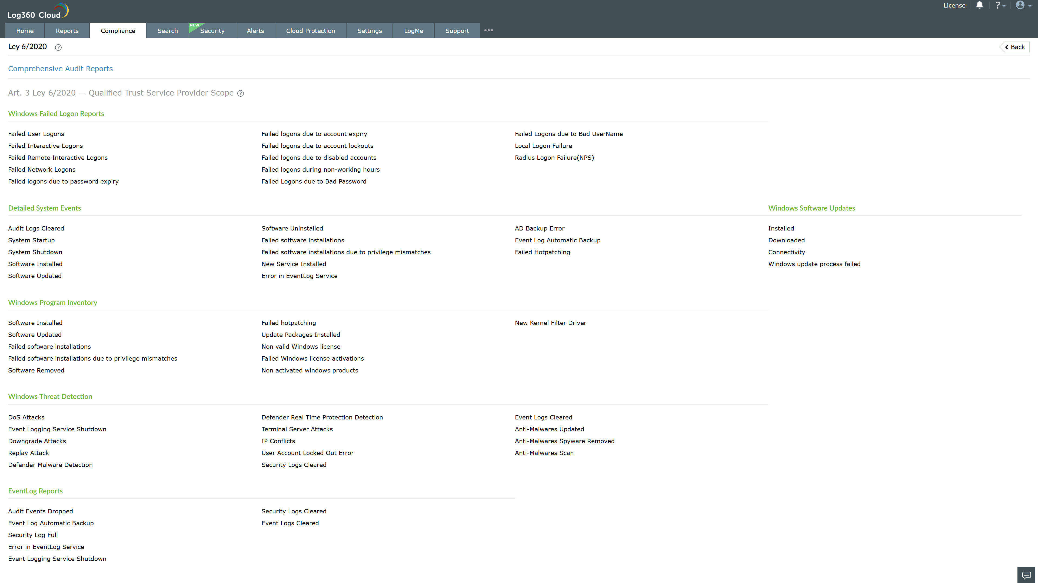
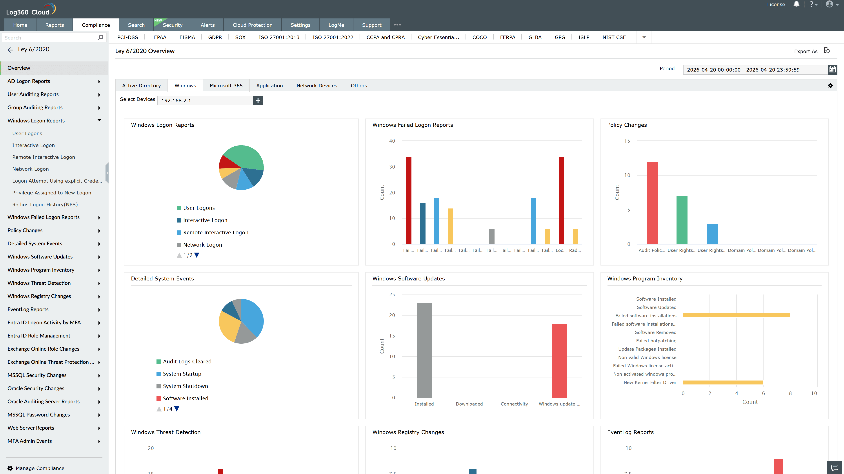
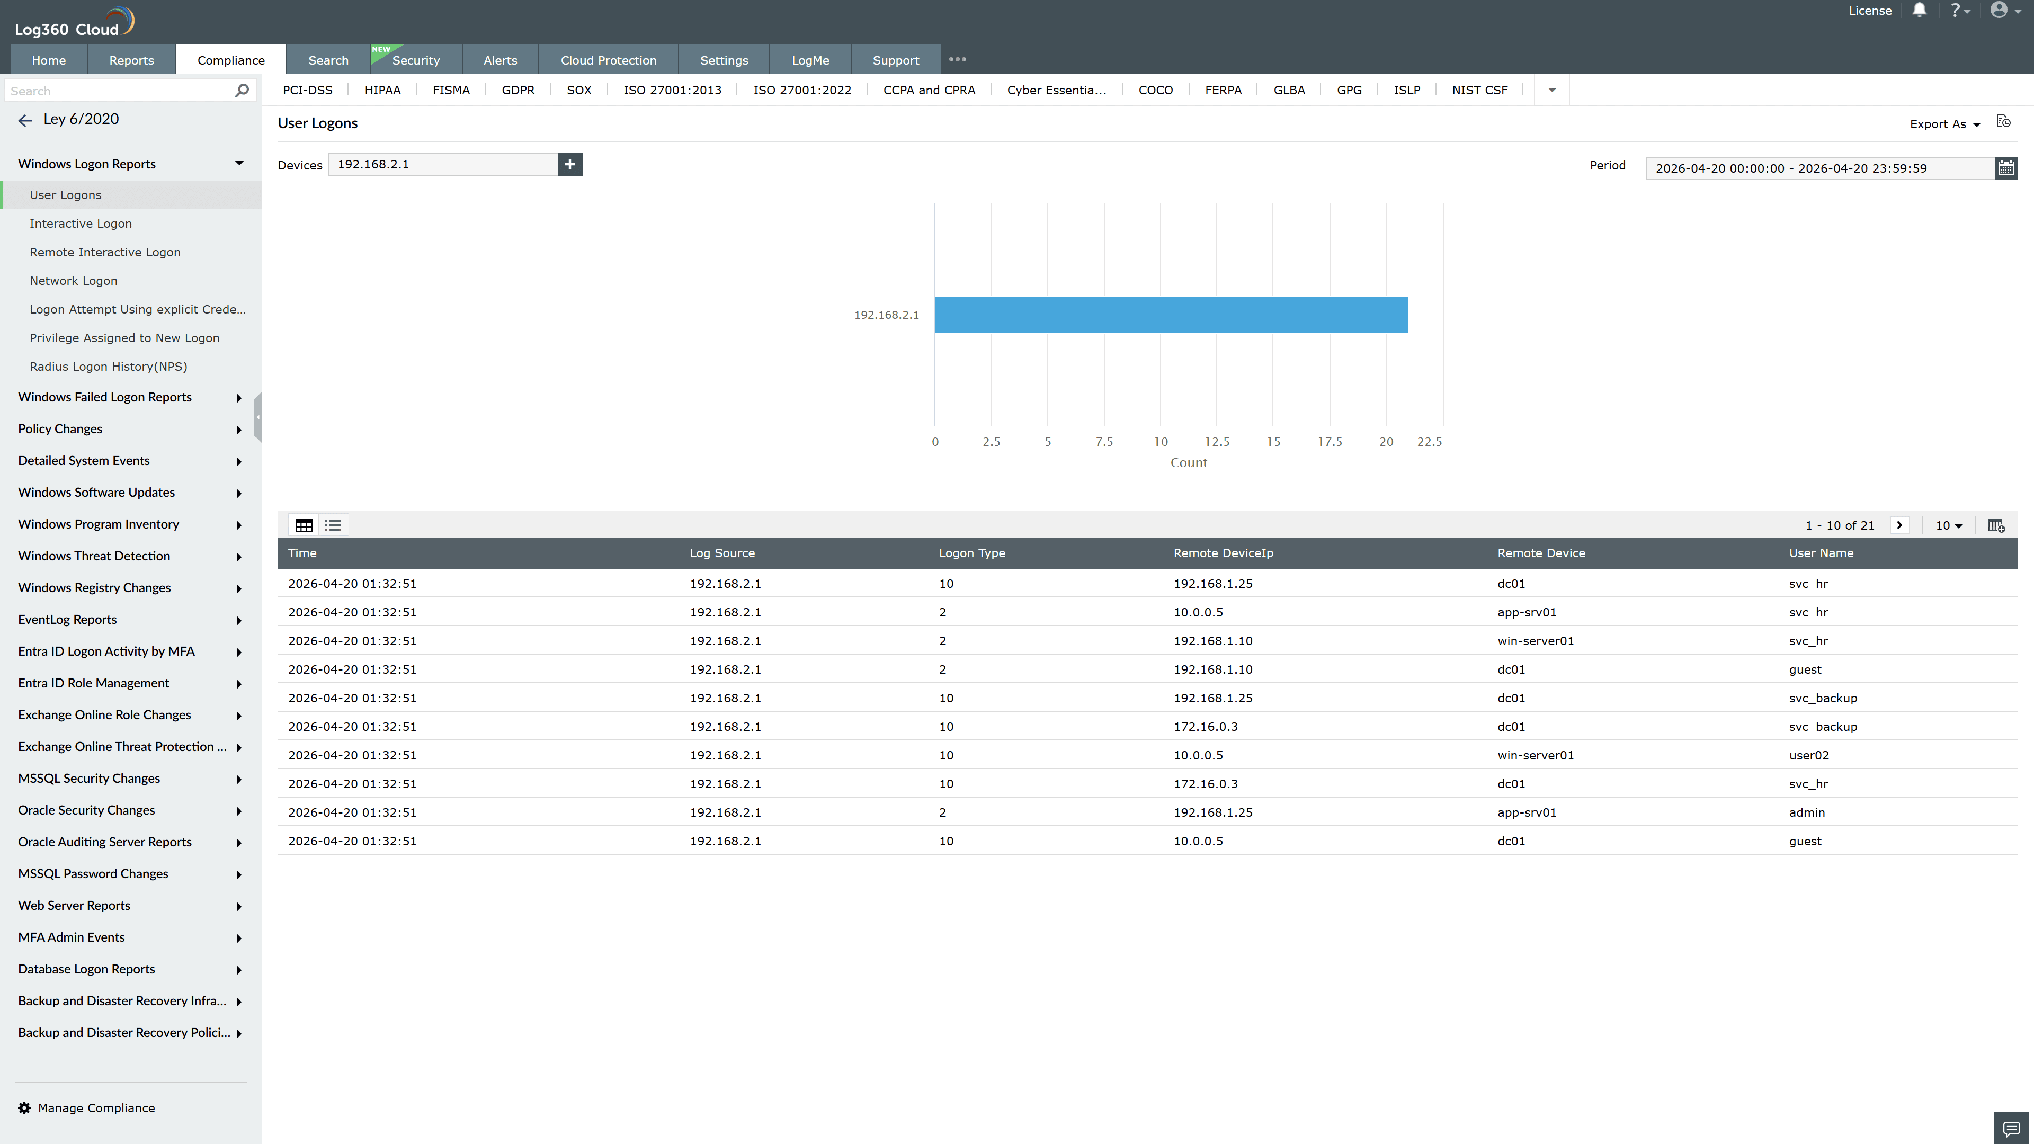
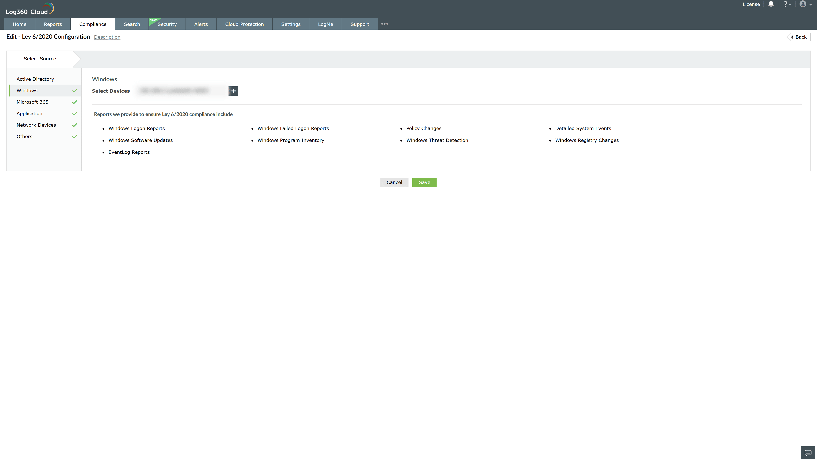
Valid Submission : Yes
Supported Editions : Free, Basic, Standard, Professional, MSSP
Help Document : https://www.manageengine.com/log-management/help/integrations/compliance-extensions.html
Help Video : Not provided
Tags : Log360, Compliance, Privacy monitoring, Data privacy, Regulatory compliance
Supported DCs : US, IN, JP, CA, AU, UK and EU
Privacy Policy:
Terms of Service:
Release Notes:
Predefined reports for the Spanish Trust Services Law (Law 6/2020) Compliance

