Swiss EPRA and MedDO Healthcare Cybersecurity Compliance for Log360
Tagline: Protect Swiss electronic patient records and meet EPRA and MedDO cybersecurity requirements with Log360.

Overview
The Swiss EPRA + MedDO Healthcare Cybersecurity Compliance extension for Log360 supports Swiss healthcare providers, EPD communities, and medical device operators in meeting the security monitoring and data protection requirements of the Electronic Patient Record Act (EPRA) and the Medical Device Ordinance (MedDO).
Log360 collects and analyzes logs from electronic health record systems, medical devices, cloud platforms, and network infrastructure, providing security teams with visibility into patient data access and system integrity events. Compliance teams can detect unauthorized access to health records and generate audit evidence for Swiss health regulators.

Key Features
- Generate predefined compliance reports covering EPRA and MedDO requirements including patient record access monitoring, authentication events, and data integrity controls.
- Monitor access to electronic patient records and connected medical devices to detect unauthorized queries and data exfiltration attempts.
- Configure real-time alerts for healthcare-specific security events such as unauthorized record access, bulk data exports, and audit log modifications.
- Export compliance evidence in PDF and CSV formats for Swiss healthcare authority submissions and internal data protection officer reviews.
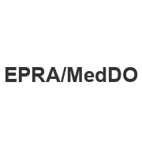
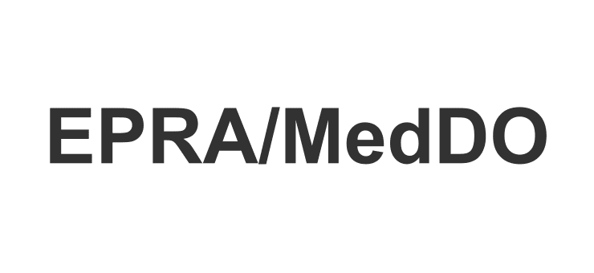

Screenshots
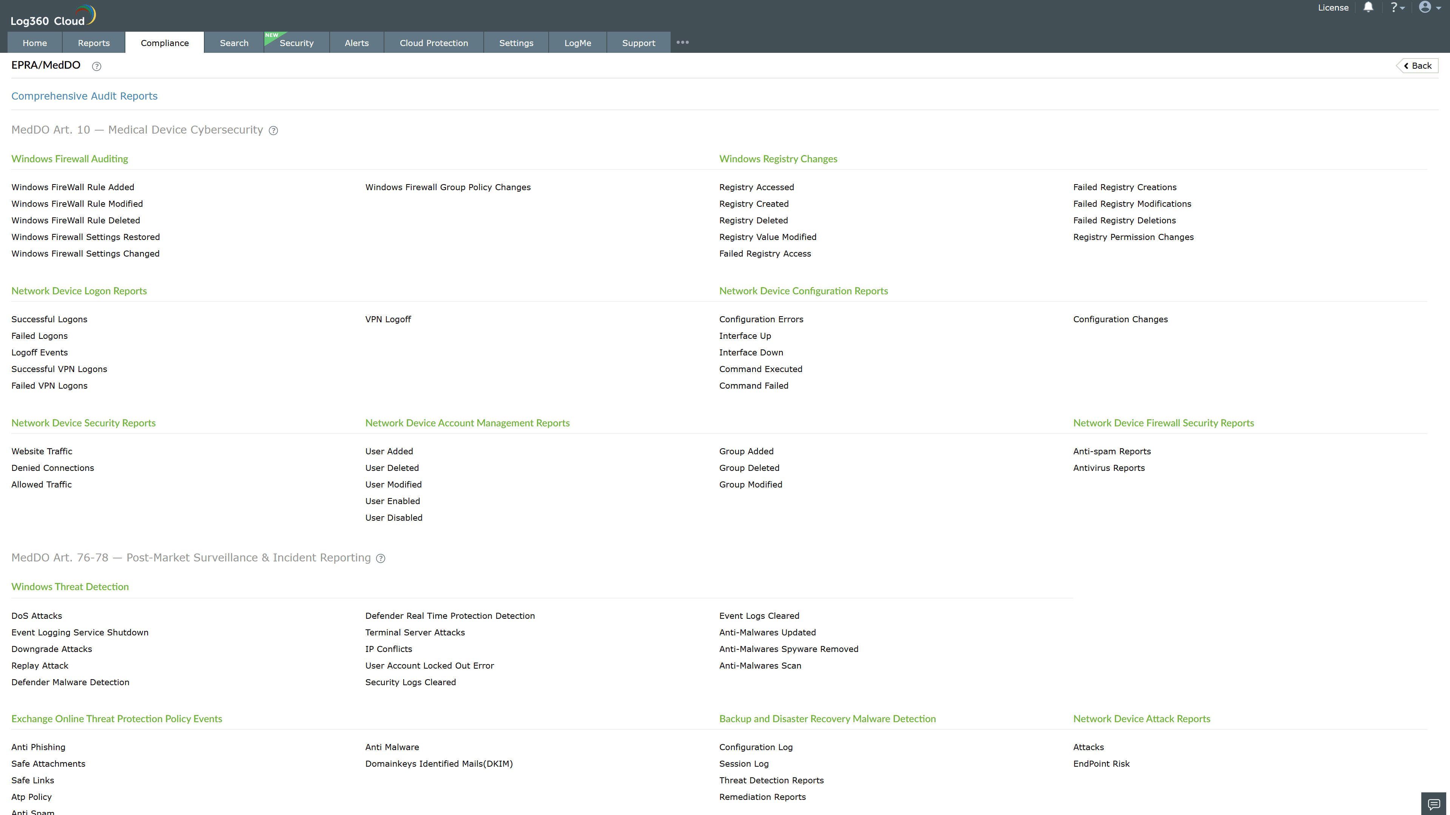
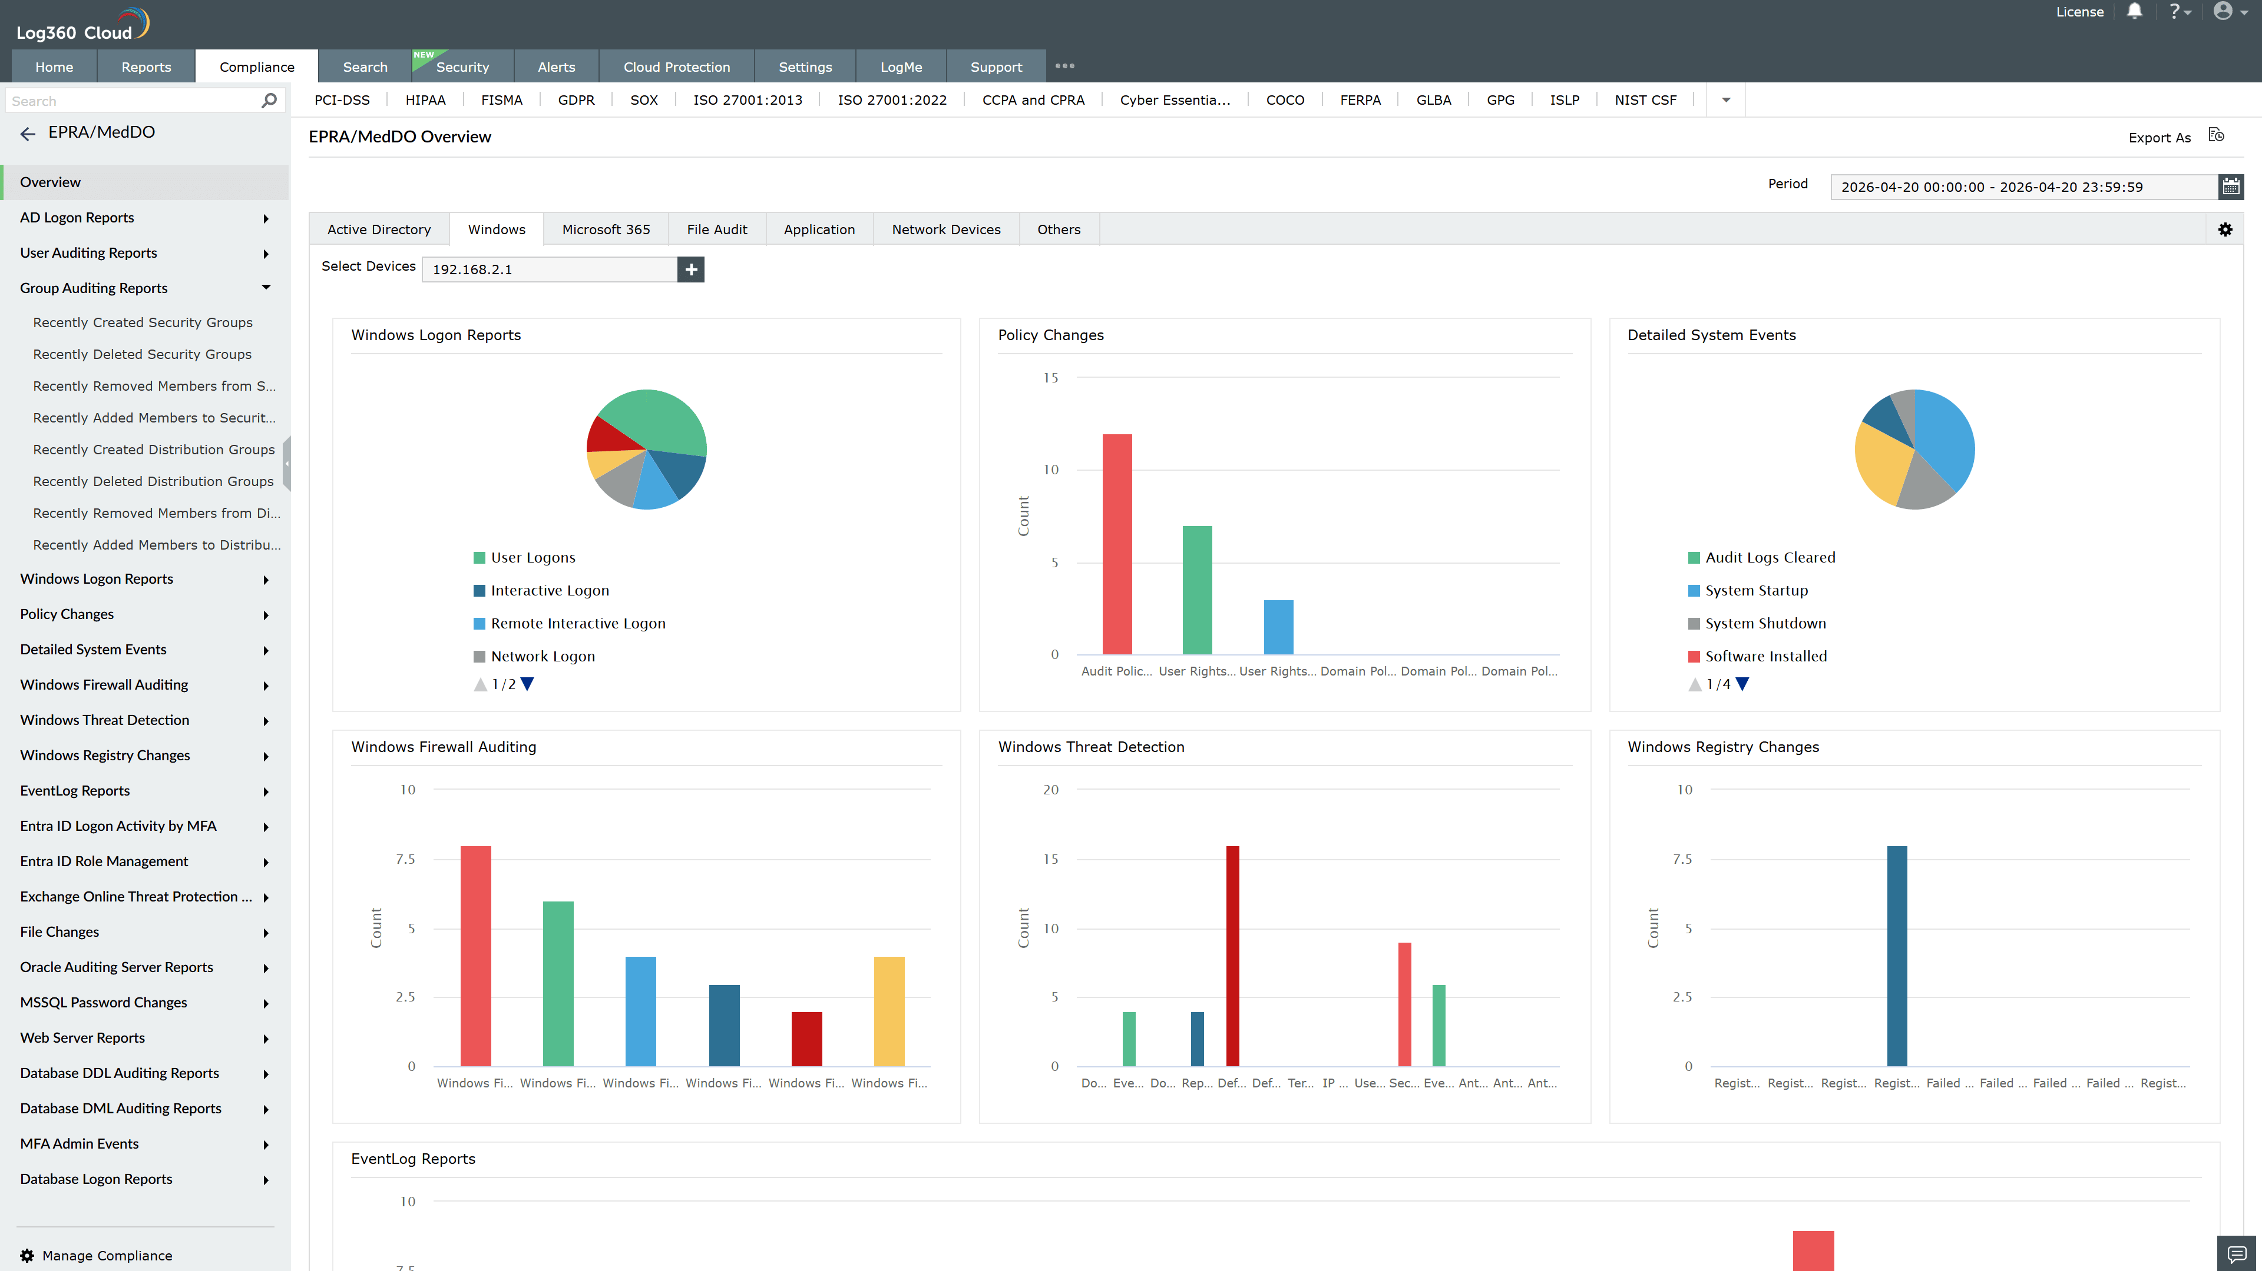
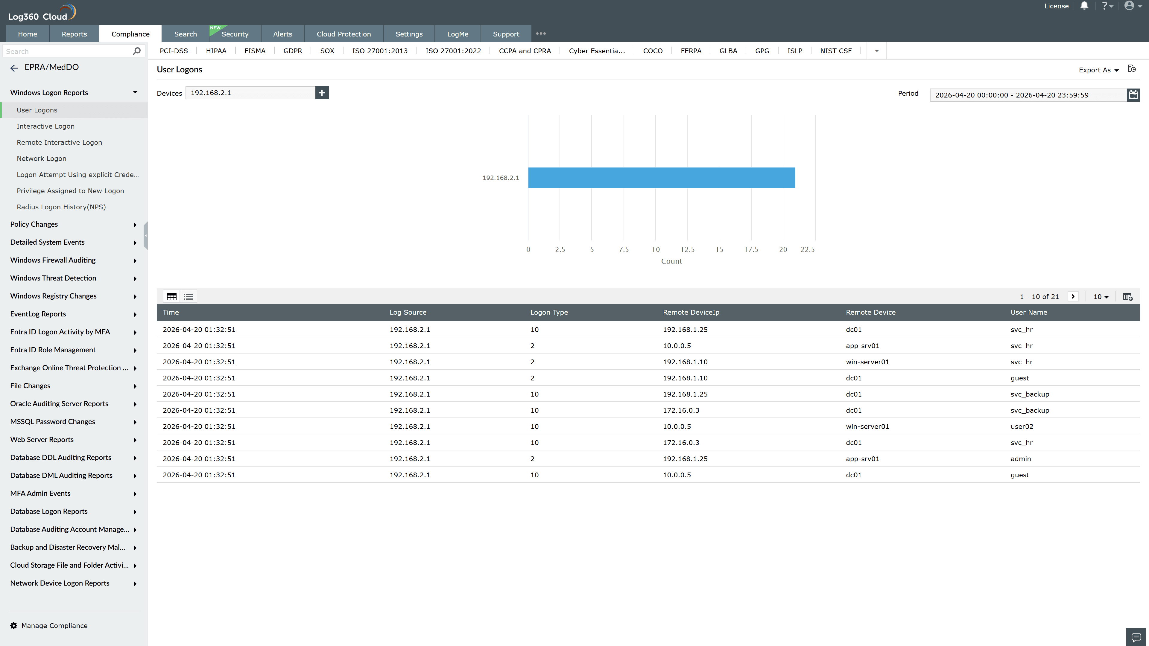
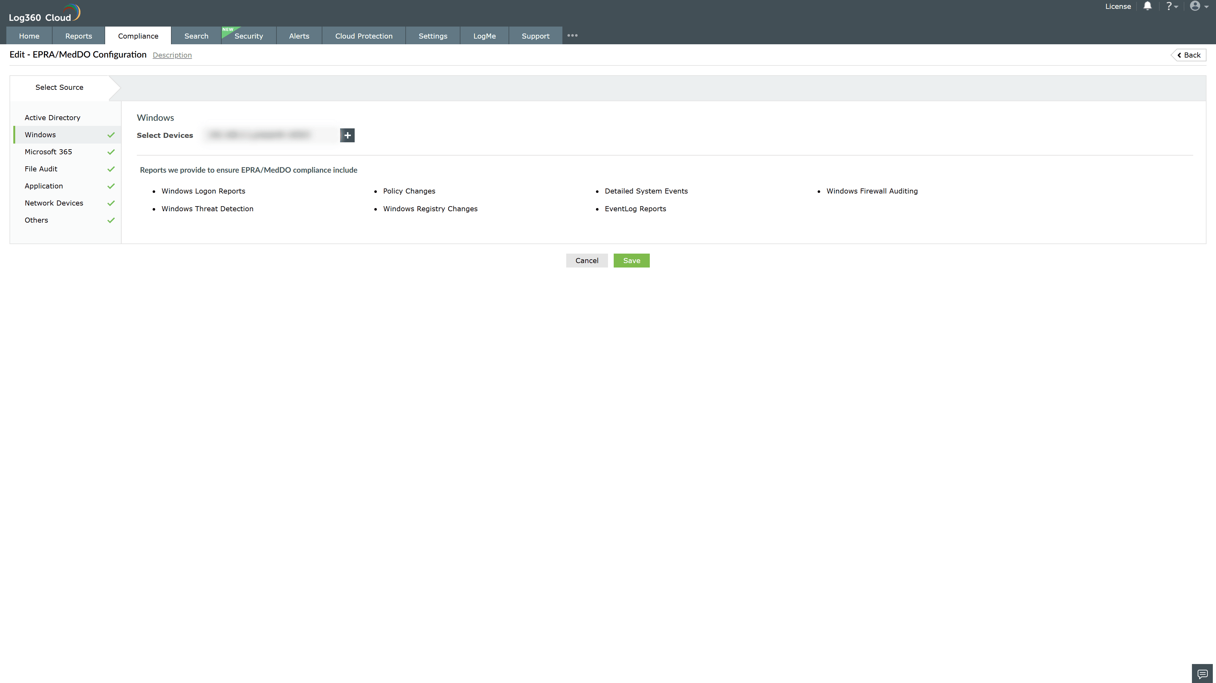
Valid Submission : Yes
Supported Editions : Free, Basic, Standard, Professional, MSSP
Help Document : https://www.manageengine.com/log-management/help/integrations/compliance-extensions.html
Help Video : Not provided
Tags : Log360, Compliance, Privacy monitoring, Data privacy, Regulatory compliance
Supported DCs : US, IN, JP, CA, AU, UK and EU
Privacy Policy:
Terms of Service:
Release Notes:
Predefined reports for the EPRA and MedDO Compliance

