Swiss Financial Market Infrastructure Act Compliance for Log360
Tagline: Align with FinMIA's IT security and governance requirements using Log360.

Overview
The Swiss Financial Market Infrastructure Act (FinMIA) Compliance extension for Log360 enables Swiss stock exchanges, central counterparties, and financial market infrastructure operators to meet FinMIA's IT security, access control, and incident management requirements.
Log360 continuously collects and correlates log data from trading systems, cloud environments, network devices, and identity platforms. Security teams gain real-time visibility into access events, system changes, and potential threats, empowering them to detect incidents early and provide auditors with comprehensive compliance evidence.

Key Features
- Generate predefined compliance reports aligned to FinMIA IT security requirements covering access management, data integrity, and incident logging.
- Track privileged access events, critical system changes, and administrative actions across financial market infrastructure in real time.
- Leverage preconfigured threat intelligence and correlation rules to detect suspicious activity targeting trading systems and sensitive financial data.
- Export audit-ready reports in PDF and CSV formats for FINMA supervisory reviews and internal governance committees.
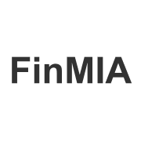
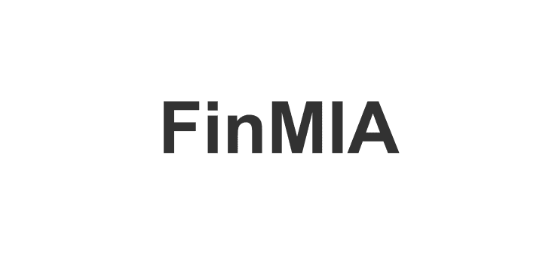

Screenshots
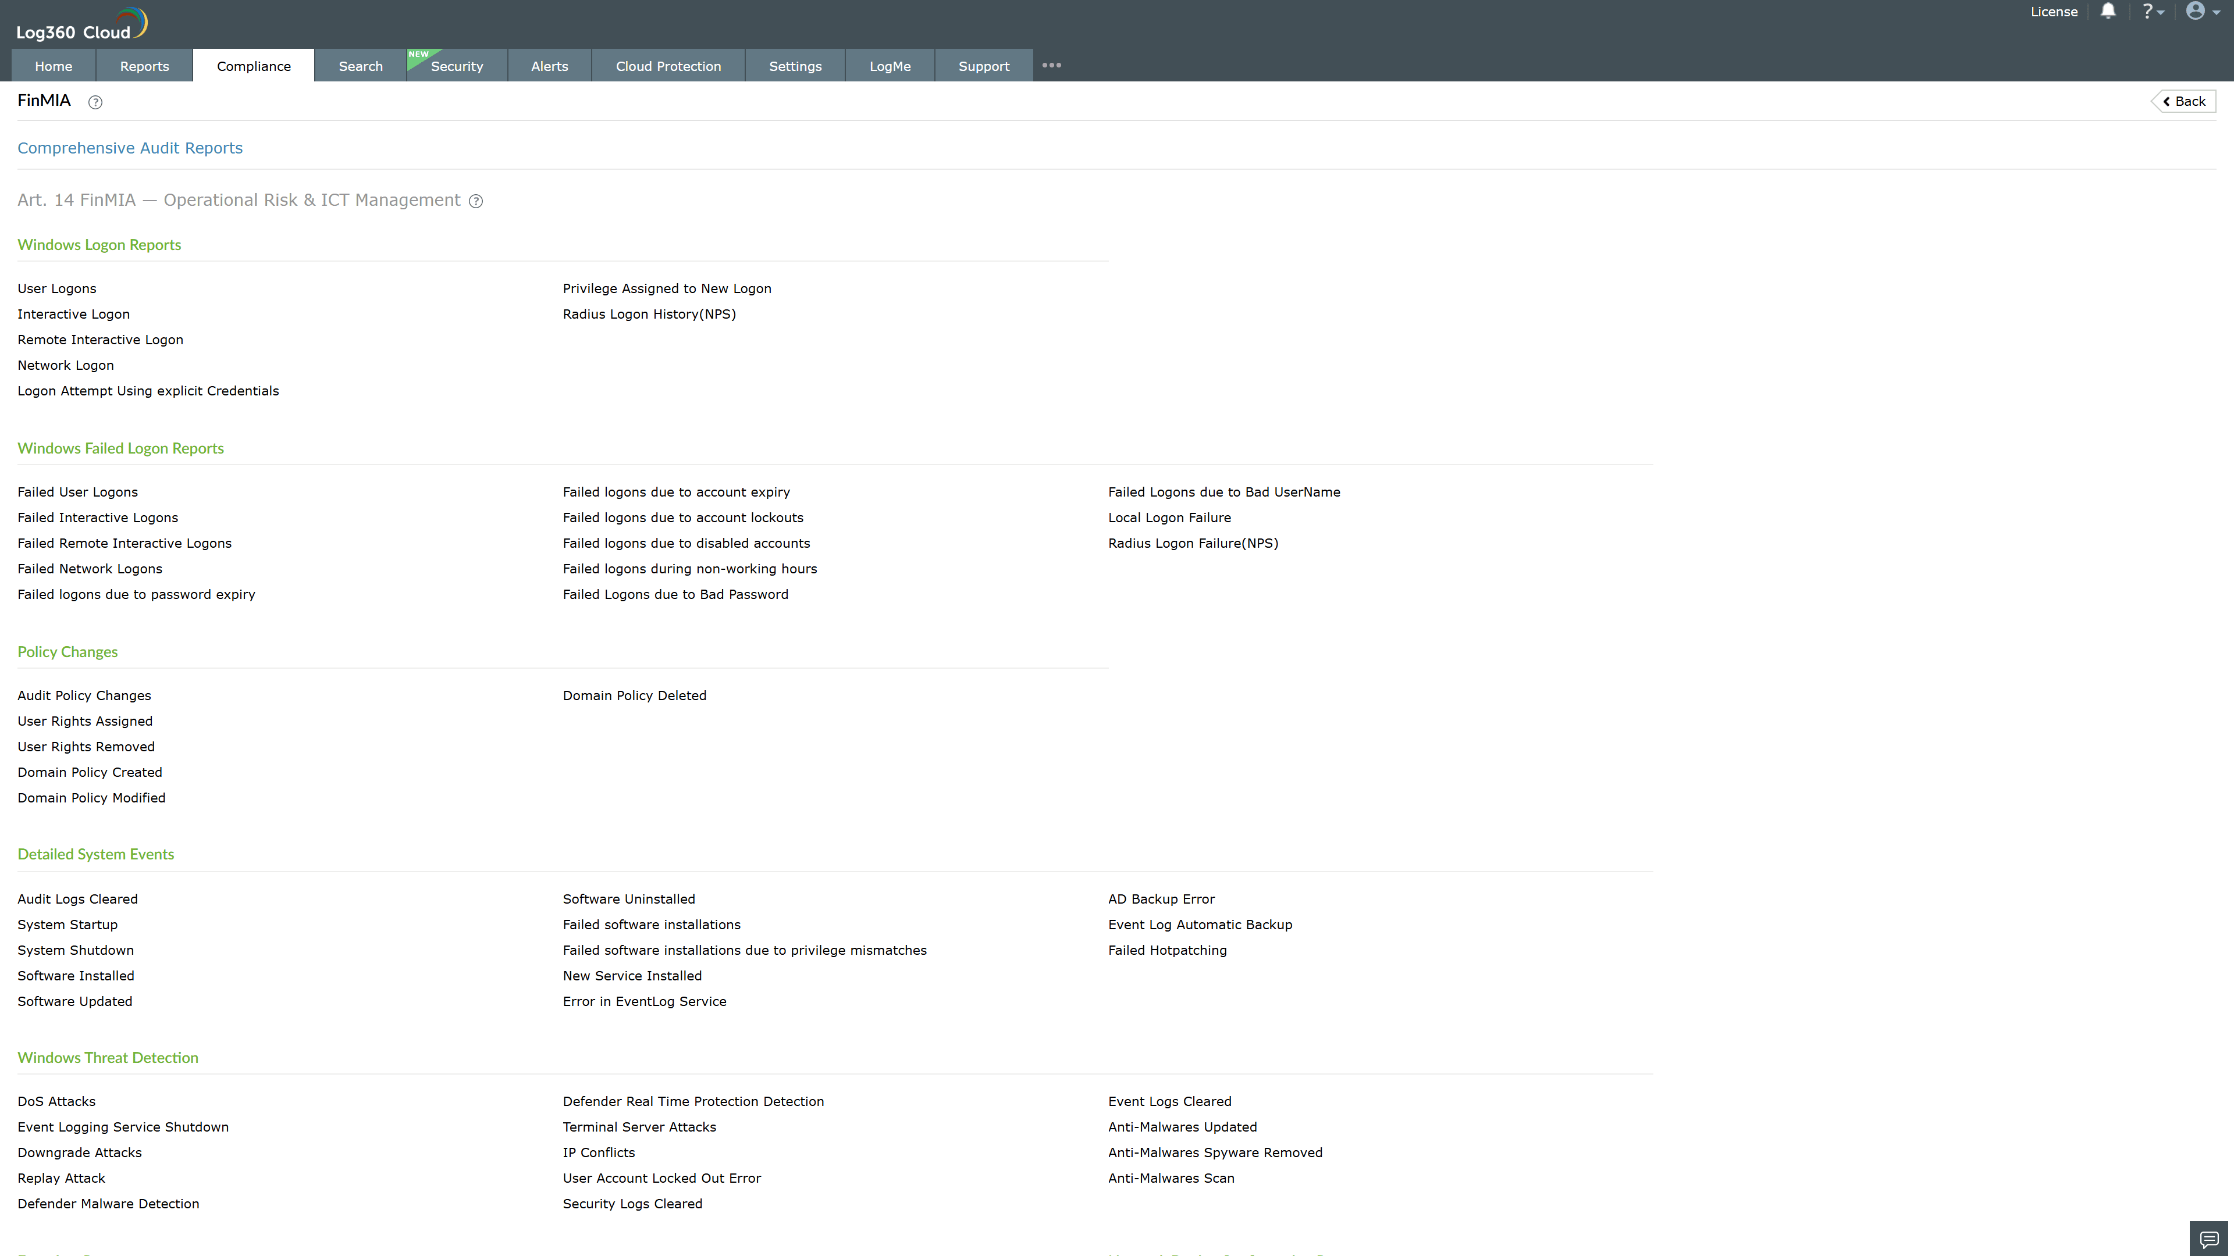
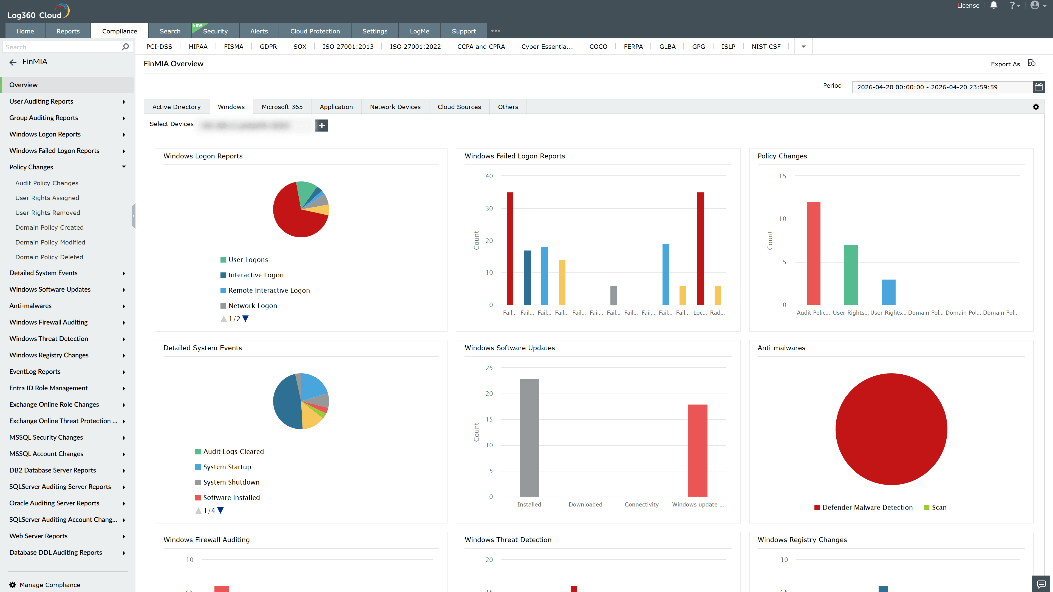
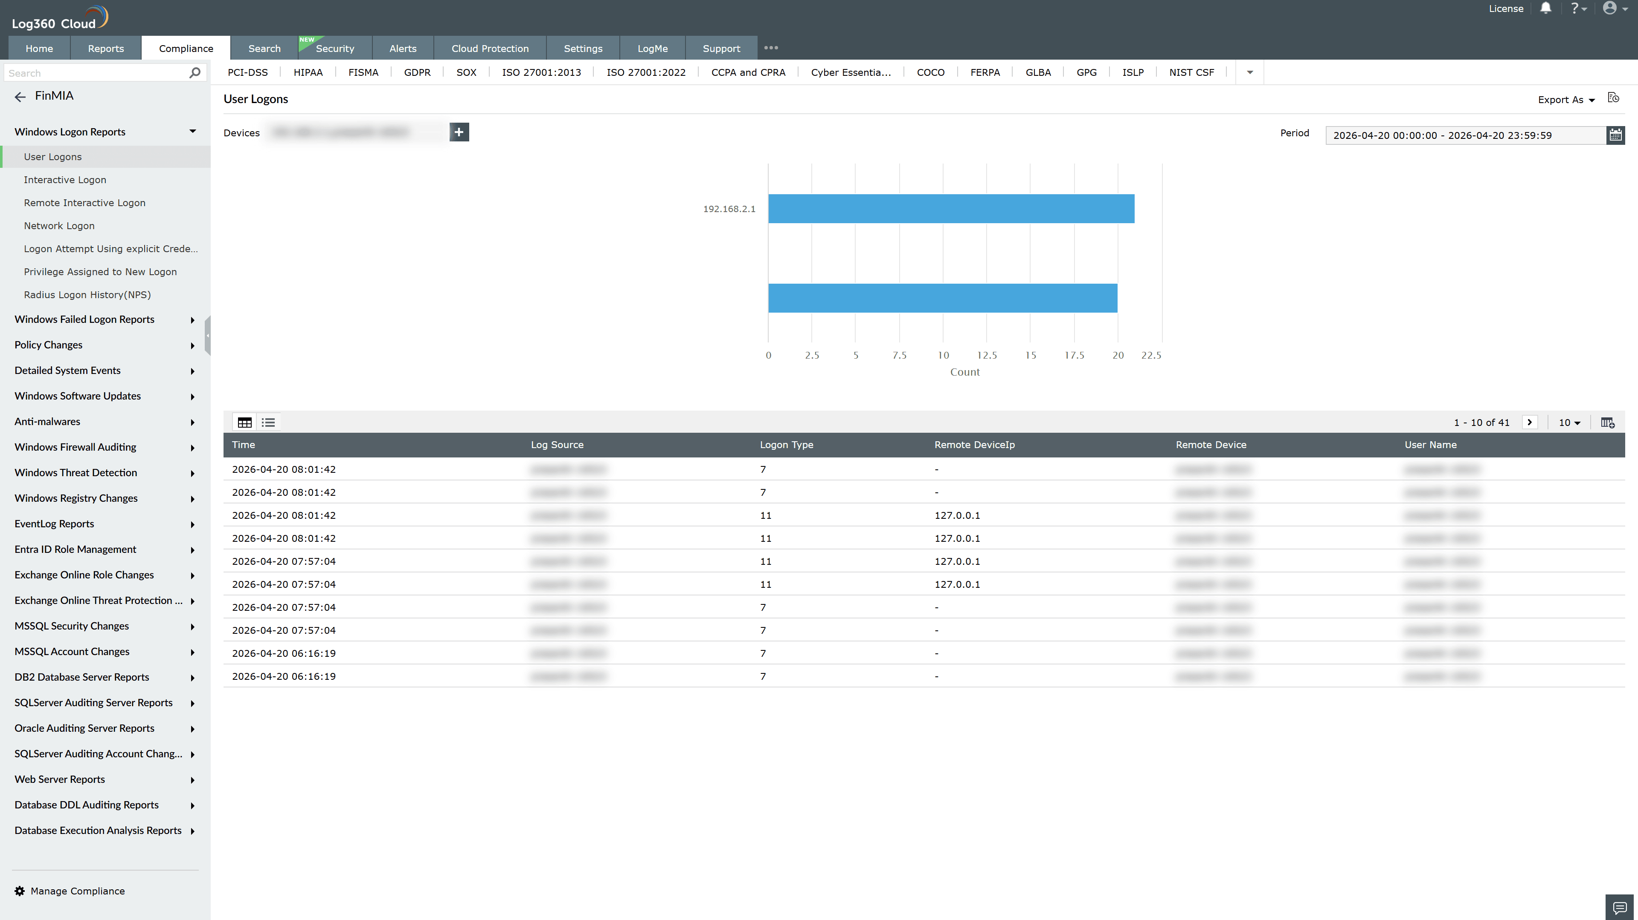
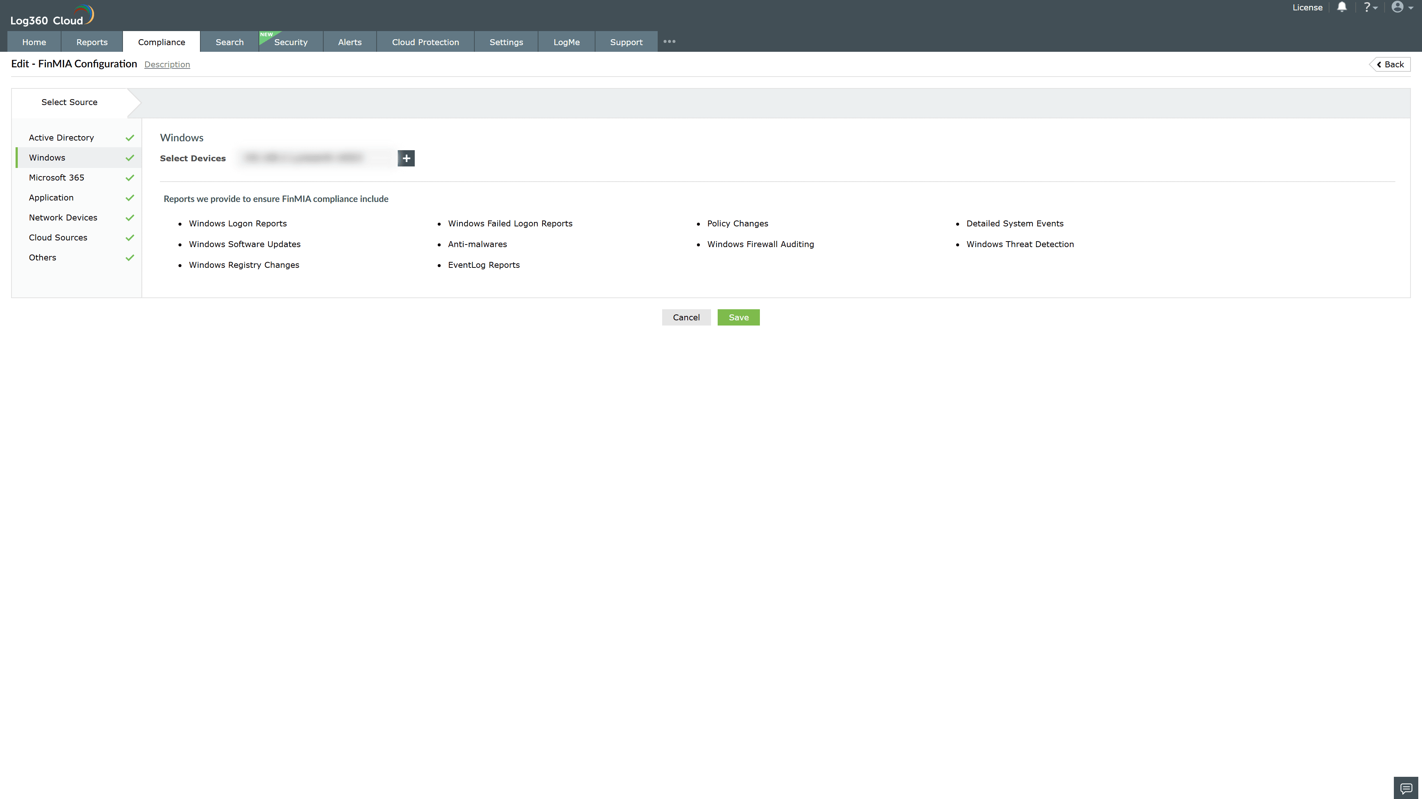
Valid Submission : Yes
Supported Editions : Free, Basic, Standard, Professional, MSSP
Help Document : https://www.manageengine.com/log-management/help/integrations/compliance-extensions.html
Help Video : Not provided
Tags : Log360, Compliance, Privacy monitoring, Data privacy, Regulatory compliance
Supported DCs : US, IN, JP, CA, AU, UK and EU
Privacy Policy:
Terms of Service:
Release Notes:
Predefined reports for the FinMIA Compliance

