Swiss Telecommunications Act Compliance for Log360
Tagline: Ensure telecommunications security with continuous log monitoring from Log360.

Overview
The Swiss Telecommunications Act (TCA) Compliance extension for Log360 helps Swiss telecom providers and digital service operators meet the security monitoring, data protection, and lawful interception-related obligations under the TCA.
Log360 ingests logs from network infrastructure, access systems, cloud platforms, and communication services, enabling organizations to maintain detailed audit trails of system events and user activities. Security teams can detect unauthorized access, monitor network integrity, and generate regulatory-grade reports to demonstrate compliance with TCA requirements.

Key Features
- Generate predefined audit reports covering network access events, system changes, and data handling activities relevant to TCA obligations.
- Monitor authentication logs, network device events, and user activity across telecommunications infrastructure in real time.
- Configure threshold-based alerts for TCA-relevant security events such as unauthorized system access, configuration changes, and data exfiltration attempts.
- Export compliance reports in PDF and CSV formats suitable for regulatory submissions to BAKOM and internal governance reviews.
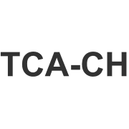
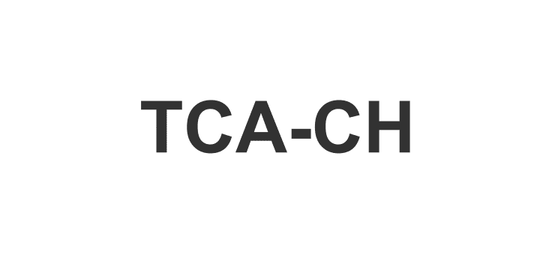

Screenshots
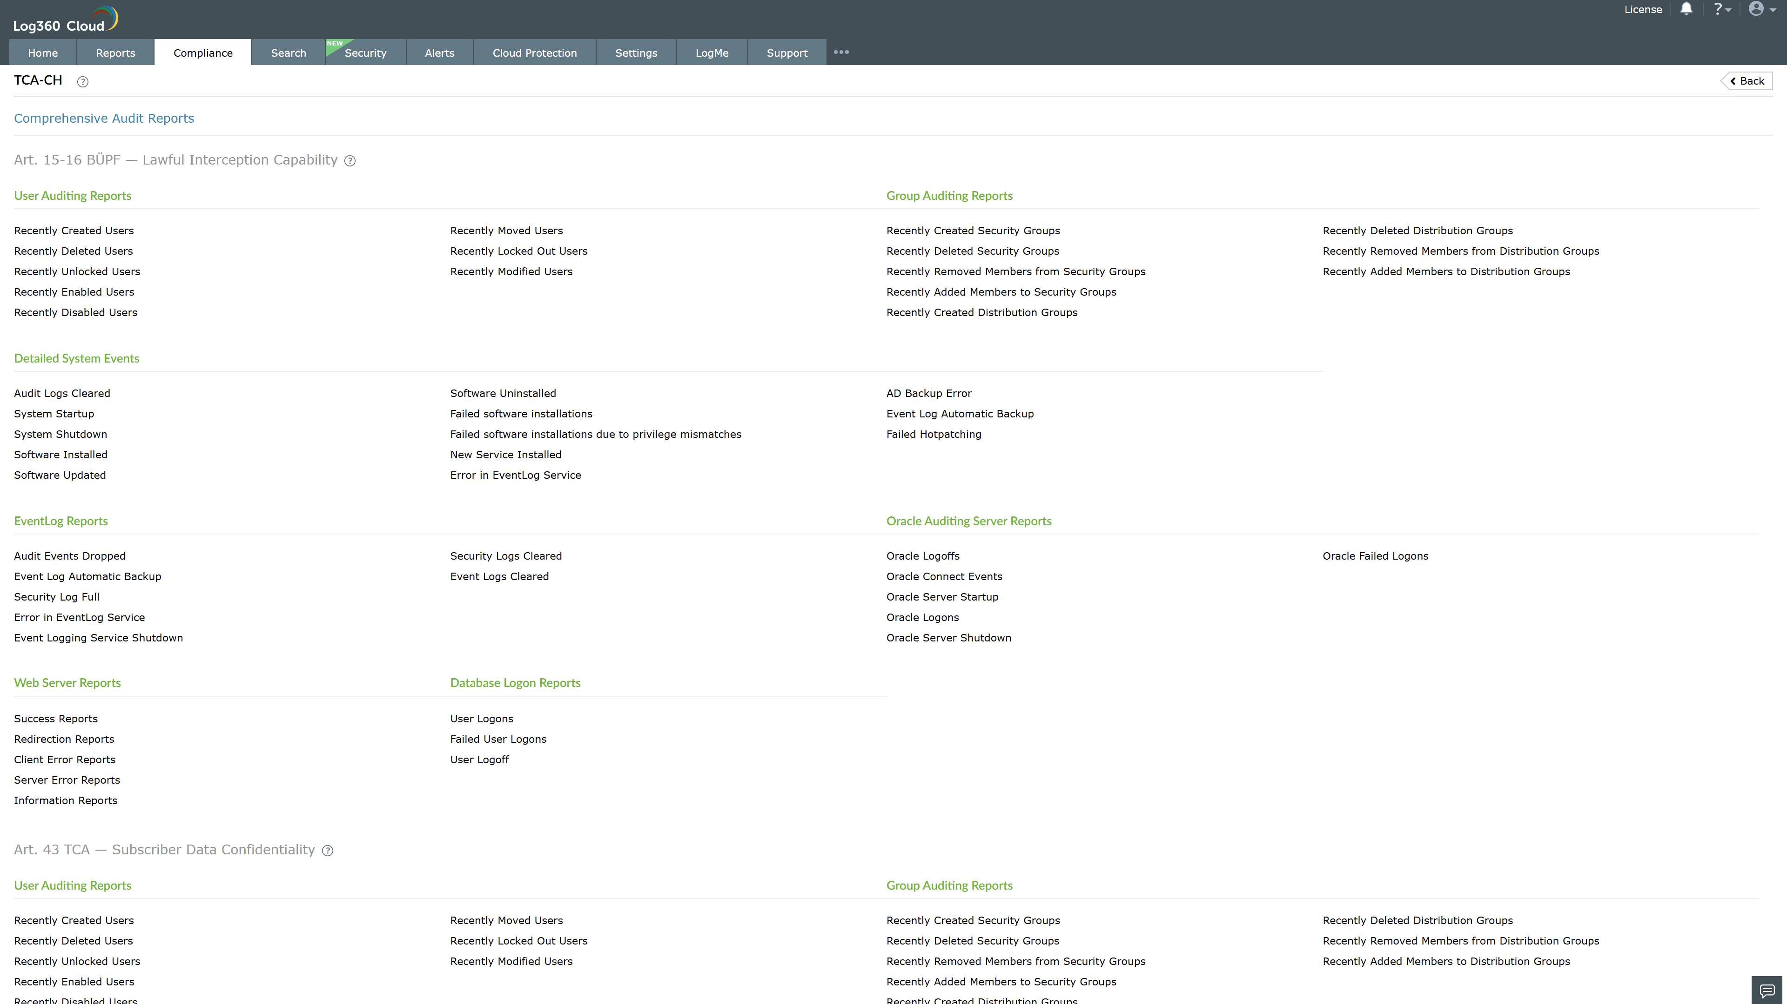
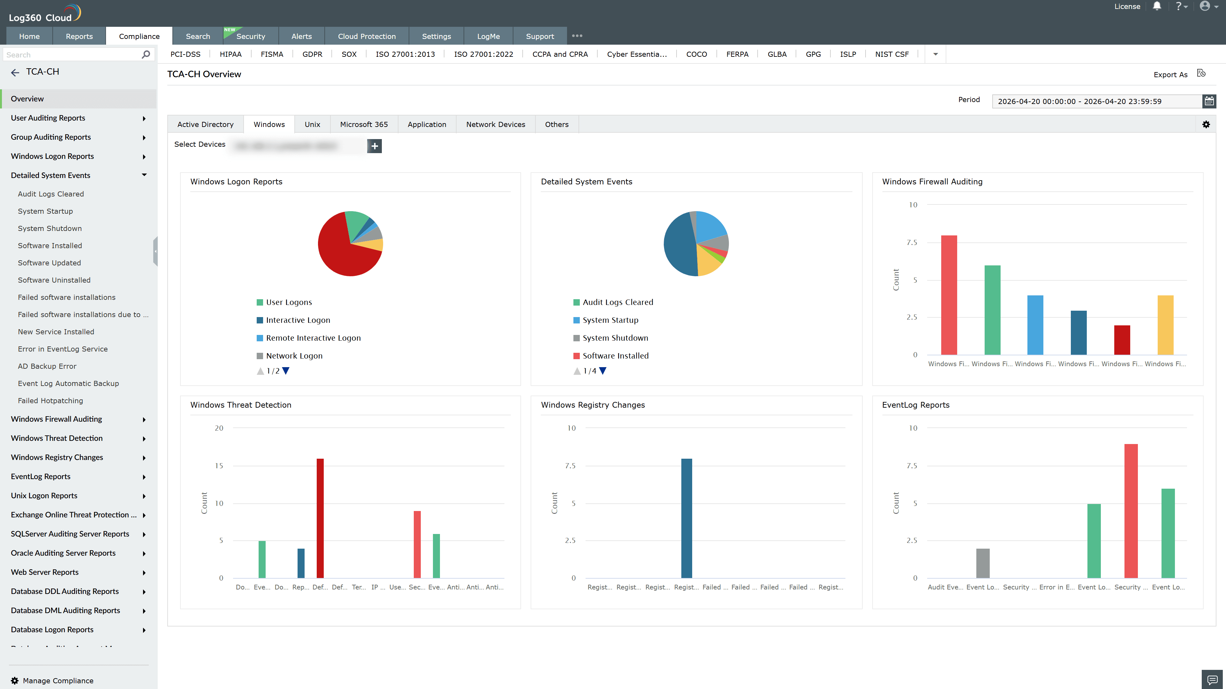
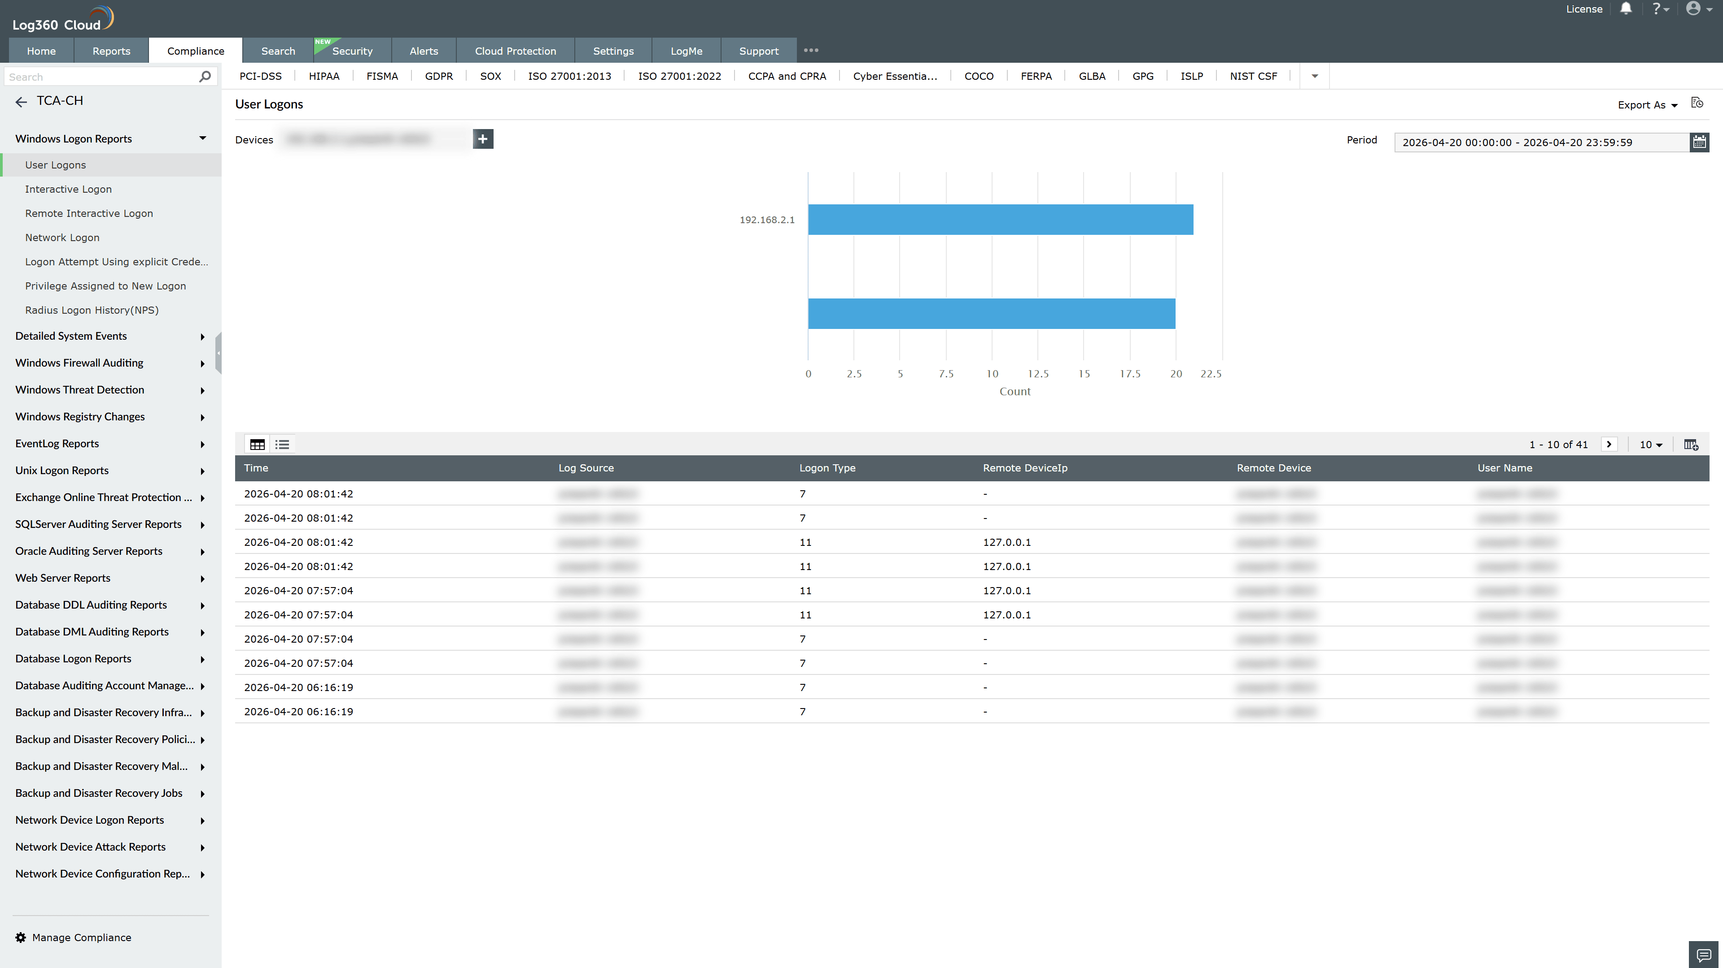
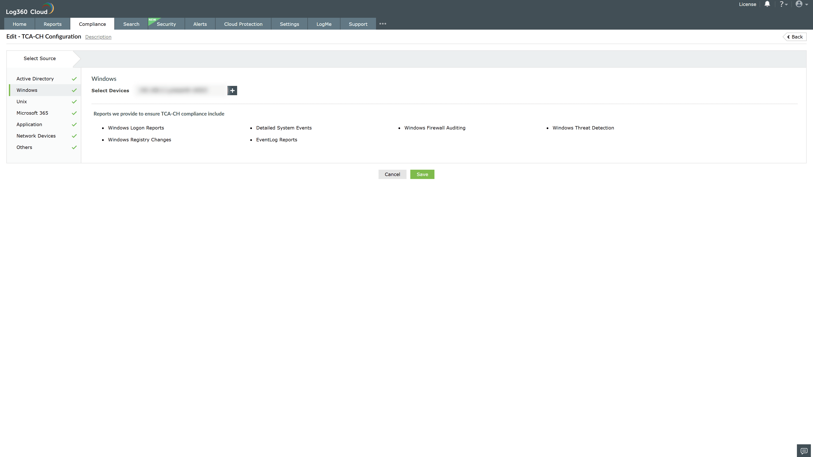
Valid Submission : Yes
Supported Editions : Free, Basic, Standard, Professional, MSSP
Help Document : https://www.manageengine.com/log-management/help/integrations/compliance-extensions.html
Help Video : Not provided
Tags : Log360, Compliance, Privacy monitoring, Data privacy, Regulatory compliance
Supported DCs : US, IN, JP, CA, AU, UK and EU
Privacy Policy:
Terms of Service:
Release Notes:
Predefined reports for the TCA Compliance

