TIBER-CH Compliance for Log360
Tagline: Strengthen Swiss financial sector cyber resilience and support TIBER-CH threat intelligence exercises with Log360.

Overview
The TIBER-CH (Threat Intelligence-Based Ethical Red Teaming — Switzerland) Compliance extension for Log360 helps Swiss financial institutions and critical service providers prepare for and respond to TIBER-CH threat-led penetration testing exercises coordinated by the Swiss National Bank and FINMA.
Log360 provides the security visibility and detection capabilities needed to evaluate blue team responses during TIBER exercises, correlating log data from across the IT estate to surface attack paths and detection gaps. Security teams can use Log360 to review detection coverage, strengthen monitoring posture, and document blue team activities.

Key Features
- Generate reports documenting detection activity, alert responses, and security event timelines during TIBER-CH red team exercises.
- Monitor attacker simulation activity across Active Directory, endpoints, cloud platforms, and network infrastructure in real time.
- Capture and archive forensic evidence for comprehensive incident investigation and post-exercise analysis.
- Export exercise documentation and detection coverage reports in PDF and CSV formats for TIBER-CH after-action reviews and regulator submissions.



Screenshots
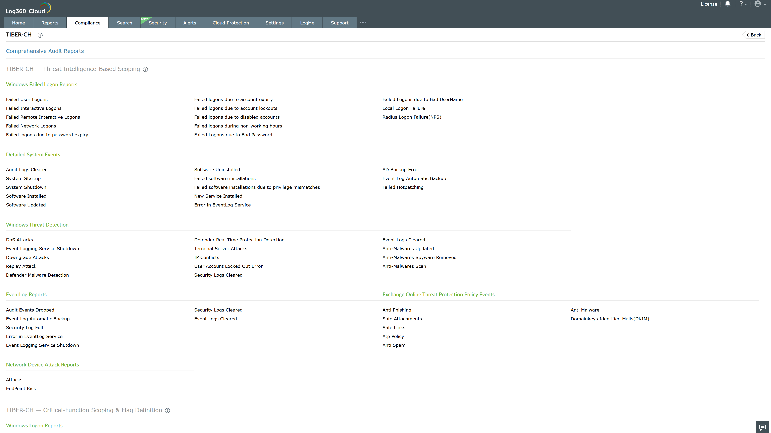
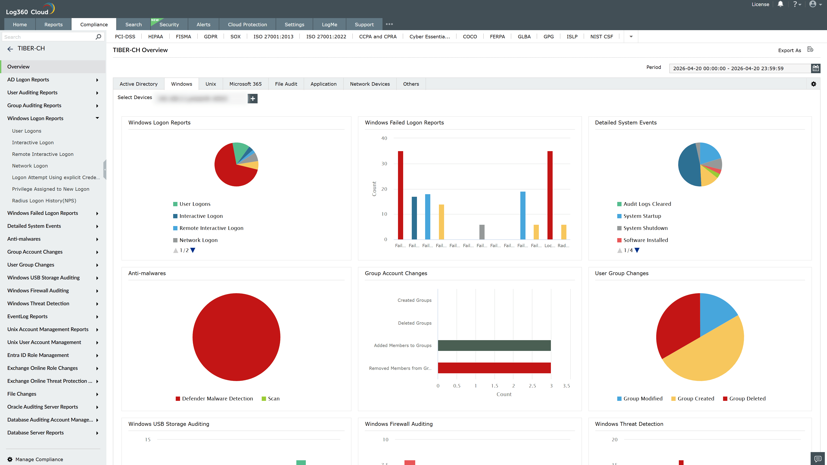
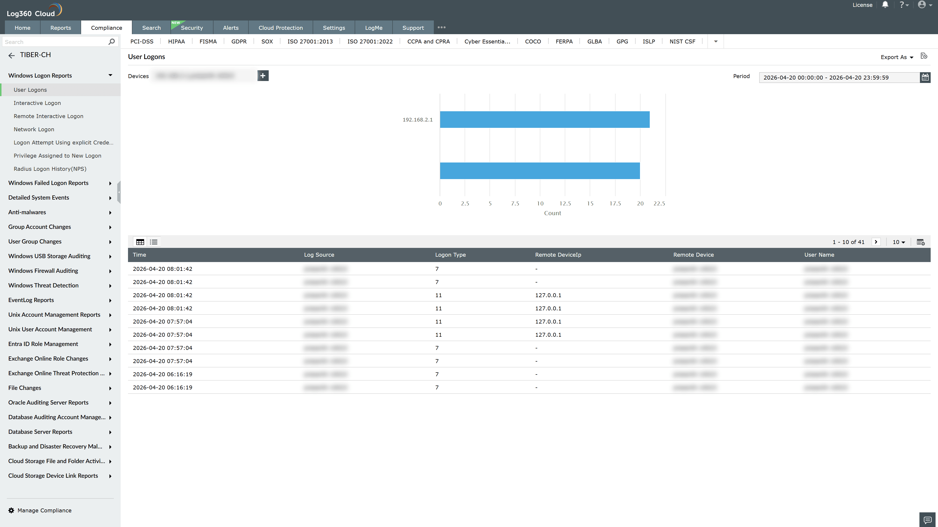
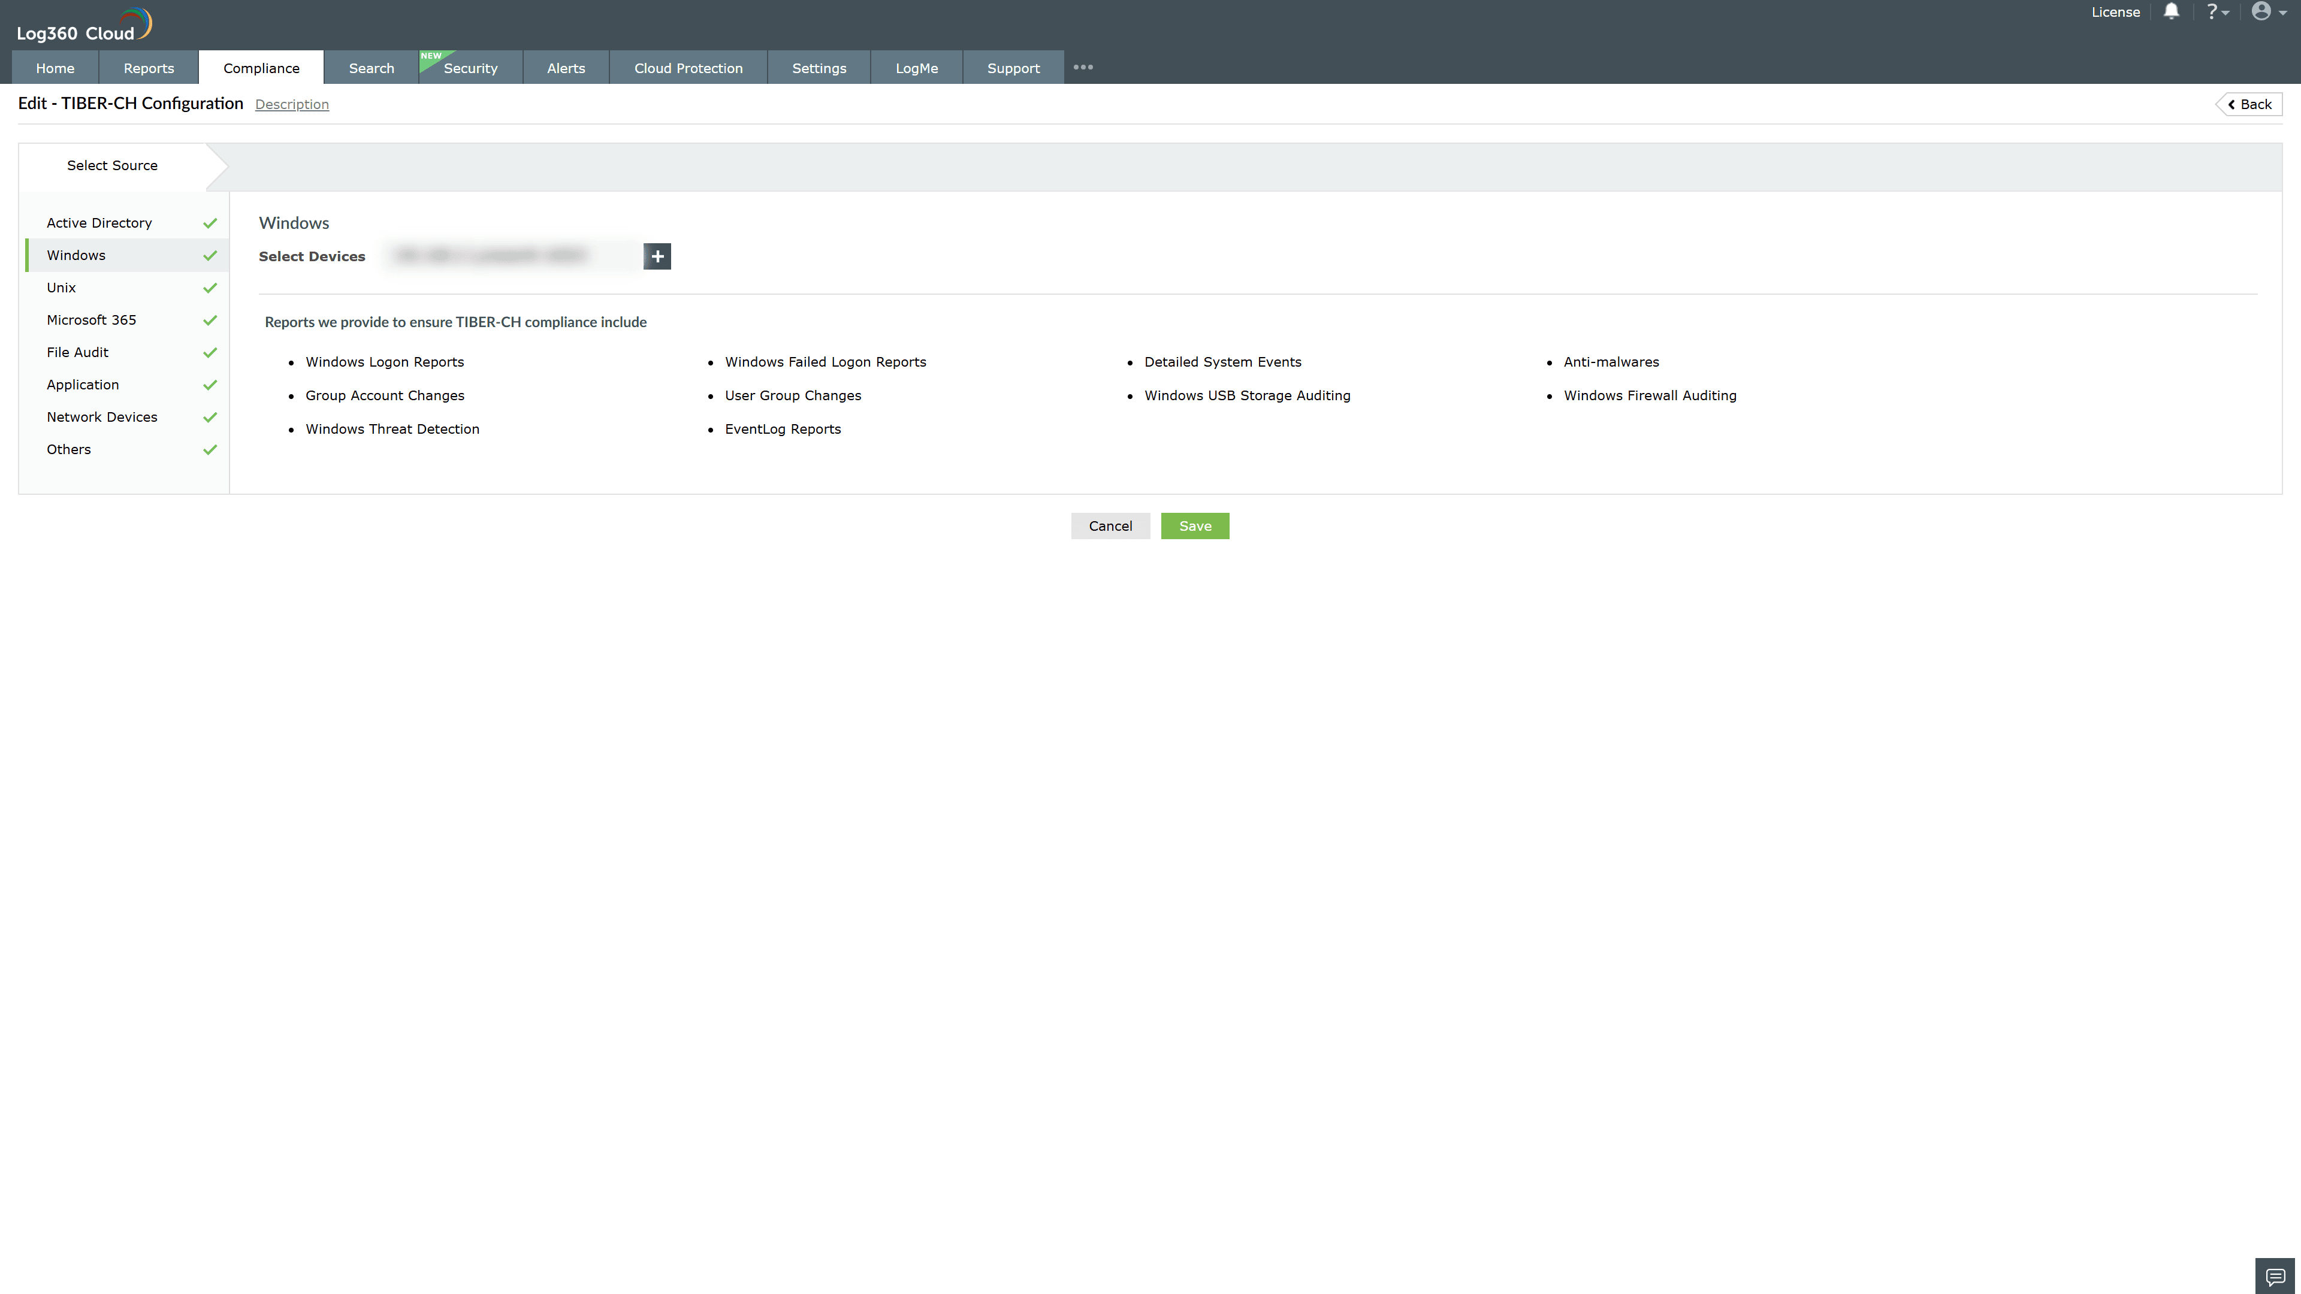
Valid Submission : Yes
Supported Editions : Free, Basic, Standard, Professional, MSSP
Help Document : https://www.manageengine.com/log-management/help/integrations/compliance-extensions.html
Help Video : Not provided
Tags : Log360, Compliance, Privacy monitoring, Data privacy, Regulatory compliance
Supported DCs : US, IN, JP, CA, AU, UK and EU
Privacy Policy:
Terms of Service:
Release Notes:
Predefined reports for the TIBER-CH Compliance

