TIBER-IT National Guide Compliance for Log360
Tagline: Support Italy's cyber resilience with detection and monitoring from Log360.

Overview
The TIBER-IT National Guide (Updated 2025) Compliance extension for Log360 helps Italian financial institutions and critical infrastructure operators prepare for and respond to TIBER-IT exercises coordinated by Banca d'Italia.
Log360 provides the detection and monitoring capabilities required to assess blue team performance during adversarial simulation exercises, correlating logs from IT systems, cloud environments, and network infrastructure to identify attack paths and detection gaps. Security teams can use Log360 to verify control coverage and generate documentation for TIBER-IT supervisory reporting.

Key Features
- Generate reports documenting security event detection, alert timelines, and blue team response activities during TIBER-IT exercises.
- Monitor attacker simulation paths across Active Directory, endpoints, network devices, and cloud environments in real time.
- Capture and archive forensic evidence for comprehensive incident investigation and post-exercise analysis.
- Export TIBER-IT exercise reports in PDF and CSV formats for Banca d'Italia after-action reviews and internal security resilience governance.

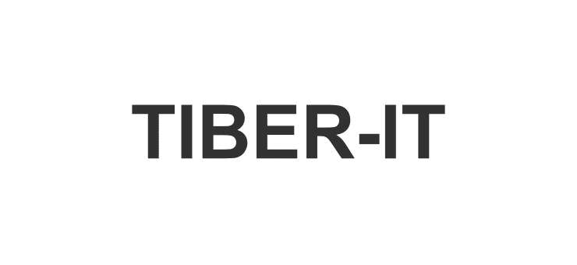

Screenshots
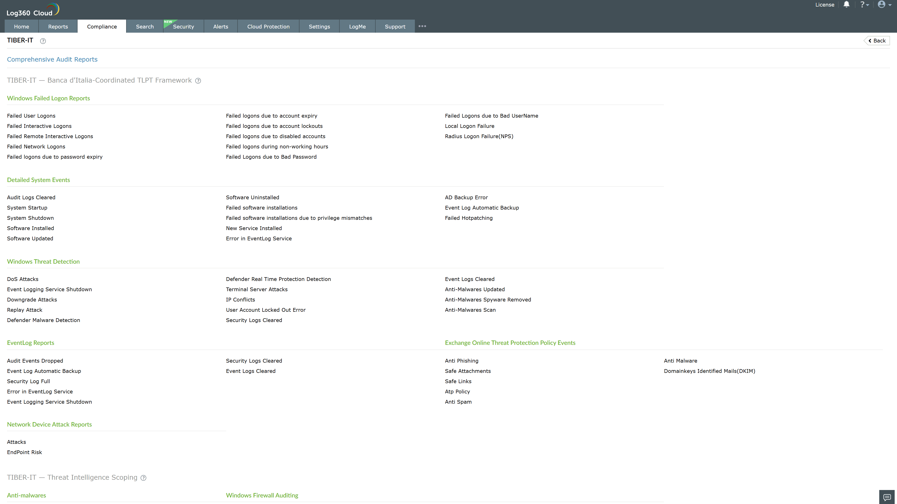
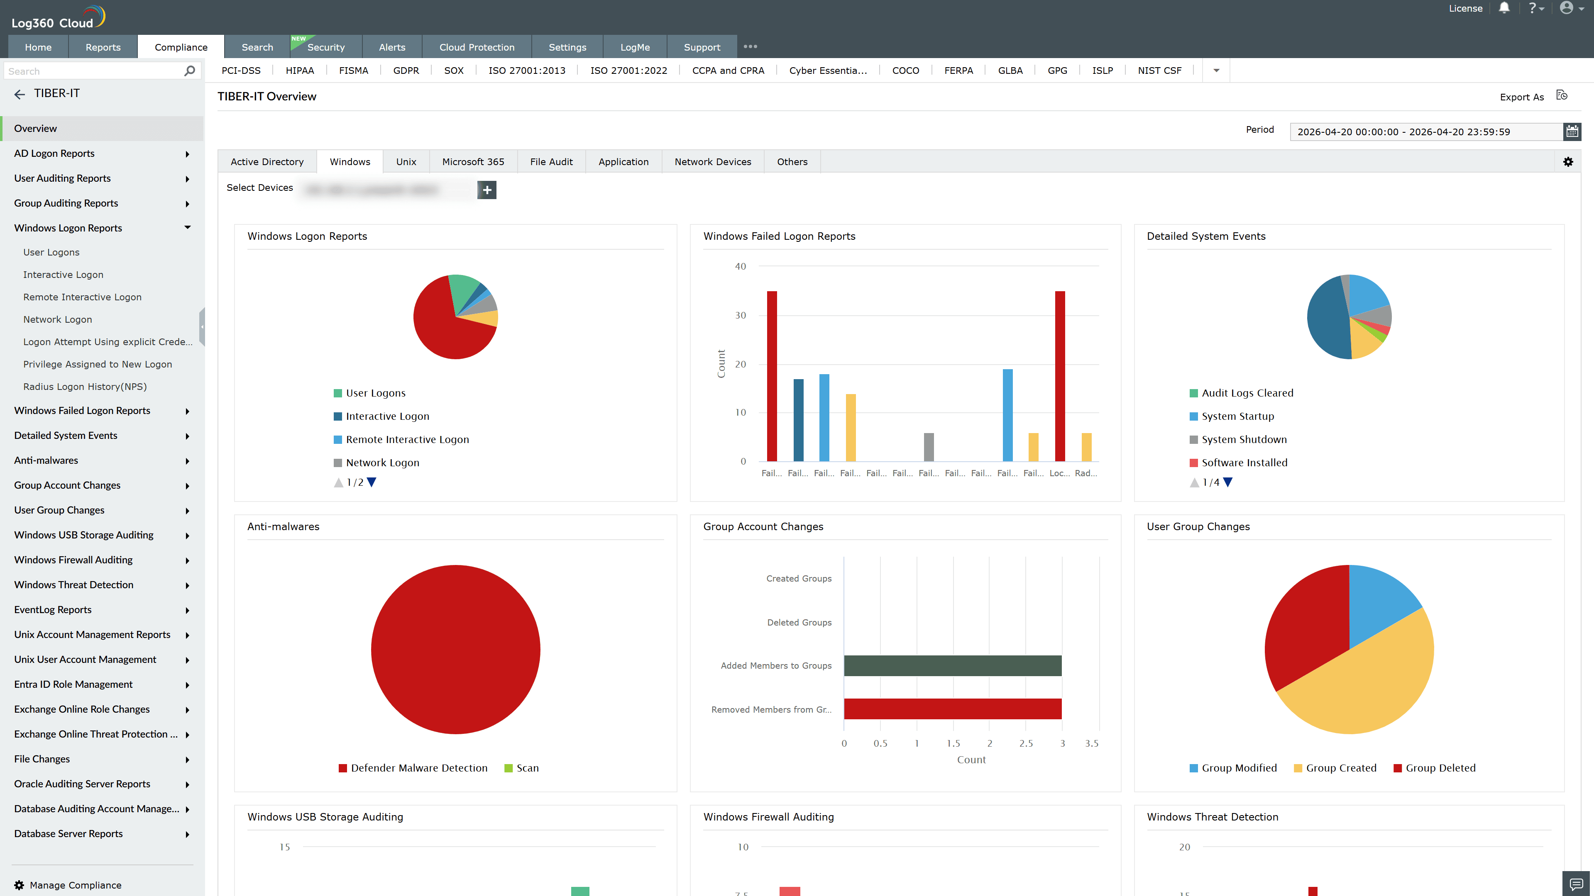
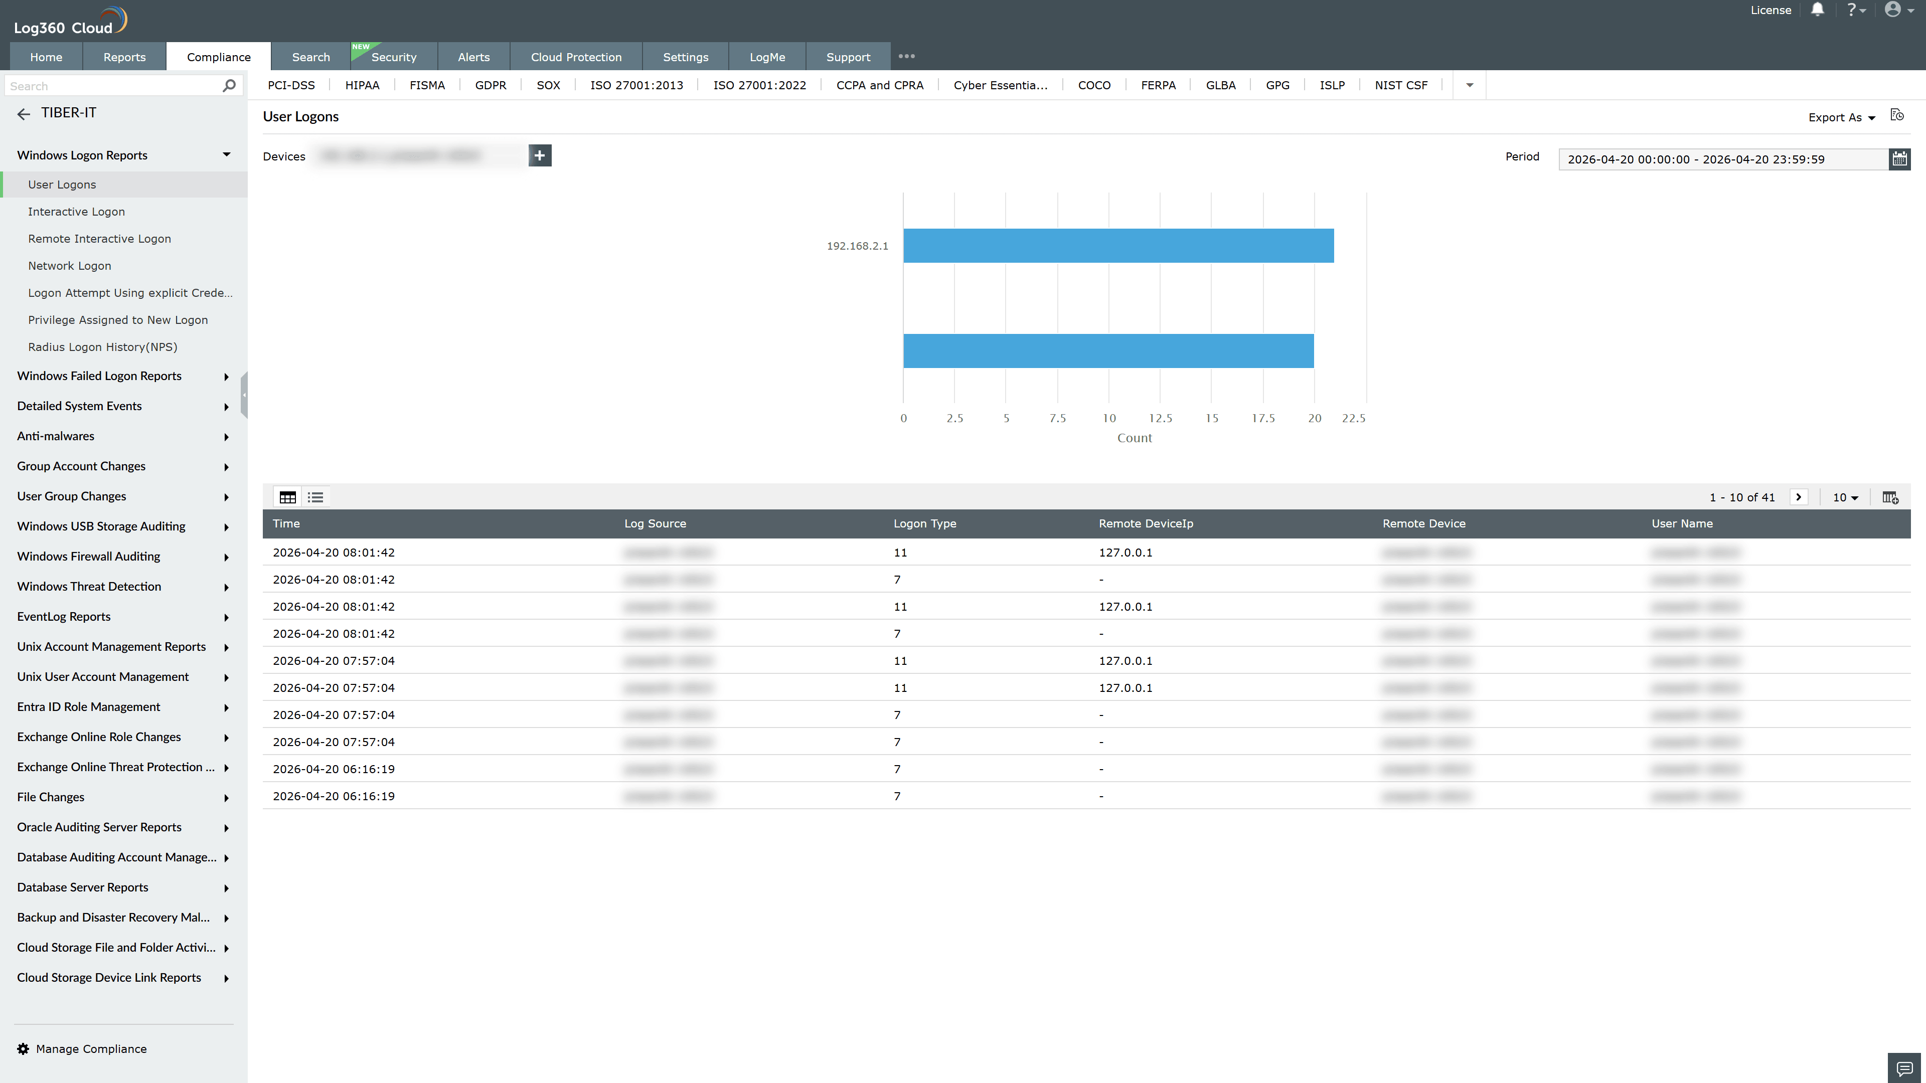
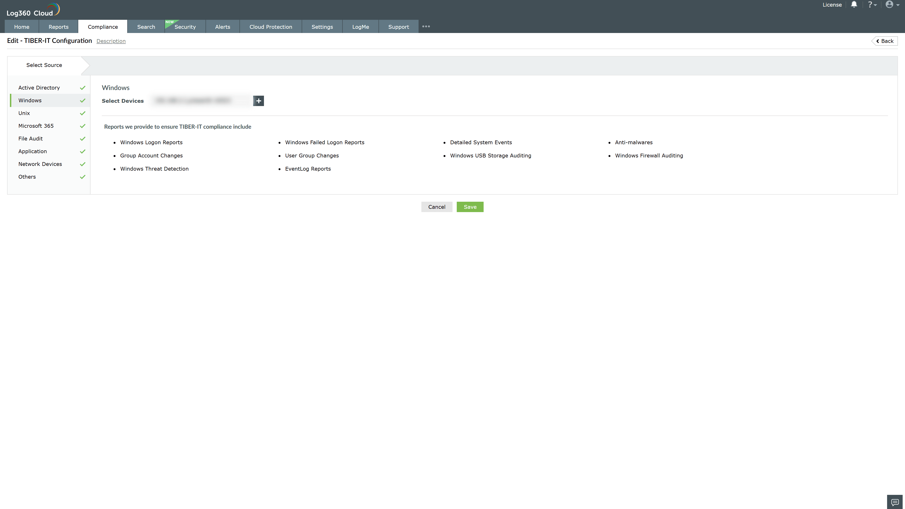
Valid Submission : Yes
Supported Editions : Free, Basic, Standard, Professional, MSSP
Help Document : https://www.manageengine.com/log-management/help/integrations/compliance-extensions.html
Help Video : Not provided
Tags : Log360, Compliance, Privacy monitoring, Data privacy, Regulatory compliance
Supported DCs : US, IN, JP, CA, AU, UK and EU
Privacy Policy:
Terms of Service:
Release Notes:
Predefined reports for the TIBER-IT Compliance

