Turkish Cybersecurity Law No 7545 Compliance for Log360
Tagline: Align with Turkey's cybersecurity legislation using incident reporting capabilities from Log360.

Overview
The Turkish Cybersecurity Law No. 7545 (2025) Compliance extension for Log360 helps Turkish organizations subject to the new national cybersecurity law meet its requirements for security monitoring, incident reporting, and data protection.
Log360 collects and correlates logs from IT systems, cloud platforms, network devices, and identity services, providing continuous visibility into security events. Compliance and security teams can detect incidents within the mandatory reporting windows, maintain audit trails, and generate documentation to demonstrate compliance to the Turkish National Cyber Incidents Response Centre (USOM) and the Information and Communication Technologies Authority (BTK).

Key Features
- Generate audit reports aligned to Turkish Cybersecurity Law 7545 requirements covering access control, incident detection, and network security monitoring.
- Detect and classify cyber threats in real time with automated incident severity assessment and notification.
- Monitor privileged user activities, authentication events, and critical system changes across Turkish regulated organizations.
- Export compliance documentation in PDF and CSV formats for BTK and USOM regulatory submissions and internal governance reporting.
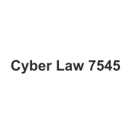
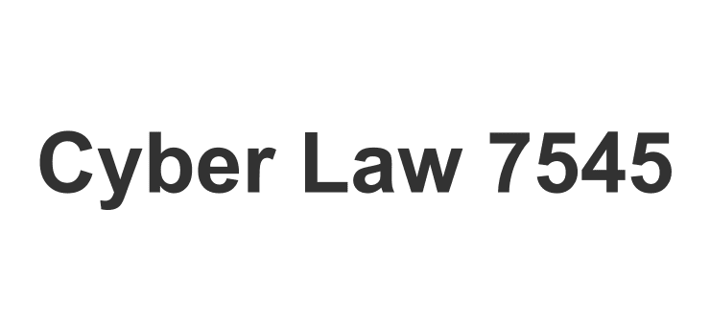

Screenshots
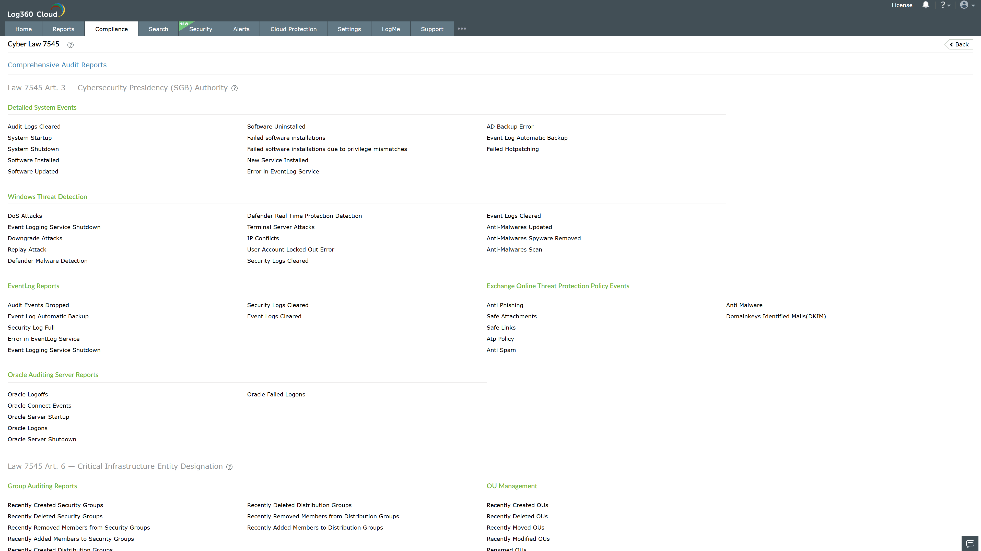
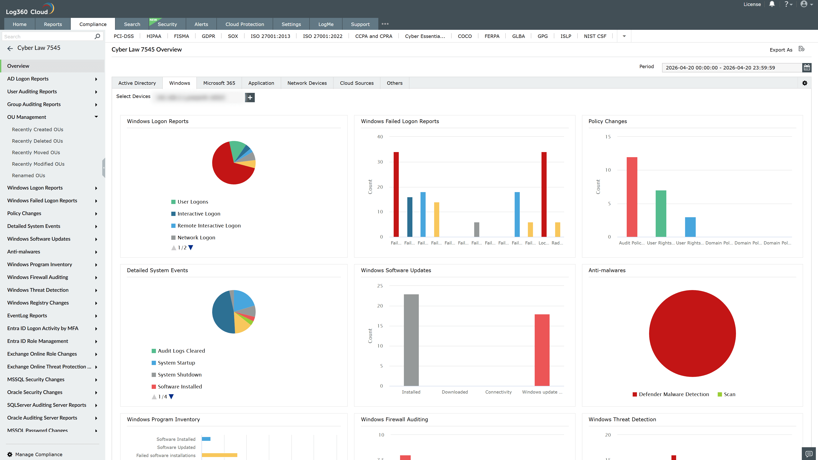
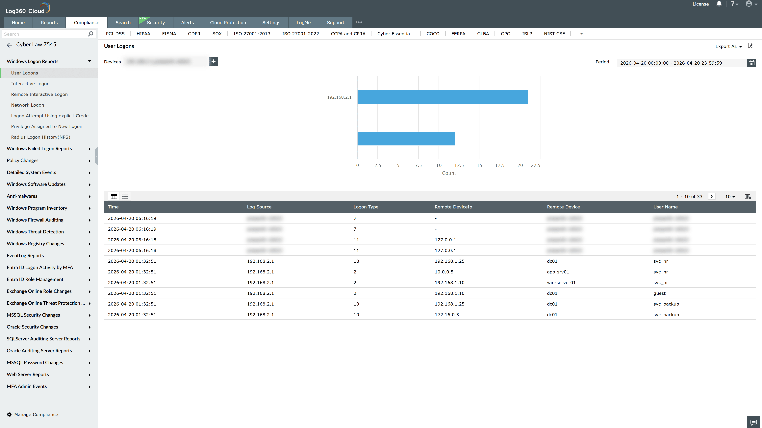
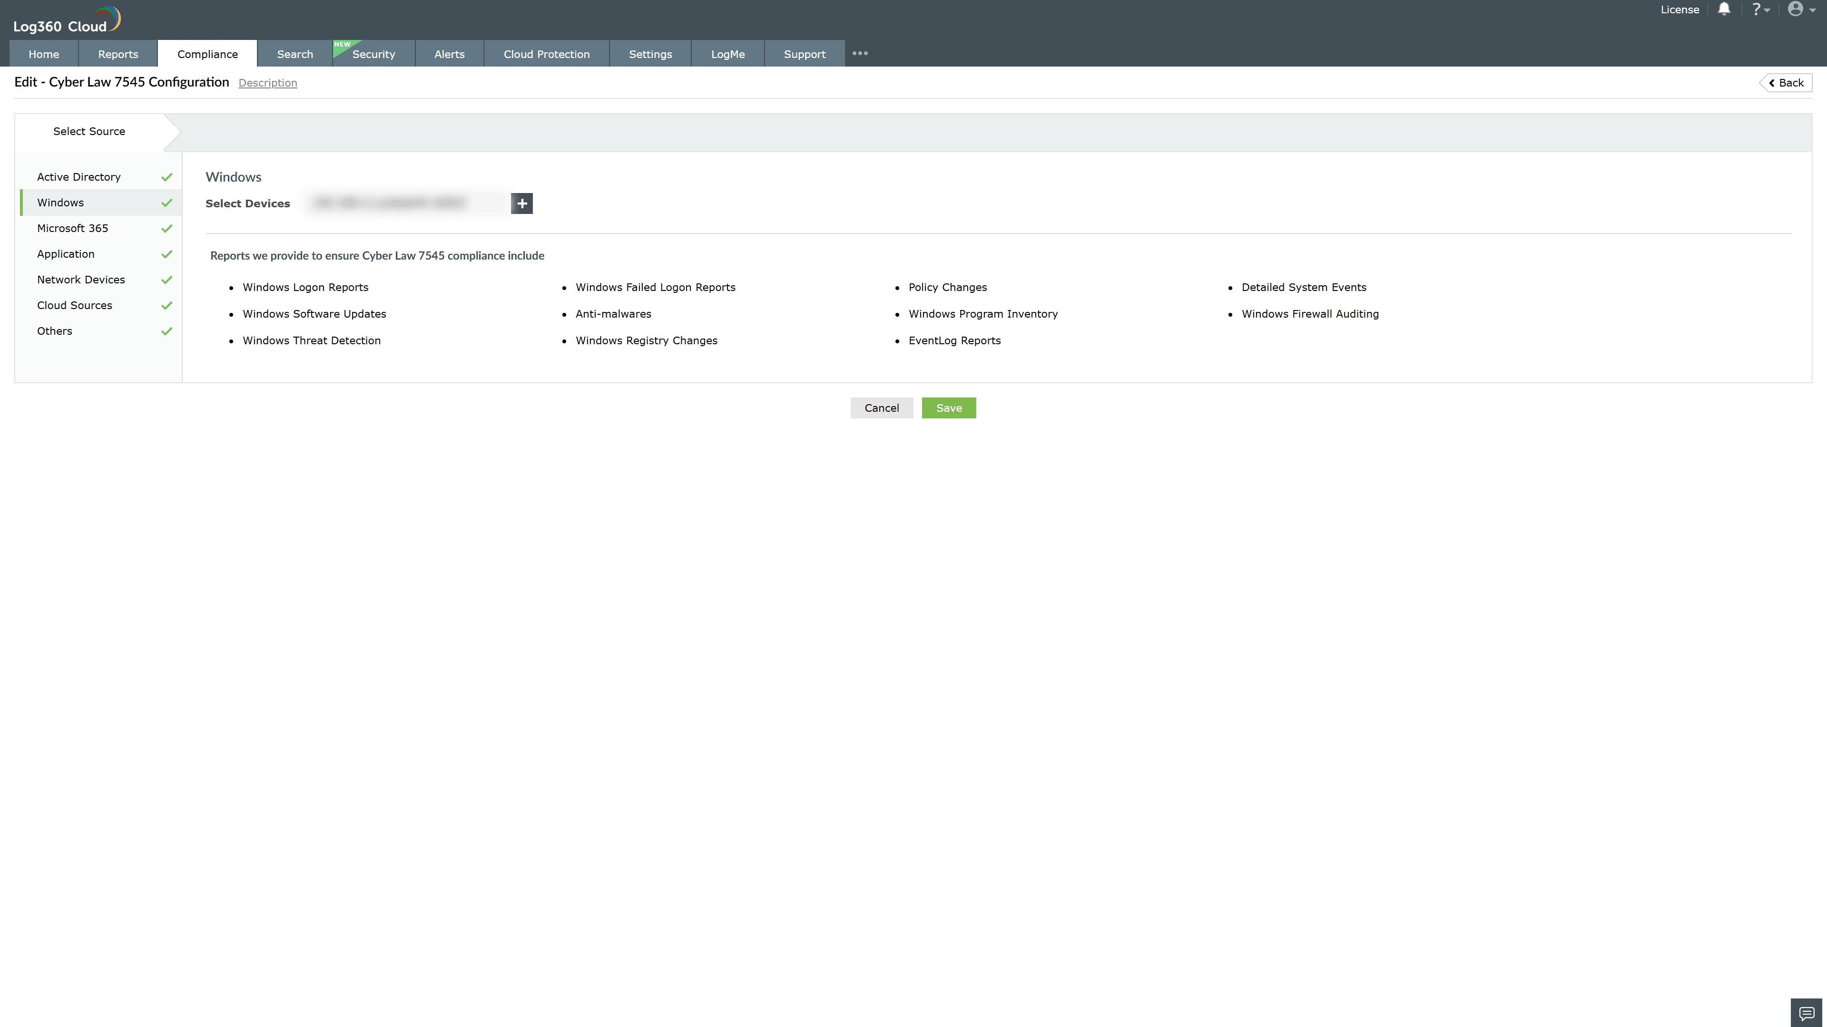
Valid Submission : Yes
Supported Editions : Free, Basic, Standard, Professional, MSSP
Help Document : https://www.manageengine.com/log-management/help/integrations/compliance-extensions.html
Help Video : Not provided
Tags : Log360, Compliance, Privacy monitoring, Data privacy, Regulatory compliance
Supported DCs : US, IN, JP, CA, AU, UK and EU
Privacy Policy:
Terms of Service:
Release Notes:
Predefined reports for the Cyber Law 7545 Compliance

