Turkish Internet Publications Regulation Compliance for Log360
Tagline: Meet Turkey's internet platform security obligations with monitoring from Log360.

Overview
The Turkish Internet Publications Regulation (Law No. 5651) Compliance extension for Log360 helps Turkish internet service providers, social media platforms, and digital content hosts meet the data retention, access audit, and security monitoring obligations under Turkey's Internet Publications Regulation.
Log360 collects and analyzes logs from web platforms, content management systems, cloud environments, and identity services, providing security teams with visibility into user access and data processing events. Compliance teams can maintain audit trails for BTK and judicial authority requirements and generate documentation for data access requests.

Key Features
- Generate predefined compliance reports covering Law 5651 data retention and access monitoring requirements for internet service and social media platform operators.
- Monitor platform access events, user authentication logs, and data handling activities to maintain the audit trails required under BTK retention obligations.
- Configure alerts for security events relevant to platform operator obligations, including unauthorized administrative access and data exfiltration indicators.
- Export compliance documentation in PDF and CSV formats for BTK regulatory submissions and responses to judicial data access orders.



Screenshots
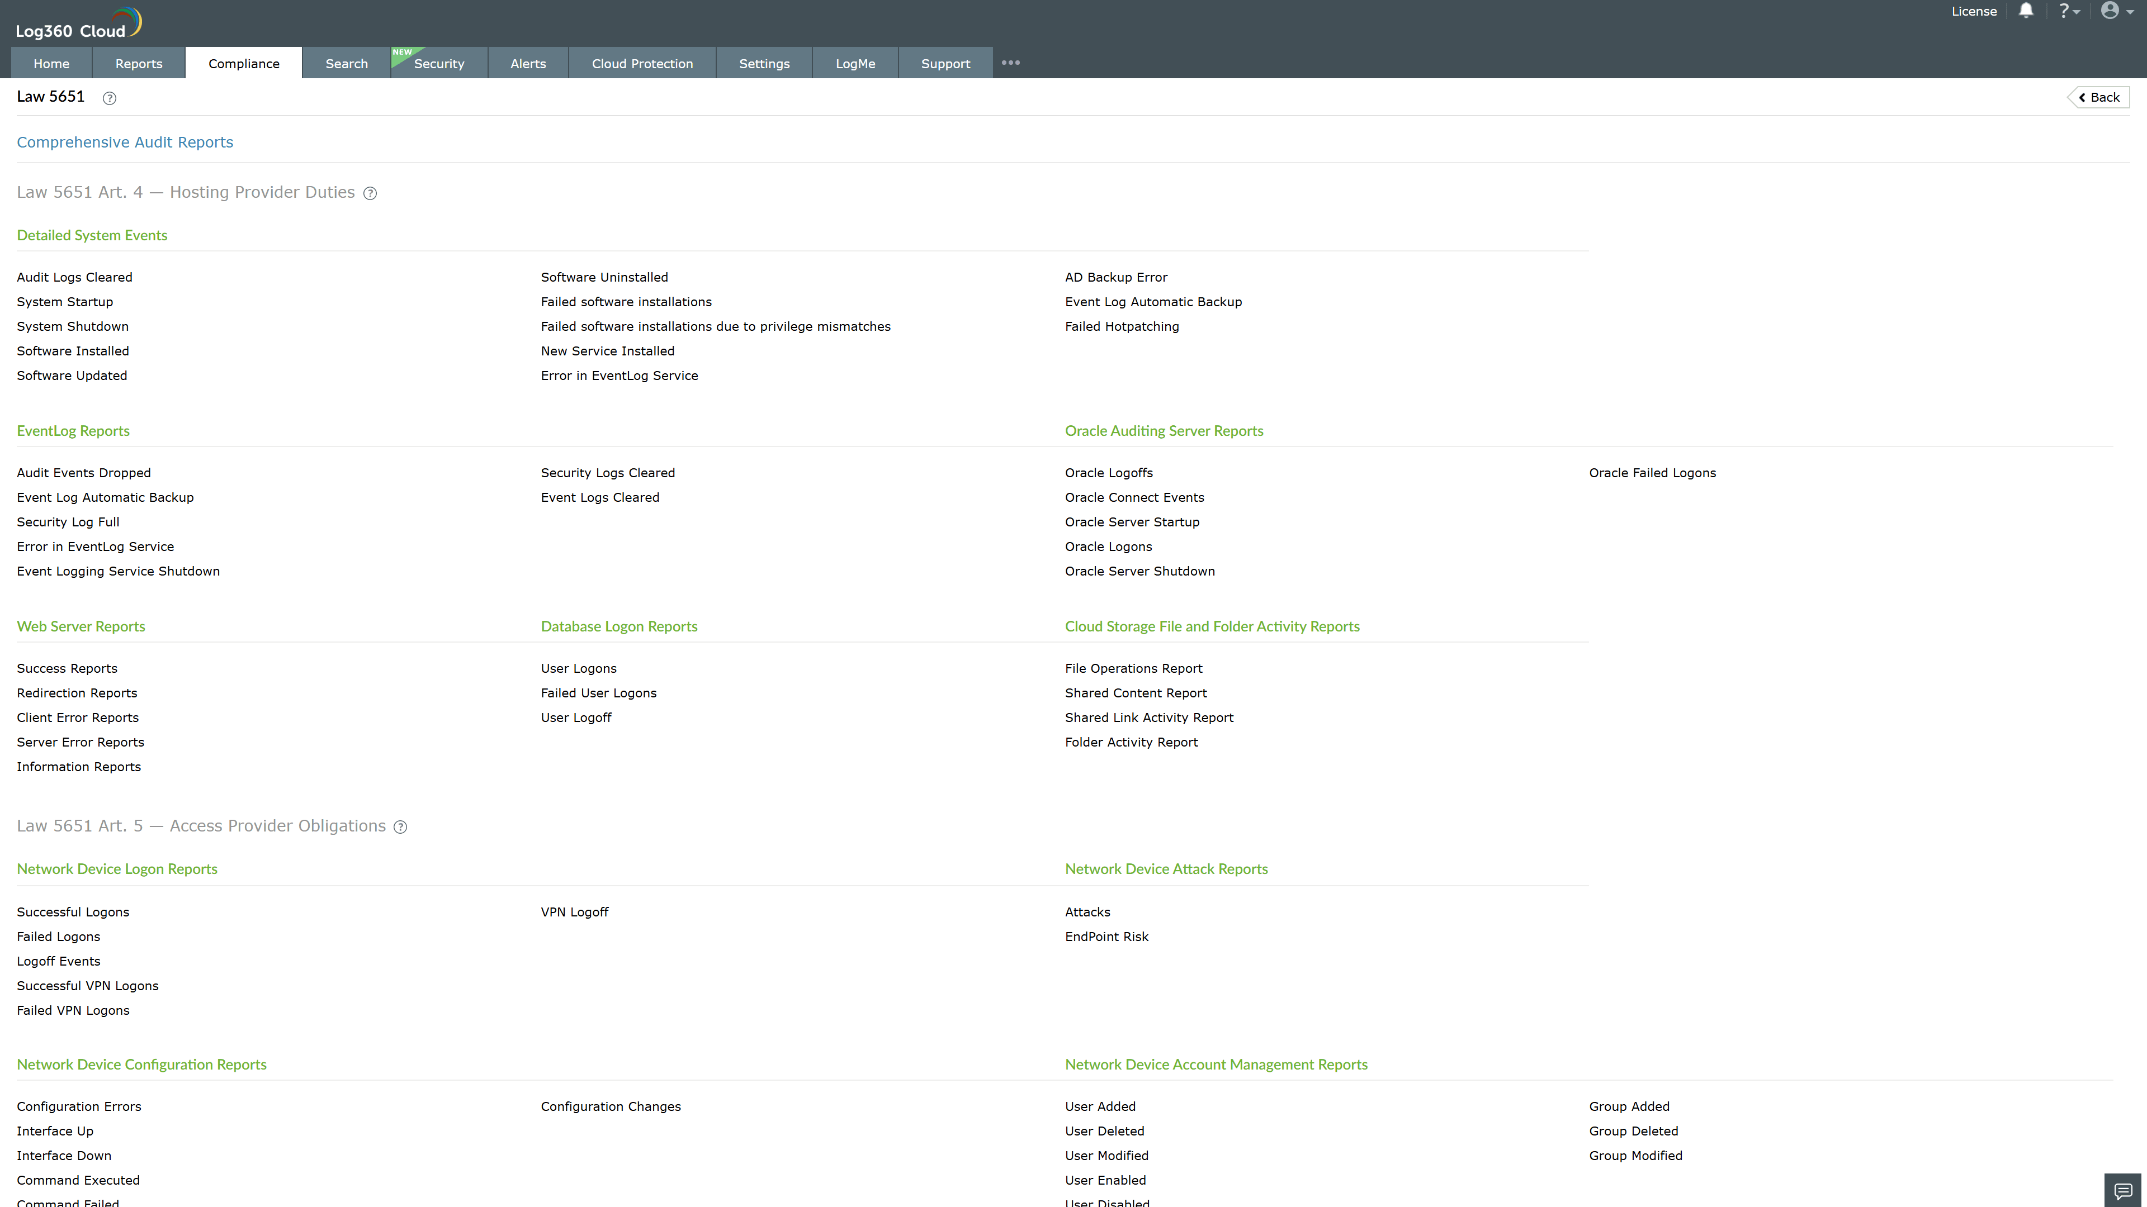
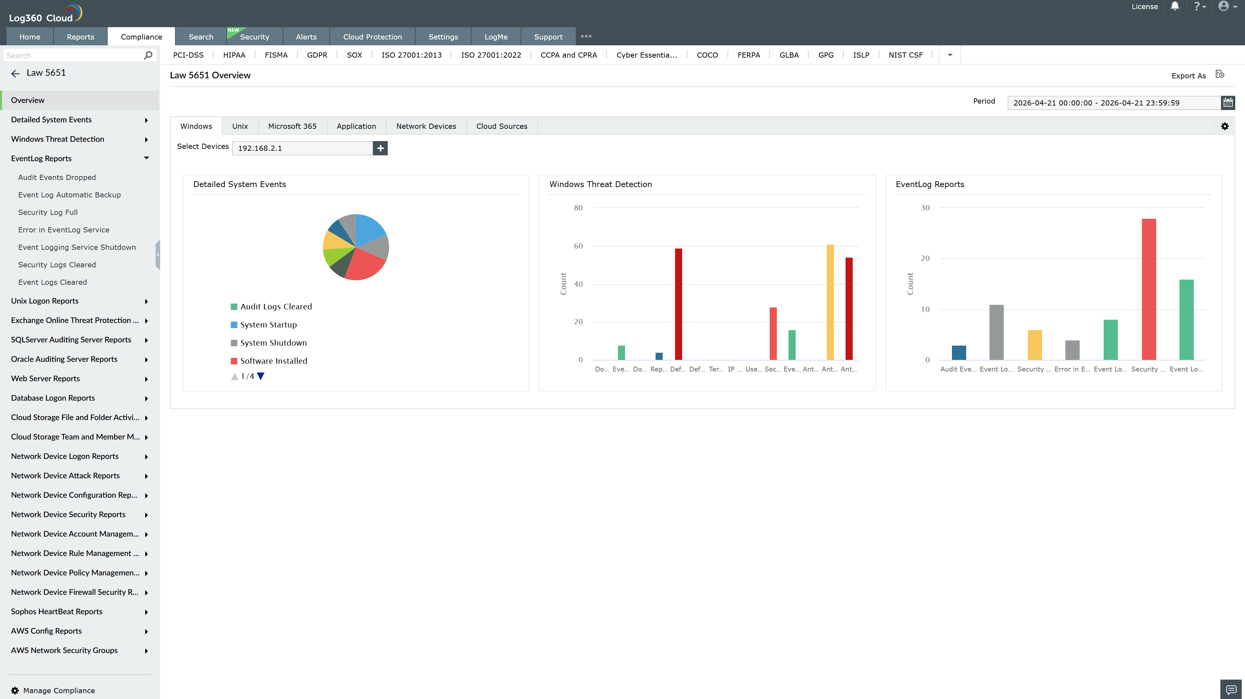
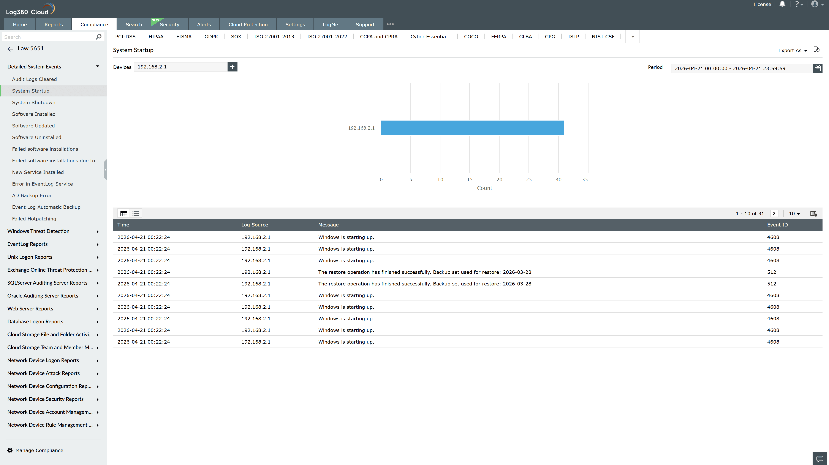
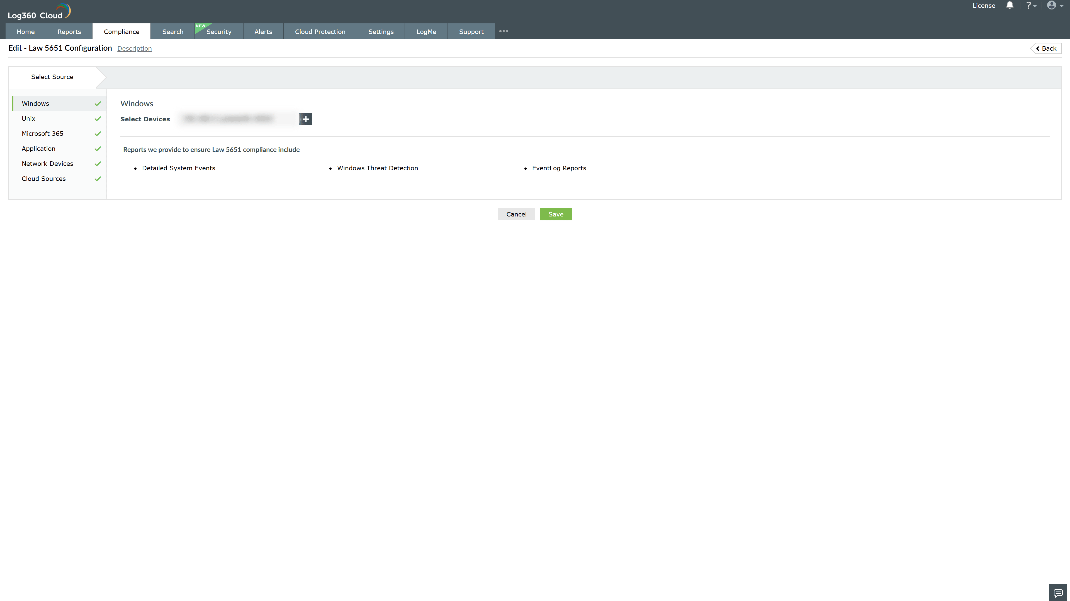
Valid Submission : Yes
Supported Editions : Free, Basic, Standard, Professional, MSSP
Help Document : https://www.manageengine.com/log-management/help/integrations/compliance-extensions.html
Help Video : Not provided
Tags : Log360, Compliance, Privacy monitoring, Data privacy, Regulatory compliance
Supported DCs : US, IN, JP, CA, AU, UK and EU
Privacy Policy:
Terms of Service:
Release Notes:
Predefined reports for the Law 5651 Compliance

