UAE CMA-SCA Virtual Asset Platform Regulation Compliance for Log360
Tagline: Align with UAE capital markets and virtual asset regulations using security monitoring from Log360.

Overview
The UAE CMA/SCA Virtual Asset Platform Regulation Compliance extension for Log360 helps UAE-regulated virtual asset platforms and exchanges meet the cybersecurity, technology risk management, and audit requirements of the Securities and Commodities Authority's virtual asset regulatory framework.
Log360 continuously monitors logs from virtual asset trading systems, wallet management platforms, cloud environments, and identity services, providing compliance and security teams with visibility into cyber risk events and regulatory control activities. Teams can detect threats, maintain forensic evidence, and generate SCA-ready audit reports.

Key Features
- Generate predefined compliance reports covering SCA virtual asset platform requirements including access management, security monitoring, and incident detection.
- Monitor virtual asset platform events in real time, detecting unauthorized access attempts, suspicious trading activity patterns, and data exfiltration indicators.
- Automatically map security events across virtual asset platforms to SCA control requirements, reducing manual audit effort and ensuring continuous compliance posture visibility.
- Export compliance evidence in PDF and CSV formats for SCA supervisory submissions and internal virtual asset risk governance.



Screenshots
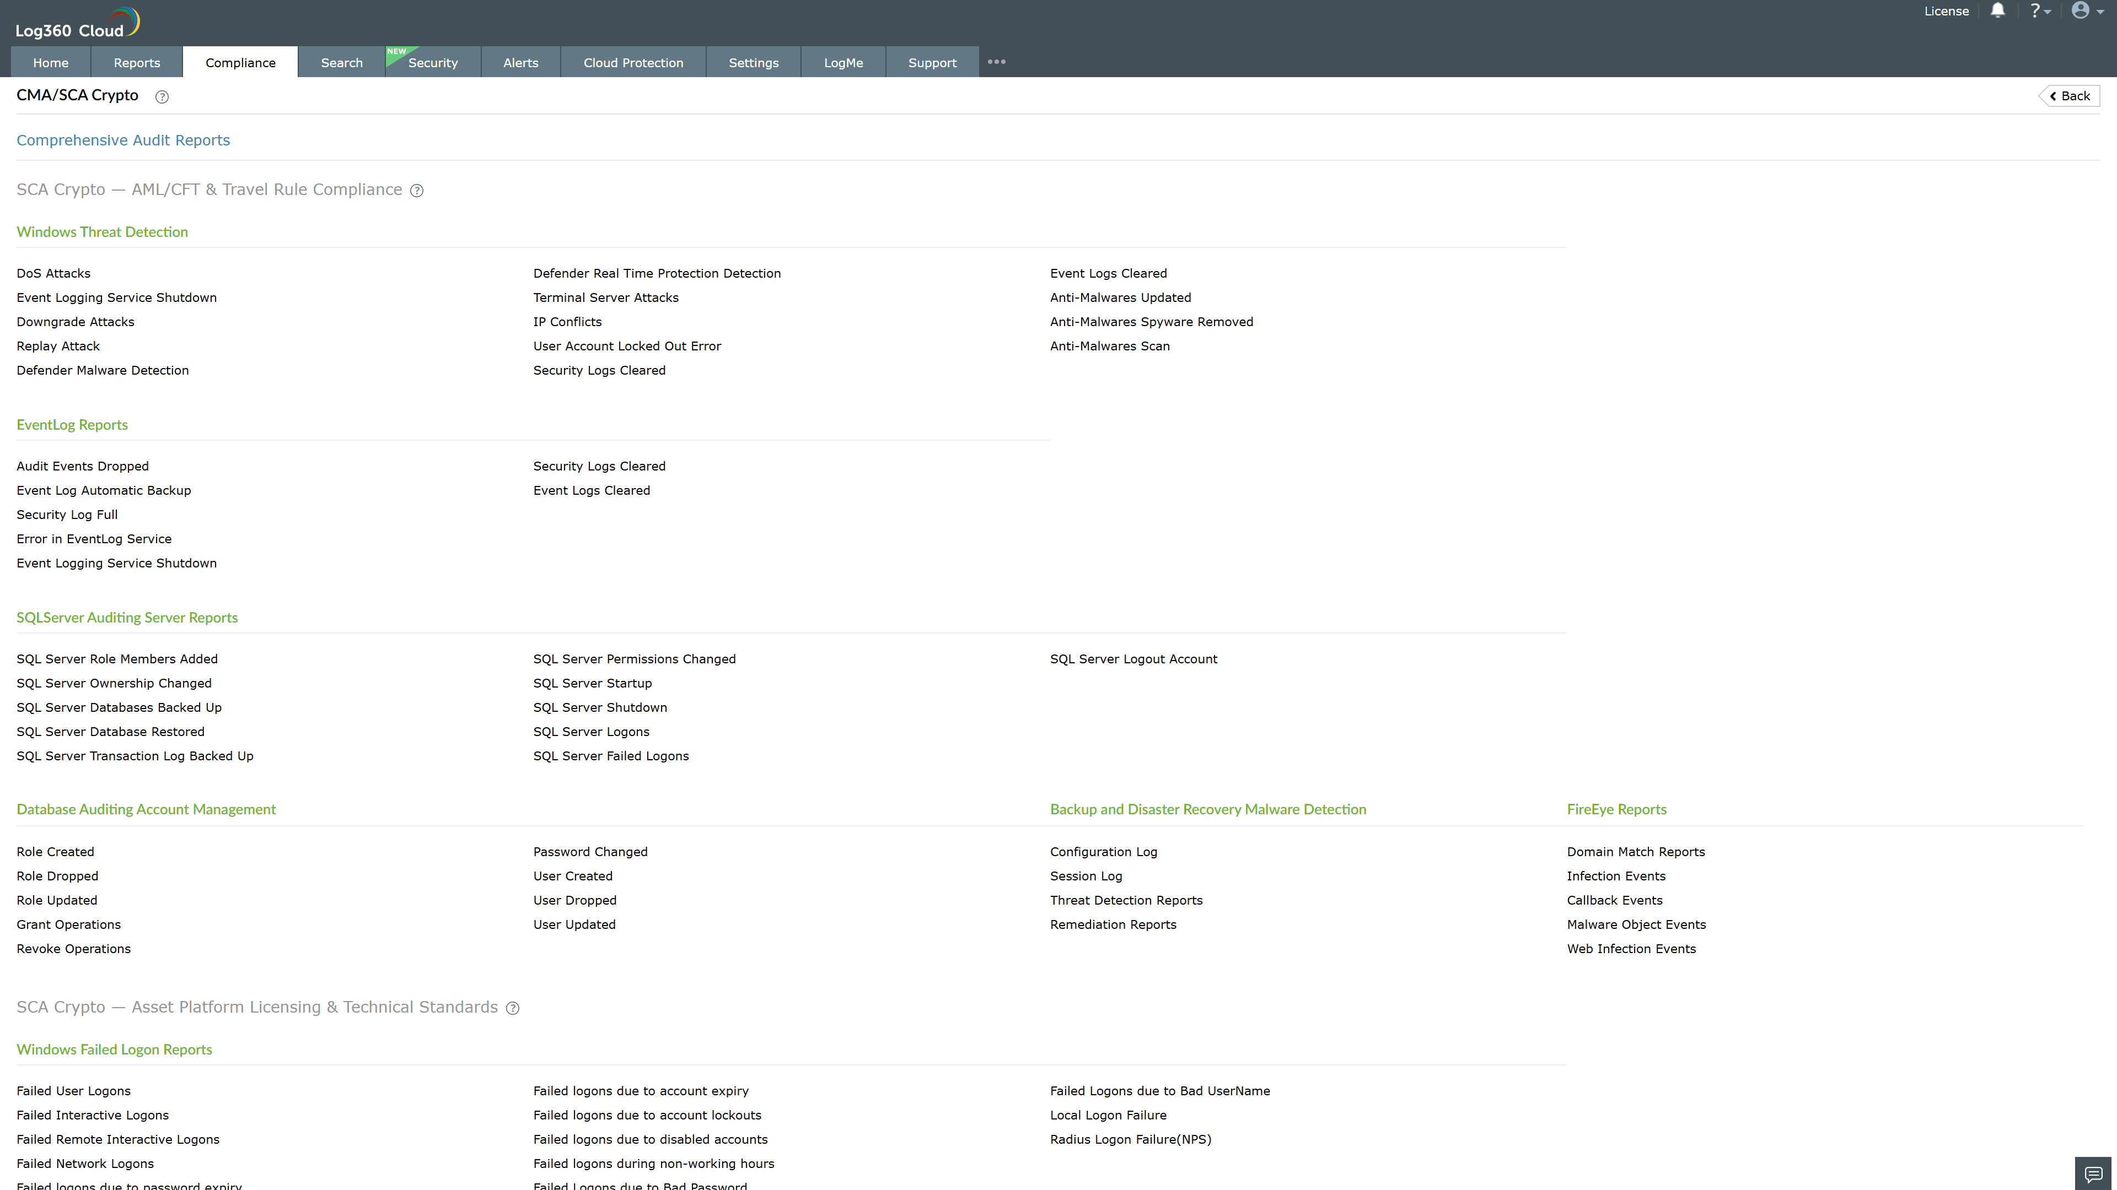
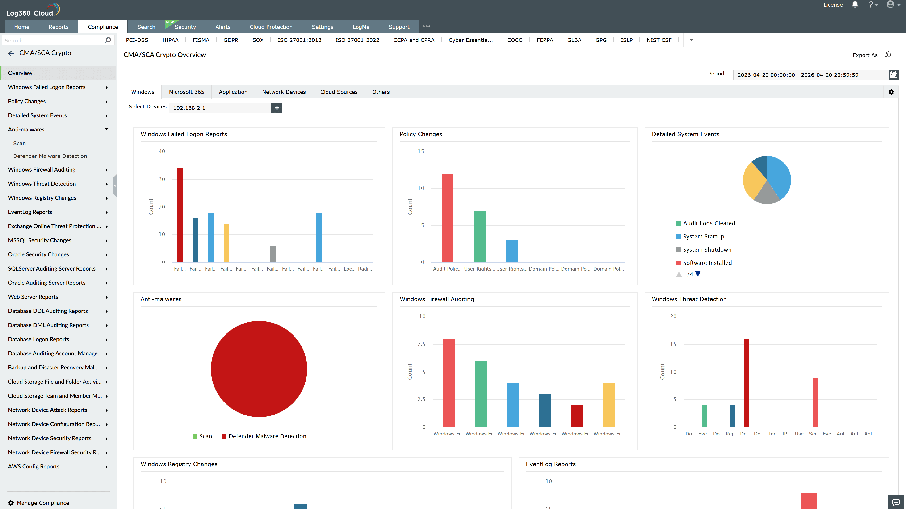
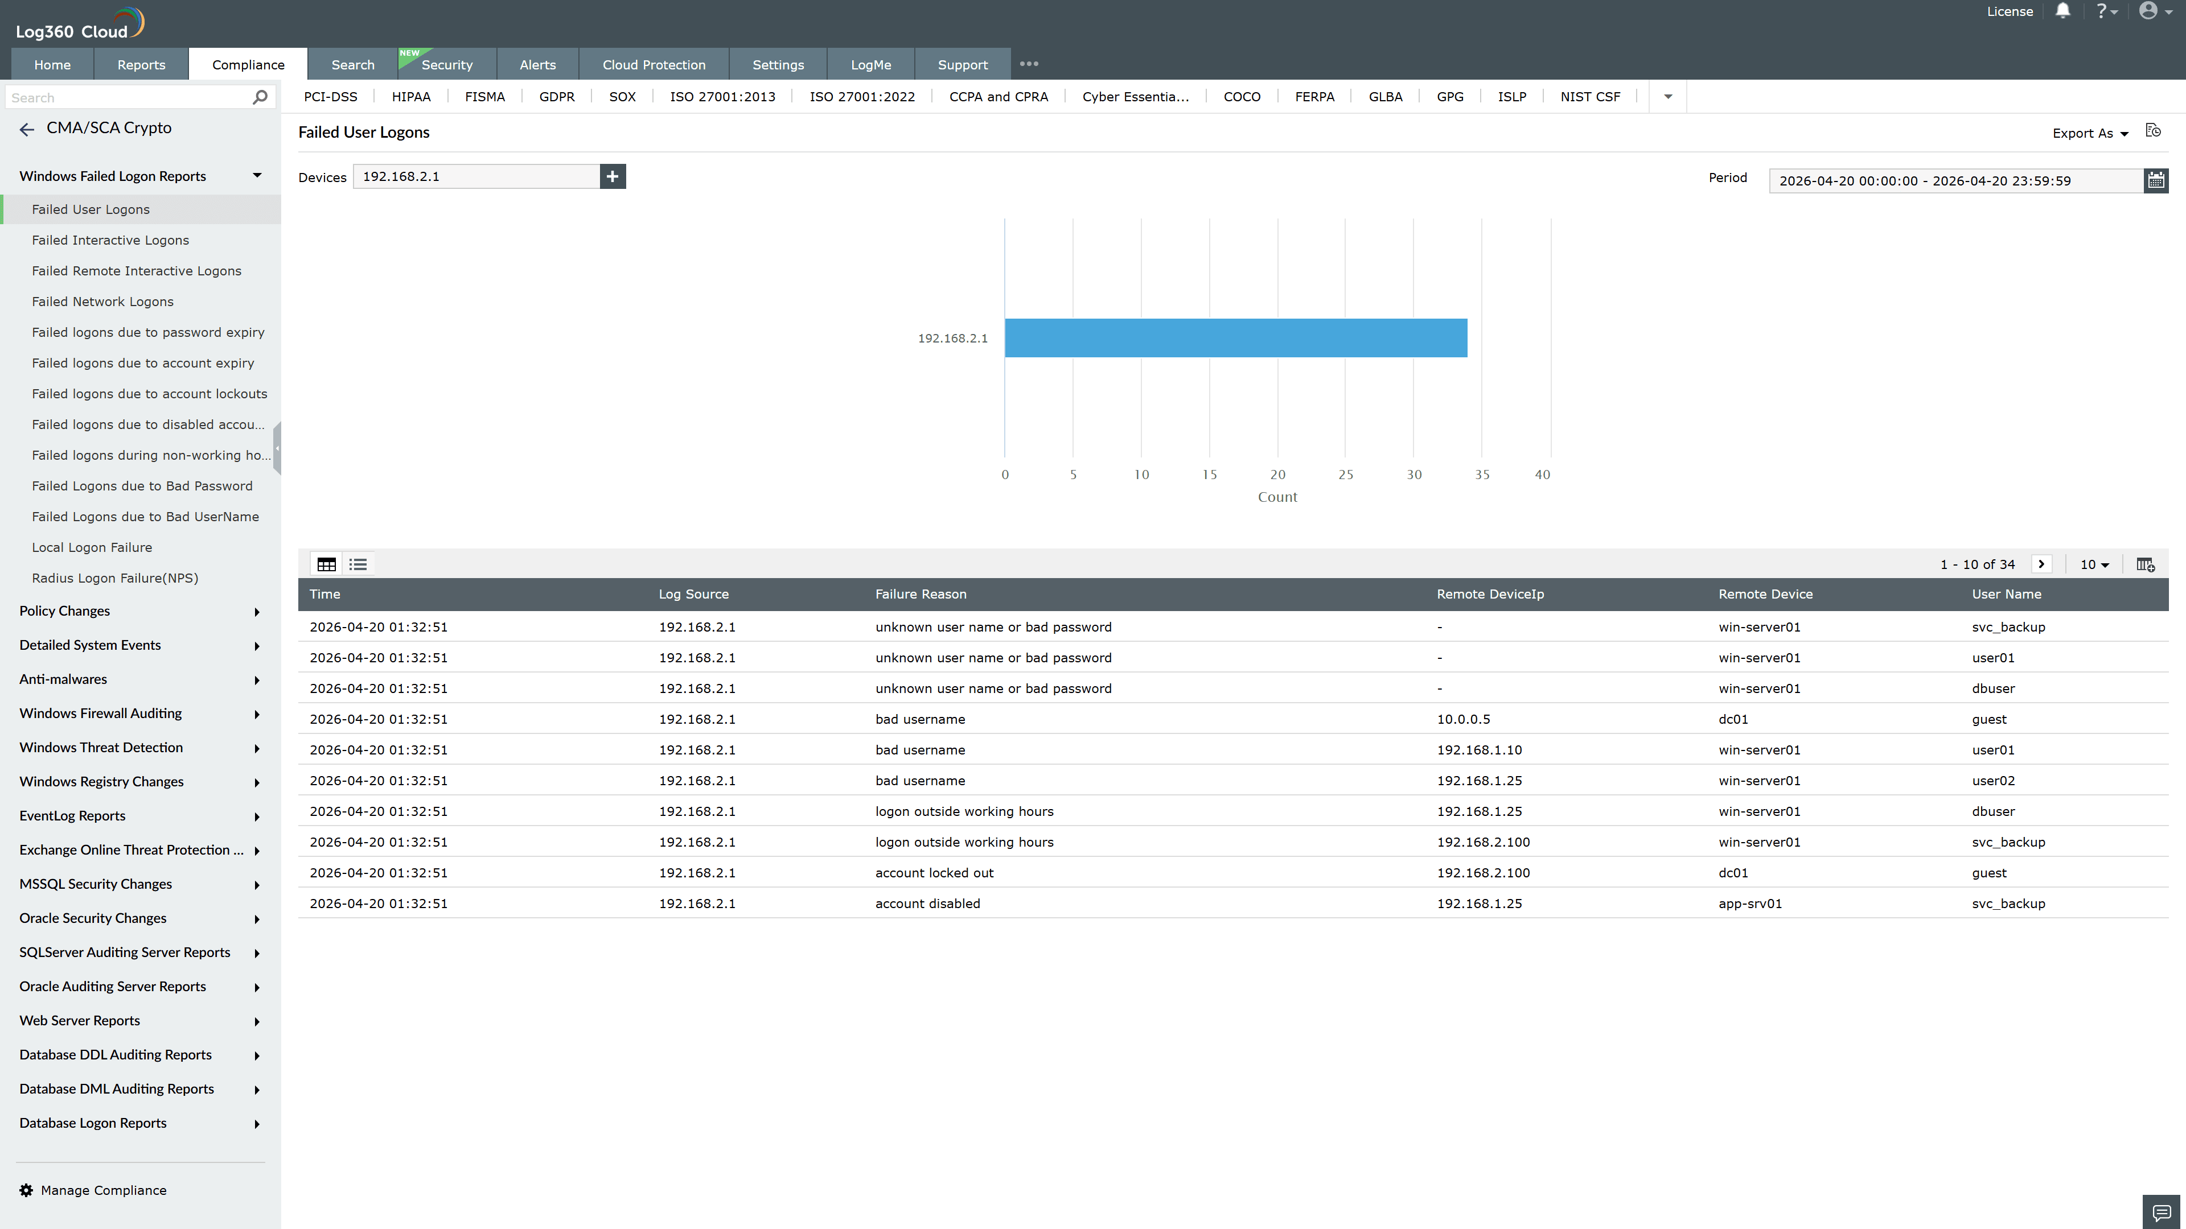
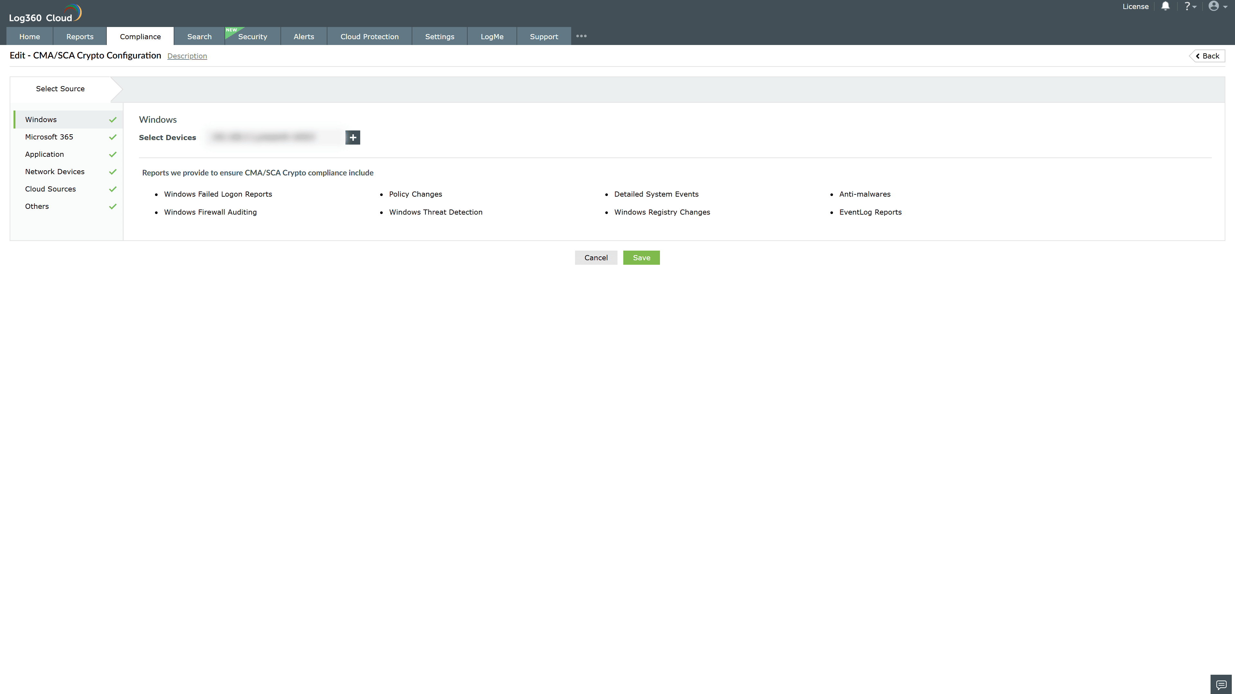
Valid Submission : Yes
Supported Editions : Free, Basic, Standard, Professional, MSSP
Help Document : https://www.manageengine.com/log-management/help/integrations/compliance-extensions.html
Help Video : Not provided
Tags : Log360, Compliance, Privacy monitoring, Data privacy, Regulatory compliance
Supported DCs : US, IN, JP, CA, AU, UK and EU
Privacy Policy:
Terms of Service:
Release Notes:
Predefined reports for the UAE CMA Compliance

