UAE Federal AML-CFT Law Compliance for Log360
Tagline: Support AML/CFT obligations and financial crime monitoring under UAE Decree-Law 20/2018 with Log360.

Overview
The UAE Federal AML/CFT Law (Decree-Law 20/2018) Compliance extension for Log360 helps UAE-regulated financial institutions and designated non-financial businesses meet the transaction monitoring, access audit, and reporting obligations related to anti-money laundering and counter-terrorism financing.
Log360 collects and correlates logs from financial systems, customer databases, cloud platforms, and identity services, supporting compliance teams in detecting suspicious access patterns and maintaining audit trails required for CBUAE and FATF reporting. Security teams can investigate anomalies and generate documentation for financial intelligence disclosures.

Key Features
- Generate compliance reports covering AML/CFT-relevant IT controls including access to financial databases, user authentication events, and transaction system monitoring.
- Monitor access to customer financial records and detect unusual data queries, exports, or modifications that may indicate financial crime enablement.
- Configure alerts for AML/CFT-relevant security events such as unauthorized access to transaction systems and privilege escalations in financial applications.
- Export audit evidence in PDF and CSV formats for CBUAE examinations, internal AML compliance officer records, and financial intelligence unit submissions.
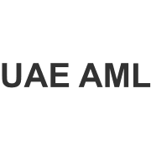
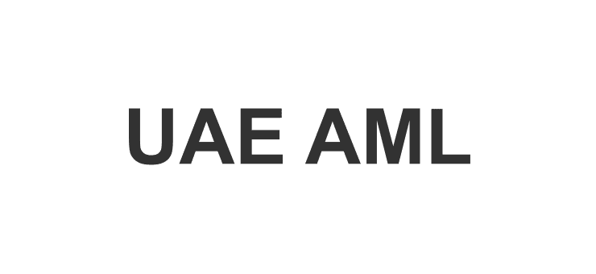

Screenshots
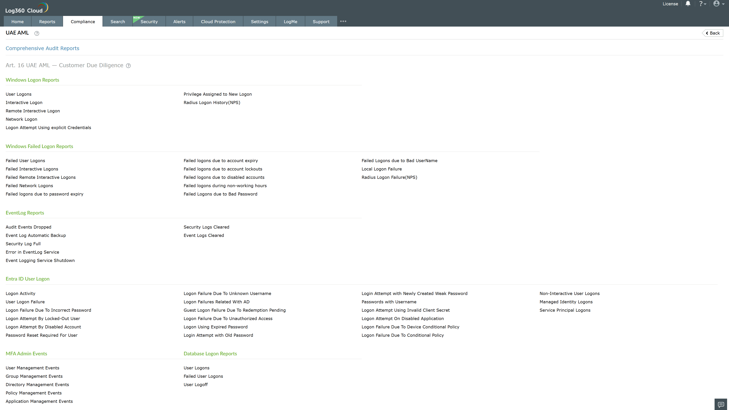
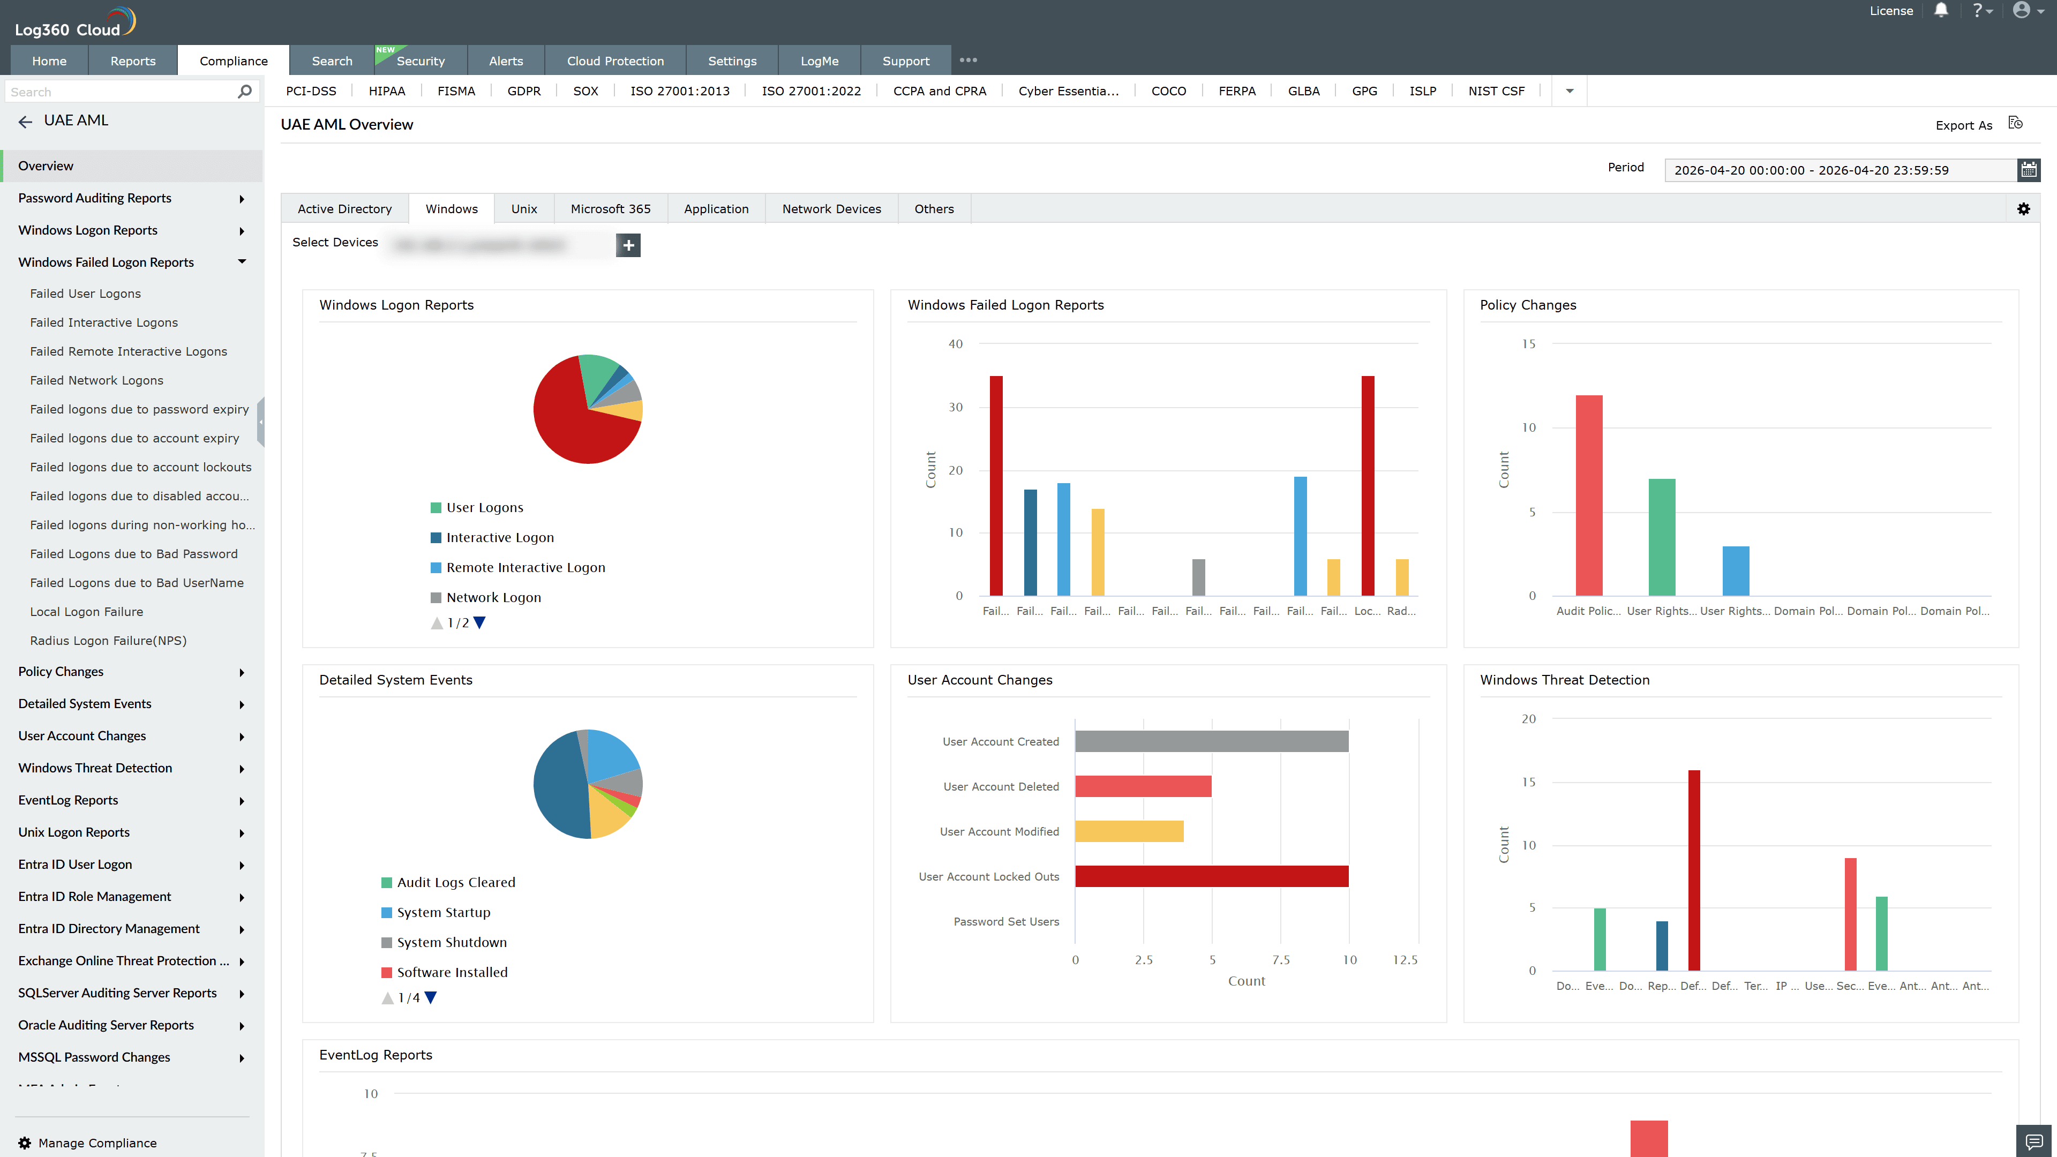
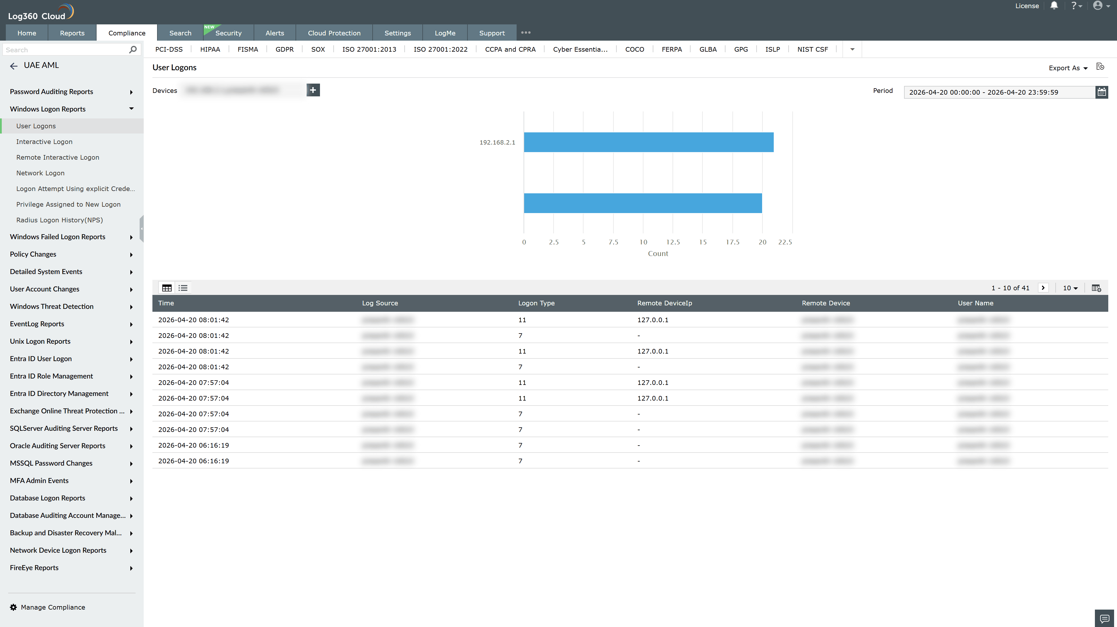
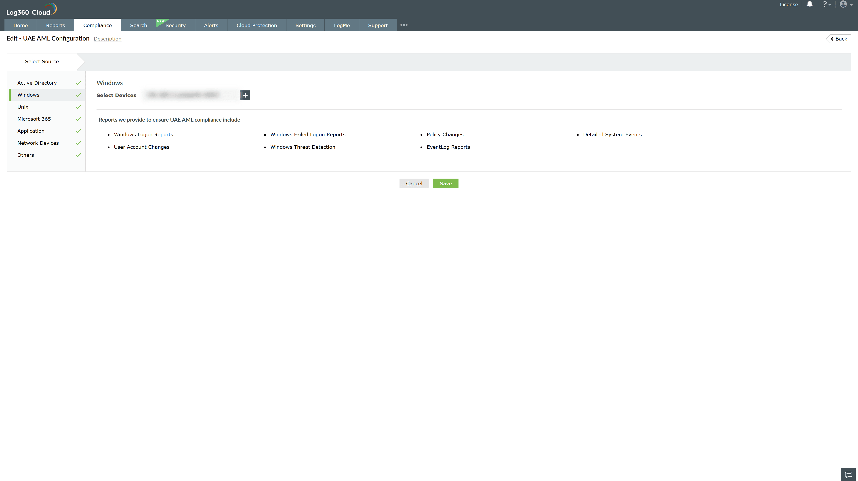
Valid Submission : Yes
Supported Editions : Free, Basic, Standard, Professional, MSSP
Help Document : https://www.manageengine.com/log-management/help/integrations/compliance-extensions.html
Help Video : Not provided
Tags : Log360, Compliance, Privacy monitoring, Data privacy, Regulatory compliance
Supported DCs : US, IN, JP, CA, AU, UK and EU
Privacy Policy:
Terms of Service:
Release Notes:
Predefined reports for the AML Compliance

