UAE Federal Cybercrime Law Compliance for Log360
Tagline: Detect cybercrimes covered under UAE Decree-Law 34/2021 with real-time monitoring from Log360.

Overview
The UAE Federal Cybercrime Law (Decree-Law 34/2021) Compliance extension for Log360 helps UAE organizations detect, investigate, and document cybercrime incidents as defined under Federal Decree-Law 34/2021.
Log360 monitors logs from network infrastructure, endpoints, cloud services, and identity platforms, correlating events to surface indicators of unauthorized system access, data theft, and electronic fraud. Security teams can rapidly investigate incidents, preserve forensic evidence, and generate the audit trails required when reporting cybercrimes to UAE authorities.

Key Features
- Generate predefined reports covering cybercrime indicators such as unauthorized system access, credential abuse, data interception, and electronic fraud events.
- Continuously monitor user activity, network traffic, and system events across your environment to detect threat patterns aligned with UAE cybercrime offence categories, enabling faster investigation and response.
- Maintain tamper-evident audit logs and forensic evidence chains to support cybercrime investigations and coordination with UAE law enforcement.
- Export incident documentation in PDF and CSV formats for submission to UAE authorities and internal legal and compliance teams.
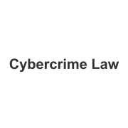
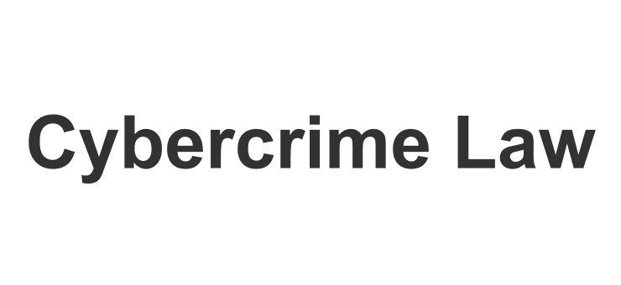

Screenshots
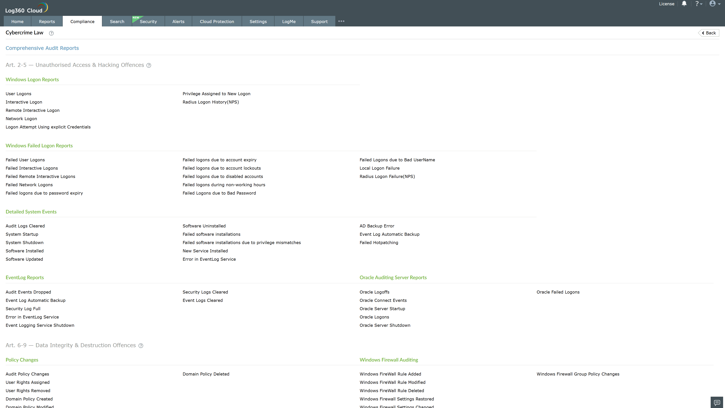
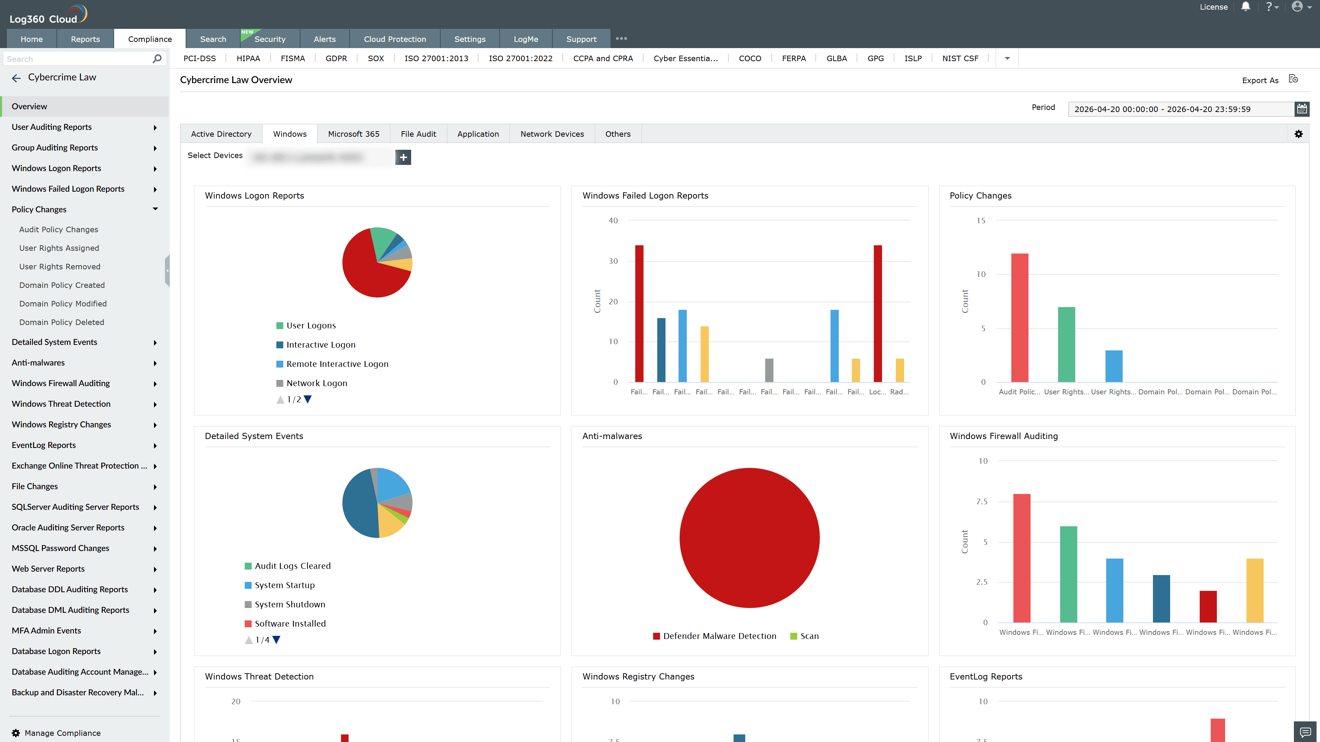
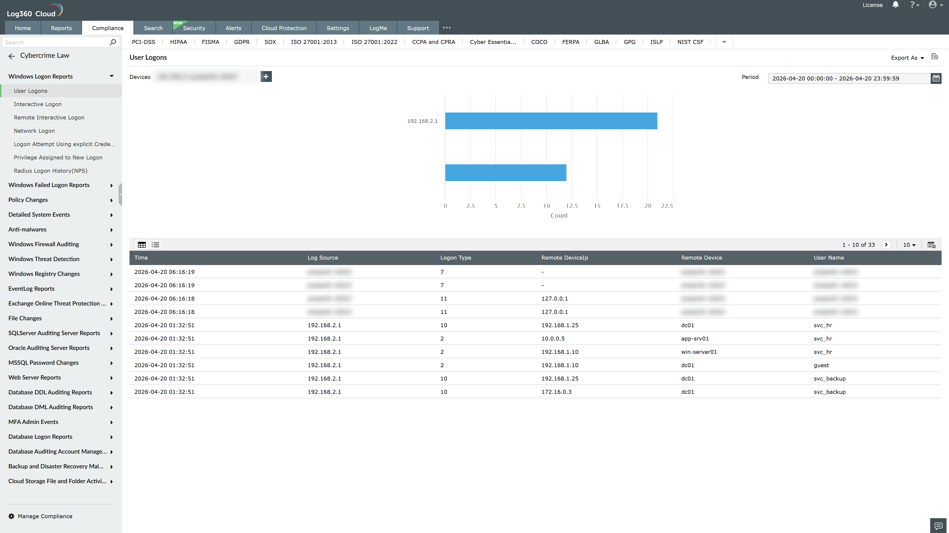
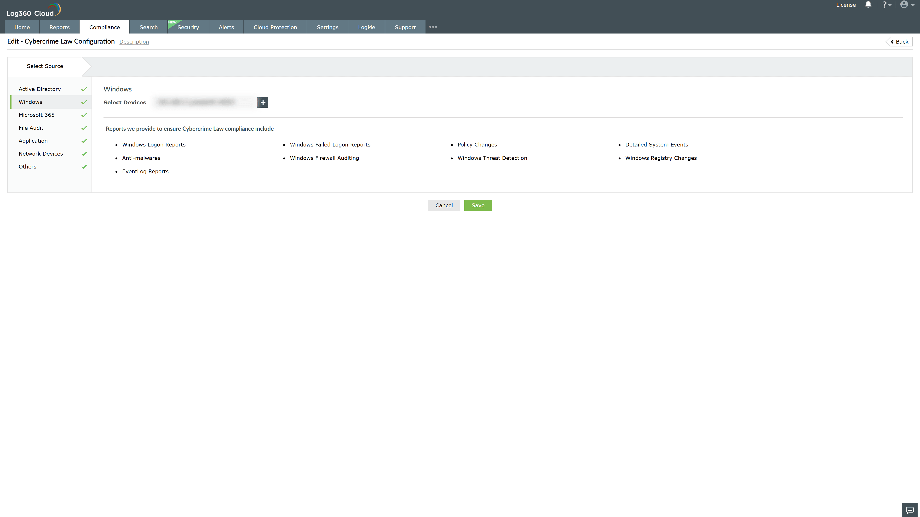
Valid Submission : Yes
Supported Editions : Free, Basic, Standard, Professional, MSSP
Help Document : https://www.manageengine.com/log-management/help/integrations/compliance-extensions.html
Help Video : Not provided
Tags : Log360, Compliance, Privacy monitoring, Data privacy, Regulatory compliance
Supported DCs : US, IN, JP, CA, AU, UK and EU
Privacy Policy:
Terms of Service:
Release Notes:
Predefined reports for the Cybercrime Law Compliance

