VAIT Compliance for Log360
Tagline: Satisfy BaFin's IT requirements for companies with security monitoring from Log360.

Overview
The VAIT (BaFin Supervisory Requirements for IT in Insurance) Compliance extension for Log360 supports German insurance undertakings in meeting BaFin's requirements for IT governance, access management, and information security management as outlined in VAIT.
Log360 ingests and correlates logs from insurance policy systems, cloud environments, network devices, and identity platforms, enabling continuous monitoring of IT security controls. Security and compliance teams can detect policy violations, investigate incidents, and generate audit documentation aligned to BaFin's VAIT expectations.

Key Features
- Generate VAIT-aligned audit reports covering IT security controls including access management, incident detection, and system integrity monitoring.
- Monitor user access to policyholder data, detect unauthorized system changes, and track privileged operations across insurance IT environments.
- Configure real-time alerts for VAIT-critical events such as unauthorized access to core insurance systems, privilege escalations, and audit log tampering.
- Export compliance evidence in PDF and CSV formats for BaFin supervisory reviews and internal IT governance audits.



Screenshots
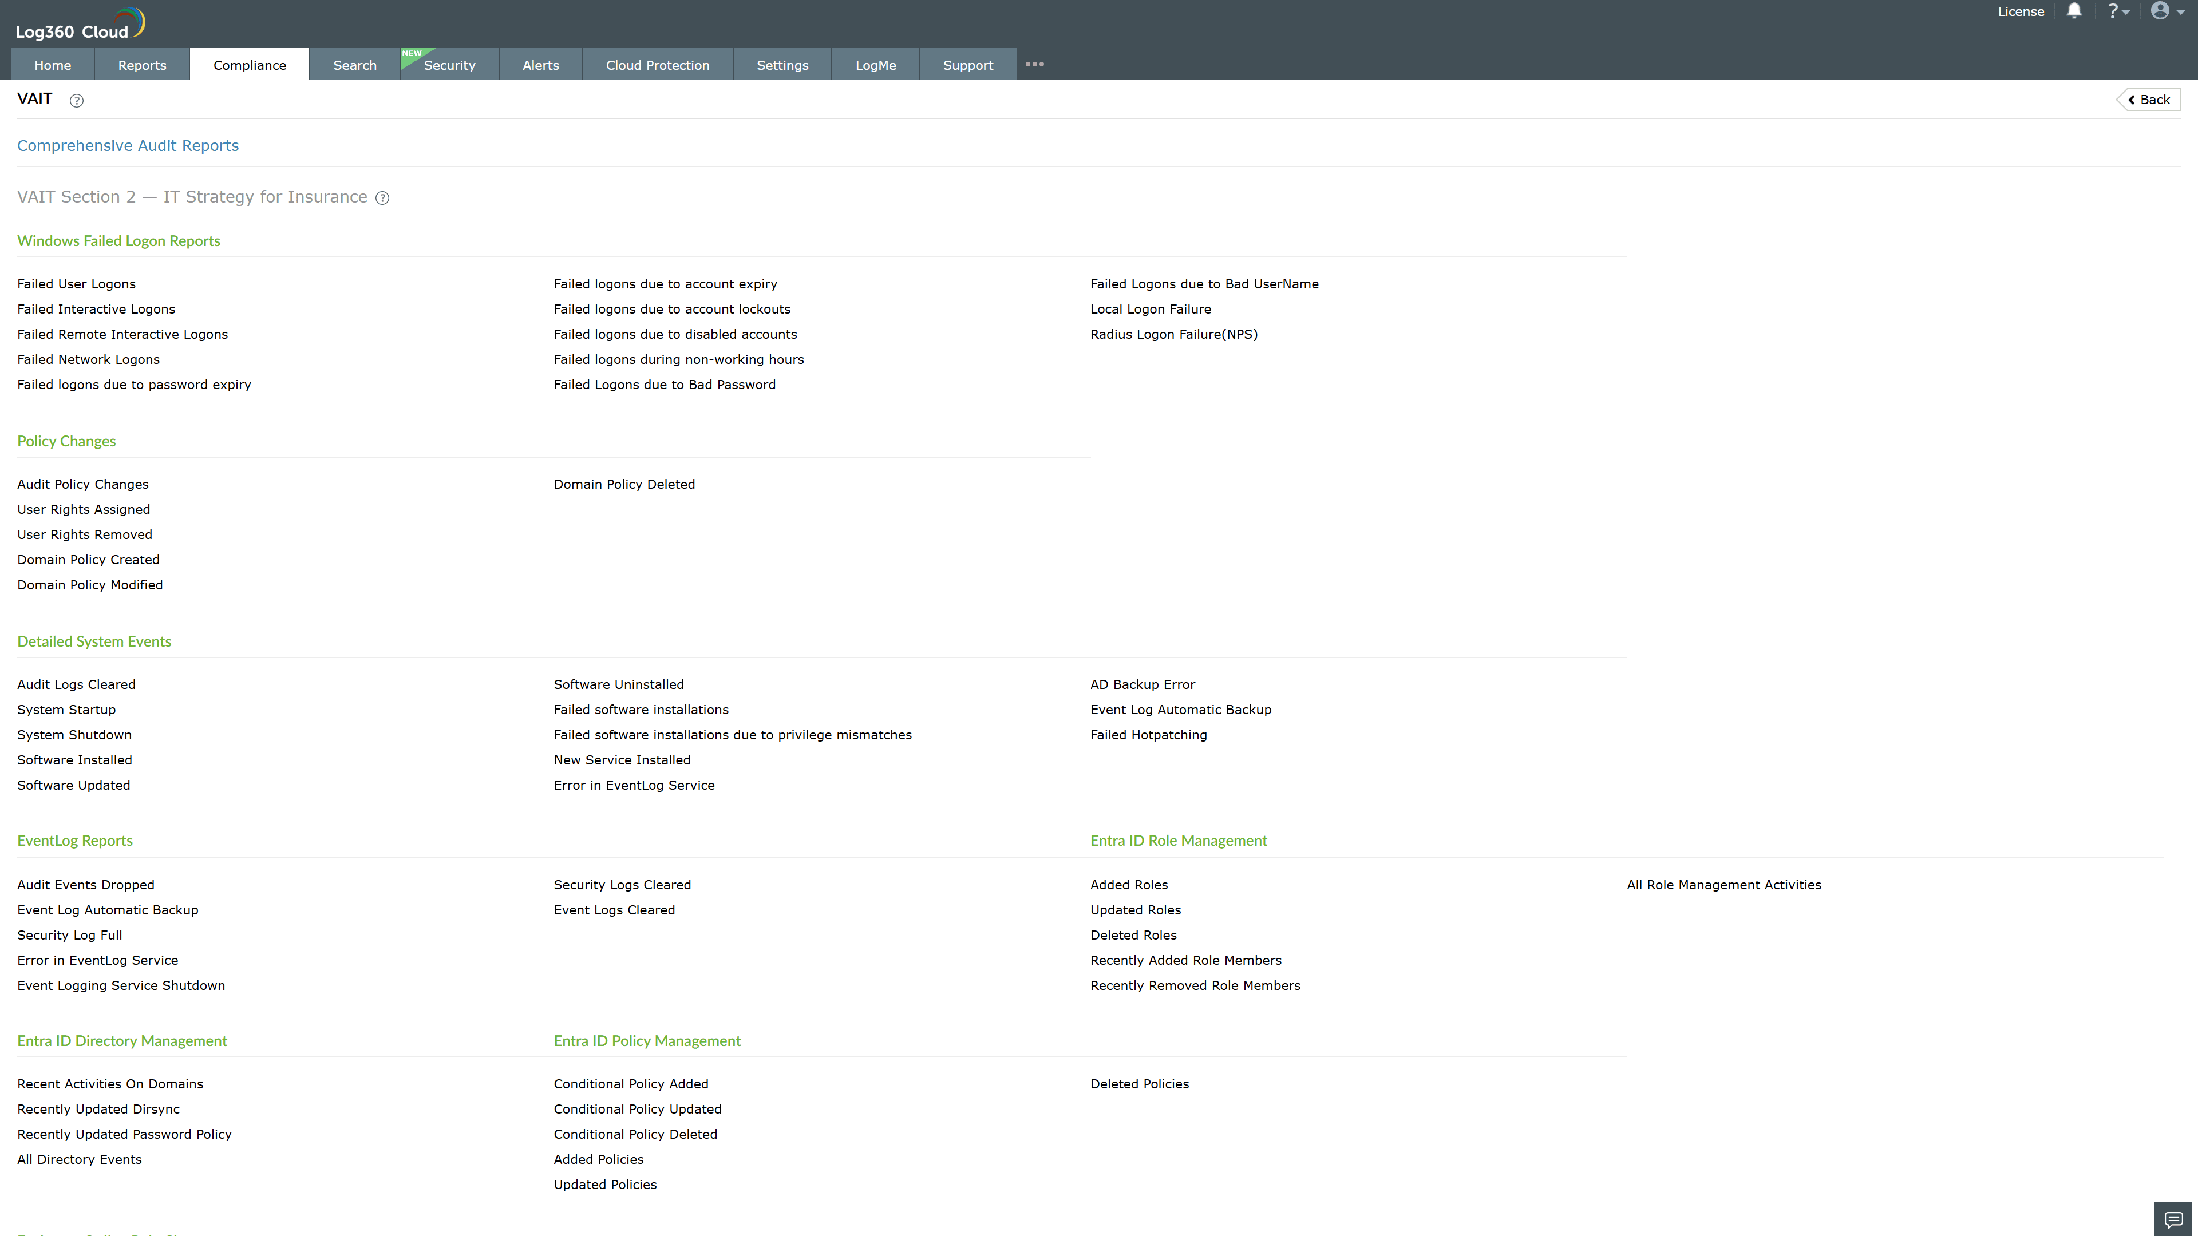
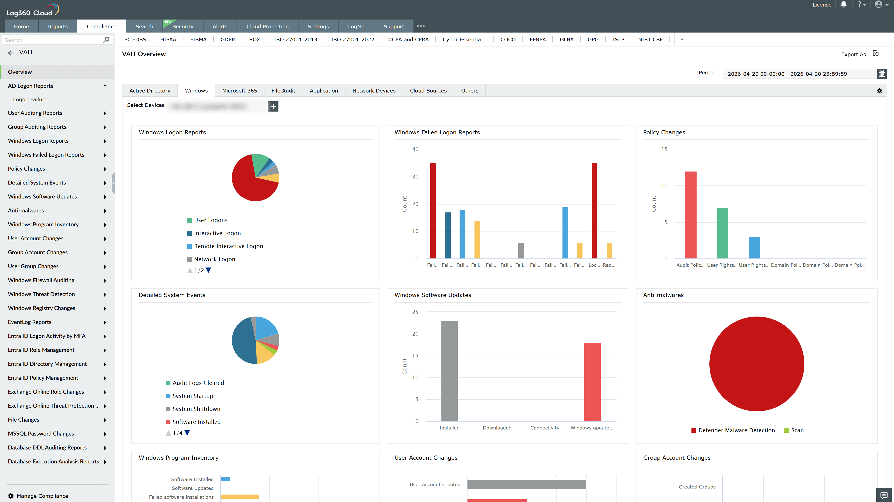
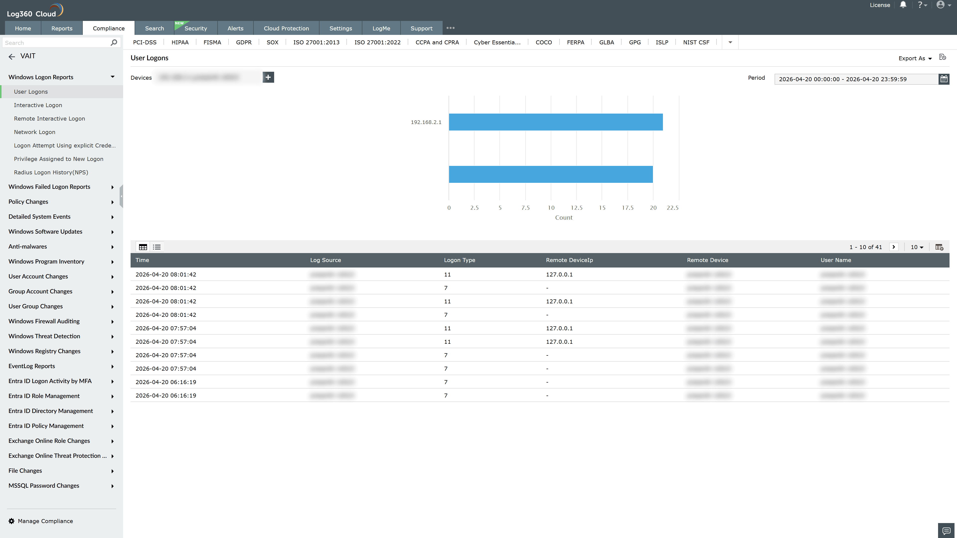
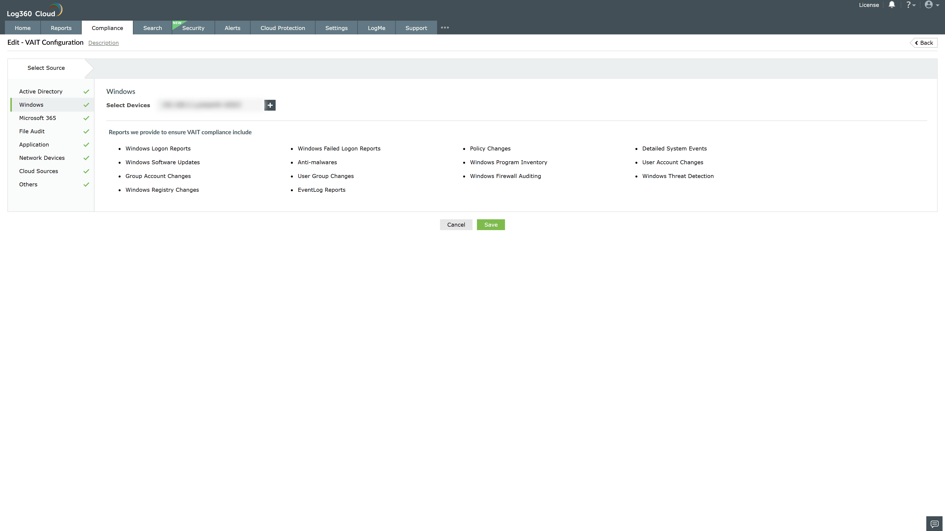
Valid Submission : Yes
Supported Editions : Free, Basic, Standard, Professional, MSSP
Help Document : https://www.manageengine.com/log-management/help/integrations/compliance-extensions.html
Help Video : Not provided
Tags : Log360, Compliance, Privacy monitoring, Data privacy, Regulatory compliance
Supported DCs : US, IN, JP, CA, AU, UK and EU
Privacy Policy:
Terms of Service:
Release Notes:
Predefined reports for the VAIT Compliance

