VARA Technology and Information Rulebook Compliance for Log360
Tagline: Meet Dubai's VARA requirements with monitoring and reporting from Log360.

Overview
The VARA Technology and Information Rulebook Compliance extension for Log360 helps Virtual Asset Service Providers (VASPs) licensed by the Dubai Virtual Assets Regulatory Authority (VARA) meet the technology risk management, cybersecurity monitoring, and data protection requirements of the VARA Technology and Information Rulebook.
Log360 collects and analyzes logs from virtual asset platforms, trading systems, cloud environments, and identity services, providing security teams with continuous visibility into cyber risk indicators. Compliance teams can monitor access to sensitive virtual asset data, detect threats, and generate VARA-ready audit documentation.

Key Features
- Generate audit reports aligned to VARA Technology Rulebook requirements covering access control, platform security monitoring, and cybersecurity incident detection.
- Track privileged user activities, administrative changes, and access events across virtual asset trading and custody systems in real time.
- Detect threats targeting virtual asset platforms through real-time monitoring of wallet access, custody transaction integrity, and platform API activity with specialized threat intelligence.
- Export compliance documentation in PDF and CSV formats for VARA supervisory submissions and internal virtual asset security governance.
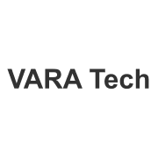
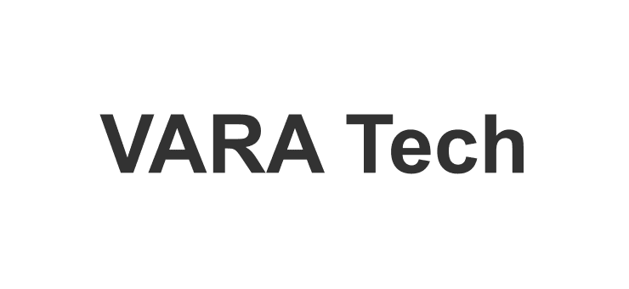

Screenshots
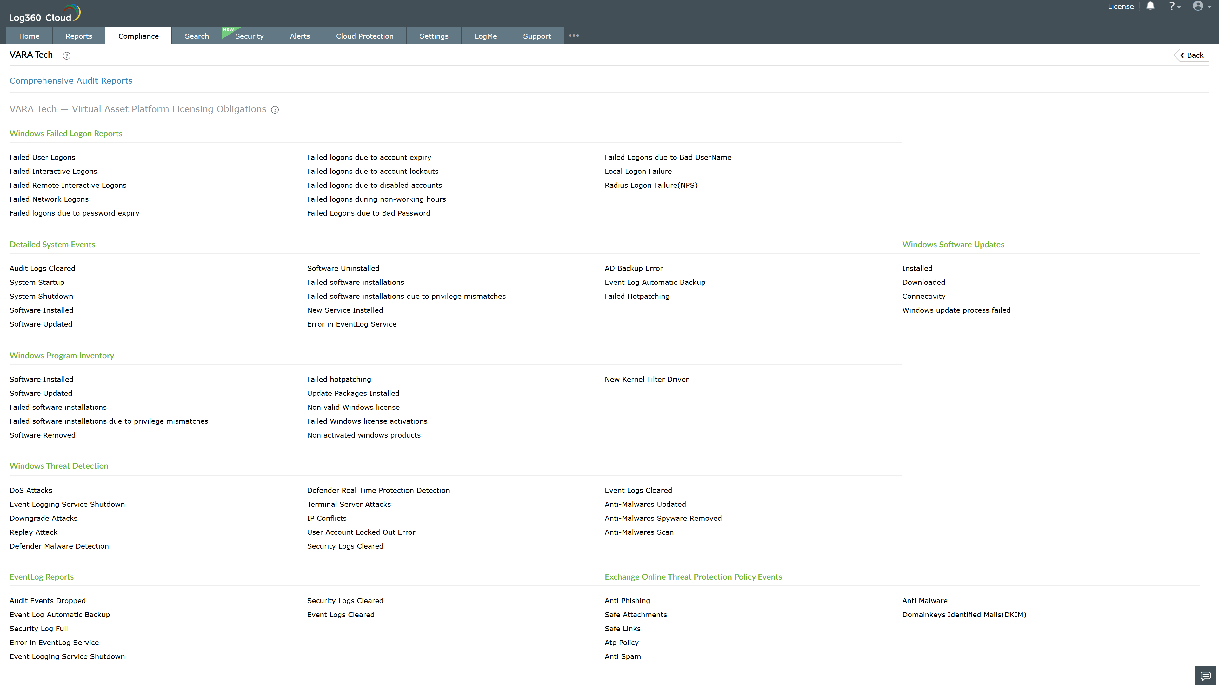
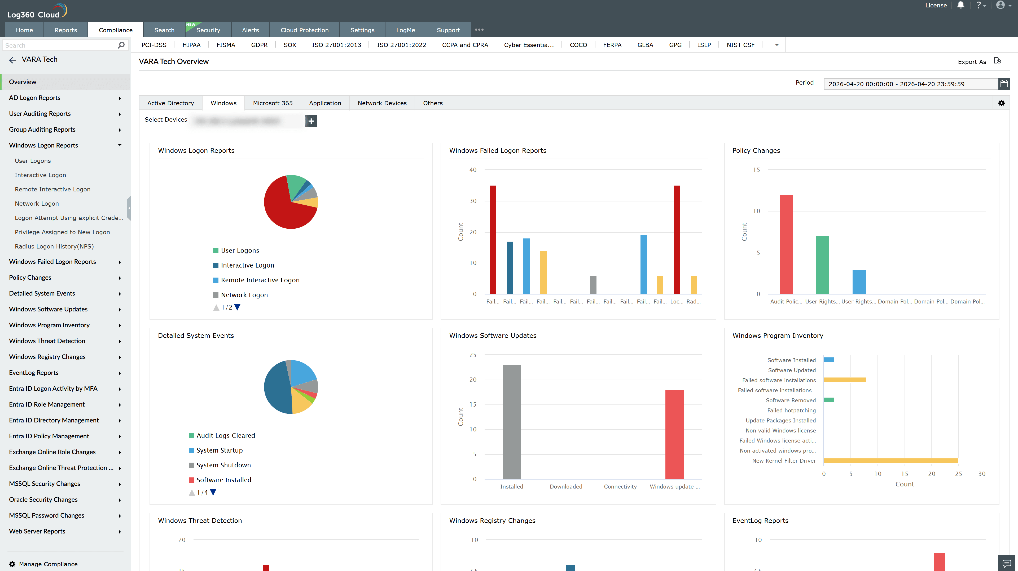
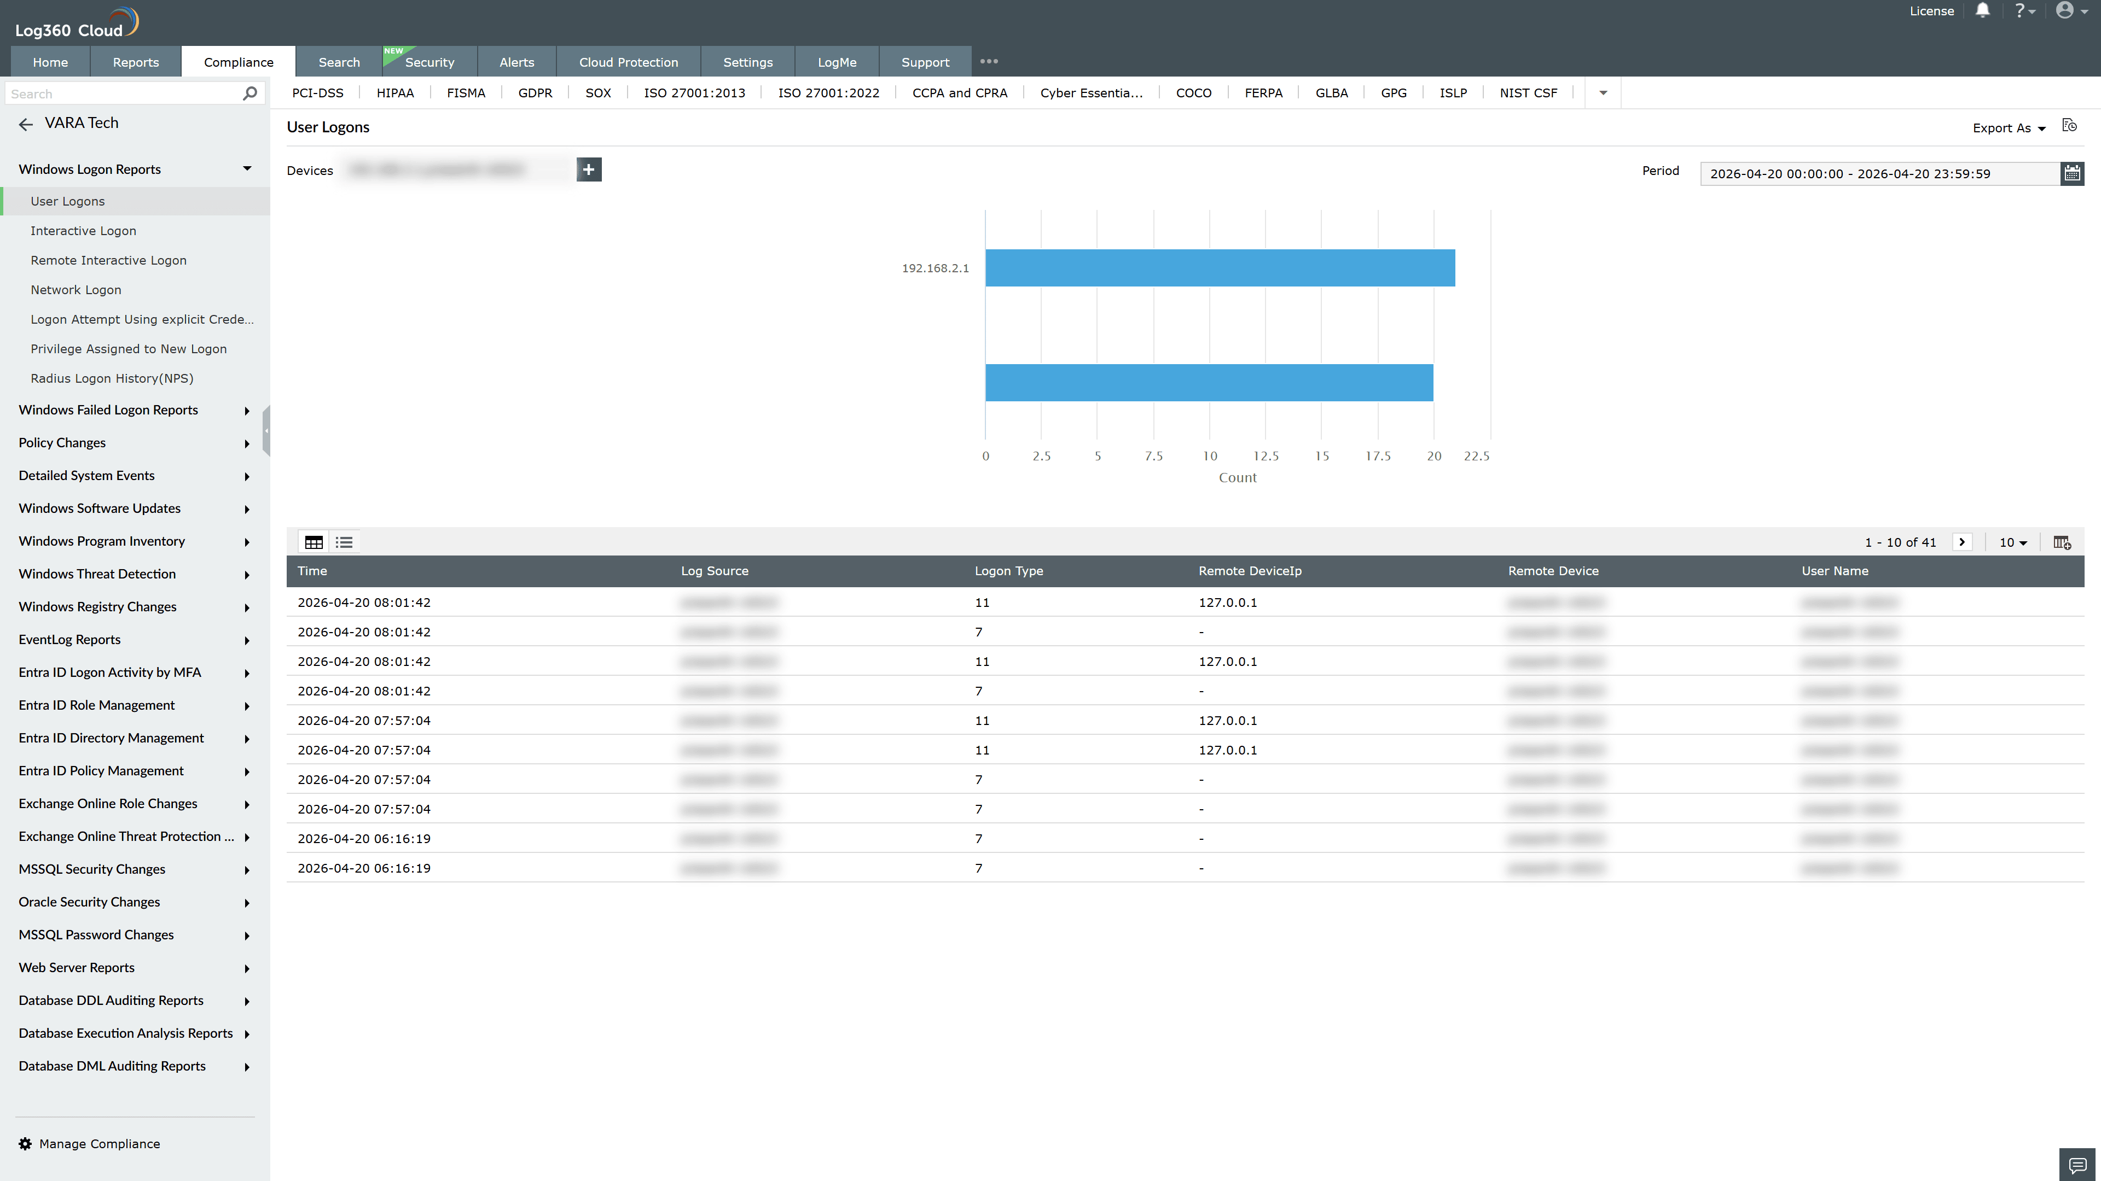
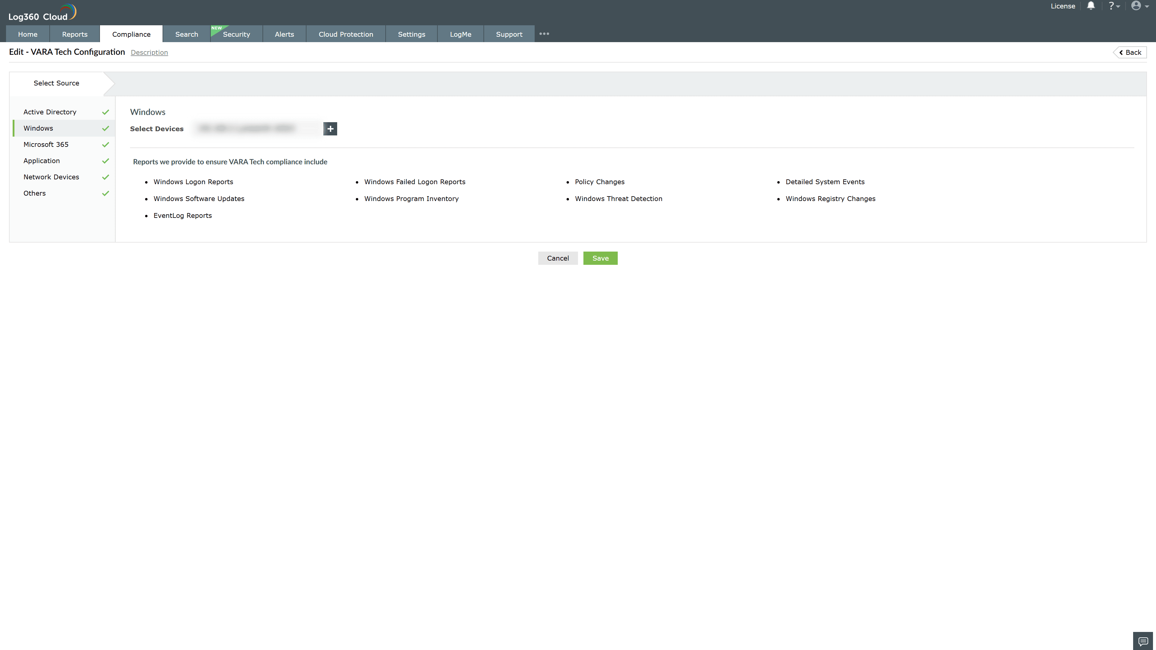
Valid Submission : Yes
Supported Editions : Free, Basic, Standard, Professional, MSSP
Help Document : https://www.manageengine.com/log-management/help/integrations/compliance-extensions.html
Help Video : Not provided
Tags : Log360, Compliance, Privacy monitoring, Data privacy, Regulatory compliance
Supported DCs : US, IN, JP, CA, AU, UK and EU
Privacy Policy:
Terms of Service:
Release Notes:
Predefined reports for the VARA Tech Compliance

