Name: Vinayak Kalaskar

SJSU Id.: 010718253

**Assignment 3**

Designing a Web application satisfying the following needs:

* A New user needs to register before accessing the site. In order to register, the new user needs to supply: First Name, Last Name, Email, Password, Security Question for Password, and your physical postal Address.
* Upon successful register, the Web application presents a log-in page that has Email and Password fields.
* Successful logon navigates the user to Landing Page that has following toolbar buttons: Medical Details, Financials, and Emergency Contacts.
* Error to logon notifies the user to re-enter user credentials.

Part 1: Storyboards

All storyboard images have been created using proto.io website. The following link can be used to directly view them: <https://vinayakkalaskar.proto.io/player/?id=be05e5cd-444c-4b4a-a9c0-9f9a90a5d053>

1: Signup page for the application. This page has sections which require a first time user to enter in order to create an account on the application. Required information by the user is first name, last name, email address, password for the account, choose one security question in case for user forgetting password, answer to the security question and physical address of the user. Email address and password are the mandatory fields.

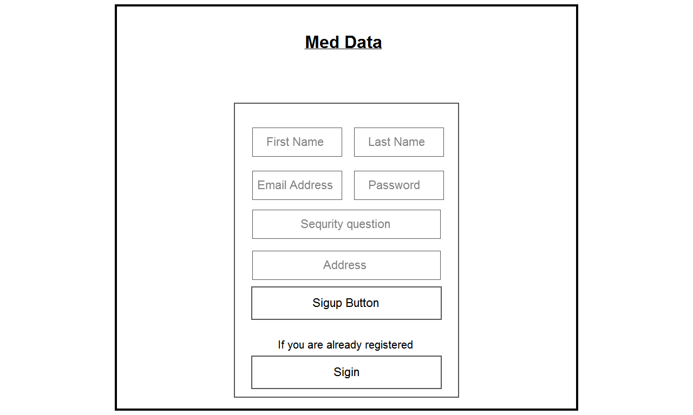

Figure 1: Storyboard SignUp Page

2: Sign In Page. After the user has successfully created an account he is redirected to the signin page where he will have to enter the email id. And password he used to create an account. Both are mandatory fields.

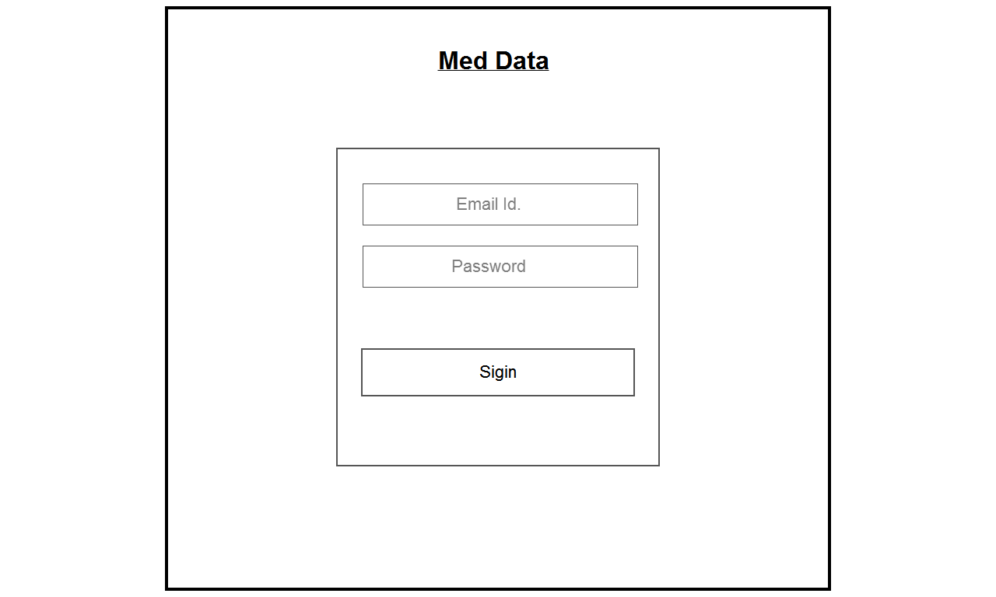

Figure 2: Storyboard Login Page

3: Unsuccessful Login. If the user does not enter the right credentials for logging in, he or she is provided with a warning sign asking them to recheck their credentials.

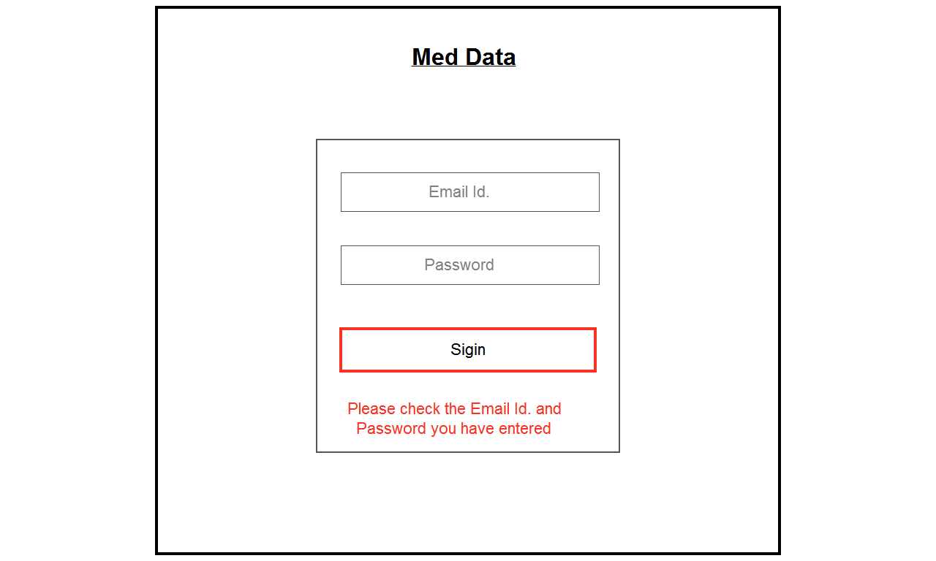

Figure 3: Storyboard Unsuccessful Login

4: Landing Page. This is the main page of the Web application. It contains the medical data, financial data and emergency data of the logged in user. The page contains three tabs and data is displayed in the center based on which tab the user has selected.

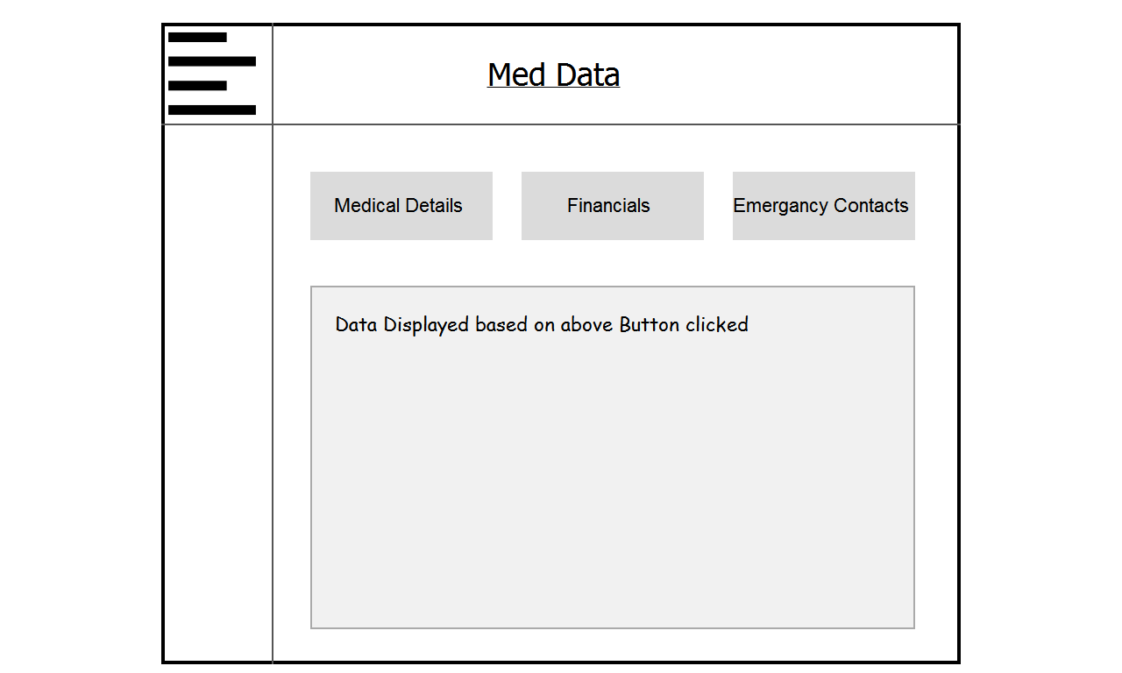

Part 2: Wireframes for the website.

1: SignUp Page

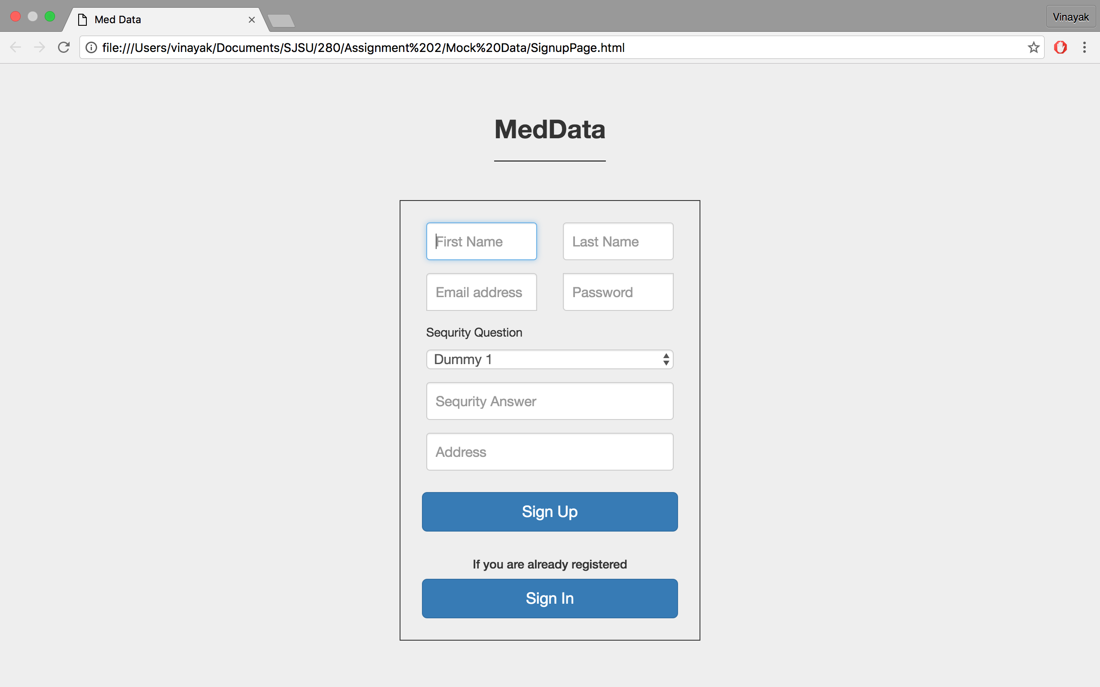

2: Login Page

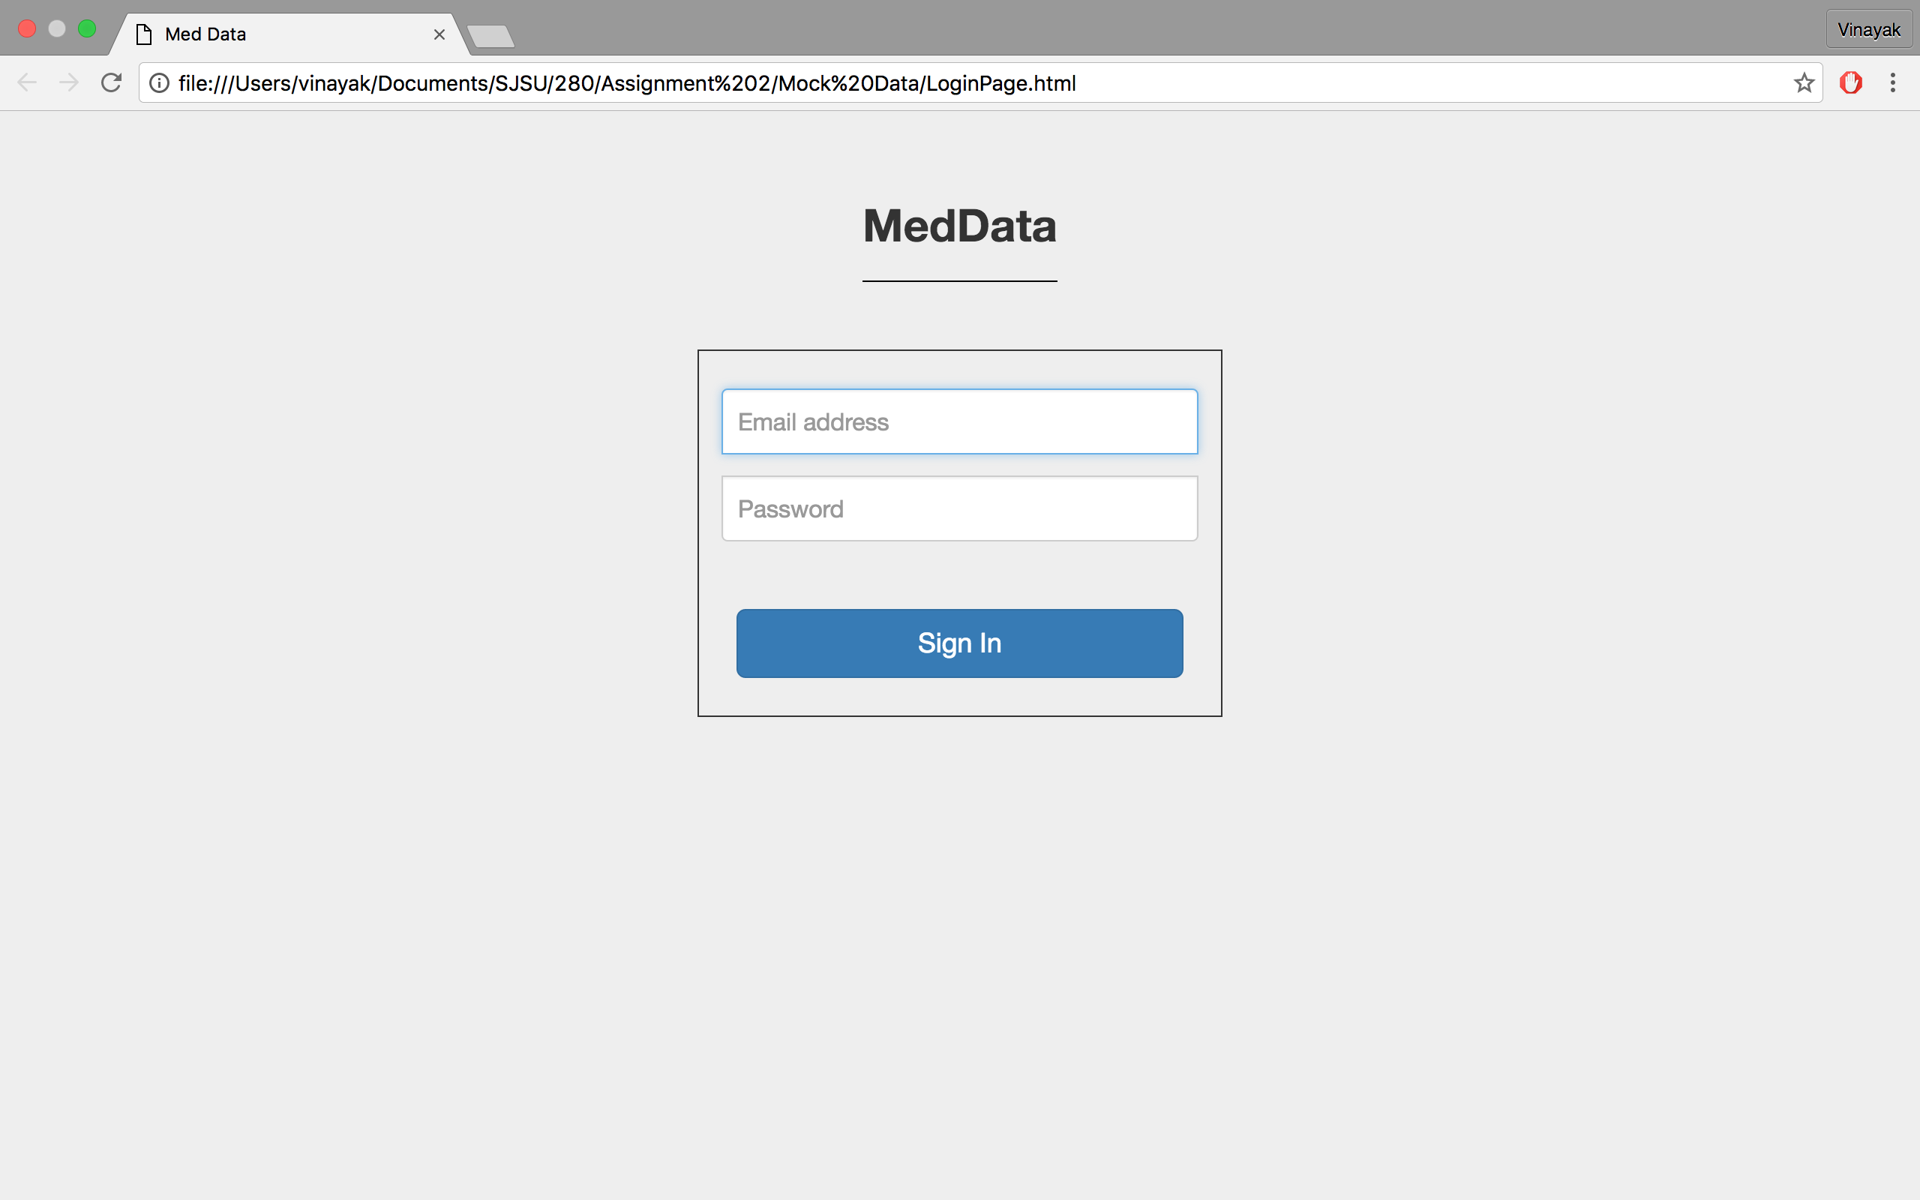

3: Unsuccessful Login Page

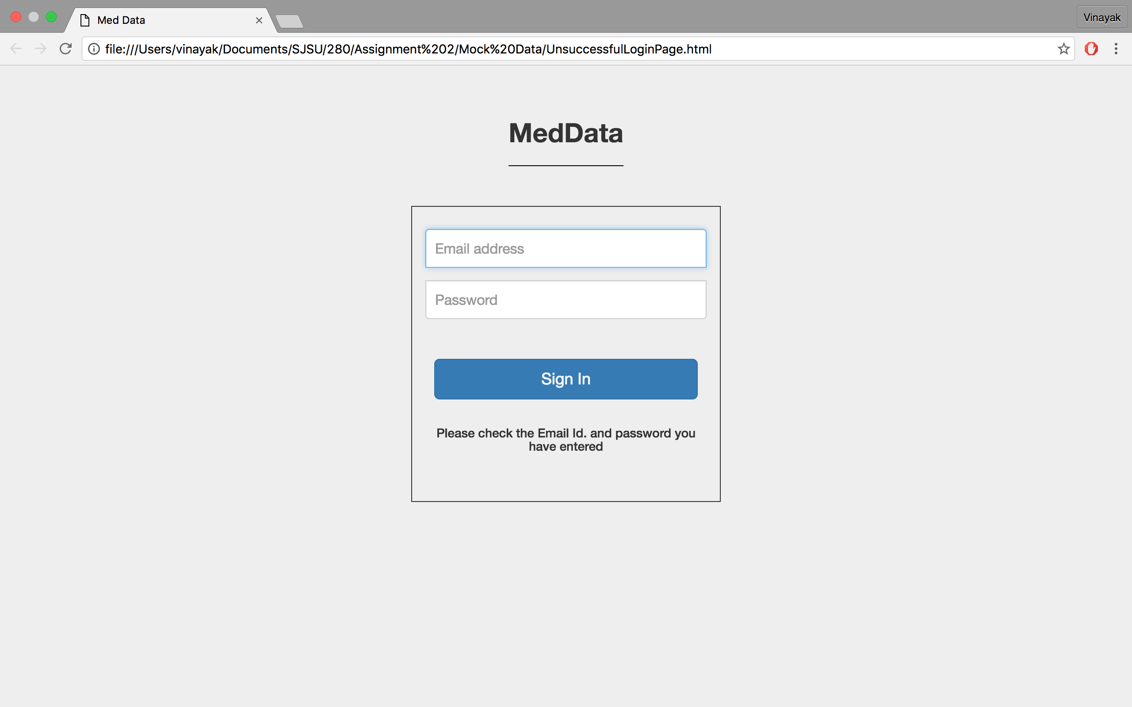

4: Landing Page (with Medical Data displayed)

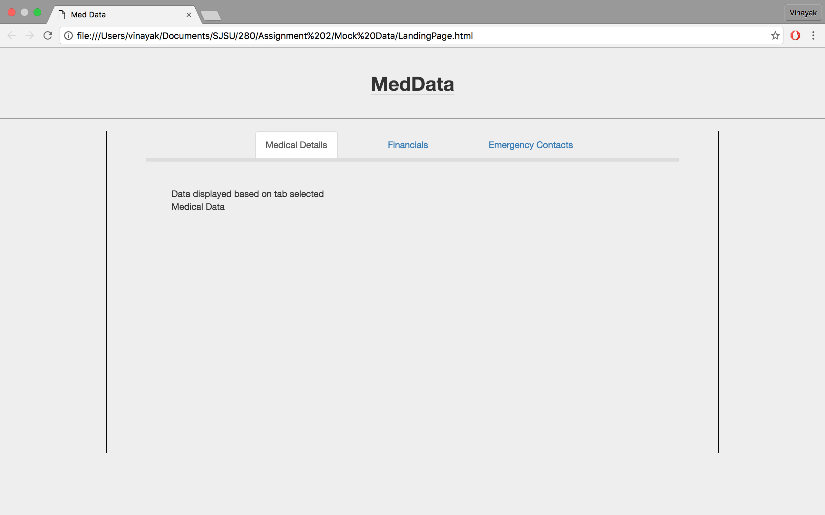

5: Landing Page (with Financial Data displayed)

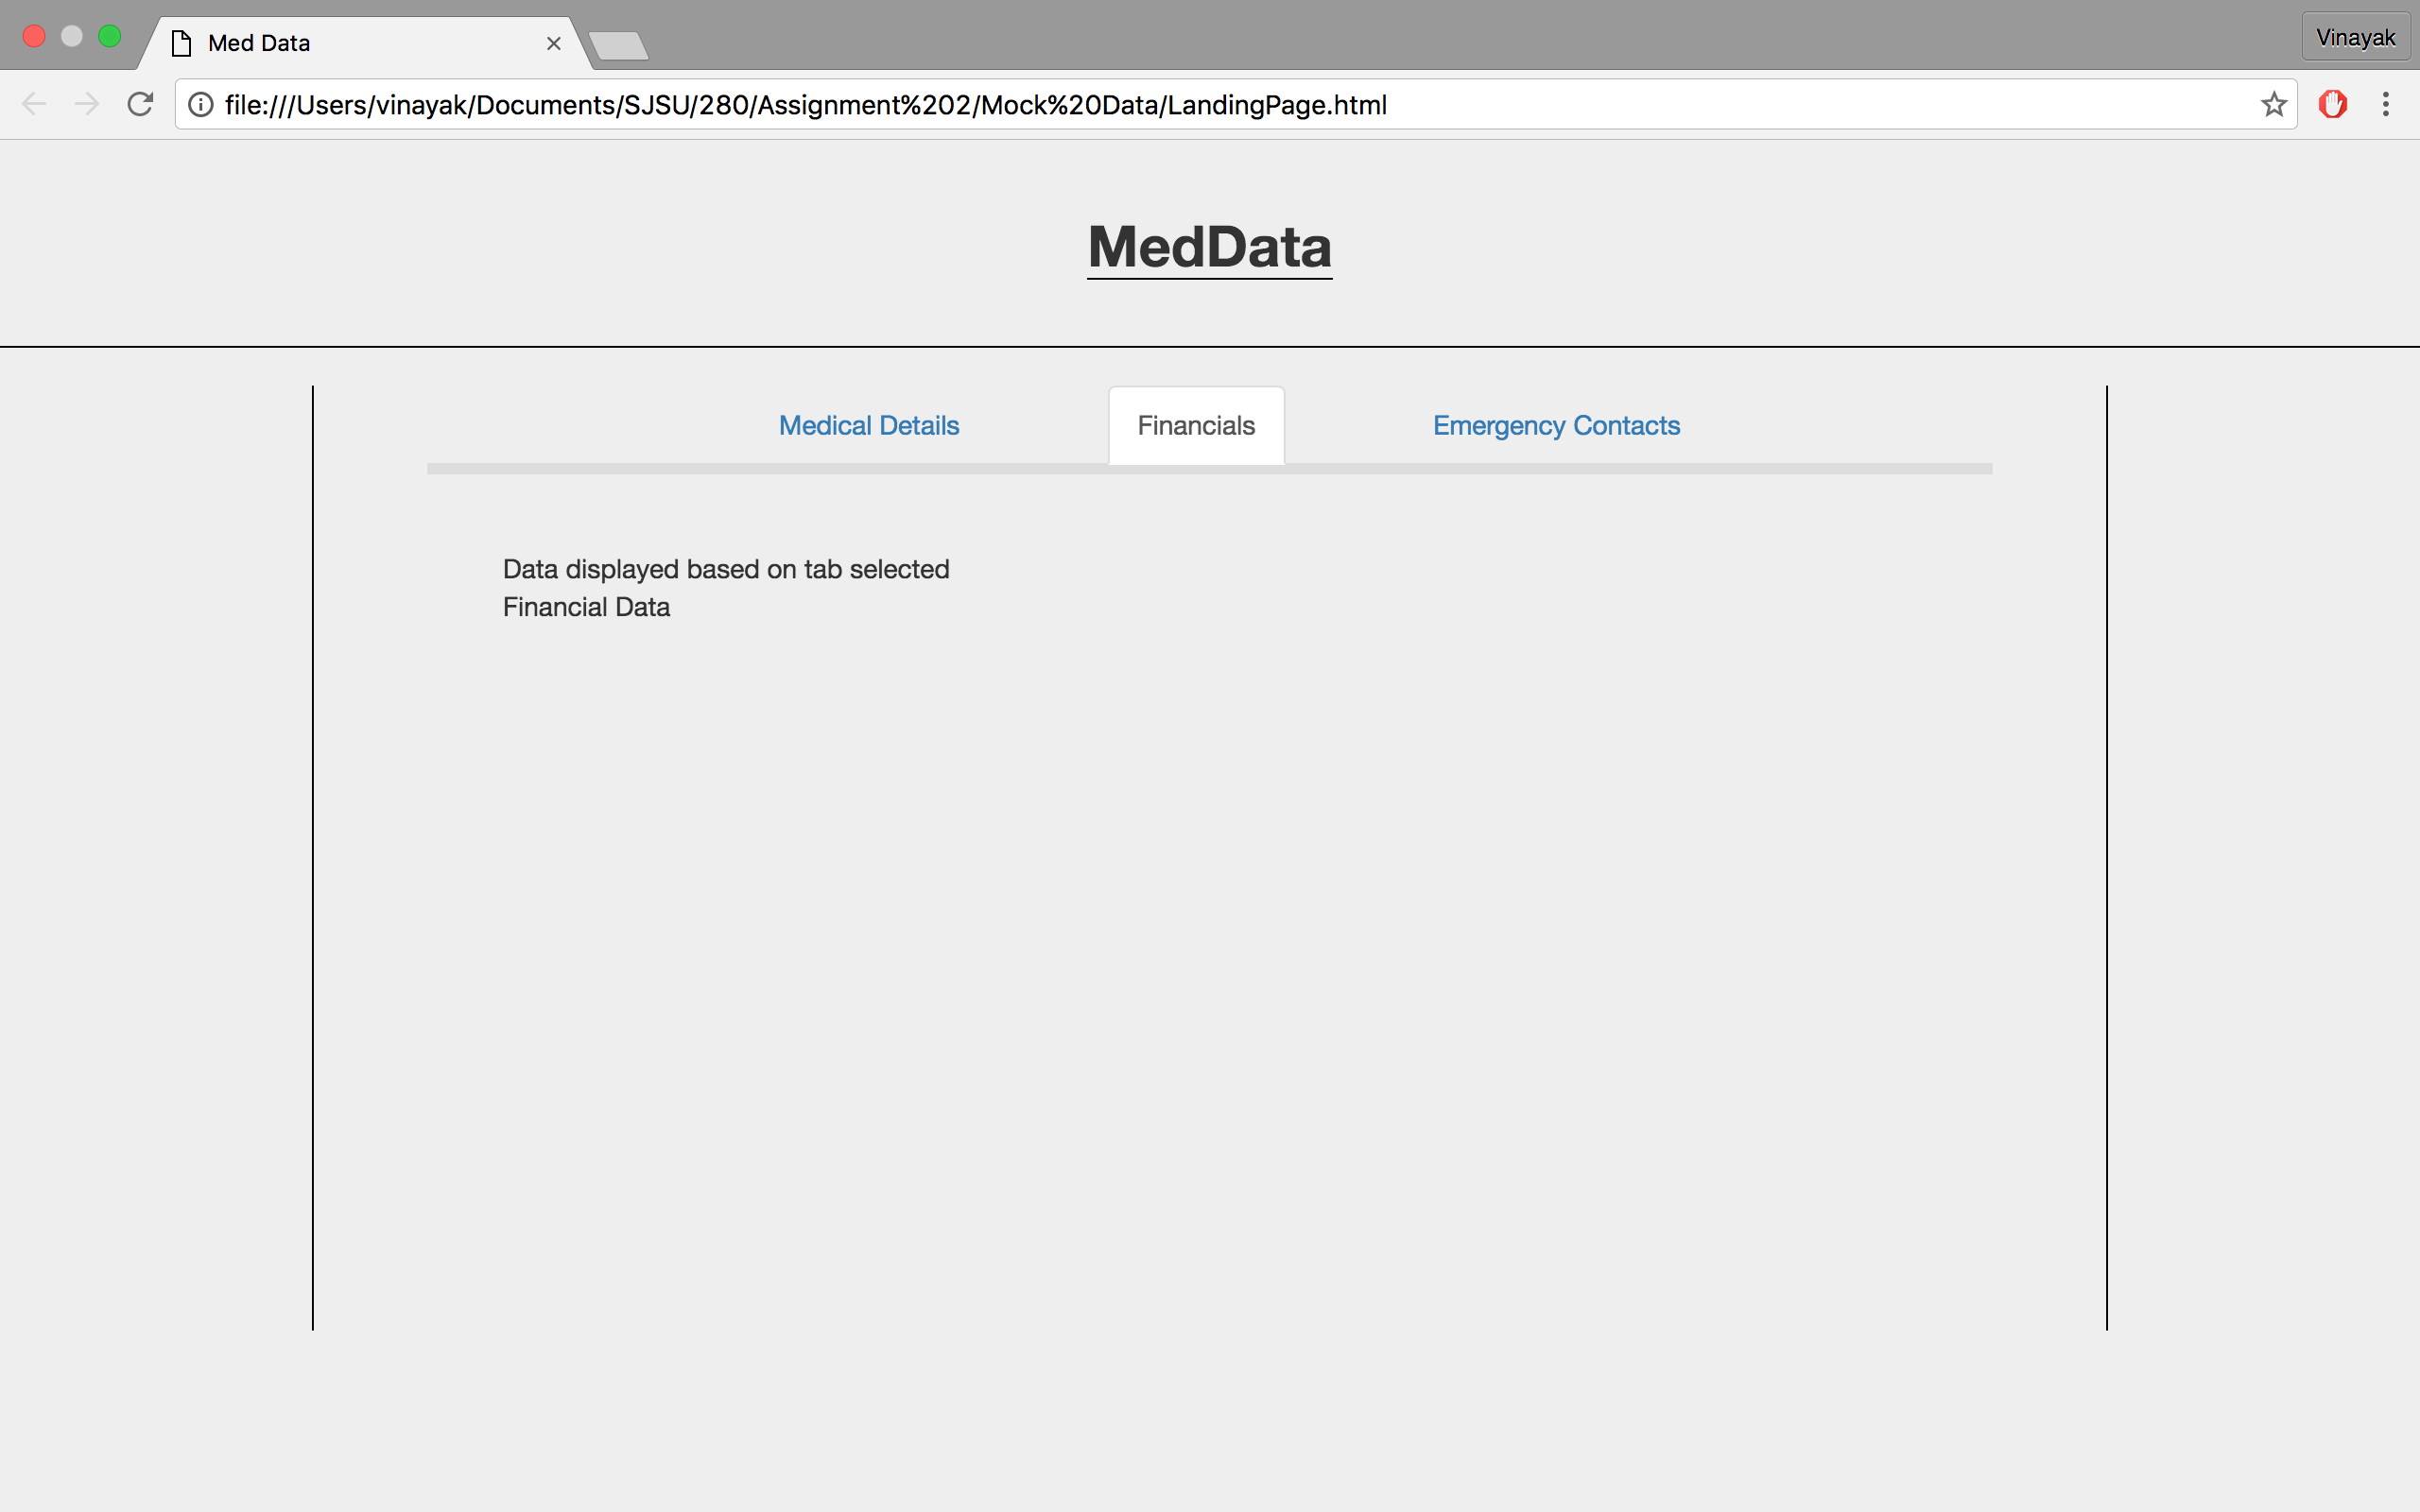

Part 3: Mock Data Webpages

1: SignUp Page

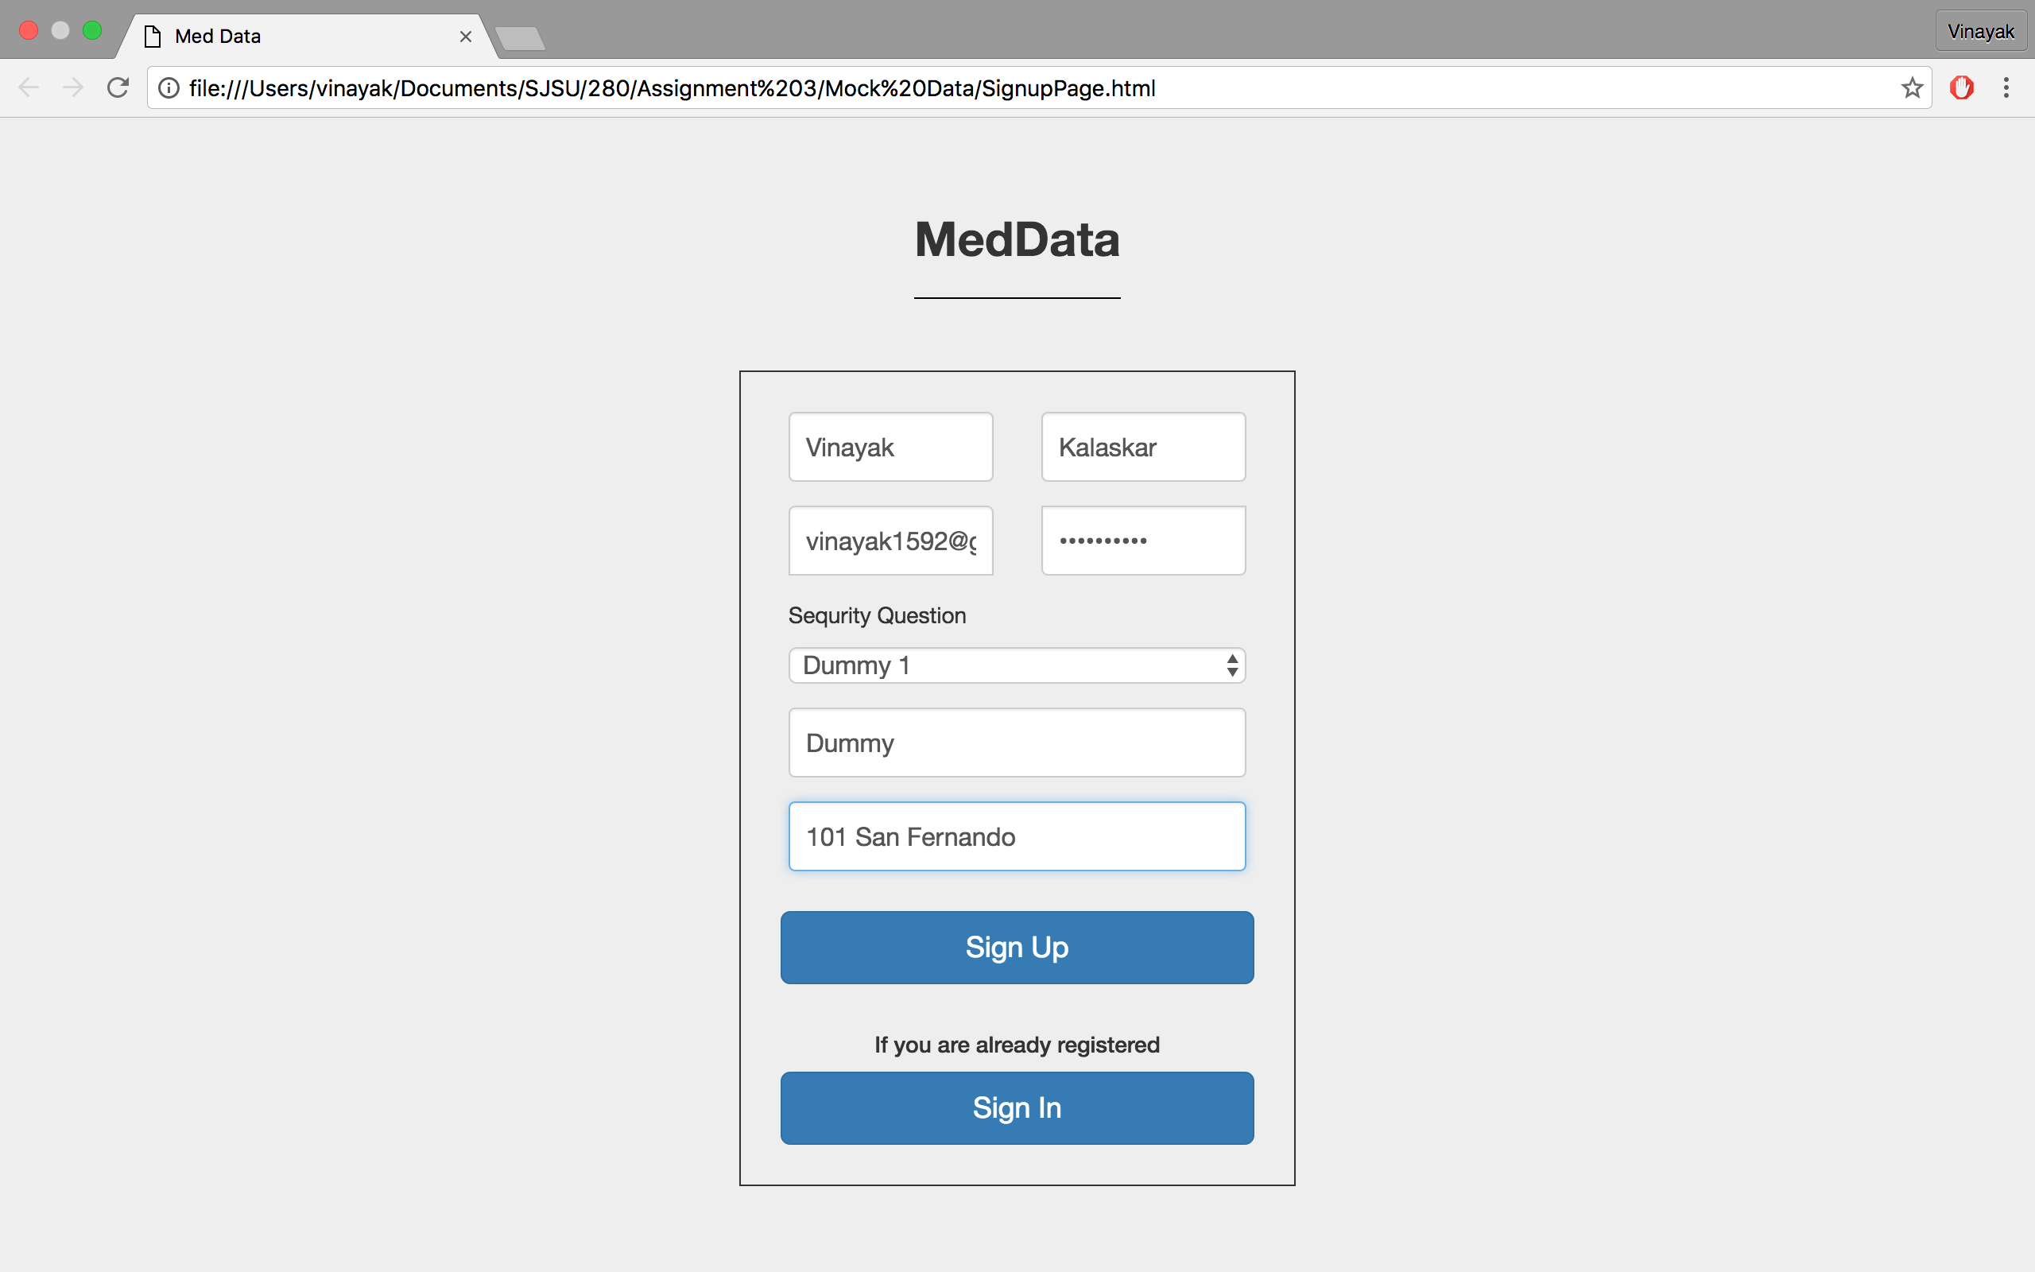

2:Login Page

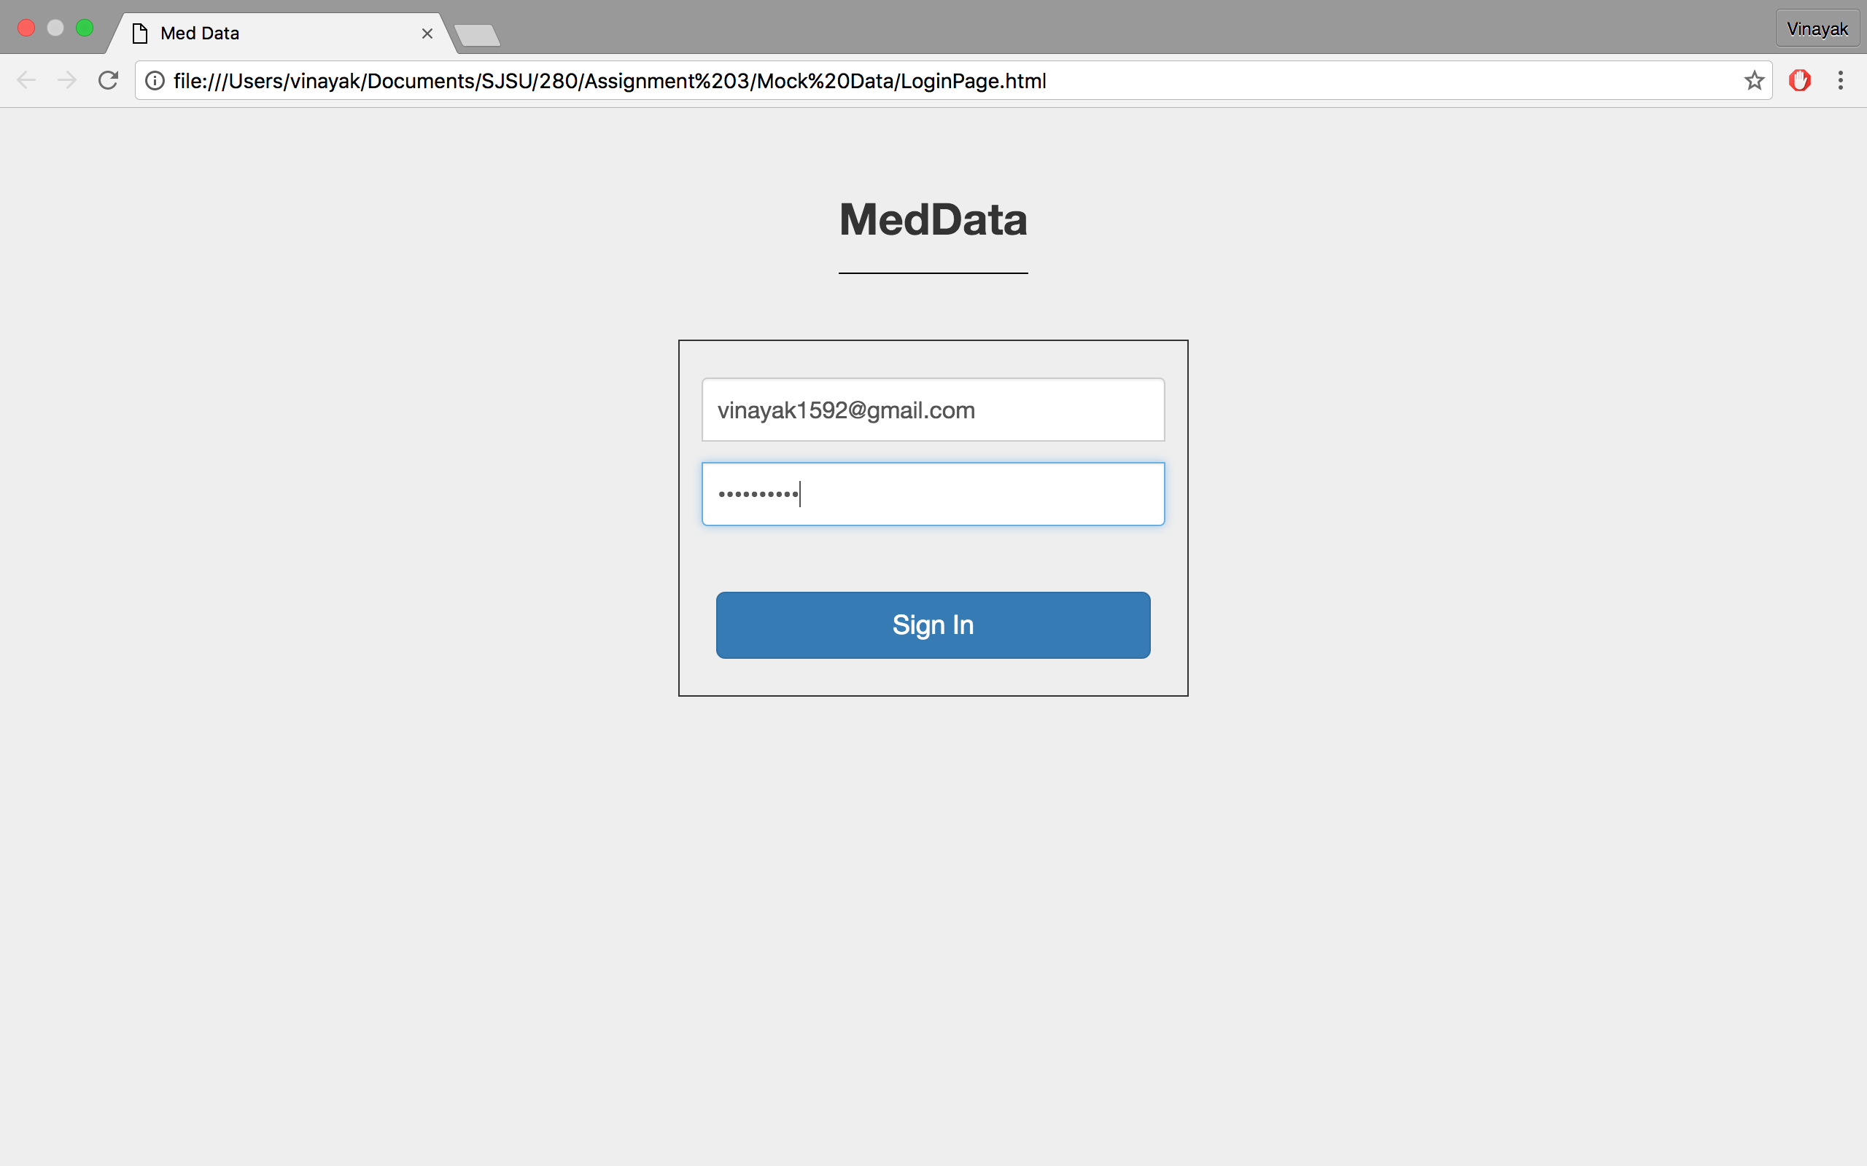

3: Landing Page(Medical Data)

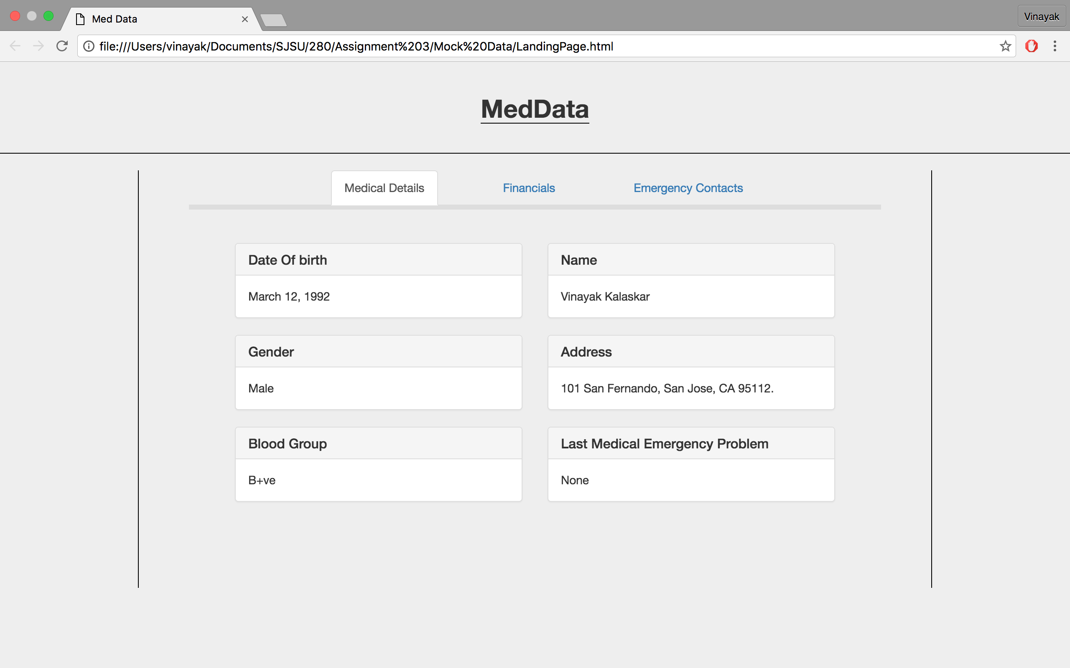

4: Landing Page (Financial Data)

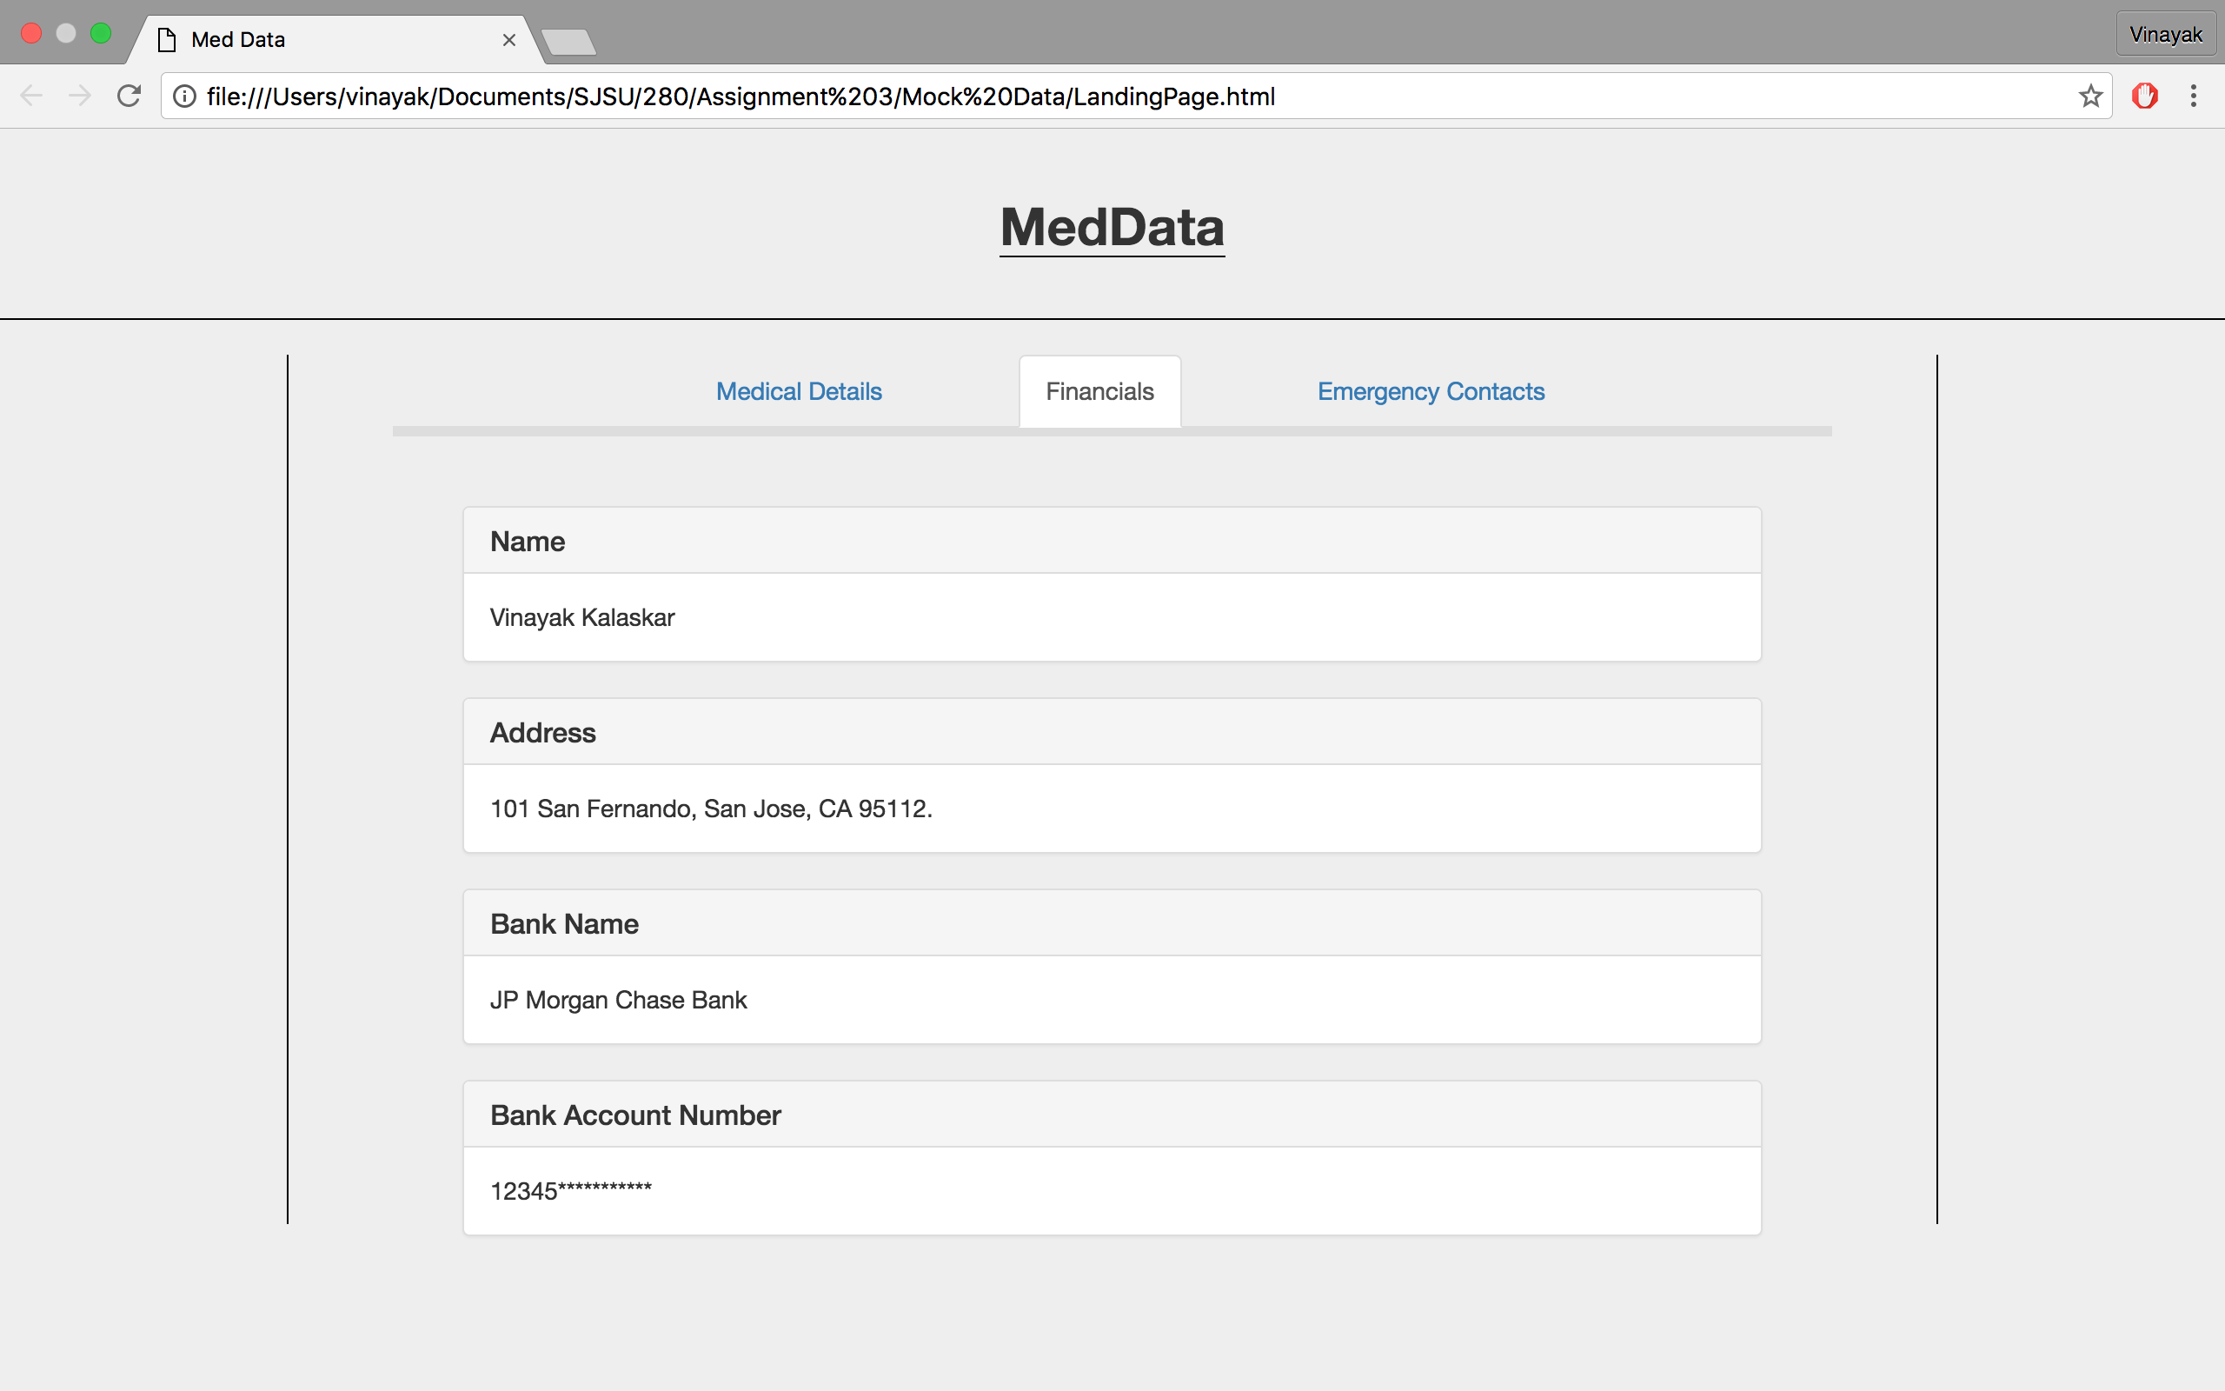

5: Landing Page (Emergency Contact Data)

