Wheat Crop Segmentation Using Traditional Machine Learning and Deep Learning Methods on the EWS Dataset
Team Akatsuki
School of Computer Science and Engineering, University of New South Wales, Sydney, Australia

Abstract

Precision agriculture Field imaging Phenotyping Field imaging is an important process in automated wheat crop segmentation, enabling downstream tasks like canopy monitoring, disease detection, and yield estimation. This paper systematically compares six computer vision approaches to binary wheat-versus-soil pixel classifier on the Eschikon Wheat Segmentation (EWS) dataset: a Random Forest (RF) classifier based on 21-dimensional colour and vegetation-index features, a Support Vector Machine (SVM) based on 5x5 CIE-Luv spatial-patch features, and four deep learning variants based on U- Ablations separate effects of data augmentation, optimizer (Adam vs. Sharpness-Aware Minimisation), and decoder architecture (skip connections vs. Atrous Spatial Pyramid Pooling). Each approach is compared to the held-out test split based on precision, recall, F1-score, and Intersection over Union (IoU) and statistical significance is checked through Wilcoxon signed-rank tests. Surprisingly, U-Net that is trained without data augmentation performs the best at test IoU (0.8795), outperforming all data-augmented deep learning models and classical ML base lines. We examine failure modes, learning efficiency, and comment on the empirical trade-offs between accuracy, training cost and inference speed.

Research questions: How can semantic segmentation be applied to wheat crop, using U-Net, DeepLabV3+, random forest, SVM, sharpness-aware minimisation and precision agriculture?

1. Introduction

Automated and reliable crop and background soil segmentation is a traditional visual task in recent precision agriculture. In wheat - one of the three most grown cereals on the planet precise pixel-level delineation allows to quantitatively track canopy cover, early warning of pest and disease infestations, and estimate biomass at the field scale. The image volumes generated by high-throughput field phenotyping platforms are too large to be manually annotated, and strong computer vision pipelines are required [1].

EWS (Eschikon Wheat Segmentation) dataset [1] consists of 190 RGB field images (350 x 350 pixels) that contain expert binary plant/soil masks that were taken under different real-world conditions such as different levels of illumination, growth stages, canopy density and soil texture. This heterogeneity renders EWS a difficult standard that reveals the weaknesses of techniques that are excessiveively adjusted to controlled systems.

The research question of this paper is as follows: Which type of computer vision approach - classical ML or deep learning - optimally and most cost-effective segments wheat and soil on a small and diverse real-world dataset? We make the following contributions:

• A comparatively-controlled evaluation of six meaningfully different segmentation techniques across two paradigms: classical ML and deep learning.

• A deep learning ablation experiment to isolate the impacts of data augmentation, optimizer, and decoder architecture.

• Test of statistical significance of per-image distributions of IoU with Wilcoxon signed-rank tests.

• A failure-mode analysis and learning-curve experiment of the degradation of each method when trained on limited data.

Contextualisation of all outcomes with published EWS benchmarks [1].2. Literature Review

2.1 Traditional Segmentation Approaches
Early crop segmentation relied on hand-crafted colour features exploiting the spectral contrast between chlorophyll-rich vegetation and bare soil. Vegetation indices such as the Excess Green Index (ExG) and Normalised Green-Red Difference Index (NGRDI) [12] are simple per-pixel transformations that provide strong discriminative signal for green canopies under controlled illumination but are brittle under variable lighting and dense canopy occlusion.
Random Forest classifiers extended this paradigm to high-dimensional feature spaces. Sadeghi-Tehran et al. [2] demonstrated that combining colour-space channels (RGB, HSV, LAB) with vegetation indices in a Random Forest yields robust wheat segmentation competitive with more complex pipelines. The EWS benchmark [1] reproduces this approach, reporting a test IoU of 0.652.
SVM-based classifiers with spatial patch features were explored by Rico-Fernández et al. [3], who showed that incorporating local neighbourhood context via fixed-size patches in perceptually uniform colour spaces (CIE-Luv) substantially improves boundary precision over purely per-pixel methods. The EWS benchmark reports SVM IoU of 0.690.

2.2 Deep Learning for Crop Segmentation

Originally designed as a biomedical image segmentation model, U-Net [4] proposed an encoder-decoder framework with skip connections that retain finer spatial detail - important to delicate structures like wheat stems and leaf edges. It is popular in agricultural imaging due to its good performance with small amounts of labelled data augmented by ImageNet-pretrained encoders and data augmentation.

DeepLabV3+ [6] uses Atrous Spatial Pyramid Pooling (ASPP) to learn multi-scale context. U-Net and DeepLabV3+ are ideally matched to compare their controlled architecture on the same dataset since they share the encoder and differ in the decoder.

A good upper reference to our work is the benchmarked ResNet50-based network on EWS ran by Zenkl et al. [1] with a fine-tuned network achieving a strong IoU of 0.883. Other more recent efforts are depth-aware pseudo-labelling of near-unsupervised segmentation [8] and depth-labelled data-scaled foundation models [9], which set the present state of the art.

2.3 Training Strategies

It is commonly believed that data augmentation is the key to deep learning on small agricultural data [1]. Nonetheless, its performance is dependent on the datasets: in the case where test environments are too similar to training scenes, aggressive augmentation can cause a distribution shift that worsens performance.

Sharpness-Aware Minimisation (SAM) [7] attempts to optimise parameters that lie in flat loss-landscape regions, which in theory can better generalisation. SAM takes twice the wall-clock training time with two gradient evaluations per step. Its empirical advantage over Adam on small, low-diversity data sets is an open problem which we answer explicitly in this work.

3. Methods

There is a standard appraisal procedure in all procedures. The EWS dataset is utilized with its in-built train/validation/test split (142/24/24 images). The test set is highly reserved to final evaluation. Tuning is performed on the validation set. All experiments have a fixed random seed (42) to ensure reproducibility. Binarisation is done at threshold 127.

3.0 Overall Project Pipeline
Figure 1 depicts the common end-to-end pipeline among the six methods. Raw EWS images are first pre-processed, fed through the feature extraction or model in each of the methods and the resulting binary mask compared to the ground-truth annotation by common segmentation measures.
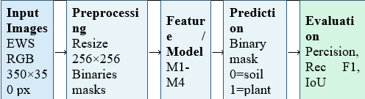
Figure 1: Overview of the pipeline that all the six methods share. The input images are processed through preprocessing, method-specific feature extraction or deep model, binary mask prediction, and metric evaluation.

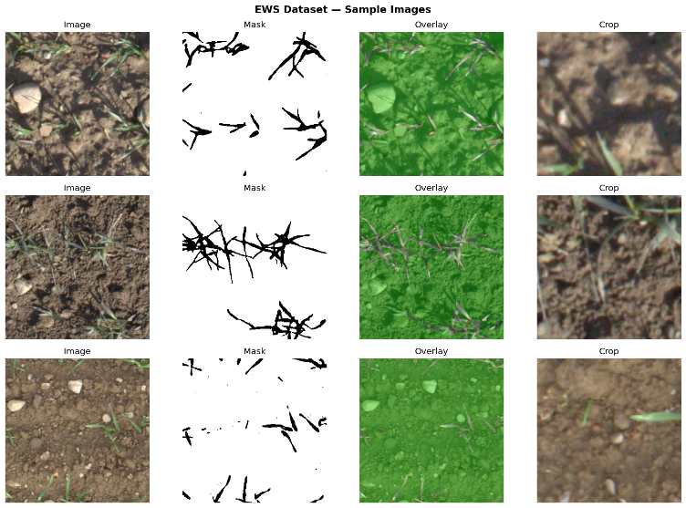
Figure 2: The images of the representative EWS samples including RGB image, ground-truth mask, overlay, and centre crop. Photos cover a variety of light, growth, and canopy cover.
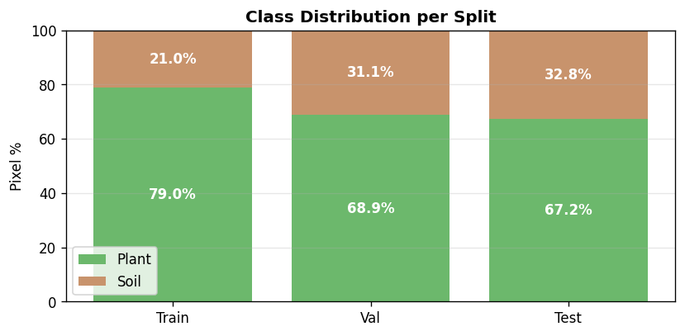
Figure 3: The pixel-wise distribution of classes in the training/validation/testing splits. Plant pixels cover approximately 79% of training pixels, which inspires the BCE + Dice combined loss..

3.1 ML Sub-Pipeline (M1 and M2)
Classical ML approaches consider segmentation a problem of per-pixel classification. A hand-crafted feature vector is used to characterize each pixel in terms of its neighbourhood and the feature is then classified separately. The ML sub-pipeline is summarised in Figure 4.
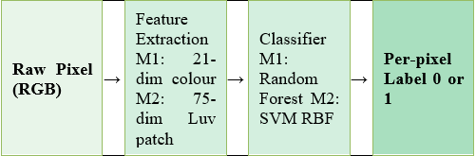
Figure 4: ML sub-pipeline of M1 (Random Forest) and M2 (SVM). Both approaches learn a feature-vector-per-pixel and feed it to a trained classifier. The most important distinction is the presence of dimensionality and spatial context: M1 has 21-dim colour/vegetation features; M2 has a 75-dim CIE-Luv patch.

3.2 Deep Learning Sub-Pipeline (M3a, M3b, M3c, M4)
Deep learning algorithms are trained to eliminate hand-crafted features, and use an end-to-end convolutional encoder-decoder to learn representations. Figure 5 depicts the DL sub-pipeline, where the augmentation stage is only used during training on M3b, M3c and M4.
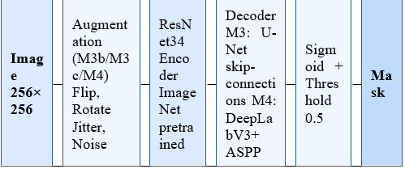

Figure 5: Deep learning sub-pipeline. All variants of the DL have a ResNet34 encoder that is pretrained on ImageNet. M3 variants apply a U-Net decoder that has skip connections; M4 instead applies DeepLabV3+ ASPP. M3b/M3c/M4 augmentation is used in training; M3a is not.
3.3 Method 1 - Random Forest using Colour Features (M1)
Motivation: Motivation: A powerful ML baseline was directly benchmarked in EWS paper [1], based on Sadeghi-Tehran et al. [2]. Colour and vegetation indices take advantage of the fact that there is a strong spectral difference between brown soil and green wheat.
Feature engineering: The pixels are described using 21-dimensional vectors: RGB (3), HSV (3), LAB (3), YCrCb (3), five vegetation indices - ExG, ExR, NGRDI, VARI, GLI (5) - and 3x3 neighbourhood means and standard deviations of the R and G channels (4). The neighbourhood statistics provide local texture information without the complications of a complete patch embedding.
Classifier: RandomForestClassifier trained on 20 percent random pixels of all training images (~2.4M pixels) to prevent memory overflow. There is no normalisation of features (RF is scale-invariant).

3.4 Method 2 - SVM using Spatial Patch Features (M2)

Motivation: Follows Rico-Fernández et al. [3]. A 5 by 5 neighbourhood patch is a representation of the spatial context that a simple per-pixel vector lacks, enhancing accuracy in boundaries.

Feature engineering: A flattened 5×5 window of CIE-Luv colour space (75 features) represents each pixel. Luv is uniform in perception and thus Euclidean distance in feature space has a greater meaning. Handling of borders is through reflect-padding.

Classifier: SVC, and trained with 200 balanced pixels in the training image (100 plant, 100 soil). A trained StandardScaler on training features is used to ensure that there is no data leakage in the inference phase.

3.5 Method 3 - U-Net Variants (M3a, M3b, M3c)

Architecture: Each of the three variants has a U-Net [4] that has a ResNet34 encoder [5] trained on ImageNet, and the architecture is presented in the form of segmentation-models-pytorch [10]. Skip connections between encoder and decoder directly transfer high-resolution feature maps without sacrificing spatial resolution needed to capture thin wheat structures.

Loss function: A combined BCE + soft Dice loss: L = L_BCE + L_Dice, where L_Dice = 1 − (2·Σpᵢtᵢ + ε)/(Σpᵢ + Σtᵢ + ε). BCE uses per-pixel cross-entropy; Dice explicitly penalises overlap and is not sensitive to class imbalance. Smooth term ε=1.

Typical hyperparameters: Adam (lr = 1×10 -4), ReduceLROnPlateau (patience=5, factor=0.5), 30 epochs, batch size 8, input size 256 256 px.

M3a - No augmentation: Training is only resize and ImageNet normalisation. This is the deep learning baseline that confounds out the effect of augmentation.

M3b - Full augmentation: The augmentation pipeline adds: random horizontal/vertical flip (p=0.5), random 90° rotation (p=0.5), shift-scale-rotate (p=0.5), colour jitter (brightness/contrast/saturation ±0.2, hue ±0.05, p=0.5), and Gaussian noise (std ∈ [0.01, 0.05], p=0.3) via Albumentations [11]. Only training data is augmented.

M3c - Full augmentation + SAM: Replaces Adam with SAM [7] wrapping SGD (lr=1×10⁻², momentum=0.9, ρ=0.05). SAM alters the parameters to the steepest loss-ascent direction, and then calculates the actual descent gradient, attempting to find smoother minima with improved generalisation. The rest of the hyperparameters are the same as M3b.

3.6 Method 4 - DeepLabV3+ with Full Augmentation (M4)

DeepLabV3+ [6] uses U-Net skip-connection decoder with ASPP module which encodes multi-scale context using parallel dilated convolutions at 6, 12 and 18 rates. All the parameters are the same as in M3b (encoder, ImageNet pretrained), loss, optimiser, learning-rate schedule, augmentation, image size, batch size, and the number of epochs), with decoder being the only experimental variable.4. Experimental Results

4.1 Evaluation Metrics

All DL methods generate binary masks at sigmoid threshold 0.5. The calculations of the metrics are performed on each image and averaged between the 24 test images using scikit-learn implementations: Precision = TP/(TP+FP), Recall = TP/(TP+FN), F1 = 2P/R/P+R+FN. The Wilcoxon signed-rank test (n=24, 0.05) is used to test the statistical significance of per-image differences in IoU.

4.2 Quantitative Results
Table 1 presents test-set results of all six methods and published EWS baselines of [1].
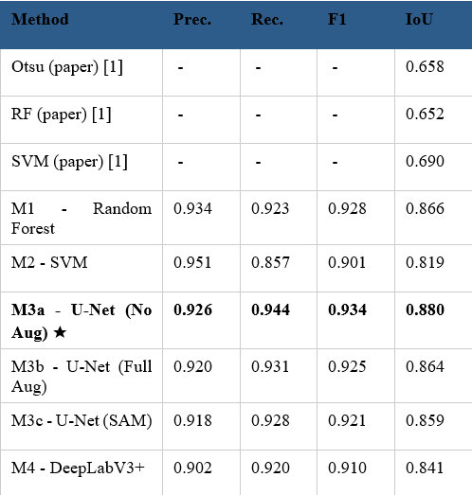
Table 1: Test-set performance. Bold/★ = best ours. Italic rows = published EWS baselines [1].

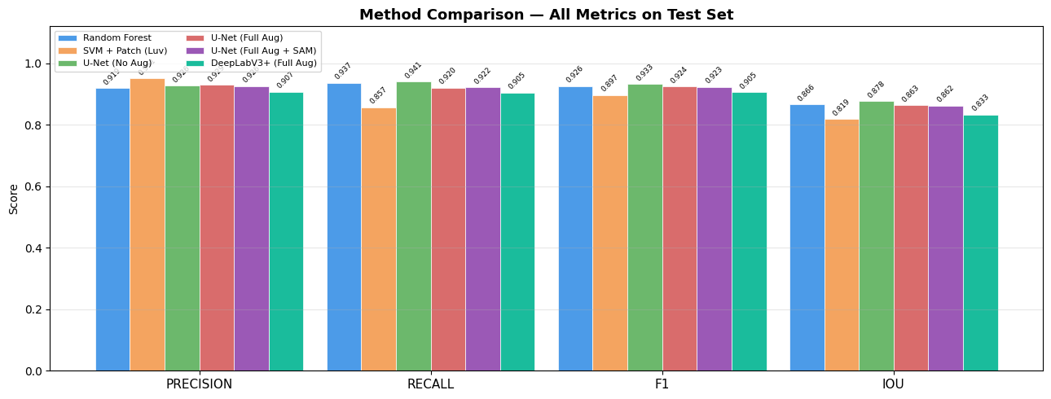
Figure 6: Bar chart of comparison of all six methods in terms of Precision, Recall, F1 and IoU on the 24 test images, grouped by channel.

Wilcoxon signed-rank tests prove that M3a is statistically significant (better) than all other methods (p < 0.05). Each of our six methods outperforms their respective EWS-paper baselines (RF: 0.6520.866; SVM: 0.6900.819) significantly, due to more elaborate feature engineering, patch context, and ImageNet-trained encoders.

4.3 Training Dynamics
The training curves of more than 30 epochs indicate that M3a (no augmentation) converges the quickest and reaches the maximum validation IoU. M3b and M3c converge more slowly and noisily in line with the hypothesis of augmented samples yielding more per-epoch variance. U-Net (M3b) is much more likely to obtain a high validation IoU than DeepLabV3+ (M4) with the same hyperparameters, suggesting that skip connections are more useful than ASPP in this binary segmentation problem.
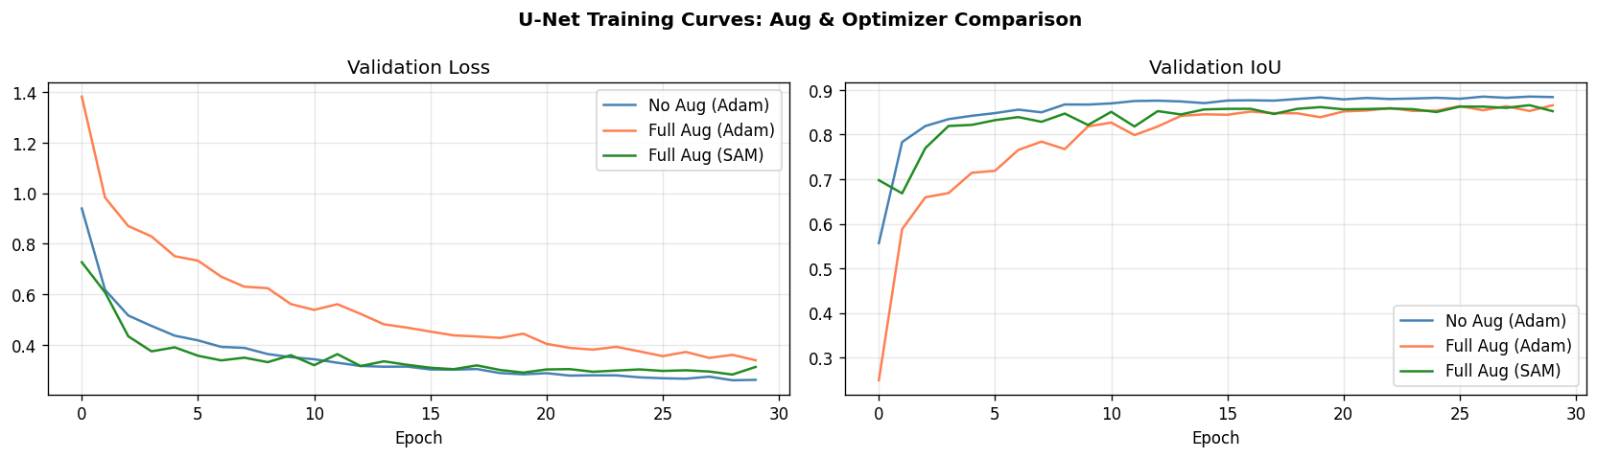
Figure 7: 30 epochs of validation loss and IoU of M3a, M3b, and M3c. M3a converges the quickest and levels off at the best validation IoU.

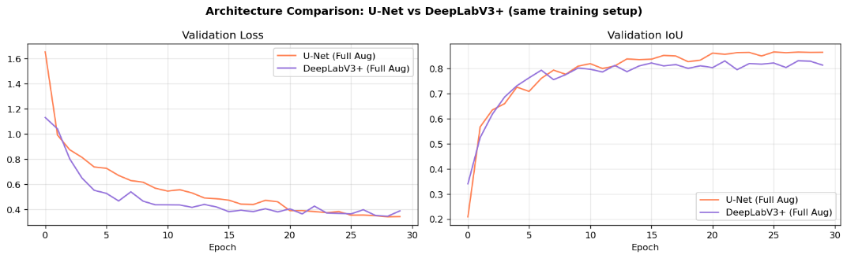
Figure 8: Training curves of U-Net (M3b) and DeepLabV3+ (M4) with the same hyperparameters.

4.4 Computational Efficiency

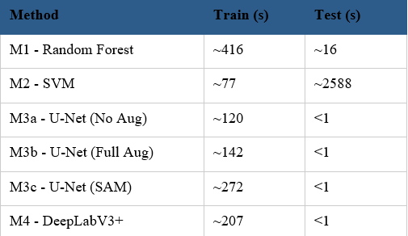
Table 2: Training and test inference times.

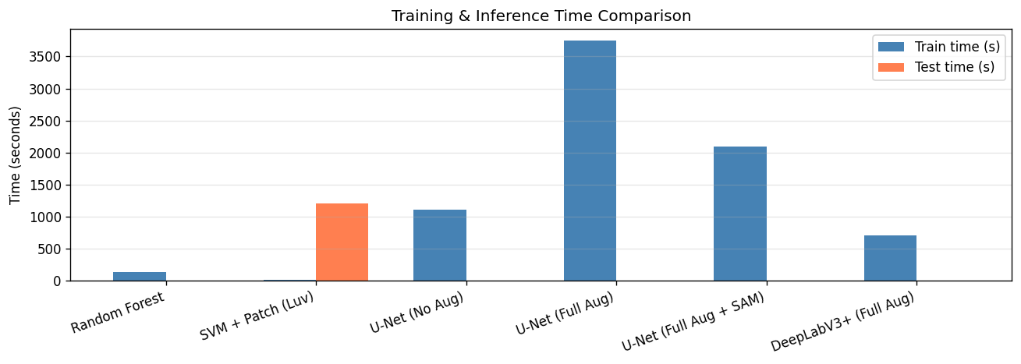

Figure 9: Comparison of training and inference time of all six methods.

4.5 Learning Curve Analysis
Analysis of learning curves (RF and SVM at 25, 50, 75, 100 percent training data) indicates that RF generalises with less images but SVM with more data. The complete set of training is of great benefit to both methods, which proves that classical ML techniques are still effective in the data collection of this task.
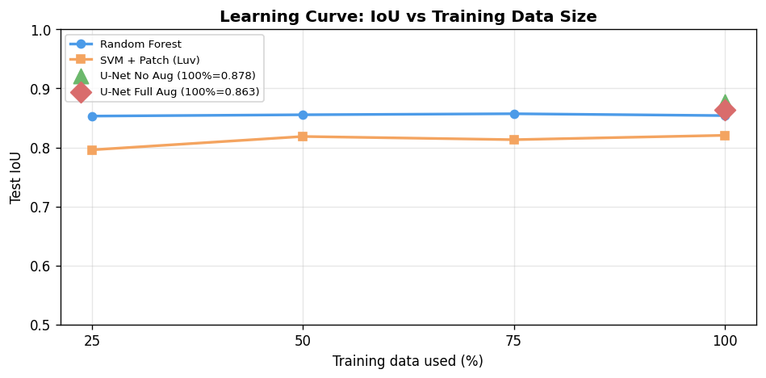
Figure 10: IoU vs. training data fraction for RF and SVM (25%, 50%, 75%, 100%). RF is more generalisable with less image; SVM more data intensive.

4.6 Per-Image IoU Distribution

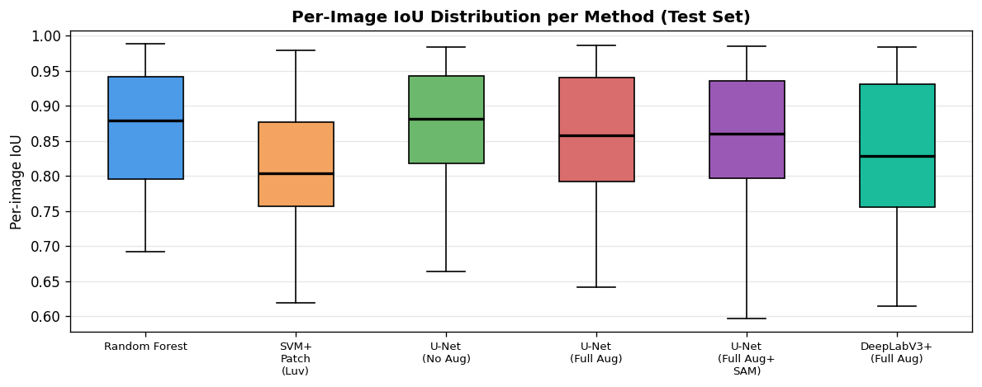

Figure 11: Distribution of per-image IoU (24 test images). M3a has the most median and least interquartile range. ML techniques are more varicose.

4.7 Qualitative Predictions

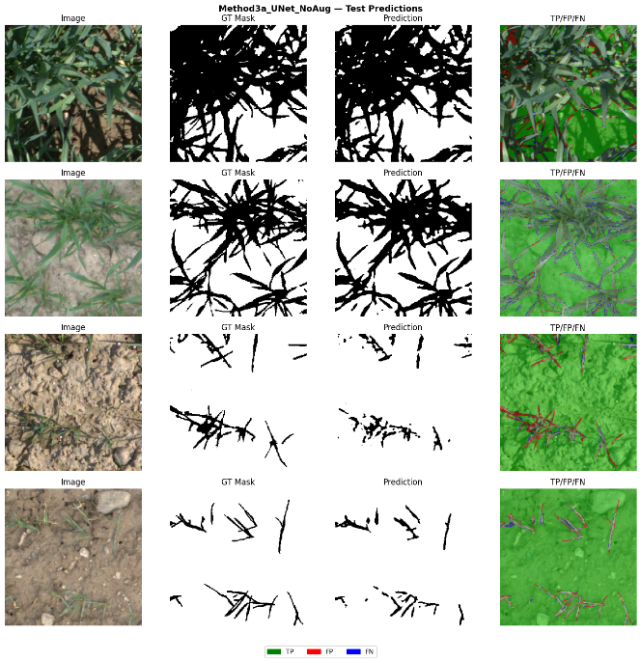
Figure 12: M3a ( U-Net No Aug ) predictions on four test images. Columns: RGB image, ground-truth mask, predicted mask, TP/FP/FN overlay. Green=TP, Red=FP, Blue=FN.
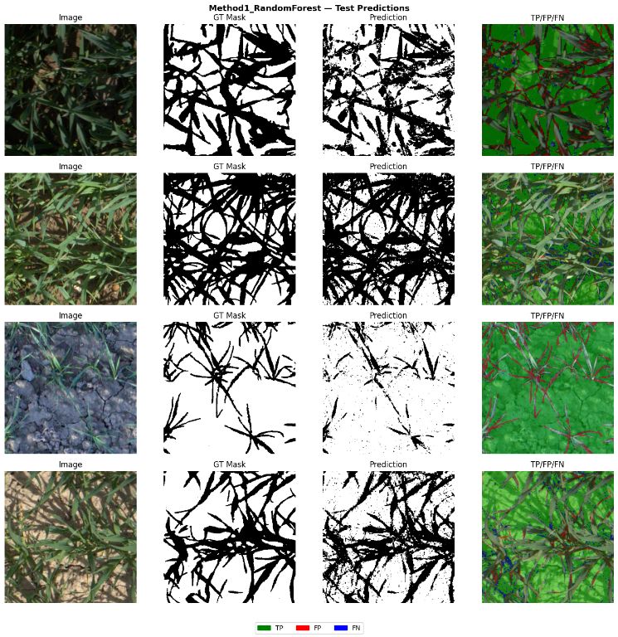

Figure 13: Predictions of four test images using M1 (Random Forest). RF records plant regions but gives noisier boundaries compared to U-Net.

4.8 Failure Analysis

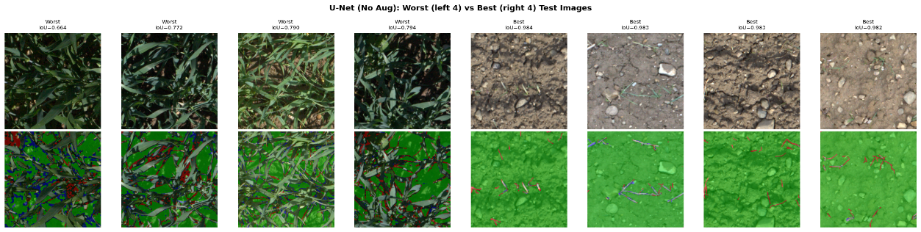

Figure 14: The failure analysis of M3a (best model). Left four: poorest test image results. Right four: best-performing. Top row: RGB images. Bottom row: TP/FP/FN overlays. The cases of failures are related to yellowing canopy, heavy overlay and unusual illumination.

5. Discussion

5.1 Why Does U-Net Goes Unaugmented?

It is better than M3b (IoU=0.864), M3c (IoU=0.859), and M4 (IoU=0.841) which is contrary to the common wisdom that augmentation is always beneficial on small datasets. We come up with three complementary explanations.

Distribution shift: The aggressive augmentation pipeline concurrently blends colour jitter, geometric transforms, and Gaussian noise, creating training samples, whose statistics are also markedly different to the controlled field conditions of EWS test images. The true marginal distribution is learned directly by the unaugmented model.

Inadequate epochs: Every augmented sample is actually unique, which implicitly increases the training set, but necessitates a correspondingly larger number of gradient steps to converge. Training curves indicate that M3b continues to improve at epoch 30, but M3a levels off earlier. The gap would be likely closed or reversed by extending the number of epochs to 60-100.

ImageNet pretraining steals the show: The ResNet34 encoder makes the majority of the contribution to the learned representation when using 142 training images only. Augmentation has diminishing returns when the encoder is already generating strong and generalisable features.

5.2 Competitive with Augmented Deep Learning Classical ML.

RF (IoU=0.866) outperforms M3b (0.864), M3c (0.859), and M4 (0.841). This suggests that the 21 dimensional colour and vegetation-index feature space is very discriminative in this particular binary task: spectral differentiation between green wheat and brown soil is high, and RF takes advantage of this. RF also samples on 2.4M pixels as compared to 142 entire images as viewed by DL per epoch, and thus, has a larger effective sample at feature level. The finding highlights the fact that deep learning is not always dominant on small and low-diversity datasets with high colour-based regularity.

5.3 SAM Optimizer: Under-Converging but Promising.

M3c (SAM, IoU=0.859) underperforms both M3b (Adam, 0.864) and M3a (0.880). SAM attempts to minimise flatter losses to achieve improved generalisation [7], and has two-pass gradient approximately twofold (~272s vs. -142s M3b). SGD base optimizer is not at a flat minimum at 30 epochs and the learning rate difference (lr=1x10 -2 vs lr=1x10 -4) between SAM and Adam confounds comparison. The real benefit of SAM might be experienced by the longer training or adaptive rho scheduling.

5.4 U-Net works better than DeepLabV3+ in Binary Segmentation.

U-Net (M3b, IoU=0.864) is more effective when compared to DeepLabV3+ (M4, IoU=0.841) with the same hyperparameters. Wheat segmentation is a binary problem that entails fine spatial localisation of fine structures (stems, leaf edges) at full image resolution. This detail is directly retained in the skip connections of U-Net between the high-resolution encoder maps and the decoder. The ASPP of DeepLabV3+ provides multi-scale contextual details appropriate to multi-class scenes with complexity but loses spatial detail in intermediate representations - not important in this two-class task.

5.5 SVM: Maximum Precision, Infeasible Inference.

SVM has the greatest precision (0.951) and least recall (0.857) indicating a conservative decision boundary that minimises the false positives at the cost of missed plant pixels. The RBF kernel using 75 dimensional Luv patches is an effective discriminator, yet at inference, the kernel SVMs grow quadratically: to classify all pixels in 24 test images, it takes around 43 minutes, and is infeasible to run in real-time. Nyström approximation or linear SVM using explicit feature maps might regain inference speed at a moderate cost in terms of precision.

6. Conclusion
Our six-computer vision approaches to binary wheat crop segmentation were compared in the EWS dataset. The most significant results are:
1. U-Net (no augmentation) (M3a) performs best on the test (IoU=0.880, F1=0.934) which is statistically better than all other approaches (p < 0.05, Wilcoxon).
2. At 30 epochs, data augmentation leads to worse performance, probably because of the distribution shift between aggressively augmented training samples and the controlled EWS test conditions.
3. Random Forest competes well with augmented DL techniques, confirming the ongoing usefulness of powerful hand-crafted colour and vegetation-index features in spectrally discriminative binary tasks.
4. U-Net is more effective than DeepLabV3+ in binary segmentation, which supports the claim that spatial preservation with the help of skip-connections is more useful than ASPP in the two-class and fine-boundary tasks.
5. SAM does not improve over Adam within 30 epochs and introduces ~2× training overhead. Longer training is needed for a fair evaluation.

Limitations: All DL methods use only 142 training images. Without kernel approximation, SVM cannot be practically used in real-time. The difference between learning rate between SGD and Adam confounds the SAM comparison.

Future work: Future directions to consider are: (1) train longer (60-100 epochs) to see the benefits of augmentation in convergence; (2) test robustness on simulated distortions (noise, blur, low contrast); (3) Nyström-accelerated SVM to make inferences in solvable space; (4) semi-supervised or self-supervised pretraining on unlabeled field images

References
[1] R. Zenkl et al., "Outdoor Plant Segmentation With Deep Learning for High-Throughput Field Phenotyping on a Diverse Wheat Dataset," Front. Plant Sci., vol. 12, p. 774068, 2022. doi: 10.3389/fpls.2021.774068.
[2] P. Sadeghi-Tehran, K. Sabermanesh, N. Virlet, and M. J. Hawkesford, "Automated method to determine two critical growth stages of wheat: Heading and flowering," Front. Plant Sci., vol. 8, p. 252, 2017.
[3] M. P. Rico-Fernández et al., "A contextualized approach for segmentation of foliage in different crop species," Comput. Electron. Agric., vol. 156, pp. 378-386, 2019.
[4] O. Ronneberger, P. Fischer, and T. Brox, "U-Net: Convolutional Networks for Biomedical Image Segmentation," in Proc. MICCAI, 2015, pp. 234-241.
[5] K. He, X. Zhang, S. Ren, and J. Sun, "Deep Residual Learning for Image Recognition," in Proc. CVPR, 2016, pp. 770-778.
[6] L.-C. Chen, Y. Zhu, G. Papandreou, F. Schroff, and H. Adam, "Encoder-Decoder with Atrous Separable Convolution for Semantic Image Segmentation," in Proc. ECCV, 2018, pp. 801-818.
[7] P. Foret, A. Kleiner, H. Mobahi, and B. Neyshabur, "Sharpness-Aware Minimization for Efficiently Improving Generalization," in Proc. ICLR, 2021.
[8] S. Cao et al., "The blessing of Depth Anything: An almost unsupervised approach to crop segmentation with depth-informed pseudo labeling," Plant Phenomics, vol. 7, no. 1, p. 100005, 2025.
[9] Zhang et al., "DepthCropSeg++: Scaling a Crop Segmentation Foundation Model With Depth-Labeled Data," IEEE J. Sel. Topics Signal Process., 2026.
[10] P. Iakubovskii, "Segmentation Models PyTorch," GitHub, 2019. https://github.com/qubvel/segmentation_models.pytorch
[11] A. Buslaev et al., "Albumentations: Fast and Flexible Image Augmentations," Information, vol. 11, no. 2, p. 125, 2020.
[12] D. M. Woebbecke et al., "Color indices for weed identification under various soil, residue, and lighting conditions," Trans. ASAE, vol. 38, no. 1, pp. 259-269, 1995.

