House Price Prediction
Internship Project
Prepared by Vinayak Ojha

1. Objective
The goal of this project is to predict residential house prices from structural and locational features, and to identify which features most strongly influence market value. Two regression models are built and compared: Linear Regression and Random Forest Regression.

2. Dataset
The dataset (Housing.csv) contains 200 records with 13 columns, including the target variable price and 12 predictor features covering physical attributes (area, bedrooms, bathrooms, stories, parking) and categorical/amenity attributes (mainroad, guestroom, basement, hotwaterheating, airconditioning, prefarea, furnishingstatus). No missing values were found; duplicate rows were dropped as a precaution and all categorical columns were one-hot encoded before modelling.

3. Methodology
- Data Loading&Exploration — loaded the CSV, inspected shape and data types, and confirmed there were no missing values.
- Data Cleaning — dropped nulls/duplicates and one-hot encoded the seven categorical columns.
- Model Building — split the data 80/20 into train and test sets (random_state=42) and trained a Linear Regression model and a Random Forest Regressor.
- Evaluation — compared models on Mean Absolute Error (MAE), Root Mean Squared Error (RMSE), and R² on the held-out test set.
- Visualization — plotted the price distribution, a feature-correlation heatmap, and an actual-vs-predicted scatter plot.

4. Exploratory Data Analysis

4.1 Distribution of House Prices
House prices are right-skewed, with most properties clustered in the lower-to-mid price range and a smaller number of higher-value outliers pulling the tail to the right.
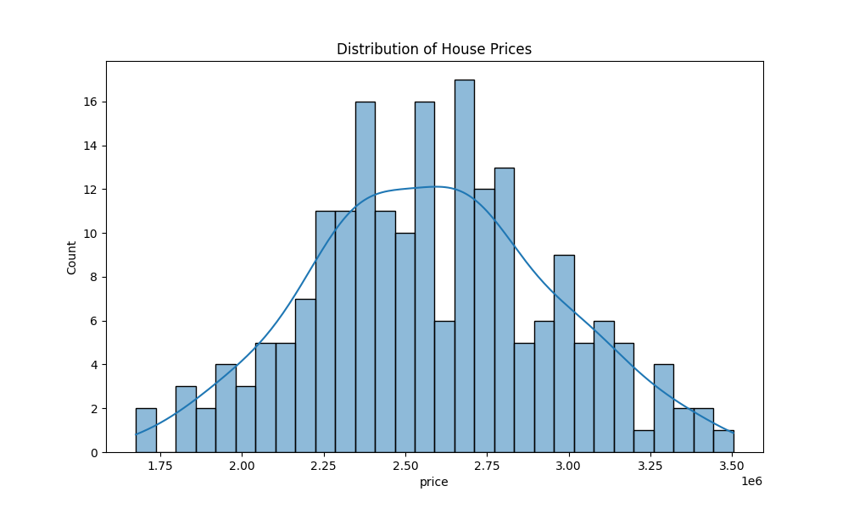

4.2 Feature Correlation with Price
The heatmap below ranks each feature's linear correlation with price. Area, number of bathrooms, air conditioning, and parking show the strongest positive correlations, followed by a main-road location and number of stories.
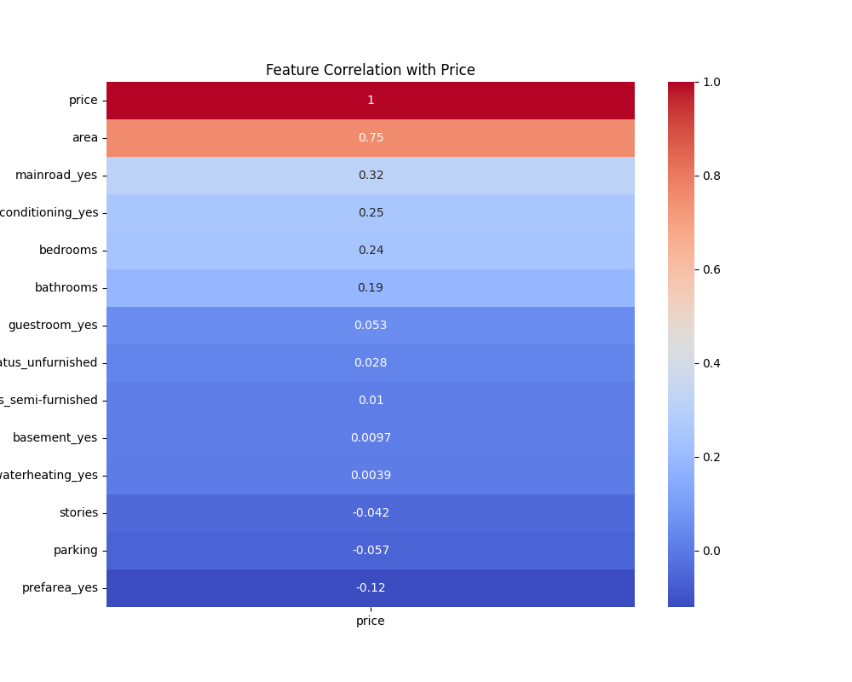

5. Model Results
Models were evaluated on the 20% held-out test split. Results:
Model | MAE | RMSE | R²
Linear Regression | 108,793 | 137,290 | 0.852
Random Forest | 132,580 | 181,662 | 0.741

On this dataset, Linear Regression generalized better than Random Forest on the test set, achieving lower error and a higher R² (0.85 vs. 0.74). This is a reasonable outcome given the small sample size (200 rows): the underlying relationship between features like area and price is fairly linear, while Random Forest's added flexibility offers little benefit and can overfit the training split. With a larger dataset or careful hyperparameter tuning (limiting tree depth, tuning n_estimators, cross-validation), the Random Forest's relative performance could improve.

5.1 Actual vs. Predicted Prices (Random Forest, test set)
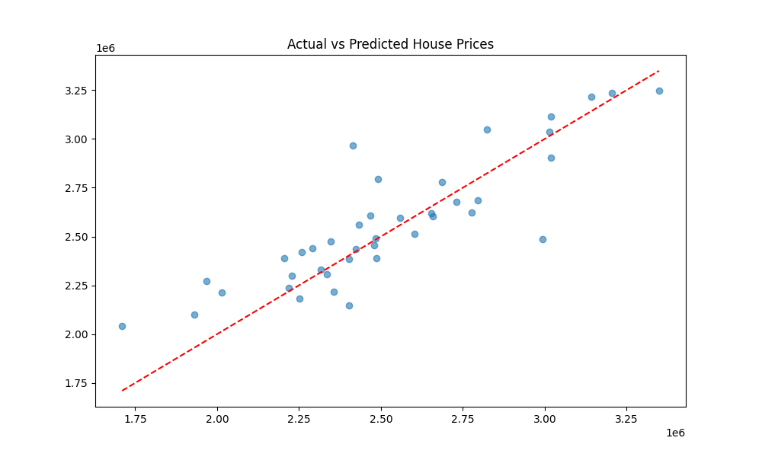

6. Insights&Summary
Area, number of bathrooms, air-conditioning status, and parking availability are the strongest drivers of property price in this dataset. A main-road location and higher furnishing level also contribute positively. Between the two models tested, Linear Regression was the more accurate and more consistent predictor on unseen data.

7. Recommendation for Real Estate Business
Marketing and pricing strategy should emphasize properties with air conditioning, generous area, and a main-road / preferred-area location, as these features are the strongest empirical drivers of higher valuations in this dataset. Agents can use the trained regression model as a quick sanity check to flag listings that look under- or over-valued relative to their features.

8. Next Steps
- Evaluate regularized linear models (Ridge, Lasso) and gradient-boosted trees for comparison.
- Tune Random Forest hyperparameters (max_depth, n_estimators, min_samples_leaf) via grid/randomized search.
- Use k-fold cross-validation for a more reliable performance estimate given the small sample size.
- Collect more data / additional features (location coordinates, age of property, school proximity) to improve accuracy.

