Low Level Design (add product module)

Project Code | Team 5
Project Name | Asset Management System

Prepared/Modified by | Role | Date of Preparation
Team 5 | Software Engineer | 01/11/2017
Reviewed by | Role | Date of Review
Prabhjot Singh,Rahul Yadav | Software Engineer | 01/11/2017
Approved by | Role | Date of Approval
Zainab F Kulkarni | Training Manager
Circulation List | shweta.a.tripathi@capgemini.com,  vinayak.kedia@capgemini.com,  sayantani.banerjee@capgemini.com,  snehal.bagade@capgemini.com,  rohit.khandagale@capgemini.com,  pranjali.gupta@capgemini.com,  rahul.mukherjee@capgemini.com. | Version Number of the template:1.0
Version Number | 1.0

Table of Contents

1. Description Of The Unit 3
2. References 4
3. Dependencies / Assumptions 5
4. Class Diagrams 6
5. Sequence Diagrams 7
6. Design Components 8
6.1 List Of UI Components 8
6.2 List Of Design Classes 8
7. Re-Usable Routines/Components 9
8. Messages 10
9. Configuration Files 11
10. Crud Matrix Table 12
11. Data Mapping Matrix 13
12. Action Flow Matrix 14
13. Stored Procedures 15
14. Program Specification / Pseudo Code 16
REVISION HISTORY OF THE WORK PRODUCT 17

Description Of The Unit

The Raise Request module allows the Manager of the application to raise a request for assets on behalf of his/her employees into the database. This module can be used by the manager of the application.

On clicking on the Raise Request button in the “ ” page, the manager is redirected to the Asset Request form page. The manager enters all the details of the asset like asset ID, allocation ID and asset quantity and insert request to the application. If the entered asset details are invalid, appropriate error messages are displayed.

After entering all the asset details, the details are inserted into the database on clicking the Raise Request button.

After raising the request, Manager can view status of the requests raised by him by clicking on the View Status button on the basis of Allocation ID.

References

Reference | Description
Repository reference | https://IGTEBLRSVNTNG.igatecorp.com/svn/B230Jul15PLPTeam5_JEE
Class Diagram | /Project Documents/Design Documents/HLD/Class Diagrams/ Class Diagrams
URS | /Project Documents/Requirements/Case Study/ Asset Management System .doc
UTP | /Project Documents/Test Plan/UTP/Test Case/ Test_Asset_Management_Module.xls
DB Design | /Project Documents/Design Documents/HLD/DB Design/ Asset Management System_Team5_DBDESIGN.xls

Dependencies / Assumptions
Dependencies:
The manager or admin should be logged in.

Assumptions:
The asset details are stored in the database.

Class Diagrams

Class Diagram

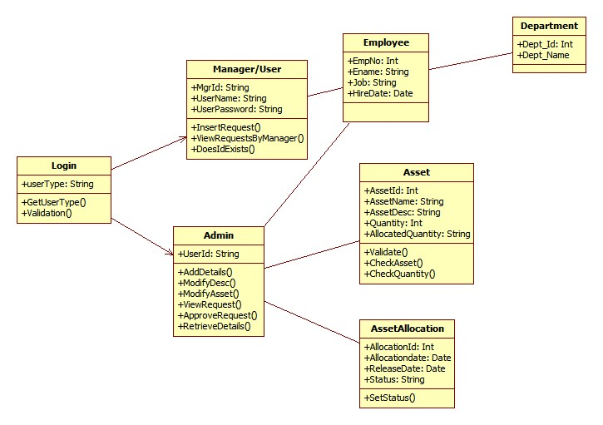

Sequence Diagrams
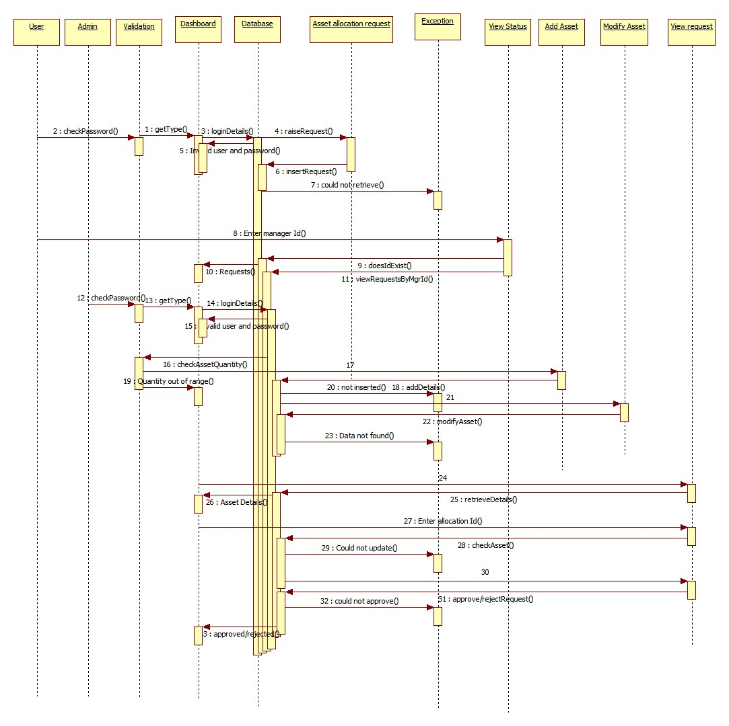

Design Components

List Of UI Components
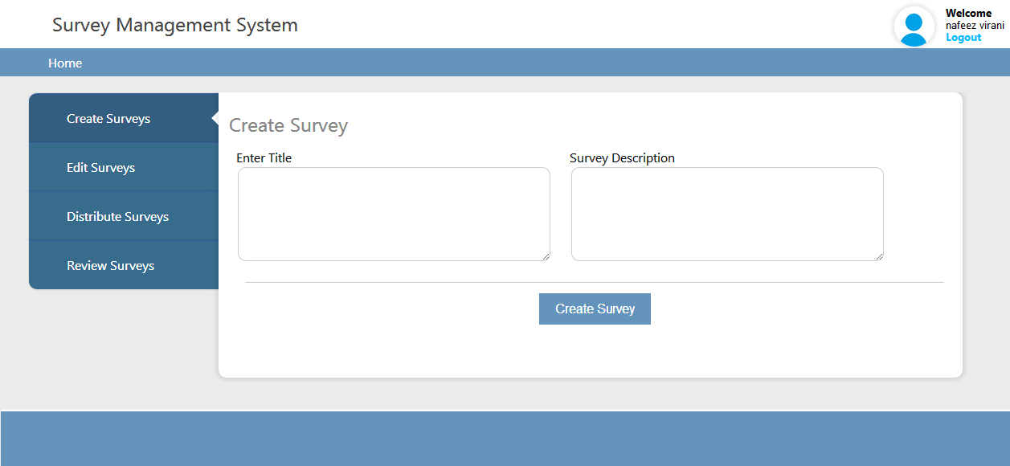
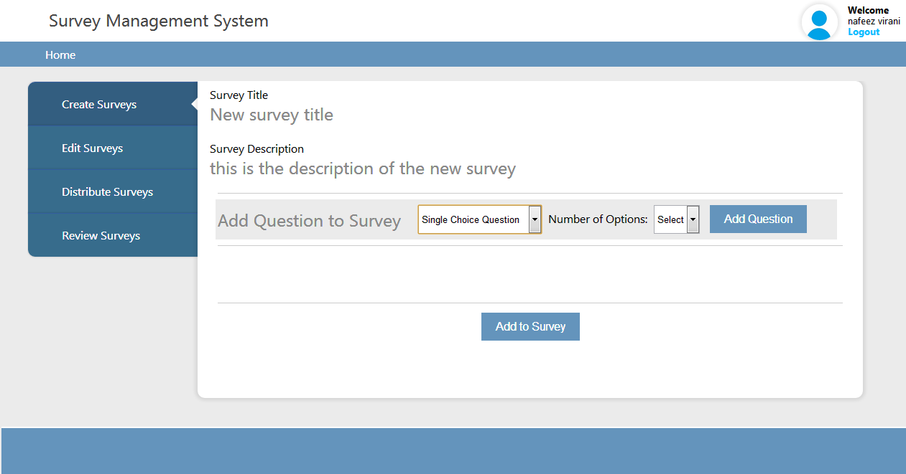

List Of Design Classes
Sr. No. | LLD Name | Class Name | Method Name | Method Description
1 | Manager/  User | Asset,  AssetAllocation,  Employee,  Login | Appropriate Getters and Setters methods | Getters and Setters are used to retrieve and set the property values respectively
2.1 | Manager/  User | AssetController, | Home(HttpServletRequest request,Model model): String  ModelAndView RaiseRequest(HttpServletRequest request,Model model)  InsertRequest(@ModelAttribute("allocation") @Valid AssetAllocation assetRequest ,BindingResult result,Model model,HttpServletRequest request): String  ModelAndView ViewStatus(@RequestParam("allocationId") int allocationId, HttpServletRequest request)  logoutAction(HttpServletRequest req,Model m): String | After successful login, it goes to the HomePage where we will get the two options  1. Raise Request 2.View Status  1. Raise Request  It sends allocationId and empId to the jsp page.  We will enter the quantity and based on that, data will be inserted into the table.  2. View Status  We will fetch the allocationId from the table and based on that the Asset Allocation Details will be displayed.  LogOut will go back to the Login page and the session will get expired
2.2 | Manager/  User | LoginController | goToIndex(Model model): String  check(@RequestParam("userName") String username, @RequestParam("userPassword") String password,Model model,HttpServletRequest request): String  againToIndex(Model model): String | It will go to login details page which will ask for the login details  After inserting the login details if it is not valid it will redirect to the same login page, otherwise it will go to the HomePage.  After session expires it will ask again for the login details.
3 | Manager/  User | AssetAllocationService | AssetAllocation addAssetRequest(AssetAllocation assetRequest,String mgrId)  List<String> getAssetIds()  List<String> getEmpIds(String mgrId)  Login getLoginDetails(String username, String password)  ArrayList<AssetAllocation> viewRequestIds(String empno)  String checkQuantity(String assetNo)  List<AssetAllocation> viewStatus(int allocationId) | Calls all the methods of AssetDao class and returns the result to AssetController
4 | Manager/  User | AssetDao | AssetAllocation addAssetRequest(AssetAllocation assetRequest,String mgrId)  List<String> getAssetIds()  List<String> getEmpIds(String mgrId)  Login getLoginDetails(String username, String password)  ArrayList<AssetAllocation> viewRequestIds(String empno)  String checkQuantity(String assetNo)  List<AssetAllocation> viewStatus(int allocationId) | Inserting the asset details into the database and returns the result to AssetAllocationService.

e-Usable Routines/Components

Re-Usable Routines/Components

- CSS files
- Javascript files
- DataAccessException class
- Database properties files
- Logger properties files

Messages

#. | Type | Message Text
M1 | Error | User Name required
M2 | Error | Password required
M3 | Error | Invalid Username Invalid Password.
M4 | Error | Quantity should be digit between 0 and 10.

Configuration Files

File Name | Path | Description
dbinfo.properties | /Development/Source | To configure database connection.
Web.xml | /Development/Source | To configure the bean properties.
Dispatcher-servlet.xml | /Development/Source | To configure the request mapping and view resolver.
log4j.properties | /Development/Source | To configure the logger.

Crud Matrix Table

# | Table Name | Create | Read | Update | Delete
1. | USER_MASTER | Y | Y | N | N
2. | EMPLOYEE | Y | Y | N | N
3. | DEPARTMENT | Y | Y | N | N
4. | ASSET | Y | Y | Y | Y
5. | ASSET_ALLOCATION | Y | Y | Y | Y
6. | SEQ_ASSET_ID | Y | Y | N | N
7. | SEQ_ALLOCID | Y | Y | N | N

Action Flow Matrix

Sr. No. | Action | Description | Process
1 | On click of the Raise Request button in Asset Management System | Gets the drop down for Asset ID, Employee ID and textbox for Quantity | The Manager clicks on the Submit button in the Assetpage and gets the Request ID of the request.
2 | On click of the View Request button in Asset Management System | Gets the drop down for Allocation ID | After selecting the Allocation ID Manager can see the all the raise requests and the request details.
3 | On click of the Logout  Manager can logout from the application. | Manager can logout from the application. | After click on the Logout button Manager can logout from the application and control goes to the login page.

Stored Procedures

# | Stored Procedure Name  (with Description) | Input/Out Parameters | Type | Size
1. | NA | NA | NA | NA

Program Specification / Pseudo Code

<ACTION: LOGIN_CLICK >

Enter the USERNAME and PASSWORD
BEGIN
- Textbox is used to enter the username and password
- Client Side Scripting(validation):
If username or password is empty then
Display ”This Field is required”

If username or password is incorrect then
Display ”Invalid UserName ,Invalid Password”

- Server Side Scripting(validation):

BEGIN
Call check(@RequestParam() String username, @RequestParam() String password) in LoginController class
Redirect to Asset/Home.asset controller.

END

<ACTION:RAISE_REQUEST_CLICK >

Add asset
BEGIN
One dropdown for AssetId.
One dropdown for EmployeeId
Textbox to enter quantity

Client Side Scripting(validation):
BEGIN

Enter the asset quantity
If(assentQuantity<0)
DISPLAY “ Asset Quantity should be between 0 to 10”
If(assentQuantity>10)
DISPLAY “ Asset Quantity should be between 0 to 10”

END

- Server Side Scripting(validation):
CALL InsertRequest(@ModelAttribute("allocation") @Valid AssetAllocation assetRequest ,BindingResult result,Model model,HttpServletRequest request)

Redirect to "views/RequestForm" controller;

call RaiseRequest(HttpServletRequest request,Model model)
return new ModelAndView("views/RequestForm","allocation",new AssetAllocation());
Redirect to views/RequestForm controller;
END

<ACTION:VIEW_REQUEST>

BEGIN

- Drop Down
- Client Side Scripting(validation):
None
- Server Side Scripting(validation):
BEGIN

call ViewStatus(@RequestParam("allocationId") int allocationId, HttpServletRequest request,Model model)

return new ModelAndView("views/RequestForm","allocation",new AssetAllocation());

Redirect to views/RequestForm controller;

END

REVISION HISTORY OF THE WORK PRODUCT

# | Date | Version # | Section Changed | Details of changes made | Approved By
1 | O7/11/2017 | 1.0 | LLD prepared | N/A

