**A MINI PROJECTREPORT**

**ON**

**“DRISTHI”**

Submitted in the partial fulfillment of the requirements for

The degree of

**BACHELOR OF ENGINEERING IN COMPUTER ENGINEERING**

**By**

VINAYAK SHINDE

NIIKHIL BHOIR

SUJAL JADHAV

**UNDER THE GUIDANCE OF**

**Prof.** Pallavi Kharat



Department of Computer Engineering  
Saraswati College of Engineering, Kharghar, NaviMumbai  
University of Mumbai  
2023-2024

**Saraswati College of Engineering**

**Vision**

To be universally accepted as autonomous center of learning in engineering education and research.

**Mission**

* To educate Students to become responsible & quality technocrats to fulfill society and industry needs.
* To nurture student’s creativity and skills for taking up challenges in all facets of life.

**Department of Computer Engineering**

**Vision**

To be among renowned institution in computer engineering education and research by developing globally competent graduates.

**Mission**

* To produce eminent Engineering graduates by imparting quality teaching learning and providing hands on experience in programming to fulfill society and industry needs.
* To encourage students to pursue research and learn new technologies in Computer Engineering and across interdisciplinary areas so that they participate in research, innovation and entrepreneurship.
* To provide stimulating learning ambience to enhance innovative ideas, problem solving ability, leadership qualities, team-spirit and ethical responsibilities.



**(Approved by AICTE, recg. By Maharashtra Govt. DTE ,Affiliated to Mumbai University)**

**PLOT NO. 46/46A, SECTOR NO 5, BEHIND MSEB SUBSTATION, KHARGHAR, NAVI MUMBAI-410210**

**Tel. : 022-27743706 to 11 * Fax : 022-27743712 * Website: www.sce.edu.in**

**CERTIFICATE**

*This is to certify that the requirements for the project report entitled ”****Smart Cradle System****” have been successfully completed by the following students:*

Roll numbers Name

27 Vinayak Shinde

05 Nikhil Bhoir

15 Sujal Jadhav

In partial fulfillment of Sem –VI , **Bachelor of Engineering of Mumbai University in Computer Engineering** of Saraswati college of Engineering , Kharghar during the academic year 2023-24.

**Internal Guide**  **External Examiner**

Prof.Pallavi Kharat

**Project Co-ordinator**  **Head of Department**

Dr. AnajaliDhadich Prof. Sujata Bhairnallykar

**Principal**

Dr. Manjusha Deshmukh



**DEPARTMENT OF COMPUTER ENGINEERING**

**PROGRAM EDUCATIONAL OBJECTIVE’s**

1. To embed a strong foundation of Computer Engineering fundamentals to identify, solve, analyze & design real time Engineering problem as a professional or an entrepreneur for the benefit of society.
2. To motivate & prepare students for lifelong learning & research to manifest global competitiveness.
3. To equip students with communication, team work & leadership skills to accept challenges in all facets of life ethically.



**DEPARTMENT OF COMPUTER ENGINEERING**

**PROGRAM OUTCOMES**

1. Apply the knowledge of Mathematics, Science and Engineering Fundamentals to solve complex Computer Engineering Problems.
2. Identify, formulate and analyze Computer Engineering Problems and derive conclusion using First Principle of Mathematics, Engineering Science and Computer Science.
3. Investigate Complex Computer engineering problems to find appropriate solution leading to valid conclusion.
4. Design a software System, components, Process to meet specified needs with appropriate attention to health and Safety Standards, Environmental and Societal Considerations.
5. Create, select and apply appropriate techniques, resources and advance engineering software to analyze tools and design for Computer Engineering Problems.
6. Understand the Impact of Computer Engineering solution on society and environment for Sustainable development.
7. Understand Societal, health, Safety, cultural, Legal issues and Responsibilities relevant to Engineering Profession.
8. Apply Professional ethics, accountability and equity in Engineering Profession.
9. Work effectively as a member and leader in multidisciplinary team for a common goal.
10. Communicate effectively within a Profession and Society at large.
11. Appropriately incorporate principles of Management and Finance in one’s own Work.
12. Identify educational needs and engage in lifelong learning in a Changing World of Technology.



**DEPARTMENT OF COMPUTER ENGINEERING**

**PROGRAMME SPECIFIC OUTCOME**

1. Formulate and analyze complex engineering problems in computer engineering (Networking/Big data/ Intelligent Systems/Cloud Computing/Real time systems).
2. Plan and develop efficient, reliable, secure and customized application software using cost effective emerging software tools ethically.

**DECLARATION**

I declare that this written submission represents my ideas in my own words and where others’ ideas or words have been included. I have adequately cited and referenced the original sources. I also declare that I have adhered to all principles of academic honesty and integrity and have not misrepresented or fabricated or falsified any idea/data/fact/source in my submission. I understand that any violation of the above will be cause for disciplinary action by the Institute and can also evoke penal action from the sources which have thus not been properly cited or from whom proper permission has not been taken when needed.

* VINAYAK SHINDE
* NIIKHIL BHOIR
* SUJAL JADHAV

Date:

**ACKNOWLEDGEMENT**

After the completion of this work, words are not enough to express feelings about all those who helped us to reach goal.

It’s a great pleasure and moment of immense satisfaction for us to express my profound gratitude to **Project Guide**, **Prof. Pallavi Kharat,** whose constant encouragement enabled us to work enthusiastically. His perpetual motivation, patience and excellent expertise in discussion during progress of the project work have benefited us to an extent, which is beyond expression.

We would also like to give our sincere thanks to **Prof. Sujata Bhairnallykar, Head of Department**, and **Dr. Anjali Dadhich**, Project **Co-ordinator** from Department of Computer Engineering, Saraswati college of Engineering, Kharghar, Navi Mumbai, for their guidance, encouragement, and support during a project.

I am thankful to **Dr. Manjusha Deshmukh, Principal,** Saraswati College of Engineering, Kharghar, Navi Mumbai for providing an outstanding academic environment, also for providing the adequate facilities.

Last but not the least we would also like to thank all the staffs of Saraswati college of Engineering (Computer Engineering Department) for their valuable guidance with their interest and valuable suggestions brightened us.

* VINAYAK SHINDE
* NIIKHIL BHOIR
* SUJAL JADHAV

**ABSTRACT**    
  
  
  
Navigation presents a significant challenge for individuals with visual impairments,

impacting their independence and mobility in various environments. Existing assistive

technologies often rely on single sensory modalities, such as auditory cues or tactile

feedback, which may not provide sufficient information for safe and efficient

navigation. To address this limitation, we present a novel multi-sensory navigation

prototype designed specifically to enhance the independence of blind individuals in

indoor environments.

Our prototype integrates cutting-edge technologies, including computer vision,

auditory feedback, tactile interfaces, and haptic feedback mechanisms, to create a

comprehensive navigation system. Utilizing computer vision algorithms, the prototype

continuously scans the user's surroundings, detecting obstacles and identifying key

landmarks in real-time. This visual information is then processed and translated into

multi-modal feedback, including audio instructions and tactile/haptic cues, providing

users with intuitive guidance and spatial awareness.

The auditory feedback component delivers clear and context-sensitive instructions,

guiding users towards their intended destination while alerting them to potential

obstacles or hazards. Tactile interfaces embedded within wearable devices provide

additional spatial information, such as directional cues and proximity warnings,

through subtle vibrations or tactile patterns. Furthermore, haptic feedback mechanisms

offer dynamic directional cues, aiding users in navigating complex environments with

greater ease and confidence.

**Table of Contents**

|  |  |
| --- | --- |
| **List of Figures ………………………………………………………………………...** | **1** |
| **1. Introduction ………………………………………………………………………..** | **2** |
| **1.1 General ……………………………………………………………………..….** | **2** |
| **1.2 Objective and problem statement ……………………………........................** | **3** |
| **2. Methodology ……………………………………………………………….............** | **6** |
| **2.1 Algorithmic details .…………………………………………………………...** | **6** |
| **2.2 Hardware and Software requirements……………………………..............** | **12** |
| **2.3 Design Details…………………………………………………………………** | **13** |
| **3. Implementation and Results …………………………………………………….** | **15** |
| **3.1. Implementation ....………………………………………………….................** | **15** |
| **3.2. Results ...………………………………………………………………............** | **16** |
| **4.Conclusion and Future Scope……………………………………………………..** | **18** |
| **5. References………………………………………………………………...........** | **19** |

1. **Introduction**

Drishti is an IoT-based assistive device designed to aid visually impaired individuals in navigating their surroundings safely. The device integrates ultrasonic sensors for obstacle detection, a Raspberry Pi for processing sensor data, and object detection using a Raspberry Pi camera. Drishti also incorporates the Google Maps API to provide voice-based guidance and assistance to the user.

For individuals with visual impairments, navigating indoor environments presents a complex and often daunting challenge, significantly impacting their independence and quality of life.

Unlike outdoor settings wherelandmarks and auditory cues may aid navigation, indoor spaces arecharacterized by intricate layouts, dynamic obstacles, and varying environmental conditions, posing unique barriers to mobility. Traditional assistive technologies, primarily relying on auditory instructions or tactile feedback, offer limited support in addressing the multifaceted navigation needs of blind individuals within indoor settings.

# **General**

We explore the integration of computer vision algorithms for real-time obstacle detection and landmark recognition, the implementation of auditory feedback systems to deliver context-aware instructions, and the incorporation of tactile and haptic interfaces to provide tactile and kinesthetic cues. Furthermore, we present preliminary testing results and user feedback, highlighting the efficacy and potential impact of our prototype in improving the navigation experience for blind individuals. Through the development and evaluation of this innovative assistive technology, we endeavor to empower blind individuals with the freedom to navigate indoor environments with confidence, autonomy, and dignity. By addressing the complex challenges of indoor navigation, our multisensory prototype represents a significant step towards enhancing the quality of life and independence of individuals with visual impairments.

# **Objective and problem statement**

# The problem statement for Drishti, the IoT-based assistive device for visually impaired individuals, could be framed as follows:

# "Despite advancements in technology, visually impaired individuals still face significant challenges in navigating their surroundings independently and safely. Traditional methods of navigation, such as using a cane or guide dog, have limitations and may not always provide accurate information about obstacles or directions. There is a need for an innovative solution that leverages IoT technology to enhance the mobility and autonomy of visually impaired individuals by providing real-time feedback and assistance in navigating complex environments."

# List of Figures

| **Figure No.** | **Name** | **Page No.** |
| --- | --- | --- |
| 2.1.1 | circuit diagram | 5 |
| 2.1.2 |  | 5 |
| 3.1.1 | Display Moisture Level | 9 |
| 3.2.1 | Arduino UNO Board | 10 |
| 3.2.2 | Dristhi Drototype System | 11 |
|  |  |  |
|  |  |  |
|  |  |  |
|  |  |  |
|  |  |  |
|  |  |  |
|  |  |  |

**CHAPTER 1**

# INTRODUCTON

**1.1 GENERAL**

In the world of infant care, technological advancements have continually aimed to enhance the safety, comfort, and convenience of nurturing young children. The Smart Cradle System epitomizes this by integrating modern automation technologies into a traditional baby cradle. Utilizing an Arduino Uno as the central control unit, this system combines a moisture sensor, a servo motor, and an OLED display to create a responsive and interactive environment for infants.

The primary function of the Smart Cradle System is to detect moisture within the cradle, an indicator of a wet diaper, which can cause discomfort and distress to the baby. Upon detection, the Arduino Uno processes this input and orchestrates multiple responses to mitigate the issue. This includes alerting the caregiver through an innovative OLED display interface, which provides immediate and clear notifications about the moisture level in the cradle. Simultaneously, a servo motor is activated to initiate a gentle swinging motion, designed to soothe and comfort the infant until further care can be provided.

Through this system, we aim to demonstrate how combining simple electronic components and modern technology can significantly elevate the standard of infant care, providing both practical utility and peace of mind to caregivers.

## 1.2 OBJECTIVE AND PROBLEM STATEMENT

1. Enhance Infant Comfort: To utilize technology to detect and respond to discomfort caused by moisture, ensuring the infant remains dry and comfortable. The immediate detection and response system aims to reduce the discomfort time frame, enhancing the overall well-being of the infant.

2. Improve Caregiver Responsiveness: To provide real-time alerts to caregivers through an OLED display when the moisture sensor detects wetness.

3. Automate Cradle Movement: To integrate a servo motor that triggers a gentle swinging motion automatically upon moisture detection, soothing the baby and potentially easing them back to sleep without immediate caregiver intervention.

4. Safety and Security: To design the system with paramount safety features that prevent any possible harm to the infant. This includes securely housing all electronic components and ensuring the cradle's motion is smooth and stable.

5. User-Friendly Interface: To develop a simple and intuitive interface on the OLED display that can be easily operated by caregivers, regardless of their technological expertise. The interface will display essential information about the baby’s status and system operations clearly and concisely.

6. Energy Efficiency: To ensure that the Smart Cradle System operates on minimal power, making it energy-efficient and capable of running for extended periods without requiring frequent battery changes or high power consumption.

7. Scalability and Customization: To design the system so that it can be easily customized and scaled for different needs and environments. This includes adding more sensors, like temperature and sound, or integrating with broader smart home systems.

**CHAPTER 2**

# METHODOLOGY

## 2.1 ALGORITHMIC DETAILS

Algorithm:

1. Start

2. Initialize the Arduino Uno microcontroller.

3. Set up the moisture sensor, servo motor, and OLED display with appropriate configuration

4. Display a notification on the OLED screen

5. If moisture is detected Activate the servo motor to initiate a gentle swinging motion.

6. Swing the cradle until the sensor no longer detects moisture.

7. Once the period ends or moisture is no longer detected, slowly bring the cradle back to a stationary position.

8. End

**Circuit Diagram:-**

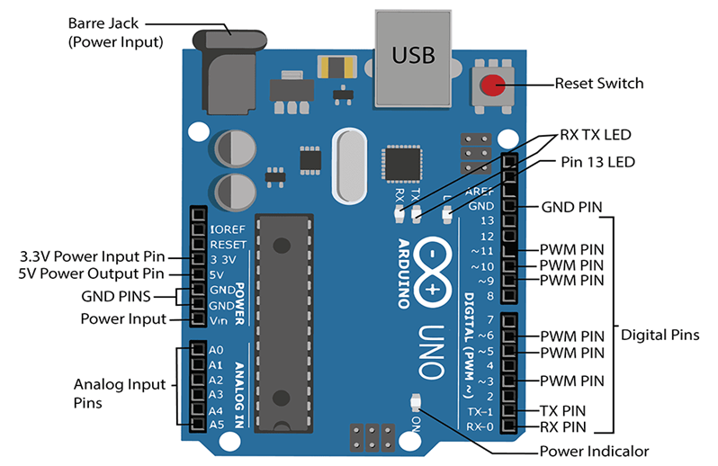

Fig 2.1.1: Arduino Uno Circuit diagram

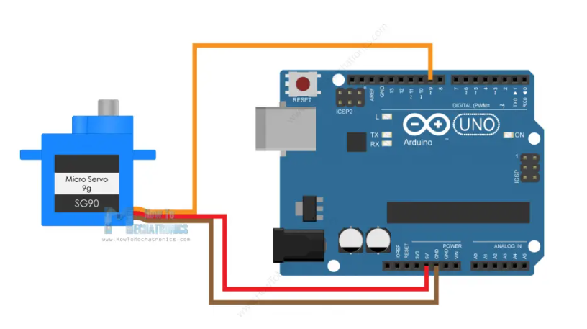Fig 2.1.2: Servo Motor and Arduino UNO Wiring

## 2.2 HARDWARE AND SOFTWARE REQUIREMENTS

**2.2.1 HARDWARE REQUIREMENTS**

1. RAM :512 MB RAM
2. Hard Drive :40 GB Hard Drive
3. Processor : Intel Core 2 Processor
4. Arduino UNO
5. Moisture Sensor
6. Servo Motor
7. Bread Board
8. OLED Display

**2.2.2 SOFTWARE REQUIREMENTS**

1. Arduino IDE

**2.3 DESIGN DETAILS :**

Arduino Uno: The Arduino Uno is a microcontroller board based on the ATmega328P. It includes 14 digital input/output pins (of which 6 can be used as PWM outputs), 6 analog inputs, a 16 MHz quartz crystal, a USB connection, a power jack, an ICSP header, and a reset button. It is a versatile board that is commonly used for building digital devices and interactive objects that can sense and control the physical world.

Servo Motor: A servo motor is a rotary actuator or linear actuator that allows for precise control of angular or linear position, velocity, and acceleration. It consists of a suitable motor coupled to a sensor for position feedback. Servo motors are commonly used in applications such as robotics, CNC machinery, or automated manufacturing.

Moisture Sensor: A moisture sensor measures the volumetric water content in soil or detects moisture levels in other materials. In the context of your project, such a sensor can be used to detect the presence of wetness (like in a diaper). These sensors typically use resistive or capacitive measurement principles to determine the moisture level.

OLED Display: OLED (Organic Light Emitting Diode) displays are a type of display technology characterized by thin, flexible screens made from organic light-emitting diodes. OLEDs provide clearer screens with greater contrast and wider viewing angle compared to LCDs. They are used in applications where you need to display rich colour and high levels of brightness and contrast in a compact format. OLED displays can be controlled via I2C or SPI communication protocols, which make them compatible with microcontrollers like the Arduino Uno.

Each of these components can be interfaced with the Arduino Uno to create complex systems such as your smart cradle system, leveraging the Arduino’s capability to process and react to real-time inputs and manage outputs like motor control and display feedback.

**CHAPTER 3**

# IMPLEMENTATION AND RESULTS

**3.1 IMPLEMENATAION:**

* Place the Moisture sensor inside the cradle
* Connect the Arduino UNO with the Laptop for power supply
* As soon as the sensor senses any moisture, the Servo motor starts rotating the cradle.
* And the OLED display shows the Moisture level i.e. HIGH when moisture detected and low when moisture not detected.

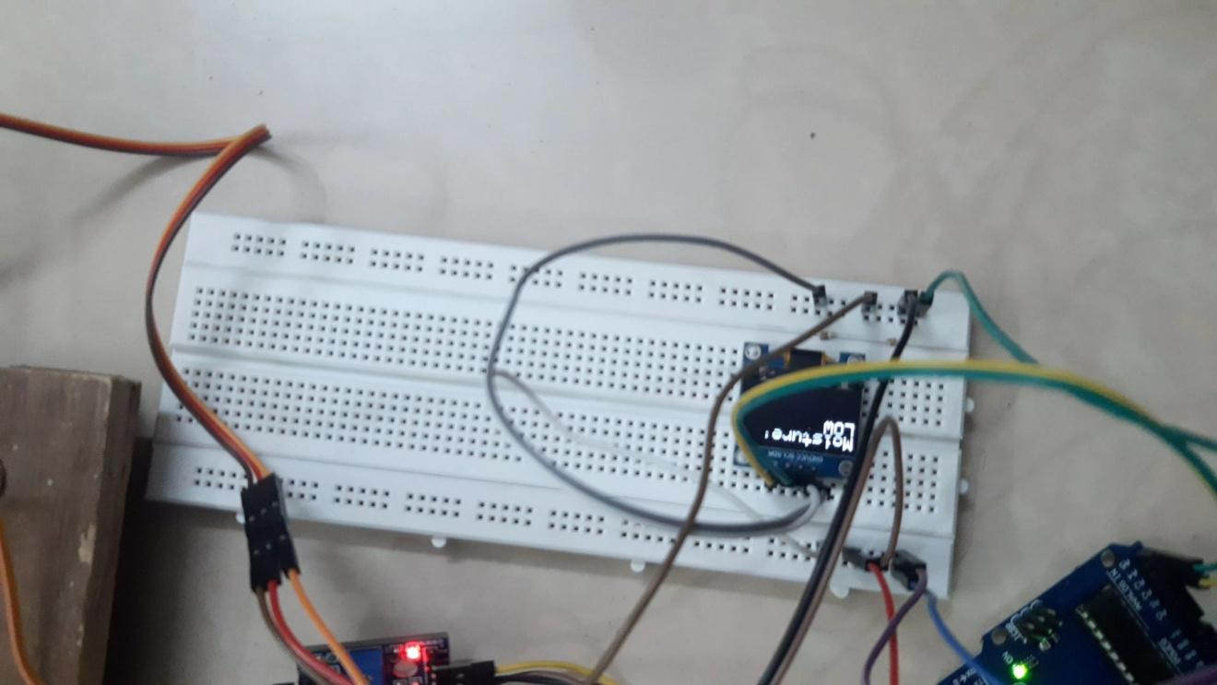

Fig 3.1.1: Display Moisture Level

**3.2 RESULTS:**

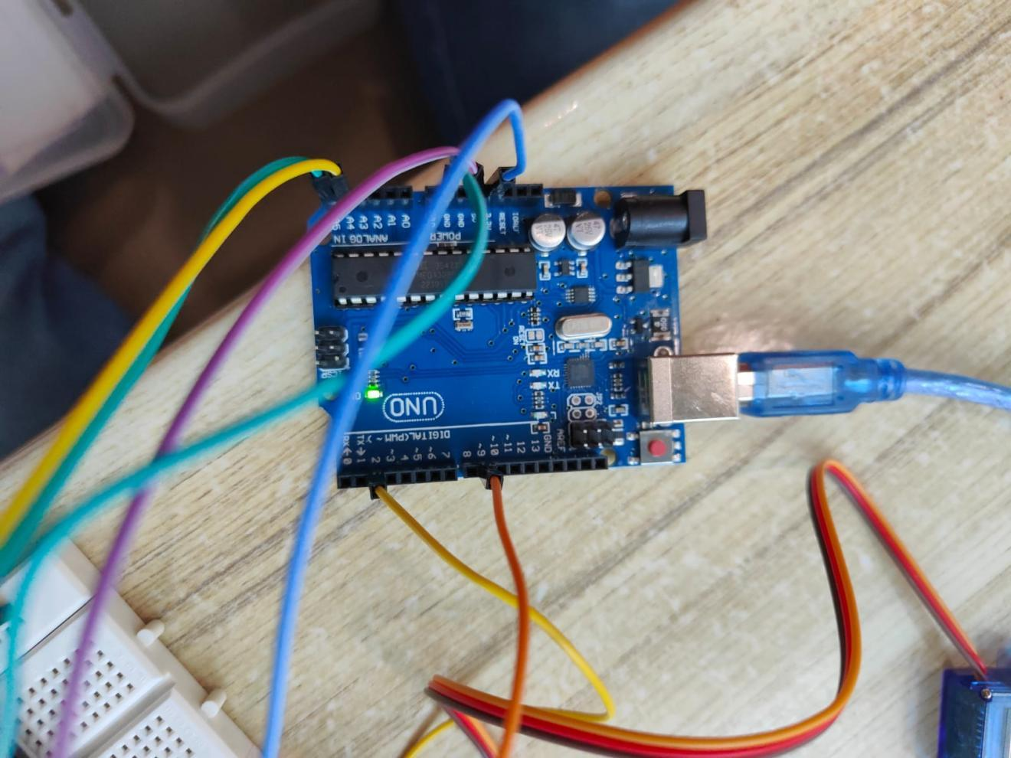

Fig 3.2.1: Arduino UNO Board

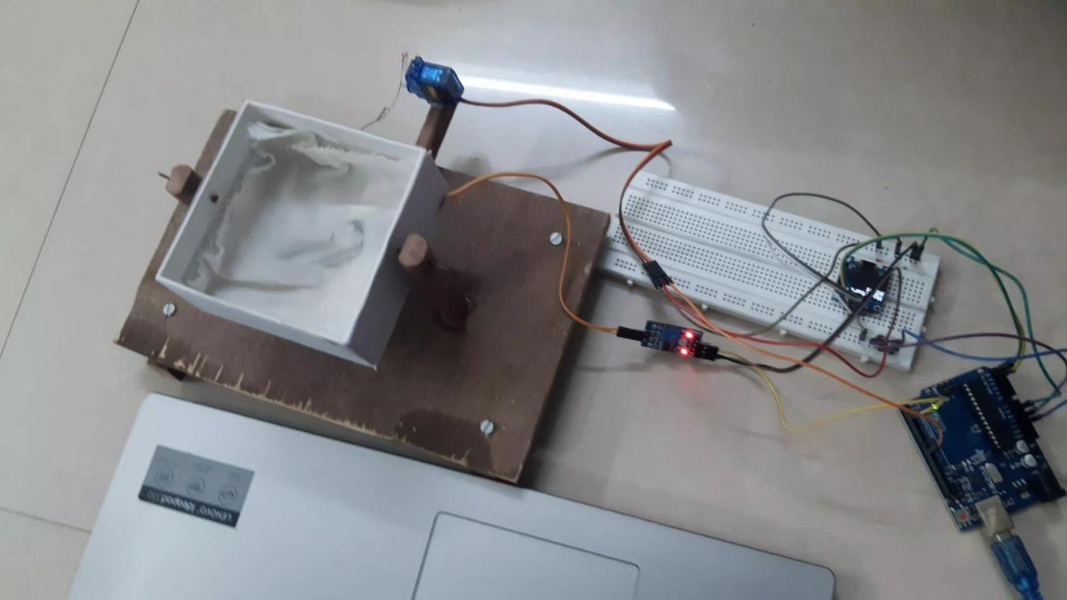

Fig 3.2.2: Smart Cradle System

**CHAPTER 4**

# CONCLUSION AND FUTURE SCOPE

The system is designed with safety and energy efficiency in mind. It includes features such as automatic shut-off once the baby is removed from the cradle, and adjustable swing speeds that can be controlled through the mobile app. Moreover, all components are securely enclosed to prevent any direct contact with the baby, ensuring utmost safety.

In the future we can modify this project by enabling remote monitoring and control through a smart phone app, allowing caregivers to adjust settings and receive alerts. Incorporate temperature and sound sensors to automatically adjust conditions based on the baby's comfort and respond to cries. Utilize AI to learn and adapt to the baby's preferences for more personalized care. Allow for add-ons such as mobiles, cameras, and additional environmental sensors to cater to evolving caregiver and infant needs.

Overall, the Smart Cradle System aims to merge traditional child care methods with modern technology to create a nurturing environment that is both safe and comforting for infants, while also enhancing the care-giving experience through smart automation and real-time responsiveness.

**CHAPTER 5**

# REFERENCES

* <https://www.researchgate.net/publication/374119786_Smart_Cradle_A_Technology-Enabled_Solution_for_Safer_and_Better_Infant_Sleep>
* Srividhya , S. ., S., M. ., & A. M., M. “Smart Cradle for Baby Monitoring”, *International Journal of Intelligent Systems and Applications in Engineering, 11(3), 412–416. 2003.*
* <https://www.instructables.com/Arduino-Soil-Moisture-Sensor/>
* <https://docs.arduino.cc/learn/electronics/servo-motors/>
* Liu Xiongping. Application of servo motor control technology to development of agricultural machinery in [J] era, 2015
* Wang Gaoli. Application and development of servo motor control technology [J] light industry technology, 2019 (35)
* <https://www.researchgate.net/publication/326118051_Research_and_application_of_a_new_soil_moisture_sensor>

**Note:** 1. Printing: on A4 size bond paper with 1.5 line spacing  
             2. Margins: Left-1.25”, Right- 1”, Top and Bottom-0.75”     
             3. Font Style: Times New Roman  
             4. Font Sizes: Title of the chapter (18), sections (16), subsections (14) and the text(12).             
             5. Number of pages ***should not exceed 25***  
             6. All equations, figures, and tables ***should be numbered***