1. **Check Whether the Entered Year is a Leap Year or No.**

using System;

using System.Collections.Generic;

using System.Linq;

using System.Text;

namespace pgm3

{

class Program

{

static void Main(string[] args)

{

try

{

Console.WriteLine("Enter Year : ");

int Year = int.Parse(Console.ReadLine());

if (((Year % 4 == 0) && (Year % 100 != 0)) || (Year % 400 == 0))

Console.WriteLine("{0} is a Leap Year.", Year);

else Console.WriteLine("{0} is not a Leap Year.", Year);

Console.WriteLine("\n\n");

}

catch (Exception ex) {

Console.WriteLine("Enter valid number");

}

Console.ReadLine();

}

}

}

**OUTPUT**

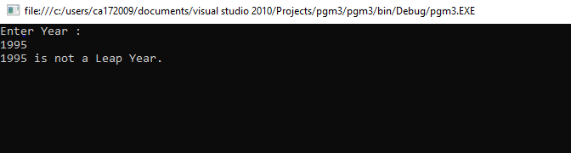

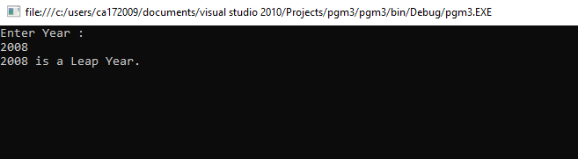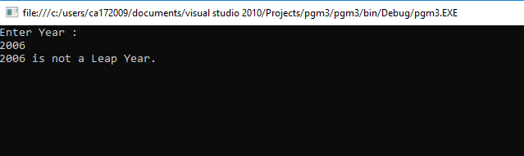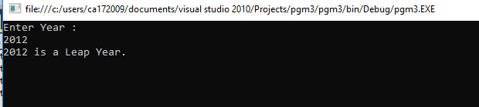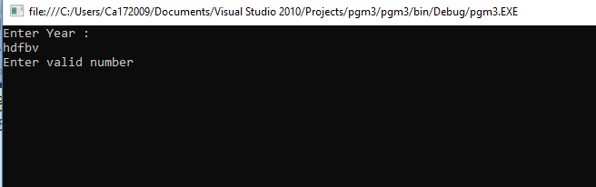

1. **Program to display the first 10 natural numbers and their sum using console application.**

using System;

using System.Collections.Generic;

using System.Linq;

using System.Text;

namespace pgm6

{

class Program

{

static void Main(string[] args)

{

int j, sum = 0;

Console.Write("The first 10 natural number are :\n");

for (j = 1; j <= 10; j++)

{

sum = sum + j;

Console.Write("{0} ",j);

Console.Write("\n");

}

Console.Write("\nThe Sum is : {0}\n", sum);

Console.ReadLine();

}

}

}

**OUTPUT**

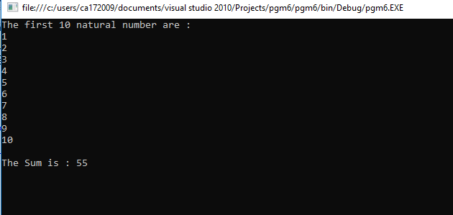

1. **Program to display the addition, subtraction, multiplication and division of two number using console applications.**

using System;

using System.Collections.Generic;

using System.Linq;

using System.Text;

namespace ArthmaticOperation

{

class Program

{

static void Main(string[] args)

{

Console.WriteLine("This Program is developed by Shubham Sajannavar");

Console.WriteLine("Roll No : CA172007, Rani Channamma University, Belgavi");

int add, sub, mul, num1, num2;

float div;

Try

{

Console.WriteLine("Enter 1st Number : ");

num1 = Convert.ToInt32(Console.ReadLine());

Console.WriteLine("Enter 2nd Number : ");

num2 = Convert.ToInt32(Console.ReadLine());

add = num1 + num2;

sub = num1 - num2;

mul = num1 * num2;

div = num1 / num2;

Console.WriteLine("Addition of\t\t"+num1+"and" + num2 + " = " + add);

Console.WriteLine("\nSubstration of \t\t"+num1+"and"+num2 + " = " + sub);

Console.WriteLine("Multiplication of \t"+num1+"and"+ num2 + " = " + mul);

Console.WriteLine("\nDivision of \t\t" +num1+"and"+num2 + " = " + div);

}

catch (Exception ex)

{

Console.WriteLine("Enter valid Number");

}

Console.ReadKey();

}

}

}

**OUTPUT**

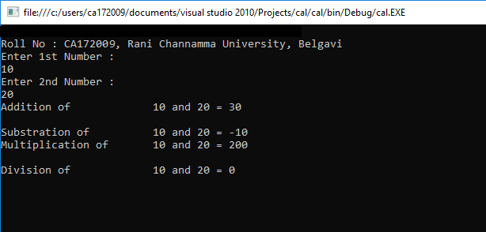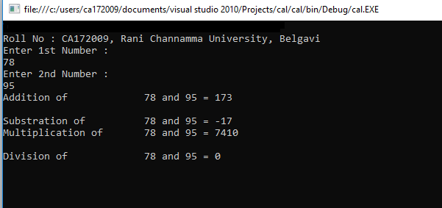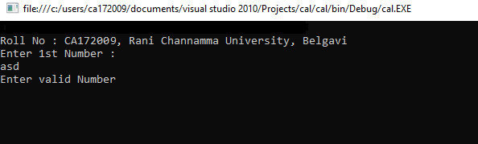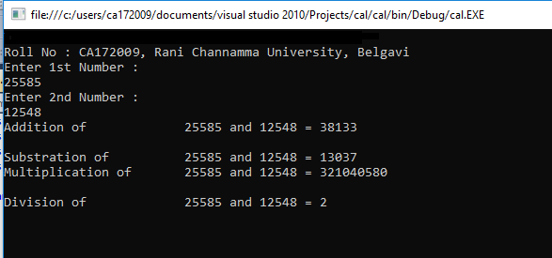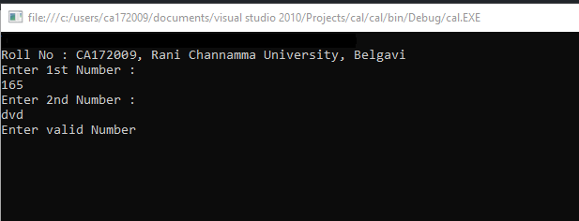

1. **Describe the enumerations programming constructs, which provides a human-readable form of a series of related constant values in C#.**

using System;

using System.Collections.Generic;

using System.Linq;

using System.Text;

namespace EnumerationDemo

{

class ProgramOne

{

enum CollegeDays

{

MONDAY, TUESDAY, WEDNESDAY, THURSDAY, FRIDAY, SATURDAY

}

static void Main(string[] args)

{

foreach (var day in Enum.GetValues(typeof(CollegeDays)))

{

Console.WriteLine("{0} : {1}", day, (int)day);

}

Console.Read();

}

}

}

**OUTPUT**

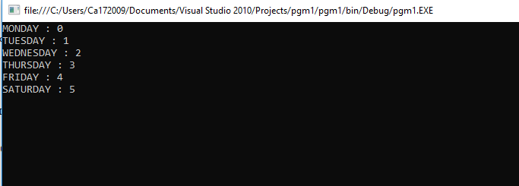

1. **Program to display the addition using the windows application.**

using System;

using System.Collections.Generic;

using System.ComponentModel;

using System.Data;

using System.Drawing;

using System.Linq;

using System.Text;

using System.Windows.Forms;

namespace pgm7

{

public partial class Form1 : Form

{

public Form1()

{

InitializeComponent();

}

private void button1_Click(object sender, EventArgs e)

{

float a;

float b;

float c;

a = Convert.ToInt32(textBox1.Text);

b = Convert.ToInt32(textBox2.Text);

c = a + b;

label3.Text = "SUM :" + c;

}

}

}

**OUTPUT**

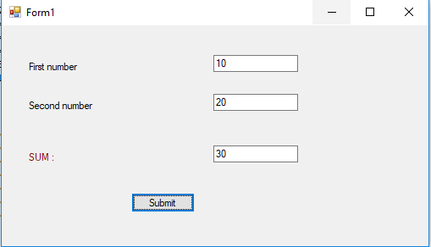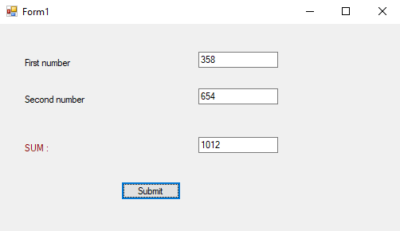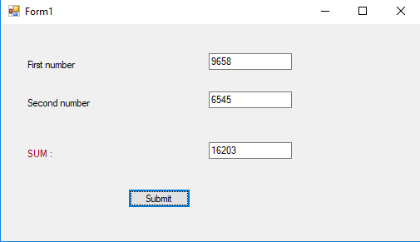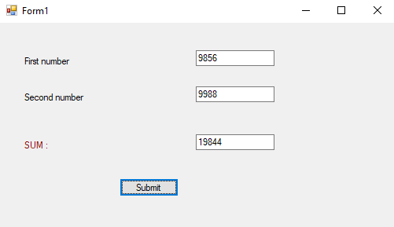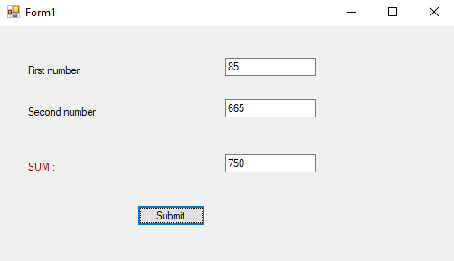

1. **Write a program to convert input string from lower to upper and upper to lower case.**

using System;

using System.Collections.Generic;

using System.Linq;

using System.Text;

namespace LowUpp

{

public class Exercise15

{

public static void Main()

{

string str1;

char[] arr1;

int l, i;

l = 0;

char ch;

Console.Write("\n\nReplace lowercase characters by uppercase and vice-versa :\n");

Console.Write("Input the string : ");

str1 = Console.ReadLine();

l = str1.Length;

arr1 = str1.ToCharArray(0, l);

Console.Write("\nAfter conversion, the string is : ");

for (i = 0; i < l; i++)

{

ch = arr1[i];

if (Char.IsLower(ch))

Console.Write(Char.ToUpper(ch));

else

Console.Write(Char.ToLower(ch));

}

Console.Write("\n\n");

Console.ReadLine();

}

}

}

**OUTPUT**

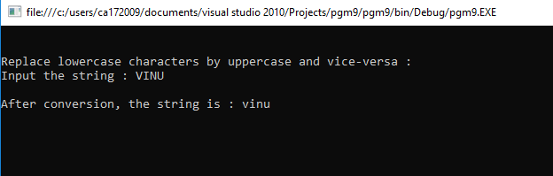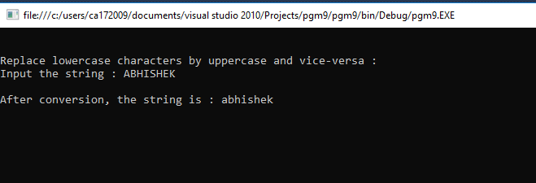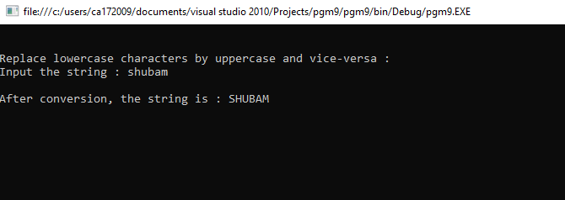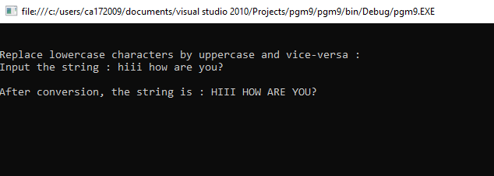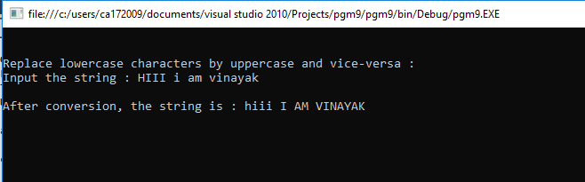

1. **Find the second largest element in a single dimensional array.**

using System;

using System.Collections.Generic;

using System.Linq;

using System.Text;

namespace pgm14

{

class Program

{

static void Main(string[] args)

{

int[] arr = new int[5];

Console.WriteLine("Enter 5 array values");

for(int i=0;i<5;i++)

{

//Console.WriteLine(i);

arr[i] = int.Parse(Console.ReadLine());

}

Array.Sort(arr);

Array.Reverse(arr);

Console.WriteLine("Second Highest Value In Array " + arr[1]);

foreach (var result in arr)

{

Console.Write(result + " ");

}

Console.ReadLine();

}

}

}

**OUTPUT**

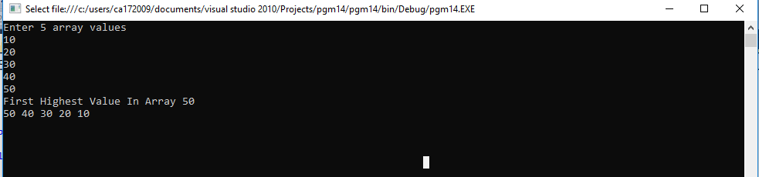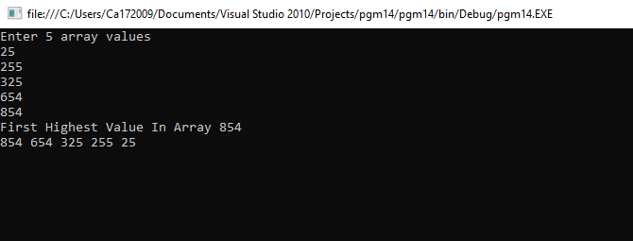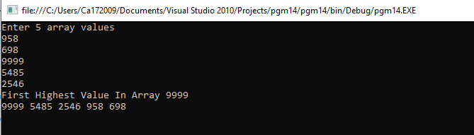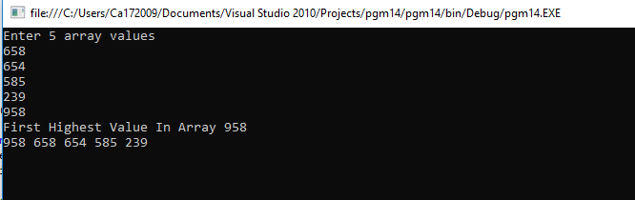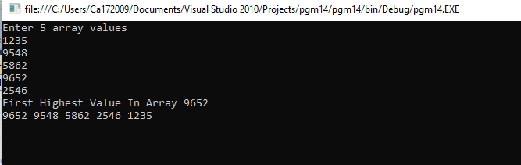

1. **Program to illustrate the use of different properties in C#.**

using System;

namespace ProgramFifteen

{

class PropertiesDemo

{

private string name;

private int age;

public string Name

{

set

{

name = value;

}

get

{

return name;

}

}

public int Age

{

set

{

if (value > 0)

age = value;

}

get

{

return age;

}

}

static void Main(string[] args)

{

PropertiesDemo p = new PropertiesDemo();

p.Name = "Vinayak";

p.Age = 23;

PropertiesDemo d = new PropertiesDemo();

d.Name = "Abhishek";

d.Age = -1;

Console.WriteLine("{0} : {1}", p.Name, p.Age);

Console.WriteLine("{0} : {1}", d.Name, d.Age);

Console.ReadLine();

}

}

}

**OUTPUT**

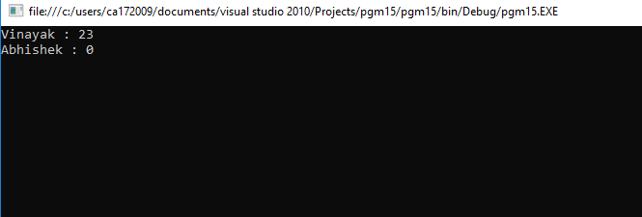

1. **Demonstrate Command line arguments processing.**

using System;

using System.Collections.Generic;

using System.Linq;

using System.Text;

namespace pgm16

{

class Program

{

static void Main(string[] args)

{

Console.WriteLine("Argument length: " + args.Length);

Console.WriteLine("Given Arguments are:");

foreach (Object obj in args)

{

Console.WriteLine(obj);

}

Console.ReadLine();

}

}

}

**OUTPUT**

