1. **Program to display the first 10 natural numbers and their sum using console application.**

using System;

using System.Collections.Generic;

using System.Linq;

using System.Text;

namespace Natural_Number

{

class Program

{

static void Main(string[] args)

{

int add=0;

Console.WriteLine("First 10 Natural Numbers");

Console.WriteLine("-------------------------------");

for(int i=1; i<=10; i++){

Console.WriteLine(+i);

add = add + i;

if (i == 10) {

Console.WriteLine("-------------------------------");

Console.WriteLine("Addition of above numbers are : "+add);

}

}

Console.WriteLine("Program is developed by CA172007 (Shubham Sajannavar) MCA 5th.");

Console.ReadKey();

}

}

}

**OUTPUT**

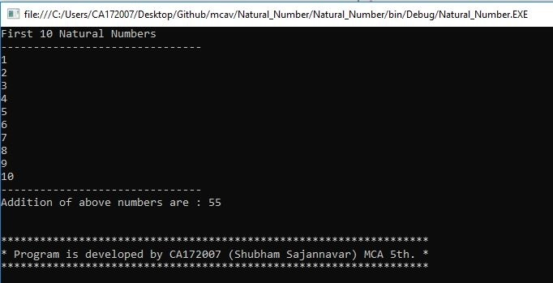

1. **Program to display the addition using the windows application.**

using System;

using System.Collections.Generic;

using System.ComponentModel;

using System.Data;

using System.Drawing;

using System.Linq;

using System.Text;

using System.Windows.Forms;

namespace AdditionUsingWindowApplication

{

public partial class Form1 : Form

{

public Form1()

{

InitializeComponent();

}

private void button1_Click(object sender, EventArgs e)

{

try

{

int a = Convert.ToInt32(textBox1.Text);

int b = Convert.ToInt32(textBox2.Text);

int c = a + b;

label3.Text = ("Addition of " + a + " and " + b + " is " + c);

}

catch (Exception ex) {

MessageBox.Show("Enter valid Numbers"+ex);

label3.Text=("Enter valid Numbers");

}

}

private void Form1_Load(object sender, EventArgs e)

{

label3.ForeColor = Color.Maroon;

label4.ForeColor = Color.Red;

label3.Text = "Output will be display here";

label4.Text = "Program is developed by CA172007 \n(Shubham Sajannavar) MCA 5th.";

}

}

}

**OUTPUT**

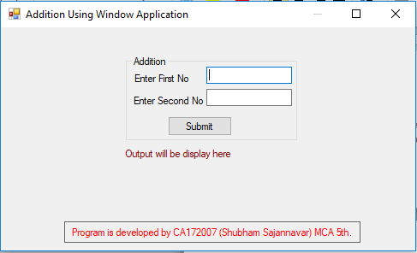

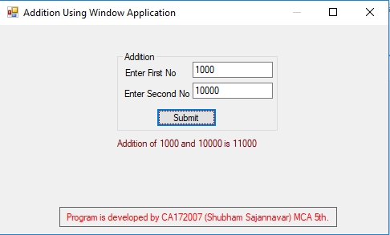

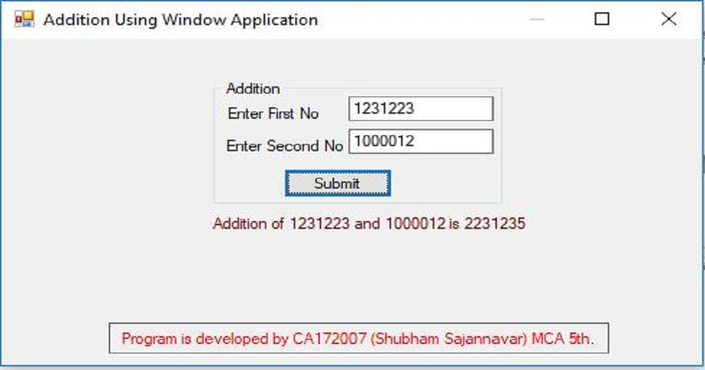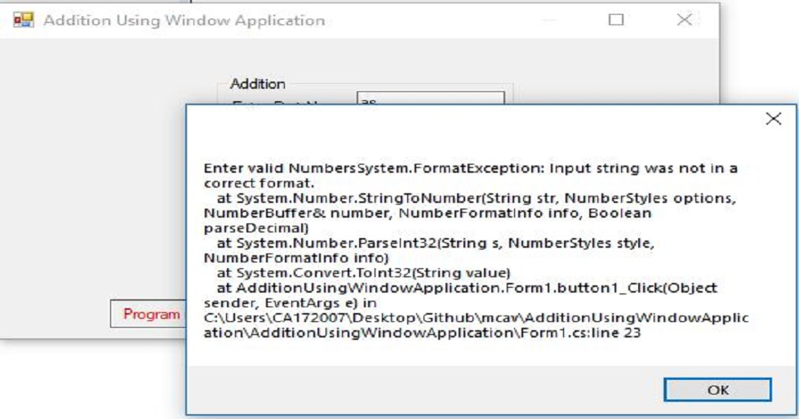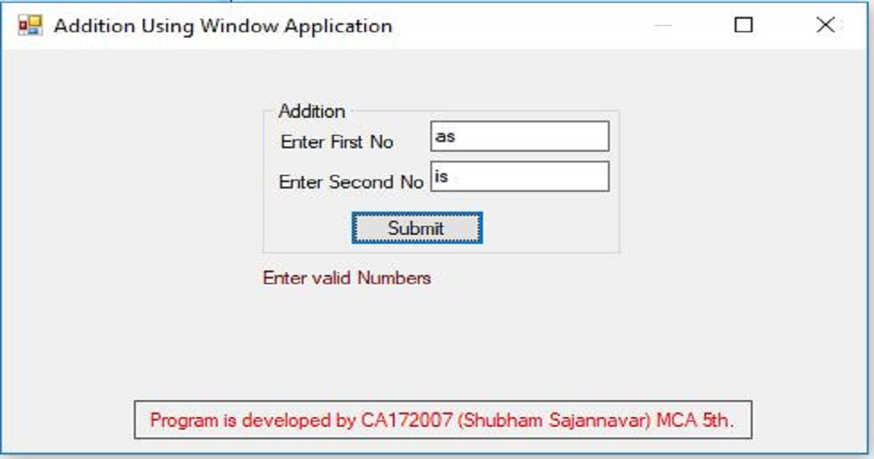

1. **Program to display the addition, subtraction, multiplication and division of two number using console applications.**

using System;

using System.Collections.Generic;

using System.Linq;

using System.Text;

namespace ArthmaticOperation

{

class Program

{

static void Main(string[] args)

{

Console.WriteLine("This Program is developed by Shubham Sajannavar");

Console.WriteLine("Roll No : CA172007, Rani Channamma University, Belgavi");

int add, sub, mul,num1,num2;

float div;

try

{

Console.WriteLine("Enter 1st Number : ");

num1 = Convert.ToInt32(Console.ReadLine());

Console.WriteLine("Enter 2nd Number : ");

num2 = Convert.ToInt32(Console.ReadLine());

add = num1 + num2;

sub = num1 - num2;

mul = num1 * num2;

div = num1 / num2;

Console.WriteLine("Addition of " +num1 + " and " + num2 + " = " + add);

Console.WriteLine("\nSubstration of " + num1 + " and " + num2 + " = " + sub);

Console.WriteLine("Multiplication of " +num1+ " and " + num2 + " = " + mul);

Console.WriteLine("\nDivision of \t\t" + num1 + " and " + num2 + " = " + div);

}

catch (Exception ex) {

Console.WriteLine("Enter valid Number");

}

Console.ReadKey();

}

}

}

**OUTPUT**

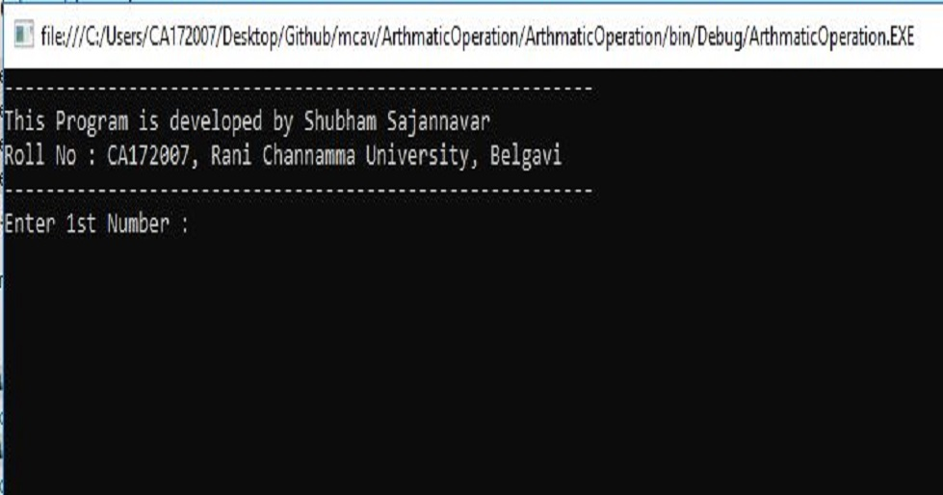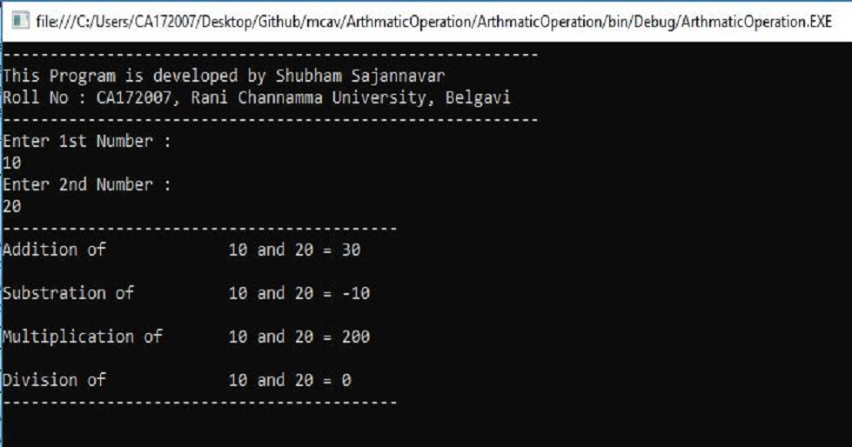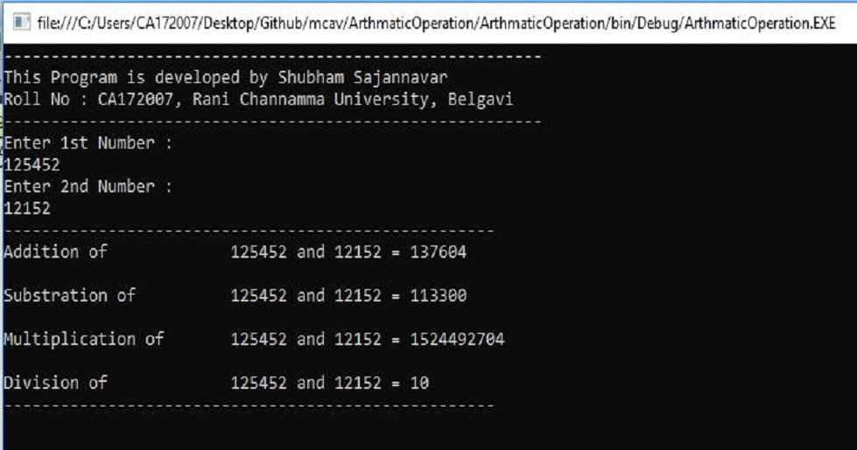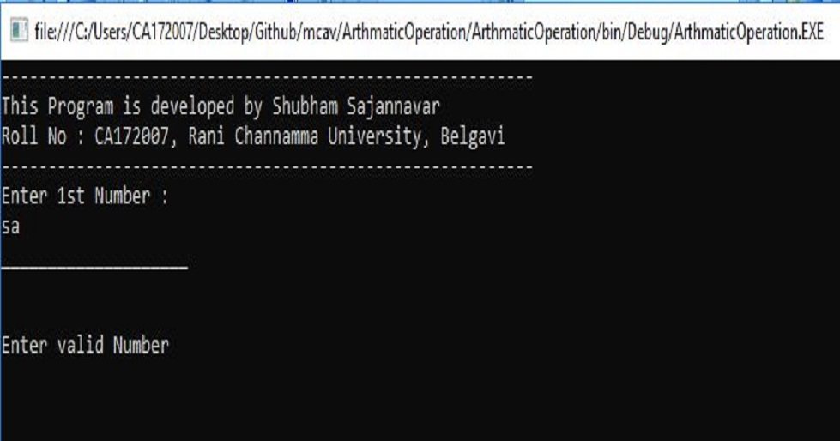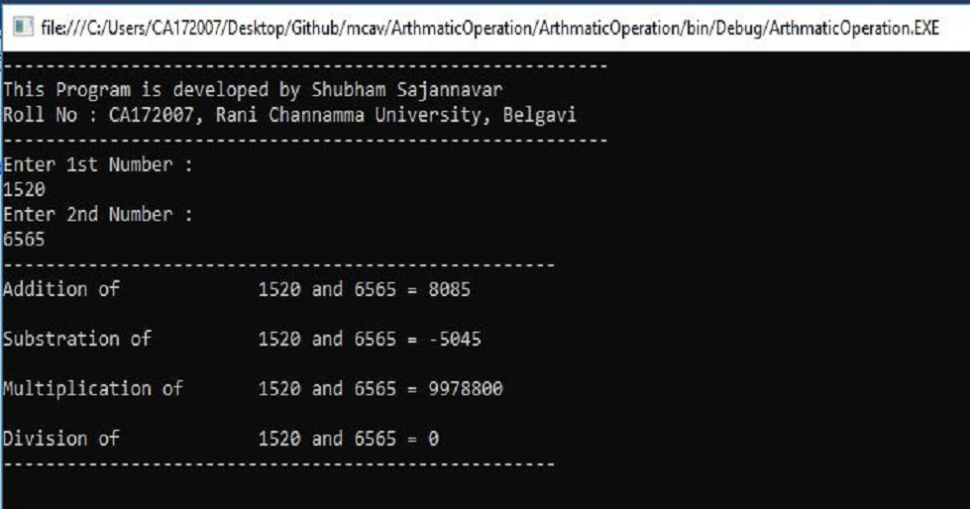

1. **Check whether the Entered Year is a Leap or Not.**

using System;

using System.Collections.Generic;

using System.Linq;

using System.Text;

namespace LeapYear

{

class Program

{

static void Main(string[] args)

{

Console.WriteLine("---------------------------------------------------------");

Console.WriteLine("This Program is to check for the leap year");

Console.WriteLine("Developed by Shubham Sajannavar Roll No : CA172007,”);

Console.WriteLine("Rani Channamma University, Belgavi");

Console.WriteLine("---------------------------------------------------------");

try {

Console.Write("Enter Year to check : ");

long year = Convert.ToInt64(Console.ReadLine());

Console.WriteLine("\n-----------------------------------------");

if (year % 400 == 0) {

Console.WriteLine("\t{0} is a Leap Year",year);

}

else if (year % 100 == 0) {

Console.WriteLine("\t{0} is not a Leap Year", year);

}

else if (year % 4 == 0)

{

Console.WriteLine("\t{0} is a Leap Year", year);

}

else {

Console.WriteLine("\t{0} is not a Leap Year", year);

}

}

catch(Exception ex) {

Console.WriteLine("Enter valid year");

}

Console.WriteLine("-----------------------------------------");

Console.ReadKey();

}

}

}

**OUTPUT**

