1. **Program to display the first 10 natural numbers and their sum using console application.**

using System;

using System.Collections.Generic;

using System.Linq;

using System.Text;

namespace Natural_Number

{

class Program

{

static void Main(string[] args)

{

int add=0;

Console.WriteLine("First 10 Natural Numbers");

Console.WriteLine("-------------------------------");

for(int i=1; i<=10; i++){

Console.WriteLine(+i);

add = add + i;

if (i == 10) {

Console.WriteLine("-------------------------------");

Console.WriteLine("Addition of above numbers are : "+add);

}

}

Console.WriteLine("Program is developed by CA172007 (Shubham Sajannavar) MCA 5th.");

Console.ReadKey();

}

}

}

**OUTPUT**

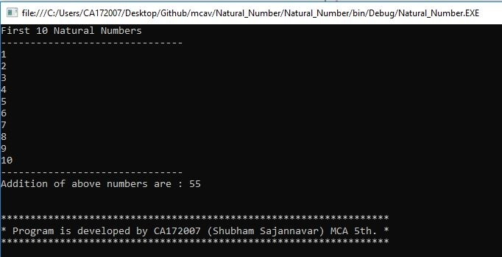

1. **Program to display the addition using the windows application.**

using System;

using System.Collections.Generic;

using System.ComponentModel;

using System.Data;

using System.Drawing;

using System.Linq;

using System.Text;

using System.Windows.Forms;

namespace AdditionUsingWindowApplication

{

public partial class Form1 : Form

{

public Form1()

{

InitializeComponent();

}

private void button1_Click(object sender, EventArgs e)

{

try

{

int a = Convert.ToInt32(textBox1.Text);

int b = Convert.ToInt32(textBox2.Text);

int c = a + b;

label3.Text = ("Addition of " + a + " and " + b + " is " + c);

}

catch (Exception ex) {

MessageBox.Show("Enter valid Numbers"+ex);

label3.Text=("Enter valid Numbers");

}

}

private void Form1_Load(object sender, EventArgs e)

{

label3.ForeColor = Color.Maroon;

label4.ForeColor = Color.Red;

label3.Text = "Output will be display here";

label4.Text = "Program is developed by CA172007 \n(Shubham Sajannavar) MCA 5th.";

}

}

}

**OUTPUT**

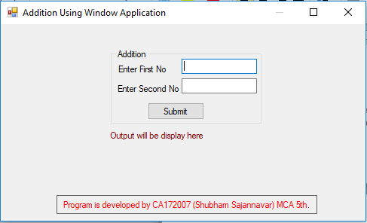

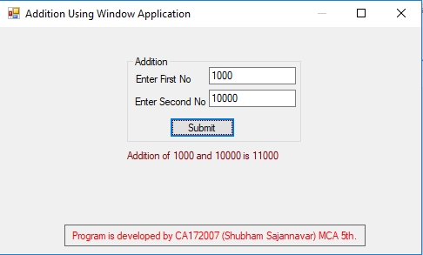

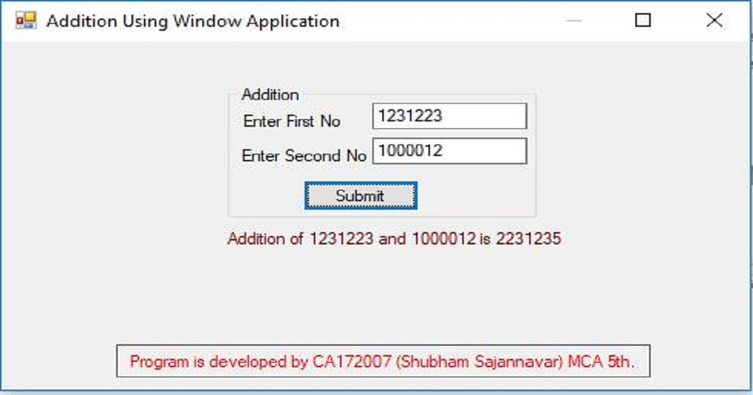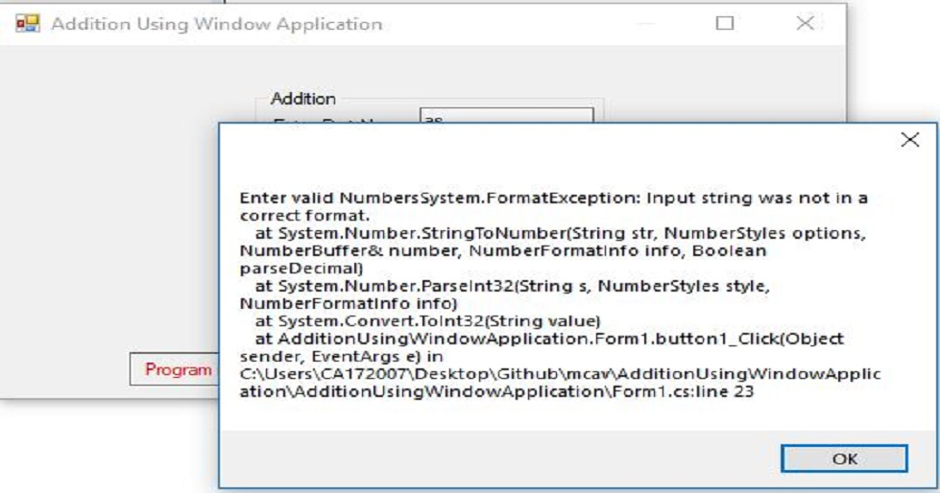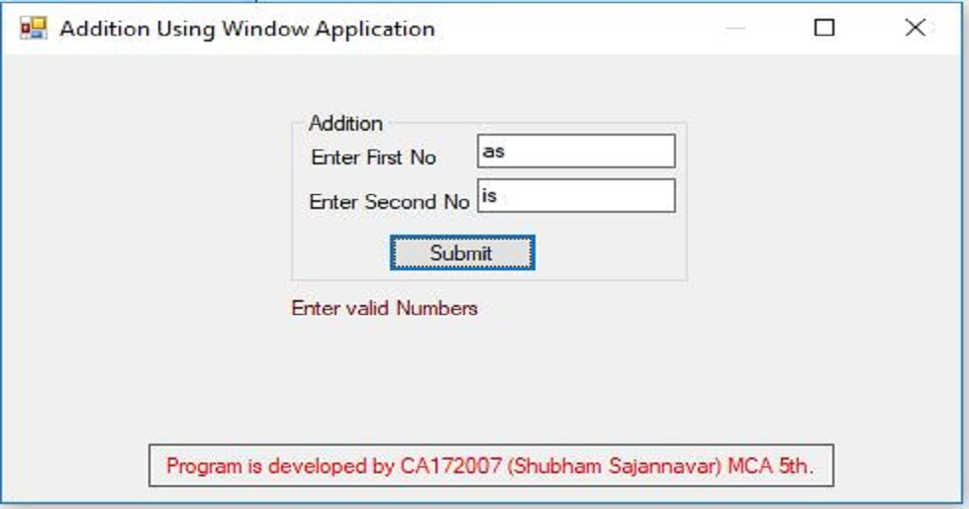

1. **Program to display the addition, subtraction, multiplication and division of two number using console applications.**

using System;

using System.Collections.Generic;

using System.Linq;

using System.Text;

namespace ArthmaticOperation

{

class Program

{

static void Main(string[] args)

{

Console.WriteLine("This Program is developed by Shubham Sajannavar");

Console.WriteLine("Roll No : CA172007, Rani Channamma University, Belgavi");

int add, sub, mul,num1,num2;

float div;

try

{

Console.WriteLine("Enter 1st Number : ");

num1 = Convert.ToInt32(Console.ReadLine());

Console.WriteLine("Enter 2nd Number : ");

num2 = Convert.ToInt32(Console.ReadLine());

add = num1 + num2;

sub = num1 - num2;

mul = num1 * num2;

div = num1 / num2;

Console.WriteLine("Addition of " +num1 + " and " + num2 + " = " + add);

Console.WriteLine("\nSubstration of " + num1 + " and " + num2 + " = " + sub);

Console.WriteLine("Multiplication of " +num1+ " and " + num2 + " = " + mul);

Console.WriteLine("\nDivision of \t\t" + num1 + " and " + num2 + " = " + div);

}

catch (Exception ex) {

Console.WriteLine("Enter valid Number");

}

Console.ReadKey();

}

}

}

**OUTPUT**

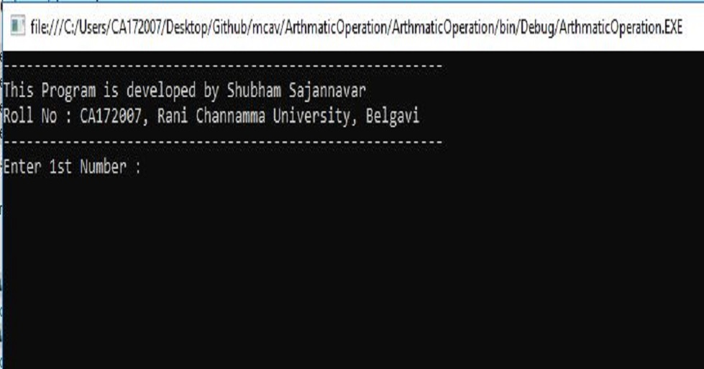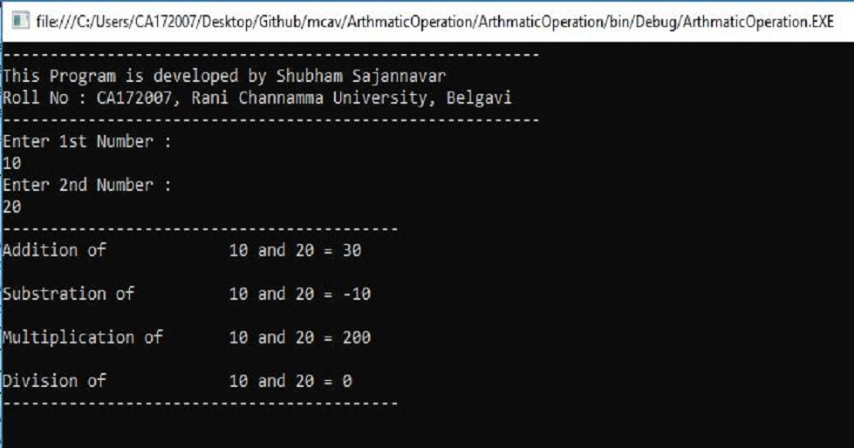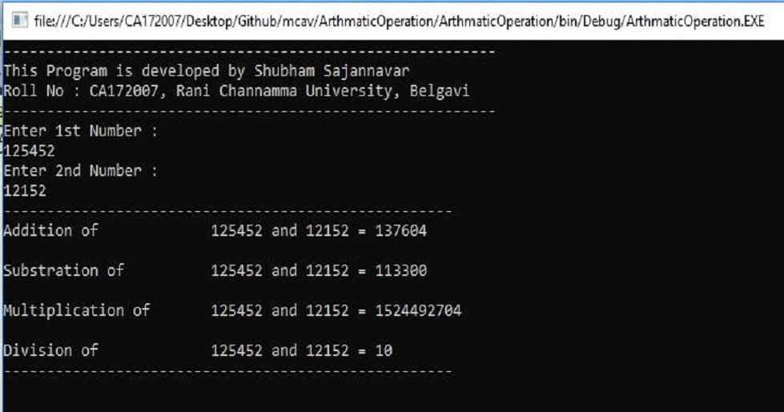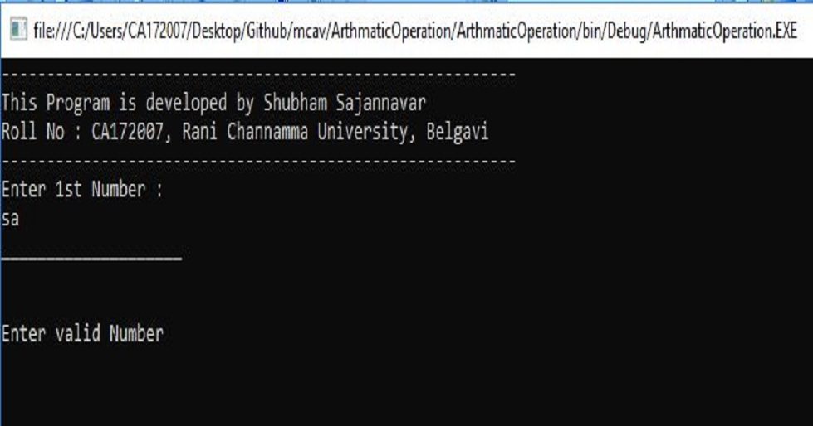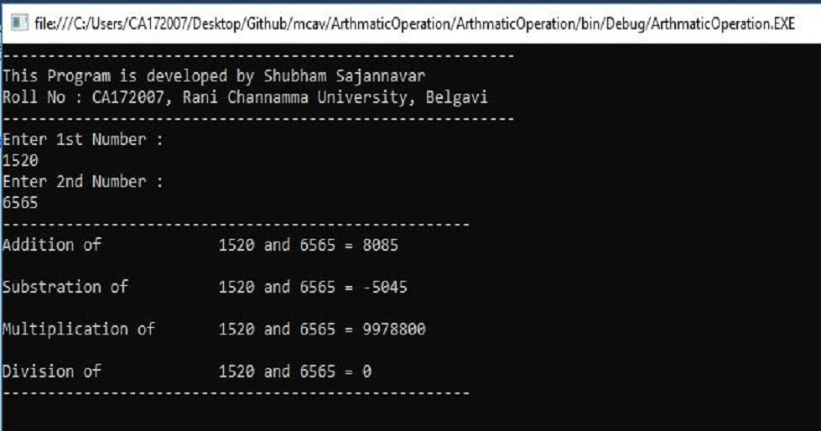

1. **Check whether the Entered Year is a Leap or Not.**

using System;

using System.Collections.Generic;

using System.Linq;

using System.Text;

namespace LeapYear

{

class Program

{

static void Main(string[] args)

{

Console.WriteLine("---------------------------------------------------------");

Console.WriteLine("This Program is to check for the leap year");

Console.WriteLine("Developed by Shubham Sajannavar Roll No : CA172007,”);

Console.WriteLine("Rani Channamma University, Belgavi");

Console.WriteLine("---------------------------------------------------------");

try {

Console.Write("Enter Year to check : ");

long year = Convert.ToInt64(Console.ReadLine());

Console.WriteLine("\n-----------------------------------------");

if (year % 400 == 0) {

Console.WriteLine("\t{0} is a Leap Year",year);

}

else if (year % 100 == 0) {

Console.WriteLine("\t{0} is not a Leap Year", year);

}

else if (year % 4 == 0)

{

Console.WriteLine("\t{0} is a Leap Year", year);

}

else {

Console.WriteLine("\t{0} is not a Leap Year", year);

}

}

catch(Exception ex) {

Console.WriteLine("Enter valid year");

}

Console.WriteLine("-----------------------------------------");

Console.ReadKey();

}

}

}

**OUTPUT**

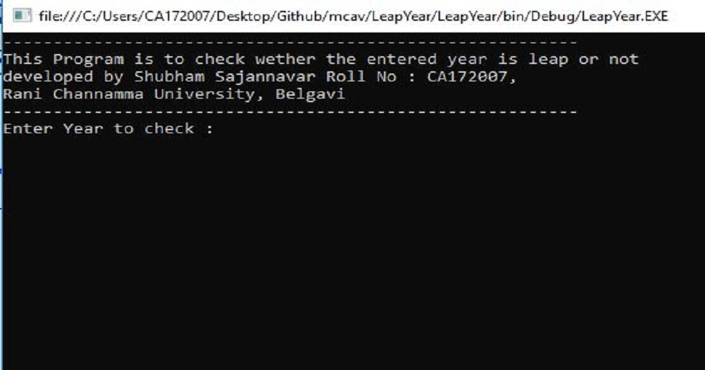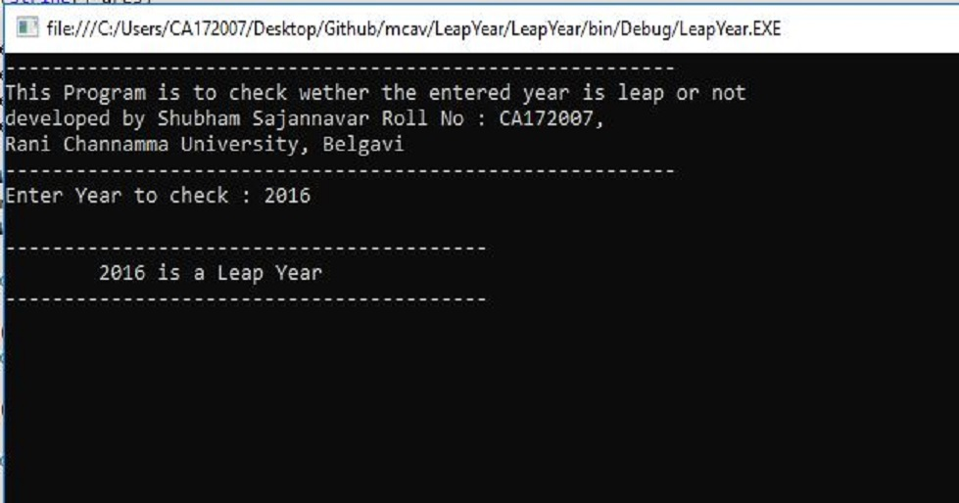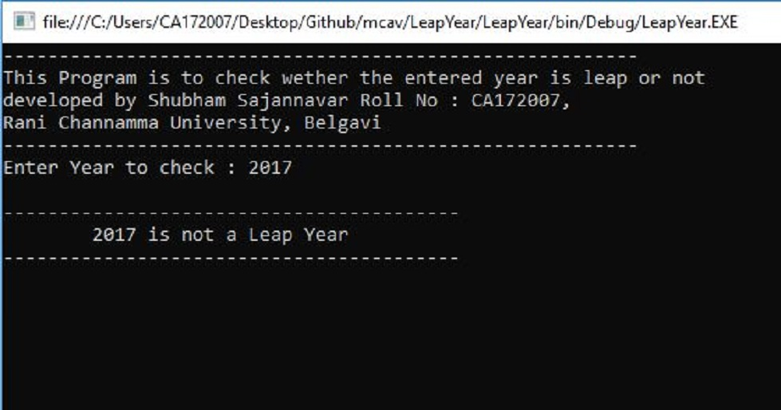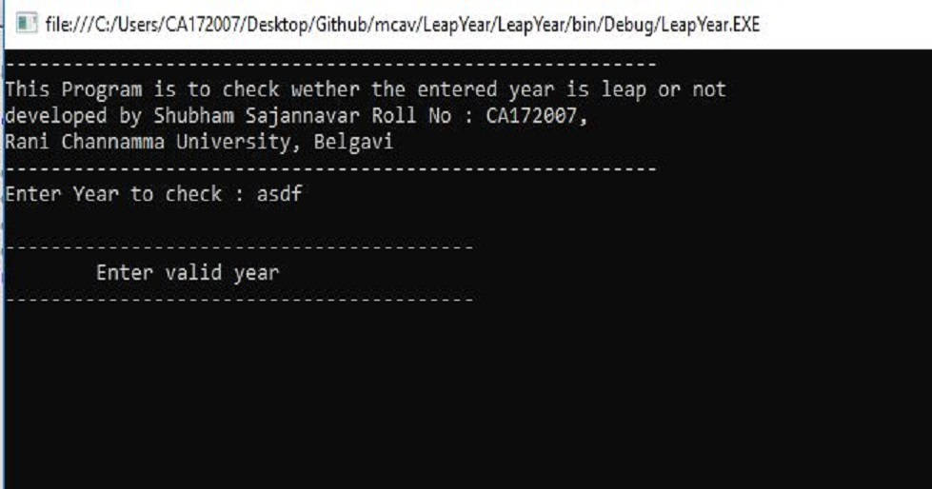

1. **Program to illustrate the use of different properties in C#.**

using System;

using System.Collections.Generic;

using System.Linq;

using System.Text;

namespace ConsoleApplication1

{

class Program

{

class PropertiesDemo

{

private string name;

private int age;

public string Name

{

set

{

name = value;

}

get

{

return name;

}

}

public int Age

{

set

{

if (value > 0)

age = value;

}

get

{

return age;

}

}

static void Main(string[] args)

{

Console.WriteLine("---------------------------------------------------------");

Console.WriteLine("This Program is developed by Shubham Sajannavar");

Console.WriteLine("Roll No : CA172007, Rani Channamma University,

Belgavi");

Console.WriteLine("---------------------------------------------------------");

PropertiesDemo p = new PropertiesDemo();

p.Name = "John";

p.Age = 12;

PropertiesDemo d = new PropertiesDemo();

d.Name = "Rohn";

d.Age = 14;

Console.WriteLine("\n {0} : {1}", p.Name, p.Age);

Console.WriteLine("\n {0} : {1}", d.Name, d.Age);

Console.ReadLine();

}

}

}

}

**OUTPUT**

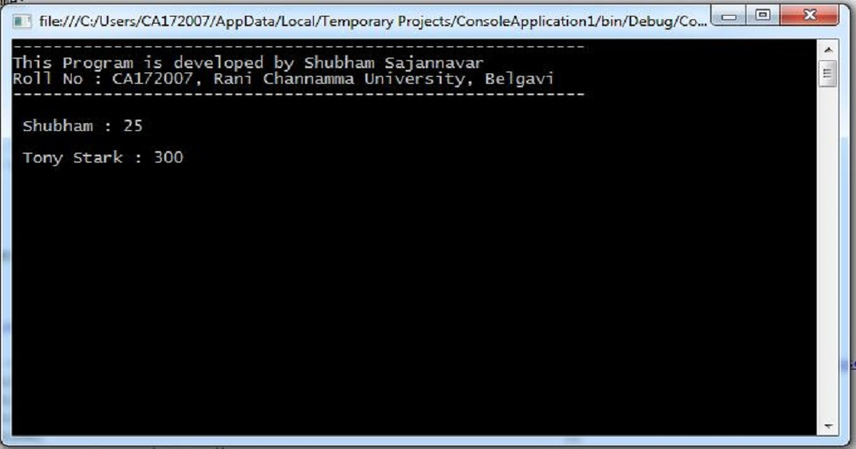

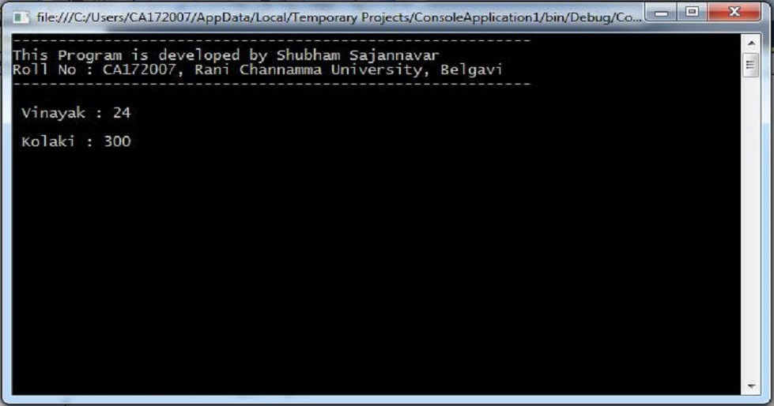

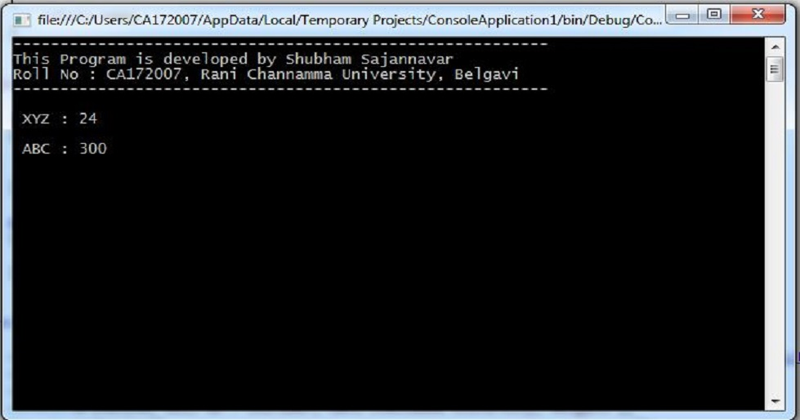

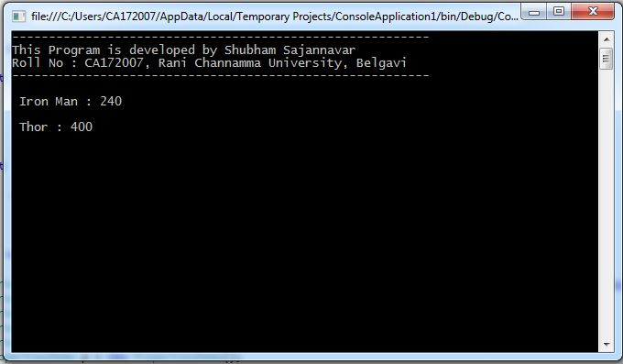

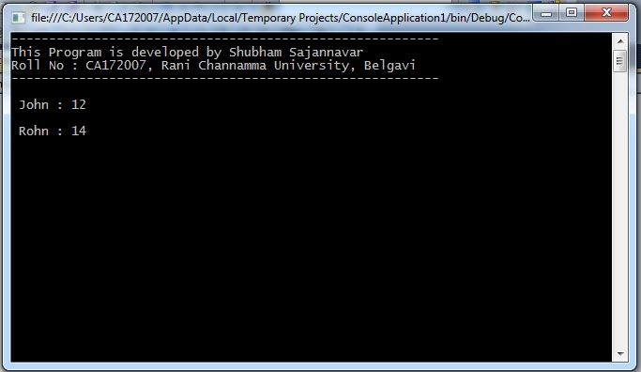

1. **Write a program to convert input string from lower to upper and upper to lower case.**

using System;

using System.Collections.Generic;

using System.Linq;

using System.Text;

namespace ConsoleApplication1

{

class Program

{

static void Main(string[] args)

{

Console.WriteLine("---------------------------------------------------------");

Console.WriteLine("This Program is developed by Shubham Sajannavar");

Console.WriteLine("Roll No : CA172007, Rani Channamma University,

Belgavi");

Console.WriteLine("---------------------------------------------------------");

string str;

char[] arr1;

int i,len=0;

char ch;

Console.WriteLine("\nEnter a String :");

str = Console.ReadLine();

len = str.Length;

arr1 = str.ToCharArray(0,len);

Console.WriteLine("\nAfter Conversion");

for (i = 0; i < len; i++) {

ch=arr1[i];

if(Char.IsLower(ch)){

Console.Write(Char.ToUpper(ch));

}else{

Console.Write(Char.ToLower(ch));

}

}

Console.ReadKey();

}

}

}

**OUTPUT**

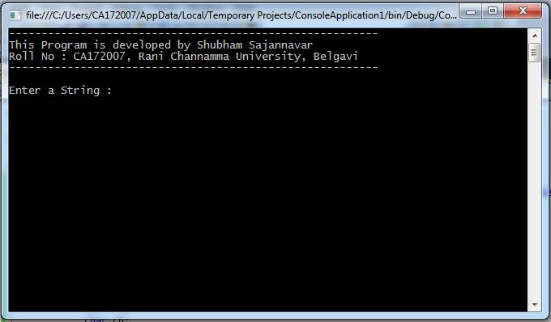

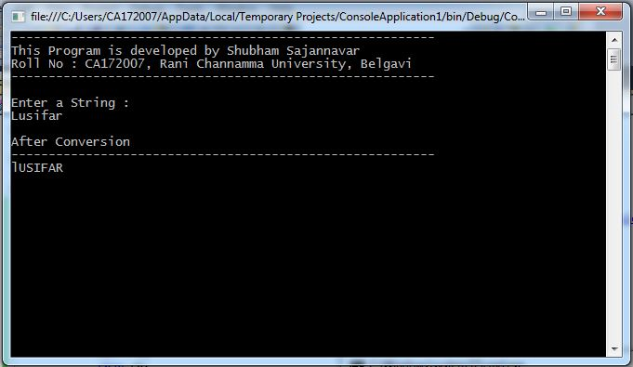

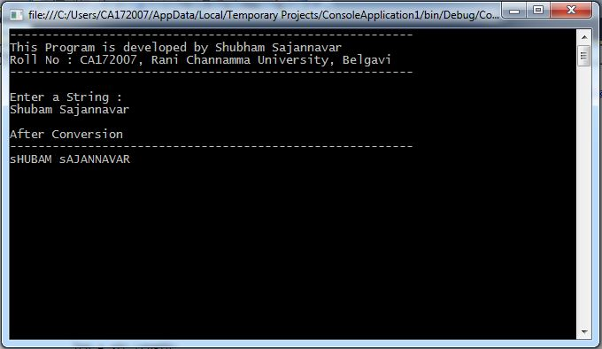

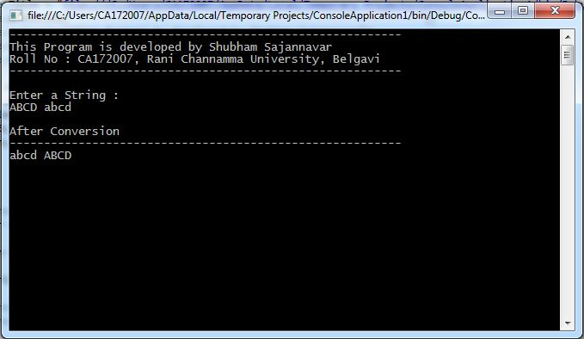

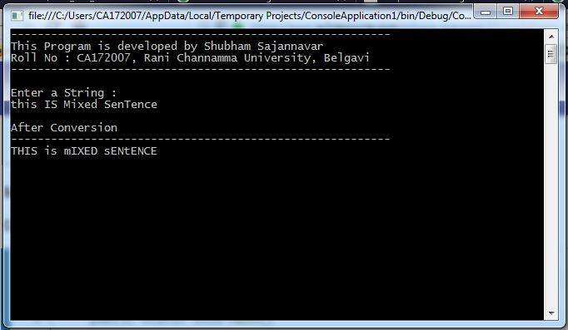

1. **Demonstrate Command line arguments processing.**

using System;

using System.Collections.Generic;

using System.Linq;

using System.Text;

namespace CommandLineArgs

{

class Program

{

static void Main(string[] args)

{

Console.WriteLine("---------------------------------------------------------");

Console.WriteLine("This Program is developed by Shubham Sajannavar");

Console.WriteLine("Roll No : CA172007, Rani Channamma University,

Belgavi");

Console.WriteLine("---------------------------------------------------------\n");

try

{

if (args.Length >= 2)

{

int num1 = Int32.Parse(args[0]);

int num2 = Int32.Parse(args[1]);

int sum = num1 + num2;

Console.WriteLine("CommandLine Args : " + num1 + " and " + num2);

Console.WriteLine("\nAddition of Command Line Args : {0}", sum);

}

else

{

Console.WriteLine("No Command Line Args Passed.");

}

}

catch (Exception ex) {

Console.WriteLine("Invalid Args Passwd");

}

Console.ReadKey();

}

}

}

**OUTPUT**

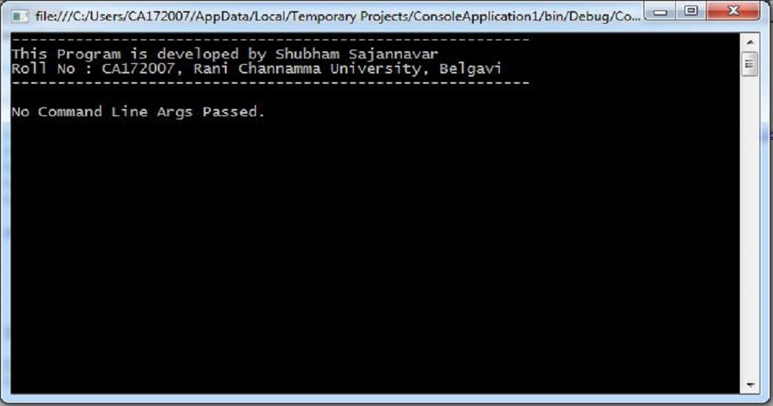

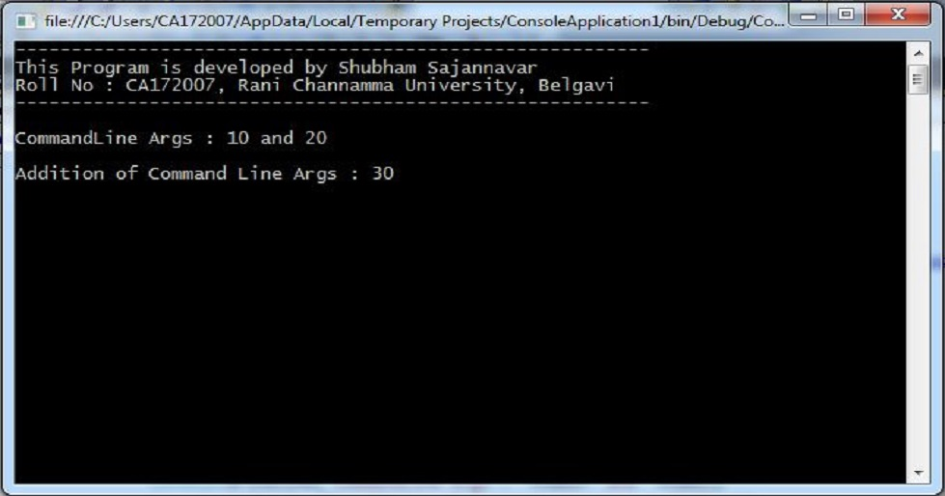

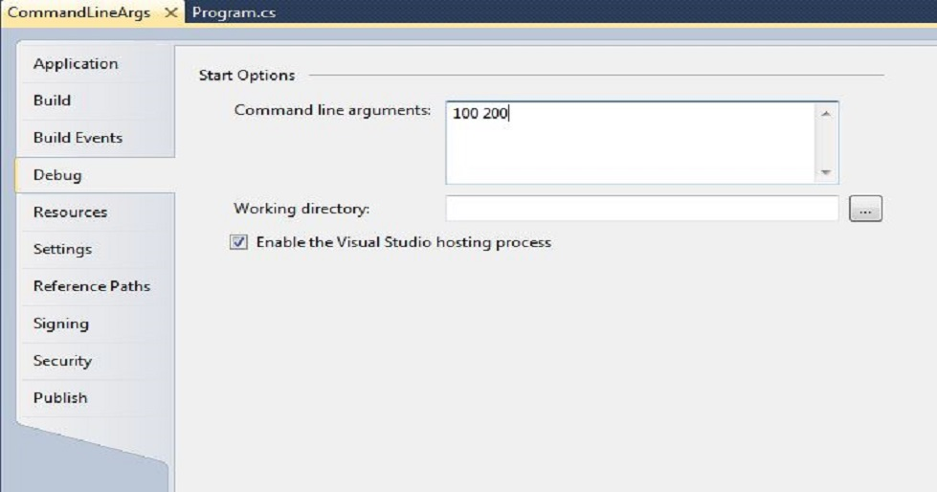

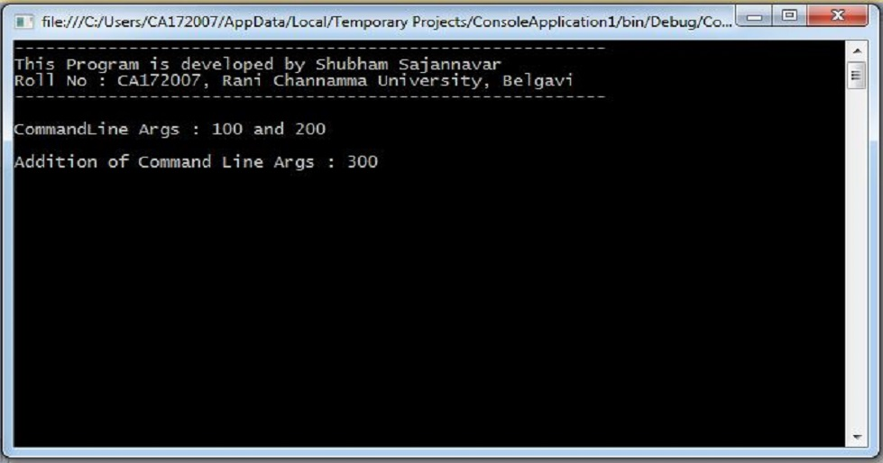

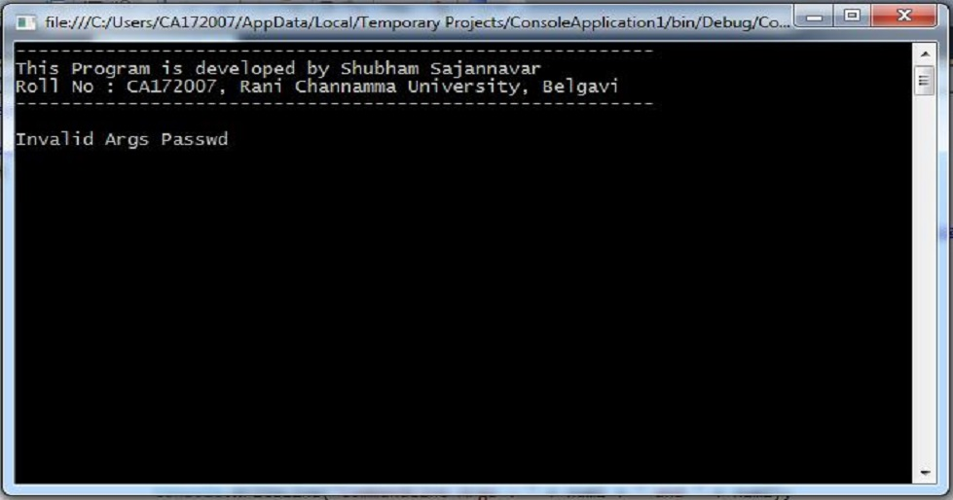

1. **Describe the enumerations programming constructs, which provides a human-readable form of a series of related constant values in C#.**

using System;

using System.Collections.Generic;

using System.Linq;

using System.Text;

namespace Enumerations

{

class Program

{

enum CollegeDays

{

MONDAY, TUESDAY, WEDNESDAY, THURSDAY, FRIDAY, SATURDAY

}

static void Main(string[] args)

{

Console.WriteLine("---------------------------------------------------------");

Console.WriteLine("This Program is developed by Shubham Sajannavar");

Console.WriteLine("Roll No : CA172007, Rani Channamma University,

Belgavi");

Console.WriteLine("---------------------------------------------------------\n");

foreach (var day in Enum.GetValues(typeof(CollegeDays)))

{

Console.WriteLine(">> {0} : {1}", day, (int)day);

}

Console.ReadKey();

}

}

}

**OUTPUT**

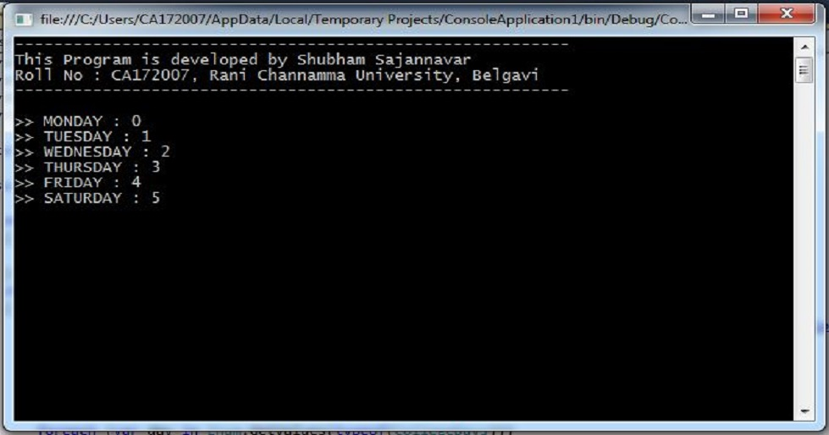

1. **Find the second largest element in single dimensional array.**

using System;

using System.Collections.Generic;

using System.Linq;

using System.Text;

namespace ConsoleApplication3

{

class Program

{

static void Main(string[] args)

{

try

{

Console.WriteLine("---------------------------------------------------------");

Console.WriteLine("This Program is developed by Shubham Sajannavar");

Console.WriteLine("Roll No : CA172007, Rani Channamma University,

Belgavi");

Console.WriteLine("---------------------------------------------------------");

int[] arr = new int[5];

Console.WriteLine("Enter 5 element in array : ");

for (int i = 0; i < 5; i++)

{

arr[i] = int.Parse(Console.ReadLine());

}

Console.WriteLine("---------------------");

Array.Sort(arr);

Array.Reverse(arr);

Console.WriteLine("Sorted Array in Reverce Order");

for (int i = 0; i < 5; i++)

{

Console.WriteLine("A[" + i + "] = " + arr[i]);

}

Console.WriteLine("Second Largest Value in Array : " + arr[1]);

}

catch (Exception ex) {

Console.WriteLine("Provide Valid Array Element.\nOnly Numeric Values are

allowed.");

}

Console.ReadKey();

}

}

}

**OUTPUT**

