**Programs**

1. Write a program to assign value of base and height then calculate area of Triangle and display it.

Ans:

class Triangle

{

public static void main(String args[])

{

int b=10,h=15;

float area;

area=(b*h)/2;

System.out.println("Area of triangle is "+area);

}

}

Output:

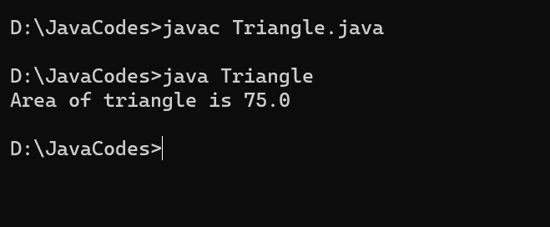

1. Write a program to assign value of Basic Salary of employee then DA is 10 % of Basic Salary and HRA is 20 % of basic salaries then calculate of Total salary of employee.

Ans:

class Salary

{

public static void main(String args[])

{

int basic=10000;

float da,hra,gross;

da=(basic*10)/100;

hra=(basic*20)/100;

gross=basic+da+hra;

System.out.println("Gross Salary is "+gross);

}

}

Output:

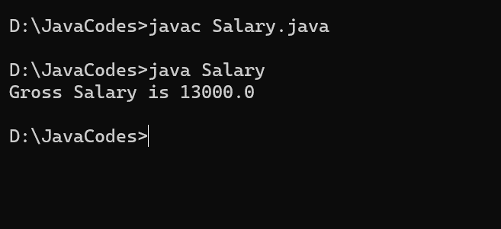

1. Write a program to accept value of marks of 5 subject and calculate percentage and display it.

Ans:

import java.util.Scanner;

class Percent

{

public static void main(String args[])

{

Scanner sc=new Scanner(System.in);

System.out.println("Enter marks of 5 subjects: ");

int m1=sc.nextInt();

int m2=sc.nextInt();

int m3=sc.nextInt();

int m4=sc.nextInt();

int m5=sc.nextInt();

int total=m1+m2+m3+m4+m5;

float per=(total*100)/500;

System.out.println("Percentage is "+per);

}

}

Output:

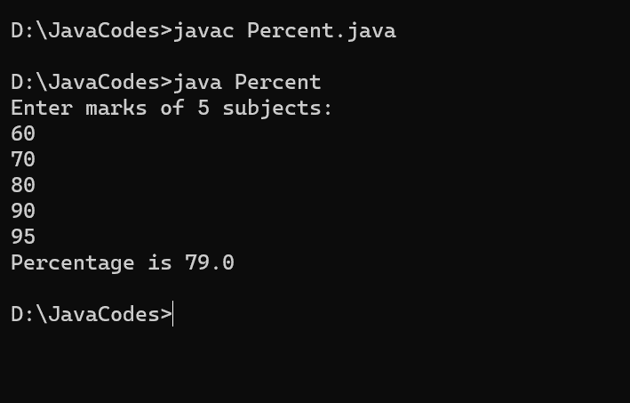

1. Write a program to accept value of radius then calculate area of circle and display it.

Ans:

import java.util.Scanner;

class Circle

{

public static void main(String args[])

{

Scanner sc=new Scanner(System.in);

System.out.println("Enter radius of circle: ");

int r=sc.nextInt();

double area=3.14*r*r;

System.out.println("Area of circle is "+area);

}

}

Output:

