**Programs**

1. Write a JavaScript program to take input number from user and check number is odd or even.

Ans:

<html>

<body>

<script>

function check()

{

var n1;

n1=parseInt(document.getElementById("no").value);

if(n1%2==0)

{

alert("Number is even");

}

else

{

alert("Number is odd");

}

}

</script>

<form align="center">

<br><br>

<h2>Program to check even odd number</h2><br>

Enter a number <input type="text" id="no"><br><br>

<button onclick="check()">Check</button>

</form>

</body>

</html>

Output:

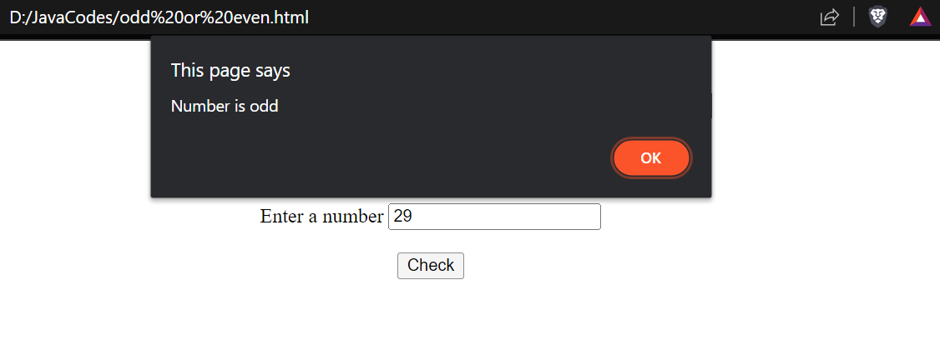

1. Write a JavaScript Program to Find the Factorial of a Number (Take input from user).

Ans:

<html>

<body align="center">

<script>

function fact()

{

var n,i,f=1;

n=parseInt(document.getElementById("no").value);

for(i=1;i<=n;i++)

{

f=f*i;

}

document.getElementById("res").innerHTML="The factorial of "+n+" is "+f;

}

</script>

<br><br>

<h2>Program to find factorial of a number</h2><br>

Enter a number <input type="text" id="no"><br><br>

<button onclick="fact()">Factorial</button><br>

<p id="res"></p>

</body>

</html>

Output:

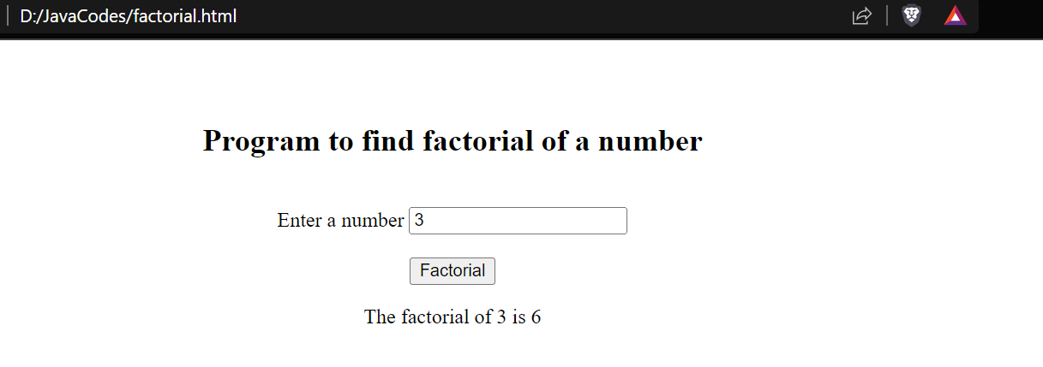

1. Write a JavaScript program to take input number from user and check number is Prime or non-prime (Take input from user) using Button click event.

Ans:

<html>

<body align="center">

<script>

function check()

{

var n,i,result=0;

n=parseInt(document.getElementById("no").value);

for(i=2;i<n;i++)

{

if(n%2==0)

{

result++;

break;

}

}

if(result==0)

{

document.getElementById("res").innerHTML = n+" is a prime number";

}

else

{

document.getElementById("res").innerHTML = n+" is not a prime number";

}

}

</script>

<br><br>

<h2>Program to check a prime number</h2><br>

Enter a number <input type="text" id="no"><br><br>

<button onclick="check()">Check</button><br>

<p id="res"></p>

</body>

</html>

Output:

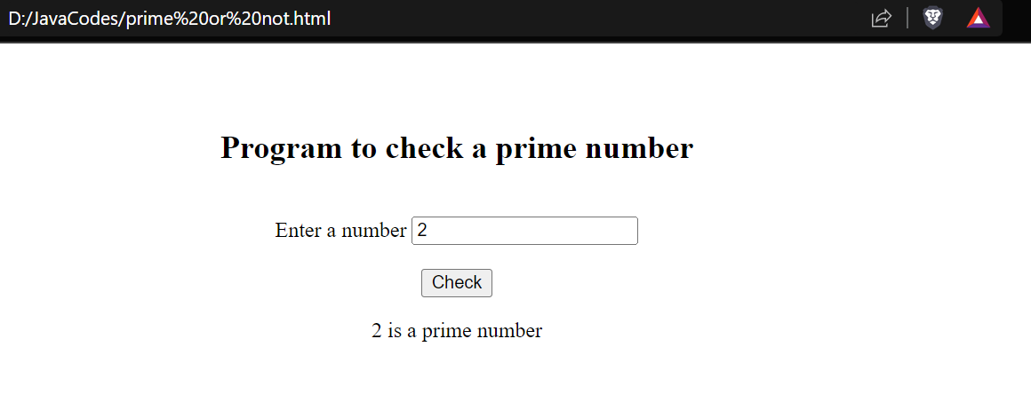

1. Write a JavaScript program to calculate multiplication and division of two numbers (input from user) using Button Click event.

Ans:

<html>

<body align="center">

<script>

var n1,n2,m,d;

function mul()

{

n1=parseInt(document.getElementById("no1").value);

n2=parseInt(document.getElementById("no2").value);

m=n1*n2;

document.getElementById("res").value=m;

}

function div()

{

n1=parseInt(document.getElementById("no1").value);

n2=parseInt(document.getElementById("no2").value);

d=n1/n2;

document.getElementById("res").value=d;

}

</script>

<h2>Program to calculate multiplication and division</h2><br>

Enter number 1 <input type="text" id="no1"><br><br>

Enter number 2 <input type="text" id="no2"><br><br>

Result <input type="text" id="res"><br><br><br>

<button onclick="mul()">Multiplication</button><br><br>

<button onclick="div()">Division</button>

</body>

</html>

Output:

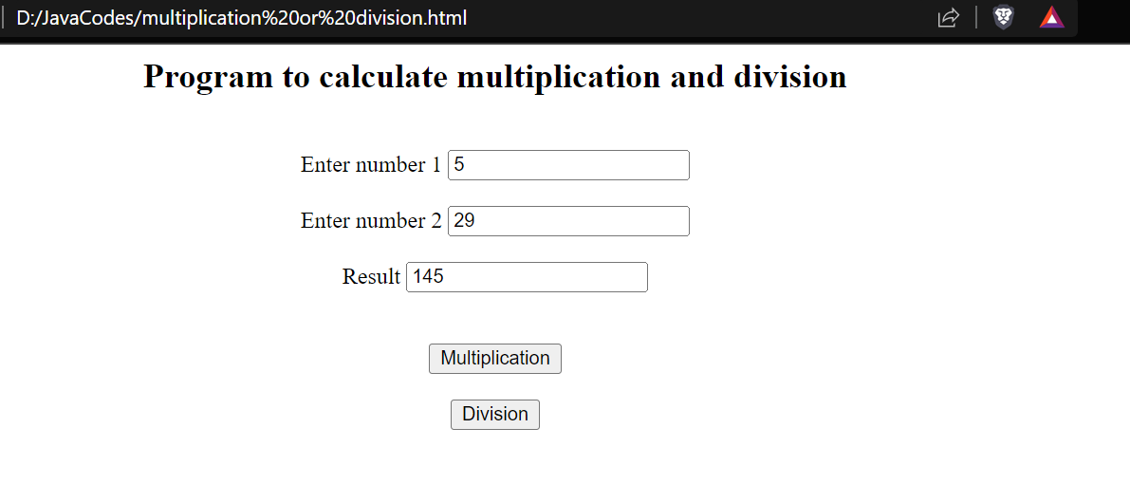

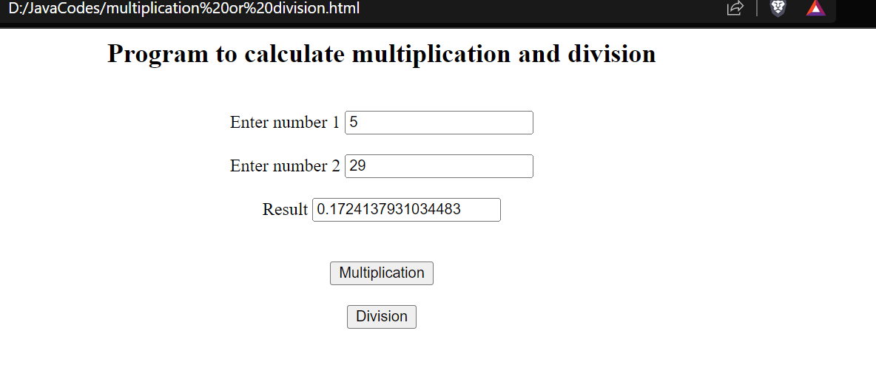

1. Write a JavaScript program using MouseOver Event and Focus event.

Ans:

<html>

<body>

<script>

function mouseover()

{

alert("Mouse over alert");

}

</script>

<h3 onmouseover="mouseover()">Keep cursor over me</h3>

</body>

</html>

Output:

