**Programs**

1. Write a Program to declare Class Product having data member id, name and price initialized it using parameterized Method for two object of class and display all records. Also calculate Total price of product and display.

Ans:

class Product

{

int id,price;

String name;

void getdata(int i,String n,int p)

{

id=i;

name=n;

price=p;

System.out.println("Details of object");

System.out.println("Id= "+id+"\t Name= "+name+"\t Price= "+price);

}

void display(int a,int b)

{

int total=a+b;

System.out.println("Total price is "+total);

}

public static void main(String args[])

{

Product p1=new Product();

p1.getdata(10,"Books",100);

Product p2=new Product();

p2.getdata(15,"Pen",10);

p1.display(p1.price,p2.price);

}

}

Output:

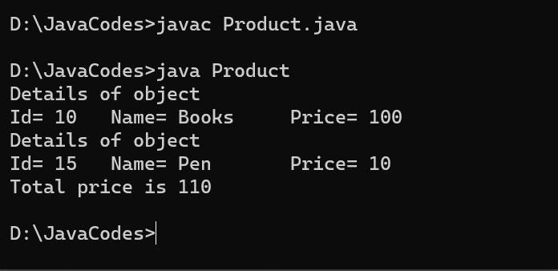

1. Write a Program to declare class Mobile with data member ‘Company_name’ &amp; ‘Screen Size’ initialized it using parameterized Method for one object of class and display it.

Ans:

class Mobile

{

String Company_name;

int Screen_size;

void getdata(String n,int s)

{

Company_name=n;

Screen_size=s;

}

void display()

{

System.out.println("Details of Mobile");

System.out.println("Company Name: "+Company_name+"\t Screen Size:

"+Screen_size);

}

public static void main(String args[])

{

Mobile m=new Mobile();

m.getdata("Tecno",15);

m.display();

}

}

Output:

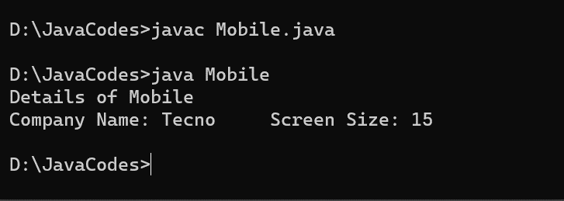

1. Write a Program to declare class Rectangle having data member length and width, accept this record for one object of class and calculate area of Rectangle and display it.

Ans:

import java.util.Scanner;

class Rectangle

{

int length,width,area;

void getdata()

{

Scanner sc=new Scanner(System.in);

System.out.println("Enter length & width: ");

length=sc.nextInt();

width=sc.nextInt();

}

void display()

{

area=length*width;

System.out.println("Area of rectangle is "+area);

}

public static void main(String args[])

{

Rectangle r=new Rectangle();

r.getdata();

r.display();

}

}

Output:

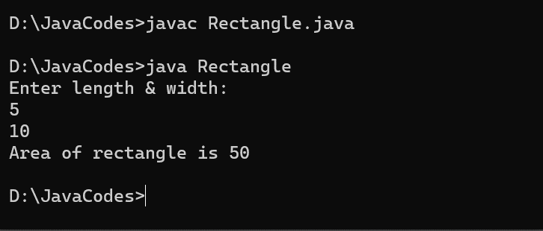

1. Write a Program to declare class Employee having data member empid, name, basic salary , Accept this record for two object of class and calculate Total Salary of Employee where DA is 10% of basic Salary and HRA is 20 % basic Salary. (Total Salary = DA+HRA+basic Salary).

Ans:

import java.util.Scanner;

class Employee

{

int empid,basic_salary;

String name;

float total,da,hra;

void getdata()

{

Scanner sc=new Scanner(System.in);

System.out.println("Enter Employee Id: ");

empid=sc.nextInt();

System.out.println("Enter Name: ");

name=sc.next();

System.out.println("Enter Basic Salary: ");

basic_salary=sc.nextInt();

}

void display()

{

da=(10*basic_salary)/100;

hra=(20*basic_salary)/100;

total=basic_salary+da+hra;

System.out.println("Id: "+empid+"\t Name: "+name+"\t Basic

Salary:"+basic_salary+"\t Total Salary: "+total);

}

public static void main(String args[])

{

Employee emp1=new Employee();

emp1.getdata();

emp1.display();

Employee emp2=new Employee();

emp2.getdata();

emp2.display();

}

}

Output:

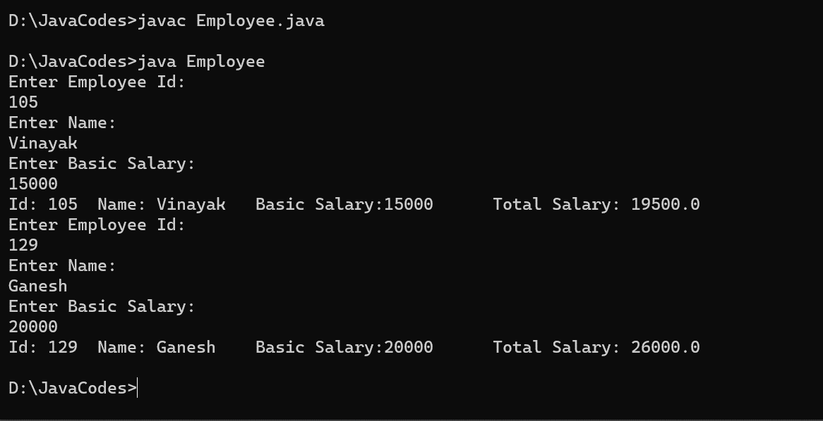

1. Write a program create a class Student having data member rollno,name and marks of two subject Accept this record for one object of class and calculate the percentage and display all records .

Ans:

import java.util.Scanner;

class Student

{

int rollno,m1,m2,total;

String name;

float per;

void getdata()

{

Scanner sc=new Scanner(System.in);

System.out.println("Enter Roll No: ");

rollno=sc.nextInt();

System.out.println("Enter Name: ");

name=sc.next();

System.out.println("Enter marks of two subjects: ");

m1=sc.nextInt();

m2=sc.nextInt();

}

void display()

{

total=m1+m2;

per=(total*100)/200;

System.out.println("Roll No: "+rollno+"\t Name: "+name+"\t Percentage:

"+per);

}

public static void main(String args[])

{

Student s=new Student();

s.getdata();

s.display();

}

}

Output:

