**Programs**

1. Write a Program to declare Class Book having data member id, name and price initialized it using parameterized constructor for two object of class and display all records.

Ans:

class Book

{

int id,price;

String name;

Book(int i,String n,int p)

{

id=i;

name=n;

price=p;

}

void display()

{

System.out.println("Id: "+id+"\t Name: "+name+"\t Price: "+price);

}

public static void main(String args[])

{

Book b1=new Book(129,"Java ",200);

b1.display();

Book b2=new Book(205,"Python",150);

b2.display();

}

}

Output:

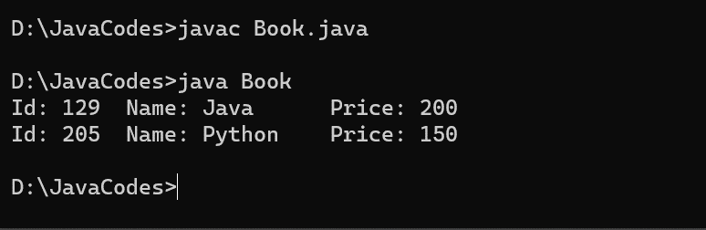

1. Write a Program to declare class Box with data member length, width, Height initialized three object using different constructors and Calculate Volume of Box and display records.

Ans:

class Box

{

int length,width,height,volume;

Box(int l,int w,int h)

{

length=l;

width=w;

height=h;

}

void display()

{

volume=length*width*height;

System.out.println("Volume of Box: "+volume);

}

public static void main(String args[])

{

Box b1=new Box(5,3,9);

b1.display();

Box b2=new Box(10,6,8);

b2.display();

Box b3=new Box(12,16,10);

b3.display();

}

}

Output:

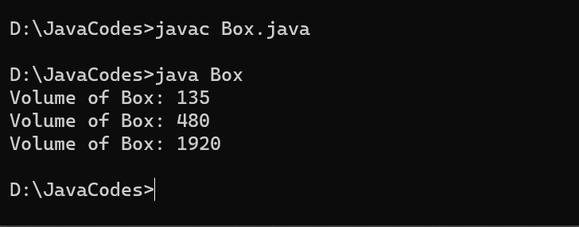

1. Write a program to count total number of characters from String.

Ans:

class NoOfChar

{

public static void main(String args[])

{

String str="NCER";

int count=0,i;

for(i=0;i<str.length();i++)

{

if(str.charAt(i)!=' ')

{

count++;

}

}

System.out.println("Total number of characters in string is "+count);

}

}

Output:

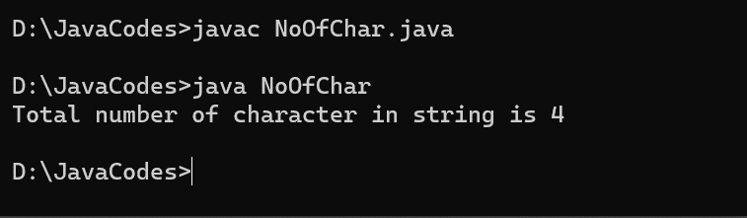

1. Write a Program to Accept First name, middle name and surname and make full name and display it.

Ans:

import java.util.Scanner;

class Concat

{

public static void main(String args[])

{

Scanner sc=new Scanner(System.in);

System.out.println("Enter First Name:");

String fname=sc.next();

System.out.println("Enter Middle Name:");

String mname=sc.next();

System.out.println("Enter Surname:");

String sname=sc.next();

StringBuffer str=new StringBuffer();

str.append(fname);

str.append(" ");

str.append(mname);

str.append(" ");

str.append(sname);

System.out.println("Your full name is "+str);

}

}

Output:

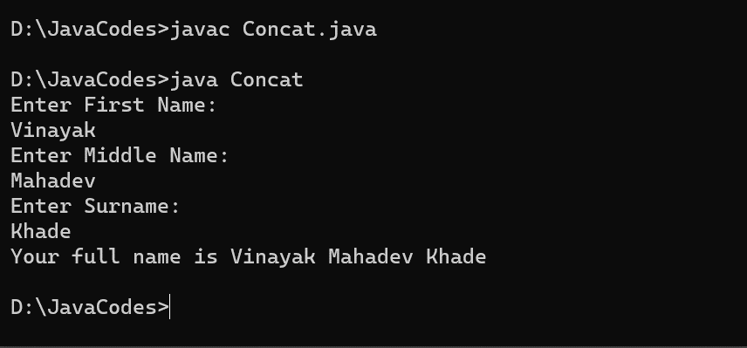

1. Write a program to count no. of vowels character in string.

Ans:

import java.util.Scanner;

class Vowels

{

public static void main(String args[])

{

Scanner sc=new Scanner(System.in);

System.out.println("Enter any string:");

String str=sc.next();

int count=0;

for(int i=0;i<str.length();i++)

{

char ch=str.charAt(i);

if(ch=='a' || ch=='e' || ch=='i' || ch=='o' || ch=='u' || ch=='A' || ch=='E' || ch=='I' || ch=='O' || ch=='U' )

{

count++;

}

}

System.out.println("Total number of vowels in string is "+count);

}

}

Output:

