**Programs**

1. Write a Program accepts three no. from user and find largest number.

Ans:

import java.util.Scanner;

class largestNo

{

public static void main(String args[])

{

Scanner sc=new Scanner(System.in);

System.out.println("Enter three numbers:");

int n1=sc.nextInt();

int n2=sc.nextInt();

int n3=sc.nextInt();

if(n1>n2 && n1>n3)

{

System.out.println(n1+" is largest number");

}

else if(n2>n1 && n2>n3)

{

System.out.println(n2+" is largest number");

}

else

{

System.out.println(n3+" is largest number");

}

}

}

Output:

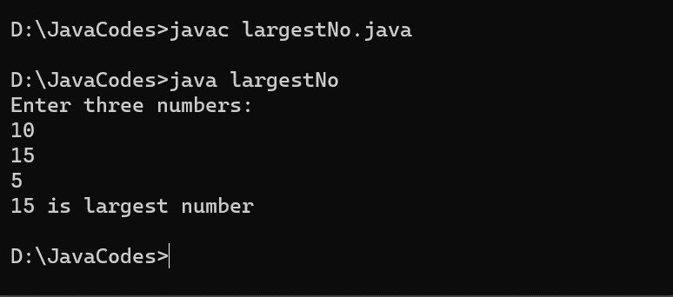

1. Write a Program accept no. from user and calculate factorial of given number.

Ans:

import java.util.Scanner;

class factorial

{

public static void main(String args[])

{

Scanner sc=new Scanner(System.in);

System.out.println("Enter a number:");

int n=sc.nextInt();

int fact=1;

for(int i=1;i<=n;i++)

{

fact=fact*i;

}

System.out.println("Factorial of "+n+" is "+fact);

}

}

Output:

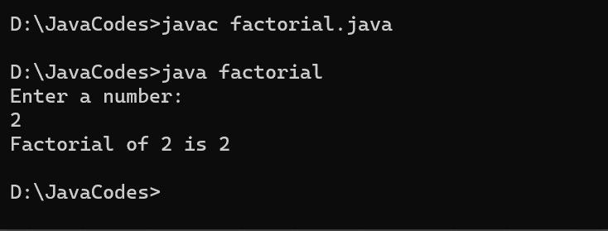

1. Write a program accepts number from user and check number is palindrome or not.

Ans:

import java.util.Scanner;

class palindrome

{

public static void main(String args[])

{

Scanner sc=new Scanner(System.in);

System.out.println("Enter a number:");

int n=sc.nextInt();

int temp,rev=0,digit;

temp=n;

while(n!=0)

{

digit=n%10;

n=n/10;

rev=rev*10+digit;

}

if(temp==rev)

System.out.println(temp+" is a Palindrome number");

else

System.out.println(temp+" is not a Palindrome number");

}

}

Output:

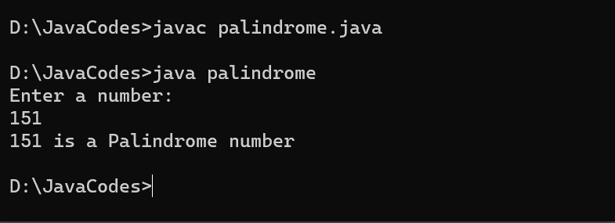

1. Write a program accepts number from user and check number is Armstrong or not.

Ans:

import java.util.Scanner;

class armstrong

{

public static void main(String args[])

{

Scanner sc=new Scanner(System.in);

System.out.println("Enter a number:");

int n=sc.nextInt();

int num,temp,sum=0;

temp=n;

while(n!=0)

{

num=n%10;

sum=sum+(num*num*num);

n=n/10;

}

if(sum==temp)

System.out.println(temp+" is a Armstrong number");

else

System.out.println(temp+" is not a Armstrong number");

}

}

Output:

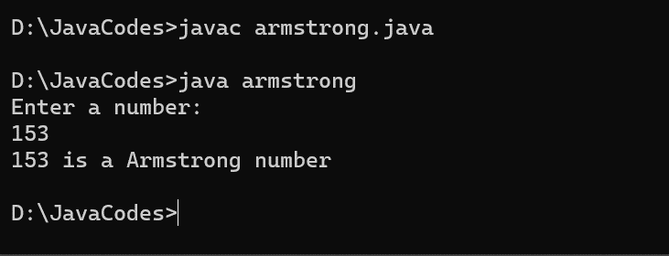

1. Write a program accepts number from user and check number is Prime or not.

Ans:

import java.util.Scanner;

class Prime

{

public static void main(String args[])

{

Scanner sc=new Scanner(System.in);

System.out.println("Enter a number:");

int n=sc.nextInt();

int flag=0;

for(int i=2;i<n;i++)

{

if(n%i==0)

{

System.out.println(n+" is not a Prime number");

flag=1;

break;

}

}

if(flag==0)

System.out.println(n+" is a Prime number");

}

}

Output:

