**Programs**

1. Write a Program accepts ‘n’ no. from user store in array and finds largest number in an array.

Ans:

import java.util.Scanner;

class arrayLarge

{

public static void main(String args[])

{

Scanner sc=new Scanner(System.in);

System.out.println("Enter total number of elements in array:");

int n=sc.nextInt();

int a[]=new int[n];

System.out.println("Enter elements of array:");

for(int i=0;i<n;i++)

{

a[i]=sc.nextInt();

}

int max=a[0];

for(int j=0;j<n;j++)

{

if(max<a[j])

{

max=a[j];

}

}

System.out.println("Maximum value is "+max);

}

}

Output:

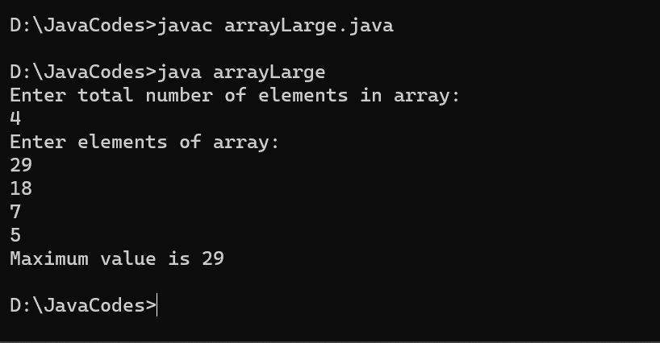

1. Write a Program accept ‘n’ no. store in array and Perform Linear Search.

Ans:

import java.util.Scanner;

class Linear

{

public static void main(String args[])

{

int size,i;

Scanner sc=new Scanner(System.in);

System.out.println("Enter the size of array:");

size=sc.nextInt();

int arr[]=new int[size];

for(i=0;i<size;i++)

{

System.out.println("Enter element: ");

arr[i]=sc.nextInt();

}

System.out.println("Enter number to find: ");

int n=sc.nextInt();

for(i=0;i<arr.length;i++)

{

if(arr[i]==n)

{

System.out.println(n+" is found at location "+i);

break;

}

}

if(i==arr.length)

System.out.println("Number not found");

}

}

Output:

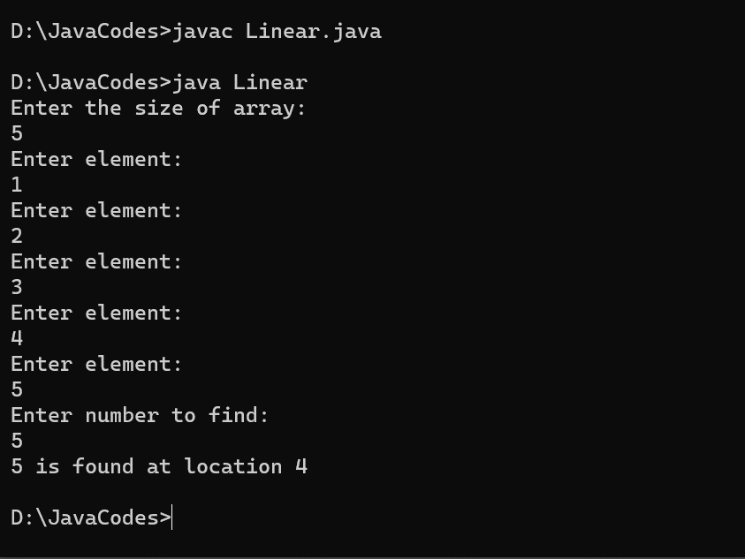

1. Write a program accepts two arrays and perform Intersection two set.

Ans:

import java.util.Scanner;

class Intersect

{

public static void main(String args[])

{

int size1,i;

Scanner sc=new Scanner(System.in);

System.out.println("Enter the size of array:");

size1=sc.nextInt();

int arr1[]=new int[size1];

for(i=0;i<size1;i++)

{

System.out.println("Enter element: ");

arr1[i]=sc.nextInt();

}

int size2;

System.out.println("Enter the size of array:");

size2=sc.nextInt();

int arr2[]=new int[size2];

for(i=0;i<size2;i++)

{

System.out.println("Enter element: ");

arr2[i]=sc.nextInt();

}

System.out.println("Intersection of two arrays is:");

for(int j = 0;j<arr1.length;j++ )

{

for(int k= 0;k<arr2.length; k++)

{

if(arr1[j]==arr2[k])

{

System.out.println(arr2[k]);

}

}

}

}

}

Output:

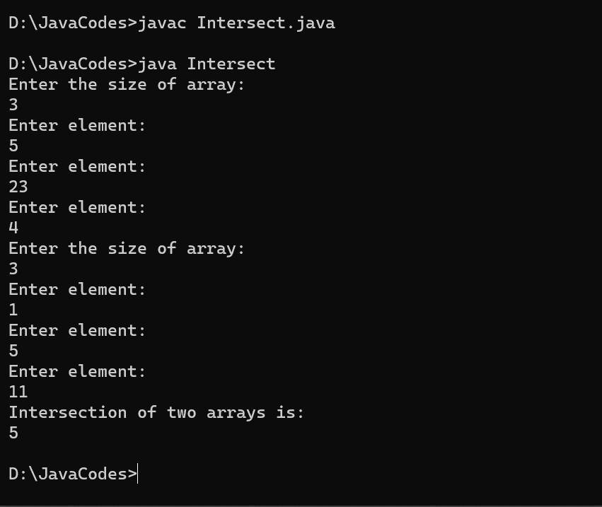

1. Write a program to accept 3x3 Matrix and calculate addition of two matrix and display it.

Ans:

import java.util.Scanner;

class Matrix

{

public static void main(String args[])

{

Scanner sc=new Scanner(System.in);

int a[][] = new int[3][3];

int b[][] = new int[3][3];

int c[][] = new int[3][3];

System.out.println("Enter all the elements of first matrix:");

for (int i = 0; i < 3; i++)

{

for (int j = 0; j < 3; j++)

{

a[i][j] = sc.nextInt();

}

}

System.out.println("Enter all the elements of second matrix:");

for (int i = 0; i < 3; i++)

{

for (int j = 0; j < 3; j++)

{

b[i][j] = sc.nextInt();

}

}

System.out.println("");

for (int i = 0; i < 3; i++)

{

for (int j = 0; j <3; j++)

{

for (int k = 0; k <3; k++)

{

c[i][j] = a[i][j] + b[i][j];

}

}

}

System.out.println("Matrix after addition:");

for (int i = 0; i < 3; i++)

{

for (int j = 0; j <3; j++)

{

System.out.print(c[i][j]+" ");

}

System.out.println("");

}

}

}

Output:

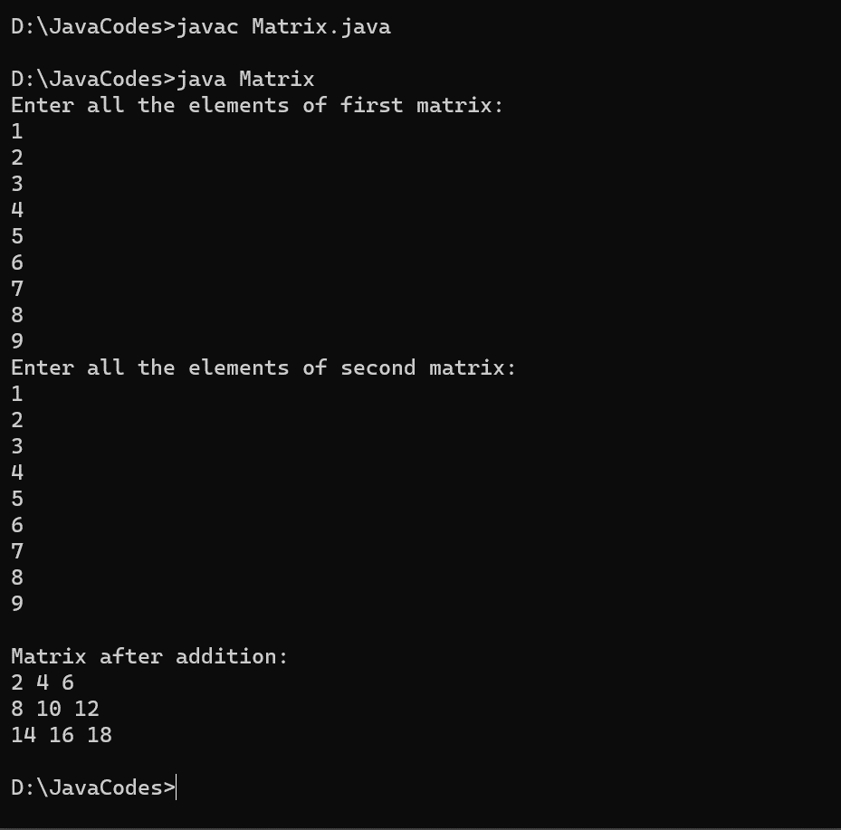

1. Write a program to declare class Employee having data member empid, name and salary. Accept records for 5 employee and display that records whose salary is greater than 5000.

Ans:

import java.util.Scanner;

class Employee1

{

int empid,salary;

String name;

void getdata()

{

Scanner sc=new Scanner(System.in);

System.out.print("Enter Employee Id: ");

empid=sc.nextInt();

System.out.print("Enter Name: ");

name=sc.next();

System.out.print("Enter Salary: ");

salary=sc.nextInt();

}

void display()

{

System.out.println("The employee id is: " + empid);

System.out.println("The employee name is: " + name);

System.out.println("The employee salary is: " + salary);

}

public static void main(String args[])

{

Employee1 emp[]=new Employee1[5];

for(int i=0;i<5;i++)

{

emp[i]=new Employee1();

emp[i].getdata();

}

for(int i=0;i<5;i++)

{

if(emp[i].salary>5000)

emp[i].display();

}

}

}

Output:

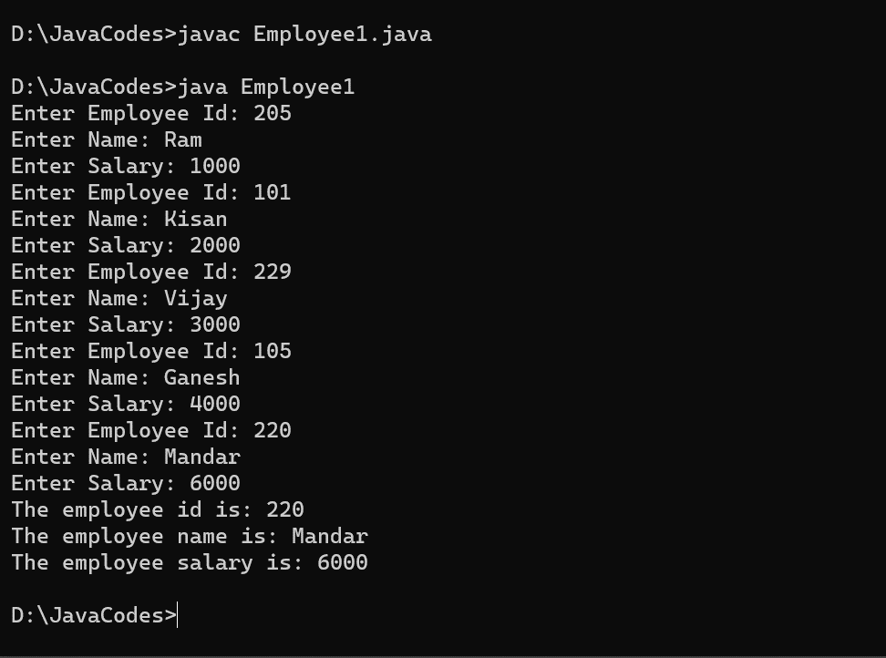

1. Write a program to declare class Product having data member id, name, price accepts records for 5 products and display all records and also display Total Price of Products.

Ans:

import java.util.Scanner;

class Product1

{

int id,price;

String name;

void getdata()

{

Scanner sc=new Scanner(System.in);

System.out.print("Enter Product Id: ");

id=sc.nextInt();

System .out.print("Enter Product Name: ");

name=sc.next();

System.out.print("Enter Product Price: ");

price=sc.nextInt();

}

void display()

{

System.out.println("The product id is: " + id);

System.out.println("The product name is: " + name);

System.out.println("The product salary is: " + price);

}

public static void main(String args[])

{

int sum=0;

Product1 p[]=new Product1[5];

for(int i=0;i<5;i++)

{

p[i]=new Product1();

p[i].getdata();

}

for(int i=0;i<5;i++)

{

sum+=p[i].price;

}

System.out.println("The total is "+sum);

}

}

Output:

