**Programs**

1. Write a Program to implement following inheritance. Assume suitable methods.

Ans:

class Student

{

int Roll_no;

String name;

Student(int r,String n)

{

Roll_no=r;

name=n;

}

void display()

{

System.out.println("Roll No.: "+Roll_no);

System.out.println("Name: "+name);

}

}

class Library extends Student

{

int Member_No;

Library(int r,String n,int m)

{

super(r,n);

Member_No=m;

}

void display1()

{

display();

System.out.println("Member No: "+Member_No);

}

}

class Inherit1

{

public static void main(String args[])

{

Library l=new Library(205,"Vinayak",1029);

l.display1();

}

}

Output:

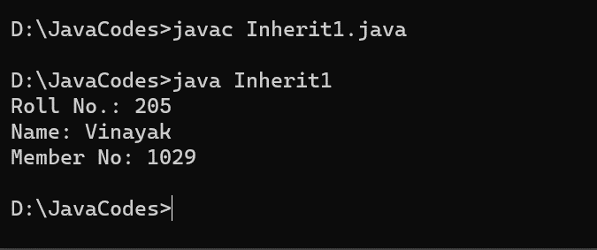

1. Write a Program to implement following inheritance. Assume suitable methods. Accept data for 5 person and display the name of employee having salary greater than 5000.

Ans:

import java.util.Scanner;

class Person

{

String Name;

int age;

void getdata()

{

Scanner sc=new Scanner(System.in);

System.out.println("Enter name: ");

Name=sc.next();

System.out.println("Enter age: ");

age=sc.nextInt();

}

}

class Employee extends Person

{

String Designation;

int Salary;

void get()

{

Scanner sc1=new Scanner(System.in);

System.out.println("Enter designation: ");

Designation=sc1.next();

System.out.println("Enter salary: ");

Salary=sc1.nextInt();

}

void display()

{

System.out.println("Employee name is "+Name);

}

}

class Inherit2

{

public static void main(String args[])

{

Employee emp[]=new Employee[5];

for(int i=0;i<5;i++)

{

emp[i]=new Employee();

emp[i].getdata();

emp[i].get();

}

System.out.println("Employee having salary greater than 5000");

for(int i=0;i<5;i++)

{

if(emp[i].Salary>5000)

emp[i].display();

}

}

}

Output:

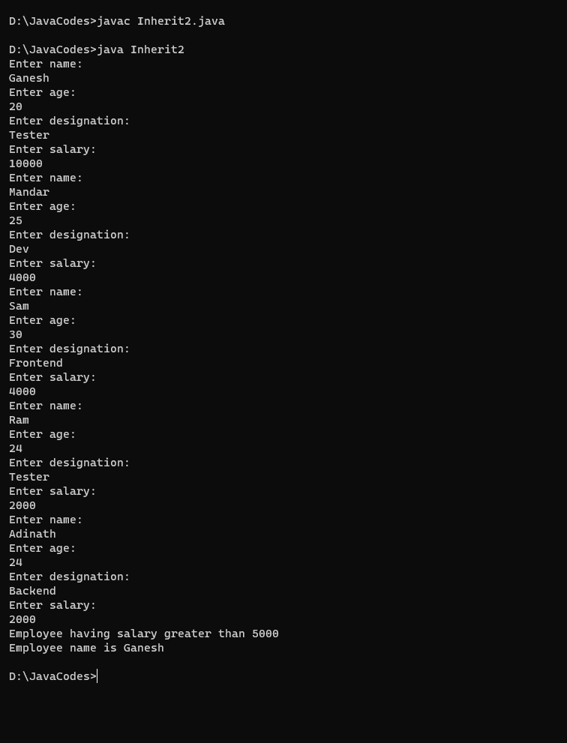

1. Write a Program to create class “Chocholate “ having data members ‘ChocoName’ & ‘ChochoQuantity’. Derive a class ‘ChochoFlavor’ having data member ‘FlavorName’. Initialize the values for two objects of ‘ChochoFlavor’ class using constructor and display it.

Ans:

class Chocolate

{

String ChocoName;

int ChocoQuantity;

Chocolate(String a,int b)

{

ChocoName= a;

ChocoQuantity=b;

}

void display()

{

System.out.println("Name of the choco: "+ChocoName);

System.out.println("Quantity of choco: "+ChocoQuantity);

}

}

class ChocoFlavor extends Chocolate

{

String FlavorName;

ChocoFlavor(String a,int b,String c)

{

super(a,b);

FlavorName=c;

}

void display1()

{

System.out.println("Flavor of the choco: "+FlavorName);

}

public static void main(String args[])

{

ChocoFlavor c1=new ChocoFlavor("Eclair",10,"Sweet");

ChocoFlavor c2=new ChocoFlavor("Melody",5,"Sweet");

c1.display();

c1.display1();

c2.display();

c2.display1();

}

}

Output:

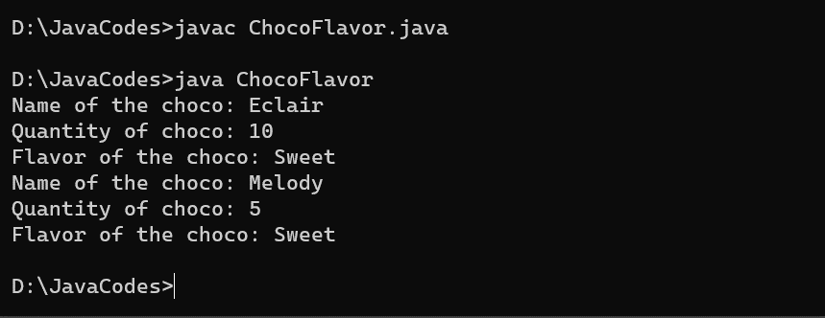

1. Write a Program to implement following inheritance. Assume suitable methods.

Ans:

import java.util.Scanner;

class Student

{

int Roll_no;

String name;

void get()

{

Scanner sc= new Scanner(System.in);

System.out.println("Enter Roll no.: ");

Roll_no = sc.nextInt();

System.out.println("Enter Name : ");

name = sc.next();

}

}

class Marks extends Student

{

int mark1,mark2,total;

void get1()

{

Scanner sc1 = new Scanner(System.in);

System.out.println("Enter Marks for 1st subject: ");

mark1= sc1.nextInt();

System.out.println("Enter Marks for 2nd subject: ");

mark2 = sc1.nextInt();

total =mark1+mark2;

}

}

class Result extends Marks

{

float percentage;

void per()

{

percentage =(total*100)/200;

}

void display()

{

System.out.println("Total Percentage: "+percentage);

}

public static void main(String args[])

{

Result r1=new Result();

r1.get();

r1.get1();

r1.per();

r1.display();

}

}

Output:

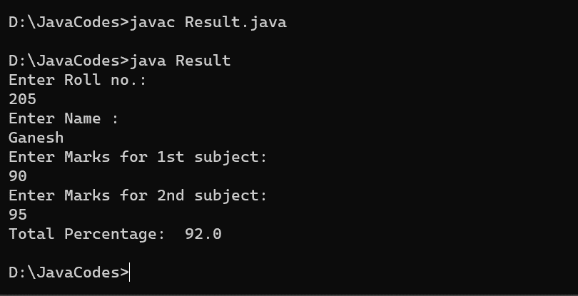

1. Write a program to create a class ‘Book’ having data members ‘author’,‘title’ & ‘publisher’ and derive a class “BookInfo” having data members ‘price’,’stock position’ and a method ‘show()’ . Initialize it using constructor and display the information for 3 objects.

Ans:

class Book

{

String author,title,publisher;

Book(String a,String t, String p)

{

author=a;

title= t;

publisher=p;

}

}

class BookInfo extends Book

{

float price;

int stock_position;

BookInfo(String a,String t, String p,float pr,int s)

{

super(a,t,p);

price=pr;

stock_position=s;

}

void show()

{

System.out.println("Author of the book: "+author);

System.out.println("Title of the book: "+title);

System.out.println("Publisher of the book: "+publisher);

System.out.println("Price of the book: "+price);

System.out.println("Stocks Remaining of the book: "+stock_position);

}

public static void main(String args[])

{

BookInfo b1=new BookInfo("Paulo Coelho"," The Alchemist","Fiction",150,50);

BookInfo b2=new BookInfo("Astrid Lindgren"," Pippi Longstocking ","Fiction",210,15);

BookInfo b3=new BookInfo("Eoin Colfer"," Artemis Fowl","Fiction",155,142);

b1.show();

b2.show();

b3.show();

}

}

Output:

