**Programs**

1. Write a Program to declare class shape then calculate Area of Circle ,Area of Triangle, Area of Rectangle , Area of Square using Method overloading.

Ans:

class shape

{

void area(double x)

{

double a=3.14*x*x;

System.out.println("Area of Circle is "+a);

}

void area(double x,double y)

{

double a=(x*y)/2;

System.out.println("Area of Triangle is "+a);

}

void area(int x,int y)

{

int a=x*y;

System.out.println("Area of Rectangle is "+a);

}

void area(int x)

{

int a=x*x;

System.out.println("Area of Square is "+a);

}

public static void main(String args[])

{

shape s=new shape();

s.area(4.2);

s.area(7.1,4.2);

s.area(4,6);

s.area(6);

}

}

Output:

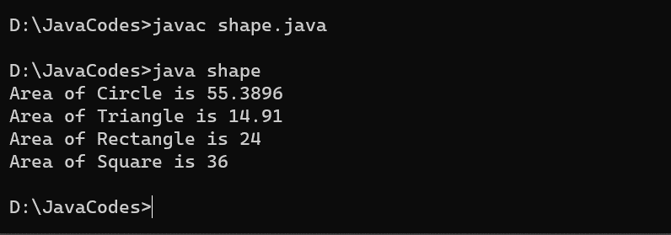

1. Write a Program to declare class shape then calculate Area of Circle ,Area of Triangle , Area of Rectangle , Area of Square using Constructor overloading.

Ans:

class shape1

{

double l,b;

shape1(double x)

{

l=x;

double a=3.14*l*l;

System.out.println("Area of Circle is "+a);

}

shape1(double x,double y)

{

l=x;

b=y;

double a=(l*b)/2;

System.out.println("Area of Triangle is "+a);

}

shape1(int x,int y)

{

l=x;

b=y;

double a=l*b;

System.out.println("Area of Rectangle is "+a);

}

shape1(int x)

{

l=x;

double a=l*l;

System.out.println("Area of Square is "+a);

}

public static void main(String args[])

{

shape1 s1=new shape1(4.1);

shape1 s2=new shape1(4.1,5.4);

shape1 s3=new shape1(4,7);

shape1 s4=new shape1(8);

}

}

Output:

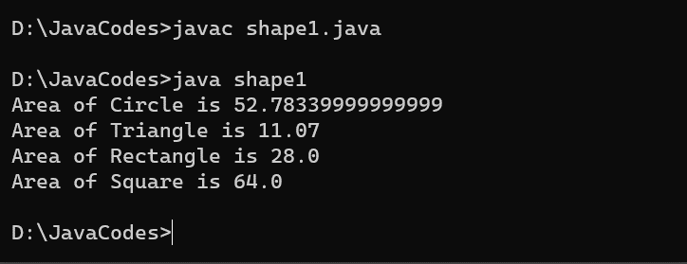

1. Write a Program to declare class Box with data member length , width , Height initialized three object using different constructors and Calculate Volume of Box and display it using constructor overloading .

Ans:

class Box1

{

int length,width,height;

Box1(int l1,int w1,int h1)

{

length=l1;

width=w1;

height=h1;

int v1=length*width*height;

System.out.println("Volume of Box is "+v1);

}

Box1(int l2,int w2,double h2)

{

length=l2;

width=w2;

double height=h2;

double v2=length*width*height;

System.out.println("Volume of Box is "+v2);

}

Box1(double l3,double w3,double h3)

{

double length=l3,width=w3,height=h3;

double v3=length*width*height;

System.out.println("Volume of Box is "+v3);

}

public static void main(String args[])

{

Box1 b1=new Box1(5,6,7);

Box1 b2=new Box1(5,8,4.5);

Box1 b3=new Box1(5.3,7.5,4.4);

}

}

Output:

