**Programs**

1. Write a Program to implement following inheritance. Assume suitable methods.

Ans:

class Student

{

int Roll_no;

String name;

void get(int r,String n)

{

Roll_no=r;

name=n;

}

}

interface Sports

{

int sport_wt=5;

void show();

}

class Result extends Student implements Sports

{

int marks1,marks2,total_marks;

float per;

public void show()

{

System.out.println("Sport wt="+sport_wt);

}

void getmarks(int m1,int m2)

{

marks1=m1;

marks2=m2;

}

void Calpercentage()

{

show();

total_marks=marks1+marks2;

per=(total_marks*100)/200;

System.out.println("Roll No.: "+Roll_no+"\nName: "+name+"\nPercentage: "+per);

}

public static void main(String args[])

{

Result r1=new Result();

r1.get(205,"Vinayak");

r1.getmarks(82,90);

r1.Calpercentage();

}

}

Output:

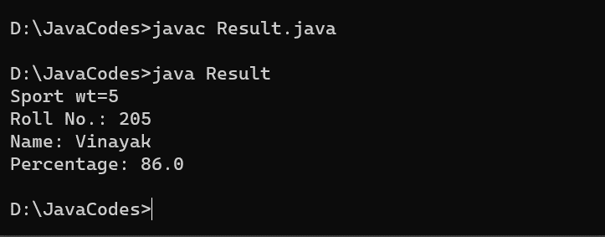

1. Write a Program to implement following inheritance.

Ans:

interface Shape

{

void Area();

}

class Rectangle implements Shape

{

int length,width,area;

void get(int l,int w)

{

length=l;

width=w;

}

public void Area()

{

area=length*width;

}

void show()

{

Area();

System.out.println("Area of Rectangle: "+area);

}

public static void main(String args[])

{

Rectangle r=new Rectangle();

r.get(9,8);

r.show();

}

}

Output:

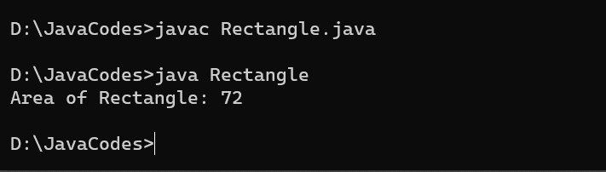

1. Write a Program to implement following inheritance. Assume suitable methods.

Ans:

interface Exam

{

void Per_cal();

}

class Student

{

int Roll_no,m1,m2;

String name;

void get(int r,int mark1,int mark2,String n)

{

Roll_no=r;

m1=mark1;

m2=mark2;

name=n;

}

}

class Result1 extends Student implements Exam

{

int total;

float per;

public void Per_cal()

{

total=m1+m2;

per=(to tal*100)/200;

}

void show()

{

Per_cal();

System.out.println("Roll No.: "+Roll_no+"\nName: "+name+"\nPercentage: "+per);

}

public static void main(String args[])

{

Result1 r=new Result1();

r.get(205,82,90,"Vinayak");

r.show();

}

}

Output:

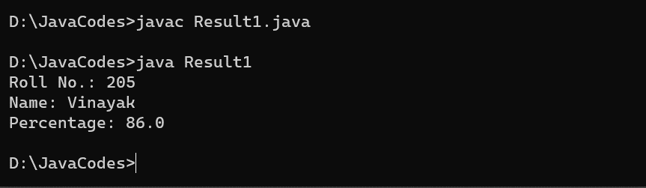

1. Write a Program to implement following inheritance. Assume suitable methods.

Ans:

class Student

{

int rollno;

String name;

void input(int r,String n)

{

rollno=r;

name=n;

}

void output()

{

System.out.println("The name is : "+name);

System.out.println("The roll no is :"+ rollno);

}

}

interface employee

{

final int B_salary=29000,HRA=10000,DA=18000;

void show();

}

class Manager extends Student implements employee

{

int M_id;

String Name;

double Total_Sal;

Manager(int r,String n, int i,String n1)

{

super.input(r,n);

M_id=i;

Name= n1;

}

void calsalary()

{

Total_Sal=B_salary+HRA+DA;

}

public void show()

{

System.out.println("The member id is :"+M_id);

System.out.println("The Manager name is :"+Name);

System.out.println("The total salary is :"+ Total_Sal);

}

public static void main(String[] args)

{

Manager m= new Manager(205, "Vinayak",1029,"XYZ");

m.output();

m.calsalary();

m.show();

}

}

Output:

