**Programs**

1. Write a program to create own exception(user defined exception) to accept no from user and throw an exception if the number is not Even.

Ans:

import java.util.Scanner;

class NotEvenException extends Exception

{

NotEvenException()

{

System.out.println("Error:Number is odd");

}

}

class evenExc

{

public static void main(String args[])

{

try

{

Scanner sc=new Scanner(System.in);

System.out.println("Enter a number:");

int n=sc.nextInt();

if(n%2==0)

System.out.println("Number is Even");

else

throw new NotEvenException();

}

catch(NotEvenException e)

{

}

}

}

Output:

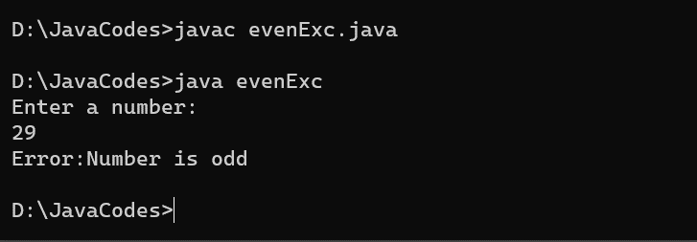

1. Write a program to create own exception(user defined exception) to accept no from user and throw an exception if the number is not Prime.

Ans:

import java.util.Scanner;

class NotPrimeException extends Exception

{

NotPrimeException()

{

System.out.println("Error:It is not a prime number");

}

}

class primeExc

{

public static void main(String args[])

{

try

{

int flag=0;

Scanner sc=new Scanner(System.in);

System.out.println("Enter a number:");

int n=sc.nextInt();

for(int i=2;i<n;i++)

{

if(n%i==0)

{

flag++;

break;

}

}

if(flag==0)

System.out.println(n+" is a Prime number");

else

throw new NotPrimeException();

}

catch(NotPrimeException e)

{

}

}

}

Output:

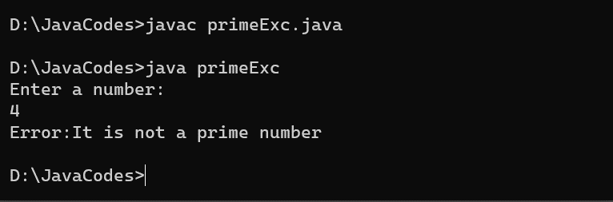

1. Write a program to create own exception(user defined exception) to accept age from user and throw an exception if the age is negative.

Ans:

import java.util.Scanner;

class AgeException extends Exception

{

AgeException()

{

System.out.println("Error:Invalid age");

}

}

class ageExc

{

public static void main(String args[])

{

try

{

Scanner sc=new Scanner(System.in);

System.out.println("Enter age:");

int age=sc.nextInt();

if(age>0)

System.out.println("Entered age is "+age);

else

throw new AgeException();

}

catch(AgeException e)

{

}

}

}

Output:

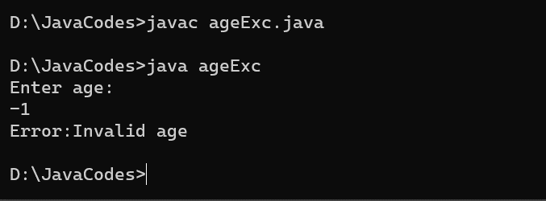

1. Write a program to create own exception(user defined exception) to accept String from user and throw an exception if the String is not starting character ‘s’.

Ans:

import java.util.Scanner;

class StringException extends Exception

{

StringException()

{

System.out.println("Error:String doesn't start with s");

}

}

class stringExc

{

public static void main(String args[])

{

try

{

Scanner sc=new Scanner(System.in);

System.out.println("Enter string:");

String str=sc.next();

char s1=str.charAt(0);

if(s1=='s' || s1=='S')

System.out.println("String is starting with s");

else

throw new StringException();

}

catch(StringException e)

{

}

}

}

Output:

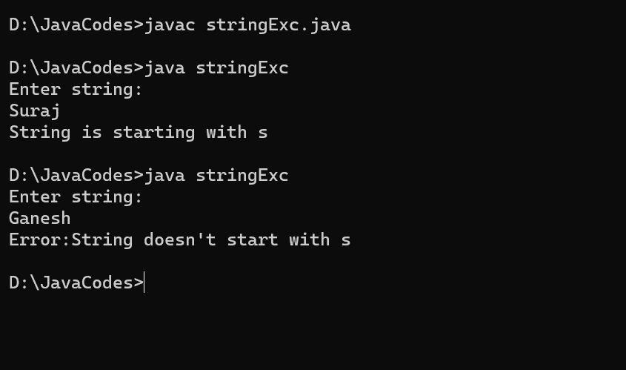

1. Write a program to create own exception(user defined exception) to accept Password from user and throw an “AuthenticationFailure” exception if the Password is incorrect.

Ans:

import java.util.Scanner;

class AuthenticateException extends Exception

{

AuthenticateException()

{

System.out.println("Error:Authentication Failure");

}

}

class passExc

{

public static void main(String args[])

{

try

{

Scanner sc=new Scanner(System.in);

System.out.println("Enter Password:");

String str=sc.next();

if(str.equals("Vinayak"))

System.out.println("Valid Password");

else

throw new AuthenticateException();

}

catch(AuthenticateException e)

{

}

}

}

Output:

