design:

UI/UX:

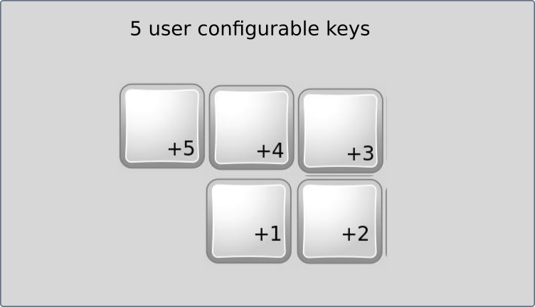

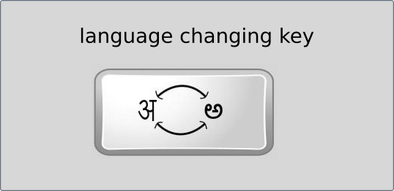

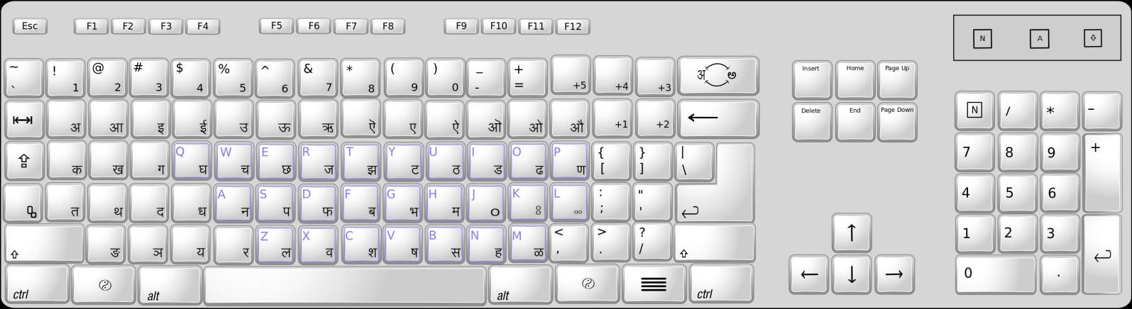

it is good to sell it this way:

1. this should NOT be presented as ‘nationalist product’, it should be presented as ‘utility product’ **:**

people’s brain is smart enough to differentiate between who is playing ‘shit game’ and who is ‘genuine’, if we try to sell this using people’s nationalist emotions they think we are not-competitive and so we are using nationalism to sell the product. so they may not think of buying the product.

if we present it as ‘utility product’ and show them different ways of using it in daily activities that they do, they feel the product is useful to get their work done and they consider buying it every time they face the situation we showed them.

for example we can show them how they can use this to comment on movie trailer on youtube in their own language, we can show them how they can express certain feelings in their own language which can’t be expressed in english on facebook, we can also make it funny by showing how they can use this to troll their favorite movie star.

more we show how it can be used more they consider buying it.

1. low cost products of the company are the ‘quality brand ambassadors’ **:**

people don’t risk higher amount on the products of the company that don’t have reputation,

but we can convince them to buy our low cost product easily, if the quality and utility of these low cost products earn their trust of the people, they will also develop trust towards other products of the brand, then we can easily convince them to buy higher cost products. then when they are ready to pay money for quality it is not that difficult to deliver quality product, quality costs money.

low cost products will usually have large number of buyers so brand reputation will propagate faster among people, domino effect will be faster and bigger.

it is okay to compromise in profit margin of these low cost products because the quality brand name they create bring much more money from other products of the company.

1. use words responsibly **:**

words we use on package and product should not show our ignorance or lack of research.

we should not use phrases like ‘punjabi keyboard’ or ‘oriya keyboard’, it should be ‘gurmukhi keyboard’ and ‘odia keyboard’

95AFBEA8BFB5