PES University — Dept. of CSE
Lab 1: Requirements Engineering & UML Use-Case Modelling
Problem Statement #24 — Smart Cities, Transport & Logistics
Public Bus Live Tracking & Crowding Estimator
Name: Vinayaka Jagadish SRN: PES1UG25CS855 Section: A
1. Problem Context & Overview
A municipal transit intelligence platform that ingests GPS feeds from city buses, estimates arrival times (ETA) at downstream stops, and computes passenger crowding levels from ticketing sensors.
Stakeholders / Actors: Commuter, Fleet Controller
2. Functional Requirements (FR-001 – FR-005)
ID | Priority | Description | Acceptance Criteria | Rationale
FR-001 | High | The system shall ingest bus GPS coordinates every 5 seconds and recalculate arrival ETAs for all upcoming route stops. | Pass: ETA updates based on current traffic speed and distance. Fail: ETA increases while the bus approaches the stop. | Commuters rely on accurate, continuously updated ETAs to decide when to leave for a stop; stale or incorrect ETAs directly reduce trust in the platform.
FR-002 | High | The system shall estimate the passenger crowding level (Low / Medium / High) for each active bus from ticketing sensor counts and refresh the estimate whenever a ticketing event is received. | Pass: crowding level updates within 10 seconds of a boarding/alighting event and matches sensor delta counts. Fail: crowding level remains unchanged after multiple boarding events. | Crowding information lets commuters choose a less-congested service and helps planners identify overcrowded routes.
FR-003 | High | The system shall allow a commuter to view the live location of a selected bus on a map, updated at least every 5 seconds while the bus is en route. | Pass: map marker position reflects the latest ingested GPS coordinate within 5 seconds. Fail: marker lags by more than 15 seconds or freezes. | Live location is the core value proposition of the platform, giving commuters visual confidence in bus position independent of the ETA figure.
FR-004 | Medium | The system shall notify a commuter, in-app, when the ETA for a bus they are tracking increases by more than 5 minutes from the previously displayed ETA. | Pass: notification is generated within 10 seconds of the ETA recalculation that crosses the 5-minute threshold. Fail: no notification is sent despite a qualifying ETA increase. | Proactively surfacing delays lets commuters re-plan their journey instead of discovering a delay only after waiting at the stop.
FR-005 | Medium | The system shall provide the Fleet Controller a dashboard listing all active vehicles with their current route, last GPS timestamp, and crowding level, and shall allow the controller to configure the delay-alert threshold per route. | Pass: dashboard reflects the latest telemetry for every active vehicle and threshold changes take effect on the next ETA recalculation. Fail: dashboard shows stale data for an active vehicle for more than 30 seconds. | Fleet controllers need a consolidated operational view to detect stalled vehicles, sensor dropouts, or systemic delays, and to tune alerting to route-specific conditions.

3. Non-Functional Requirements (NFR-001 – NFR-002)
ID | Type | Description | Priority | Acceptance Criteria | Rationale
NFR-001 | Performance & Security | The tracking engine shall handle telemetry streams from up to 1,000 active transit vehicles simultaneously, transmitted over authenticated, encrypted channels. | High | Pass: benchmarking confirms target latency (ETA recalculation within 2s of ingest) and security standards under simulated peak load of 1,000 vehicles. Fail: latency exceeds target or unauthenticated telemetry is accepted. | A city-scale service must handle the full municipal fleet without degrading responsiveness, and public infrastructure data must be protected from spoofing or interception.
NFR-002 | Reliability & Availability | Commuter-facing tracking and ETA services shall be available 99.5% of the time (monthly) and shall degrade gracefully — showing last-known position with a "data delayed" indicator — rather than failing outright when a vehicle's telemetry is delayed or lost. | High | Pass: uptime monitoring confirms 99.5% monthly availability and the UI shows a delayed-data indicator within 30 seconds of a telemetry gap. Fail: the app crashes or shows no data during a telemetry gap. | Commuters depend on this system for real-time travel decisions; unannounced downtime or silent staleness is worse than a visible "delayed" state, which preserves user trust.

4. UML Use-Case Diagram
Actors: Commuter, Fleet Controller. The diagram models the primary use cases for both actors, one «include» relationship per included sub-behaviour (Calculate ETA from GPS Feed, Estimate Crowding Level from Sensors, Authenticate User), and one «extend» relationship (Notify Commuter of Delay extends View ETA, guarded by the condition {ETA delay > threshold}).
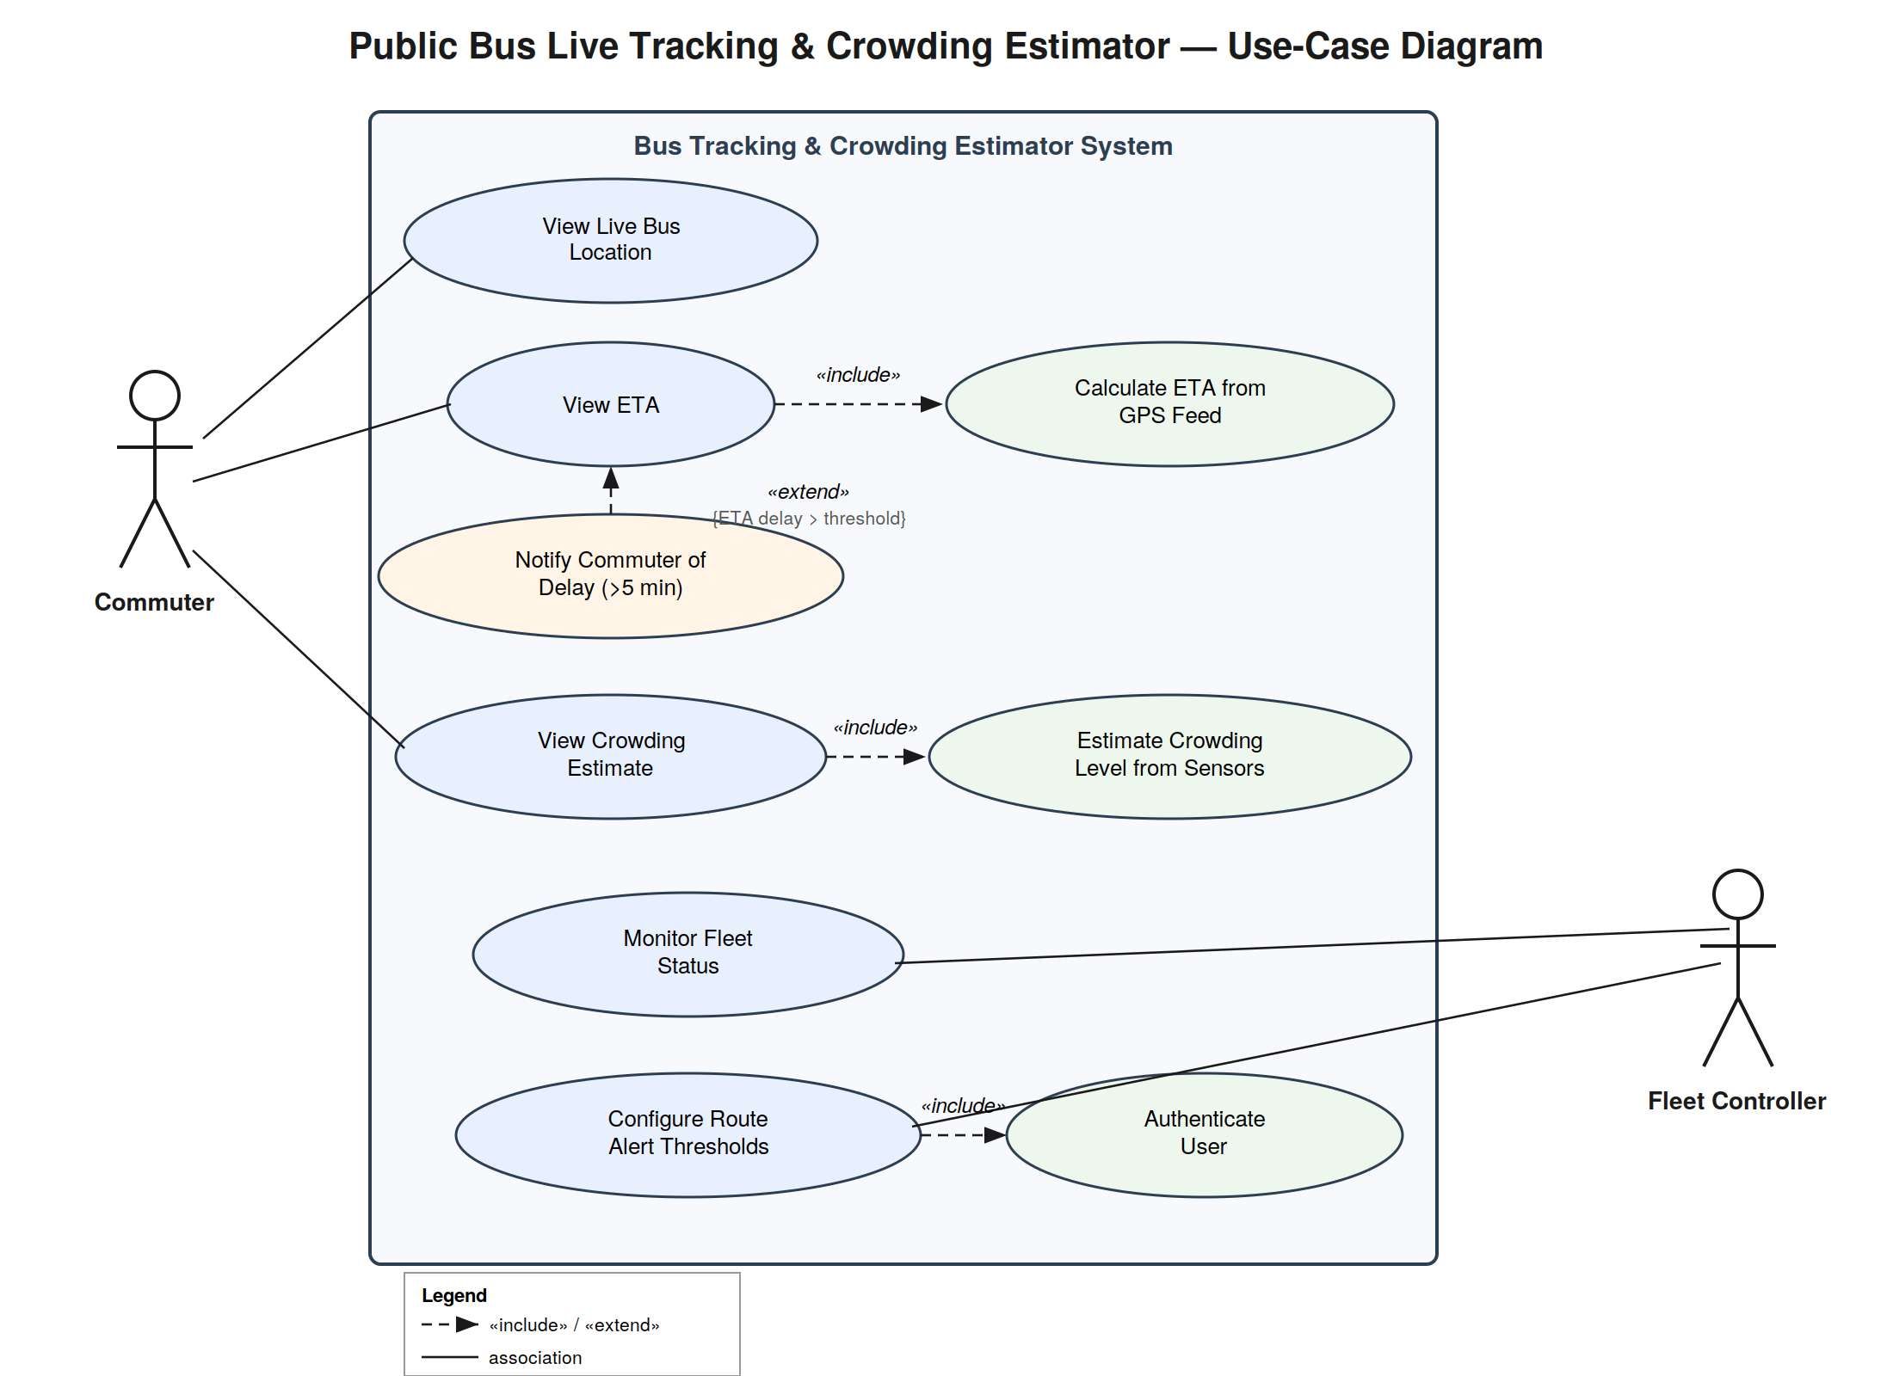

5. Use-Case Flow Specification — “View ETA”
Use Case Name | View ETA
Primary Actor | Commuter
Includes | Calculate ETA from GPS Feed (mandatory)
Extended by | Notify Commuter of Delay (>5 min), condition: {ETA delay > threshold}
Preconditions | 1. The commuter has the app open and has selected a bus/route to track.  2. The selected bus is actively transmitting GPS telemetry to the system.  3. The commuter's device has network connectivity.
Postconditions | 1. The current ETA for the selected bus at the commuter's chosen stop is displayed with a last-updated timestamp.  2. If the ETA increased by more than 5 minutes since it was last shown, the delay-notification extension has been triggered.
Main Success Scenario
1. The commuter selects a bus/route and a target stop within the app.
2. The system retrieves the latest GPS coordinate received for the selected bus.
3. The system performs «include» “Calculate ETA from GPS Feed”: it computes the ETA using the bus's current position, distance to the stop, and current traffic/speed data.
4. The system displays the computed ETA and a last-updated timestamp to the commuter.
5. The system schedules the next ETA refresh in line with the 5-second GPS ingest cycle (FR-001).
6. The commuter continues to see the ETA refresh automatically while the screen remains open; if a refresh raises the ETA by more than 5 minutes, the «extend» use case “Notify Commuter of Delay” fires.
Alternate Flow A1 — GPS Signal Lost / Stale Telemetry
A1. At step 2, the system detects that no GPS update has been received for the selected bus within the expected 5-second window.
A2. The system marks the bus's telemetry as stale, and displays the last-known ETA together with a “data delayed” indicator (per NFR-002) instead of failing silently.
A3. The system continues attempting to fetch the next GPS update; once a fresh coordinate is received, the flow resumes at step 3 of the main scenario.
A4. If telemetry remains stale for more than 2 minutes, the system displays a message advising the commuter that live tracking for this bus is temporarily unavailable.

