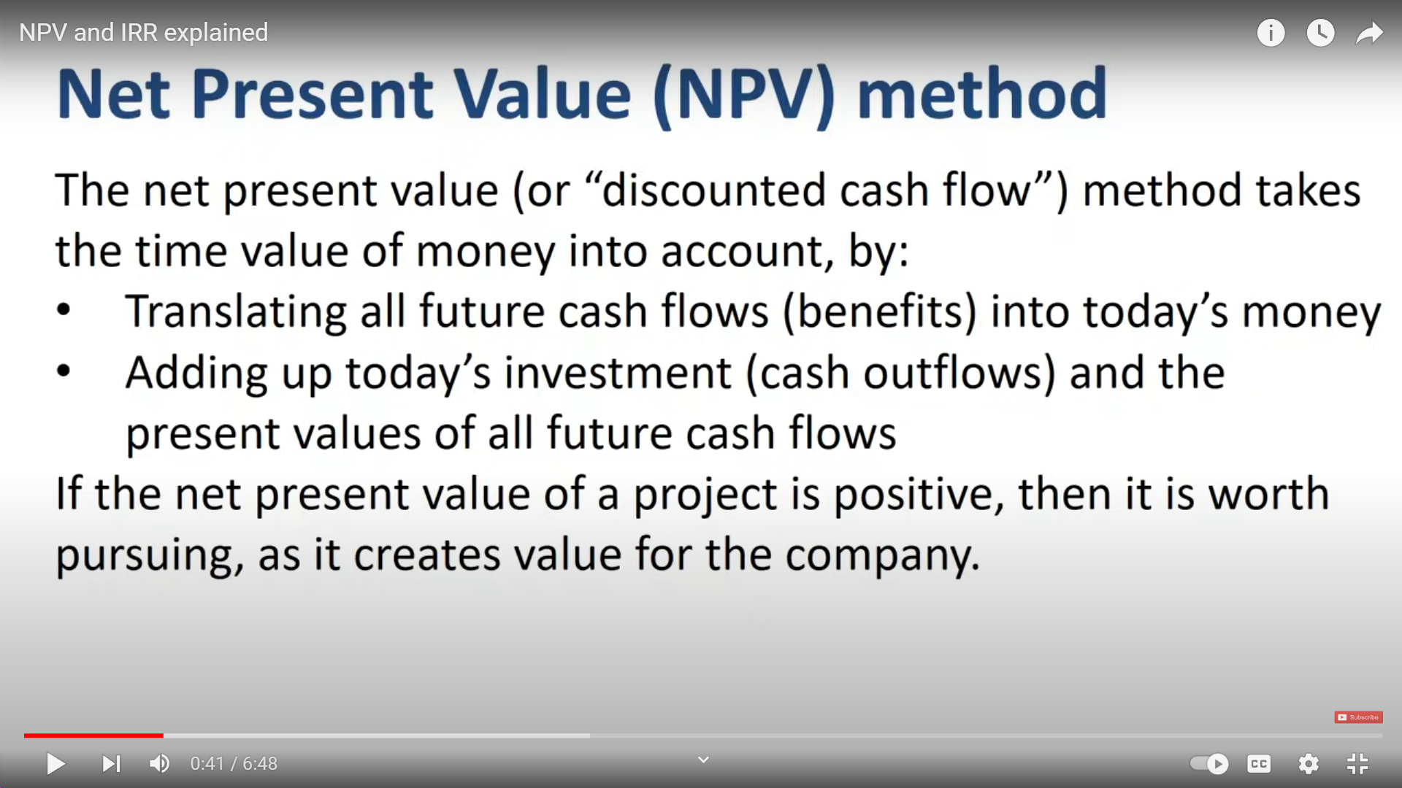

Net Present Value (NPV) is a financial metric that helps evaluate the profitability of an investment by comparing the present value of expected cash inflows with the present value of expected cash outflows over time. In simpler terms, it helps determine the net value of an investment in today's dollars, accounting for the time value of money.

Let's walk through a real-life scenario to understand NPV:

**Scenario: Investment in a Solar Panel Project**

Imagine a company is considering investing in a solar panel project with an upfront cost of $500,000. The project is expected to generate cash inflows over the next 10 years.

* **Initial Investment (Year 0):** $500,000
* **Expected Cash Inflows:**
  + Year 1: $70,000
  + Year 2: $80,000
  + Year 3: $90,000
  + Year 4: $100,000
  + Year 5: $110,000
  + Year 6: $120,000
  + Year 7: $130,000
  + Year 8: $140,000
  + Year 9: $150,000
  + Year 10: $160,000
* **Discount Rate:** 8% (this is the rate used to discount future cash flows to their present value)

Now, we can calculate the NPV using the formula:

*NPV*=∑*t*=0*n*​(1+*r*)*tCFt*​​−*C*0​  
Where:

* *NPV* is the Net Present Value
* *t* represents each time period (in years)
* *CFt*​ is the net cash flow during the time period *t*
* *r* is the discount rate
* *C*0​ is the initial investment cost

Let's calculate the NPV for our scenario:

*NPV*=(1+0.08)170,000​+(1+0.08)280,000​+…+(1+0.08)10160,000​−500,000

Once you calculate this, if the NPV is positive, it indicates that the project is expected to generate more cash inflows than the initial investment, making it a potentially profitable venture. If the NPV is negative, it suggests that the project may not be financially viable.

NPV is a valuable tool for decision-makers to assess the financial feasibility of long-term investments, taking into account the time value of money and providing a clearer picture of potential returns.