**Name: VINAYAKA GADAG**

**Email: vgadag@iu.edu**

**TASK-1**

1. What is the IP address of your computer? Of the *gaia.cs.umass.edu* server?

* IP address of computer – 192.168.1.79
* Server IP address – 128.119.245.12

1. What is the status code and phrase returned from the server to your browser?

* Status Code - HTTP/1.1 200 OK
* Phrase - Congratulations. You've downloaded the file <http://gaia.cs.umass.edu/wireshark-labs/HTTP-wireshark-file1.html>!
* Response Phrase: OK

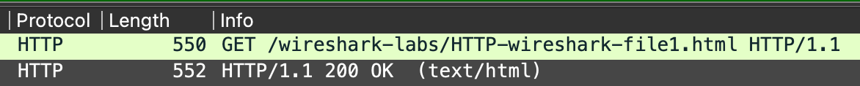

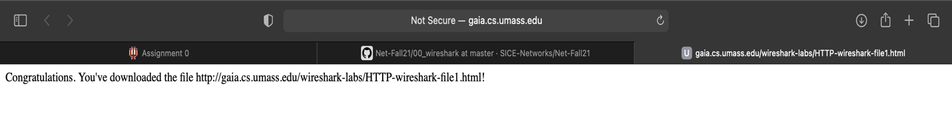

1. What languages does your browser indicate to the server that it can accept? Which header line is used to indicate this information?

* Language - en-US,en;q=0.9
* Header-line – Accept-language

1. How many bytes of content (size of file) are returned to your browser? Which header line is used to indicate this information?

* Content length - 128 bytes
* Header line – Content-Length
* Folder Data – 128 bytes

1. How long did it take from when the HTTP GET message was sent until the HTTP OK reply was received? (By default, the value of the Time column in the packet listing window is the amount of time, in seconds, since Wireshark tracing began. To display the Time field in time-of-day format, select the Wireshark View pull down menu, then select Time Display Format, then select Time-of-day.)

* Time taken - 0.0448 seconds

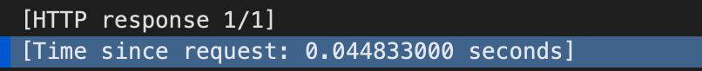

**TASK-2**

1. Take a screen shot of the wireshark window showing the ICMP packets. Depending on the number of hops between where you are on the Internet and Yahoo, you might not be able to fit all the ICMP packets on the screen. That’s OK, just make the Wireshark window as “tall” as you can, and perhaps uncheck the “packet bytes” and “packet details” sections under the “View” menu. Notice the IP addresses match up to the output from the traceroute command in your terminal window.

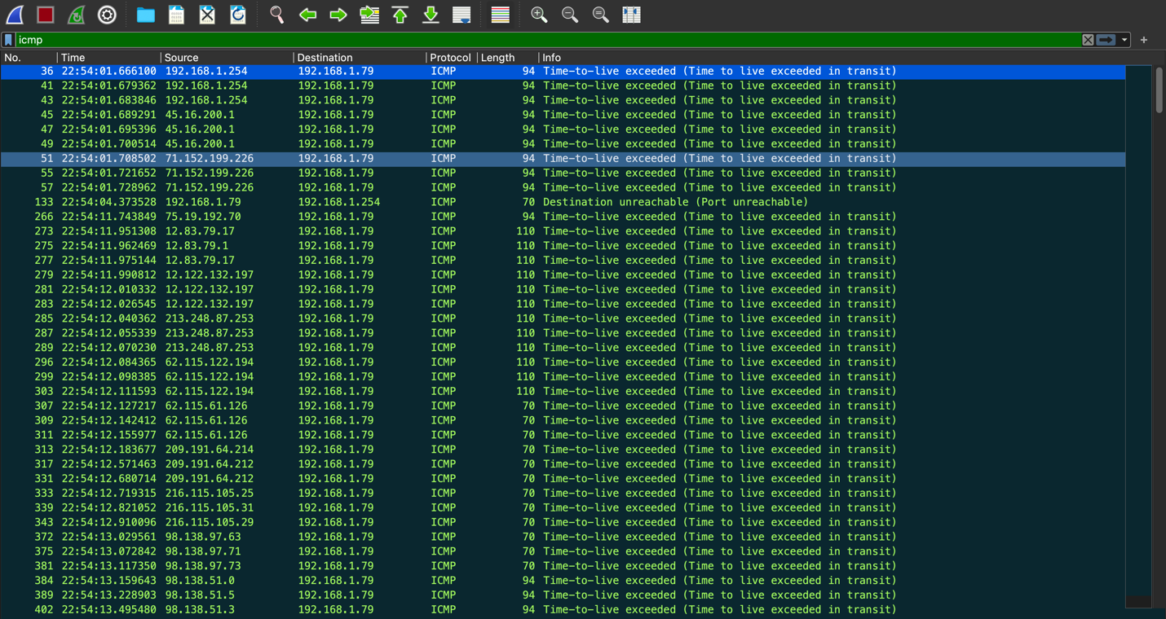

1. ❯ traceroute yahoo.com
2. traceroute: Warning: yahoo.com has multiple addresses; using 74.6.231.21
3. traceroute to yahoo.com (74.6.231.21), 64 hops max, 52 byte packets
4. 1 dsldevice (192.168.1.254) 4.029 ms 3.937 ms 3.573 ms
5. 2 45-16-200-1.lightspeed.iplsin.sbcglobal.net (45.16.200.1) 4.602 ms 4.350 ms 4.382 ms
6. 3 71.152.199.226 (71.152.199.226) 7.251 ms 7.482 ms 7.054 ms
7. 4 * * *
8. 5 * 12.83.79.17 (12.83.79.17) 19.542 ms
9. 12.83.79.1 (12.83.79.1) 8.782 ms
10. 6 cgcil402igs.ip.att.net (12.122.132.197) 15.990 ms 13.481 ms 16.429 ms
11. 7 chi-b2-link.ip.twelve99.net (213.248.87.253) 13.237 ms 14.027 ms 13.371 ms
12. 8 chi-b23-link.ip.twelve99.net (62.115.122.194) 12.861 ms 12.910 ms 13.735 ms
13. 9 yahoo-ic314777-chi-b23.ip.twelve99-cust.net (62.115.61.126) 13.186 ms 13.862 ms 14.266 ms
14. 10 ae-7.pat2.nez.yahoo.com (209.191.64.214) 27.765 ms
15. ae-5.pat1.nez.yahoo.com (209.191.64.212) 48.547 ms 39.677 ms
16. 11 et-0-0-0.msr2.ne1.yahoo.com (216.115.105.179) 40.666 ms 39.379 ms
17. et-18-1-0.msr1.ne1.yahoo.com (216.115.105.31) 26.985 ms
18. 12 et-1-0-0.clr2-a-gdc.ne1.yahoo.com (98.138.97.73) 41.330 ms
19. et-0-0-0.clr1-a-gdc.ne1.yahoo.com (98.138.97.61) 25.543 ms
20. et-1-1-0.clr1-a-gdc.ne1.yahoo.com (98.138.97.63) 38.681 ms
21. 13 lo0.fab2-2-gdc.ne1.yahoo.com (98.138.51.1) 54.203 ms
22. lo0.fab6-2-gdc.ne1.yahoo.com (98.138.51.5) 25.999 ms
23. lo0.fab5-2-gdc.ne1.yahoo.com (98.138.51.4) 25.957 ms
24. 14 usw2-1-lbd.ne1.yahoo.com (98.138.97.157) 23.631 ms
25. usw1-1-lbd.ne1.yahoo.com (98.138.97.156) 68.687 ms 23.993 ms
26. 15 media-router-fp74.prod.media.vip.ne1.yahoo.com (74.6.231.21) 40.851 ms 38.086 ms 40.438 ms