**Lesson 02 Demo 01**

**Getting Started with Tableau**

* Which segment has the highest sales across all years?
* In which year and category were the home office sales greater than the corporate sales?

**Overview:**

* Plot Sales against category, segment, and order date
* Change the mark type to the line
* Use color encoding at the yearly level

Note:Use the sample-superstore saved data source.

The result should resemble the image given below:

**Detailed Instructions:**

**1.** Open **Tableau 2021.4** (You can go to **Start Menu** -> **Tableau 2021.4**)



**2.** On the **home page**, under **Connect**, go to the **Saved Data Sources**, select **Sample – Superstore**

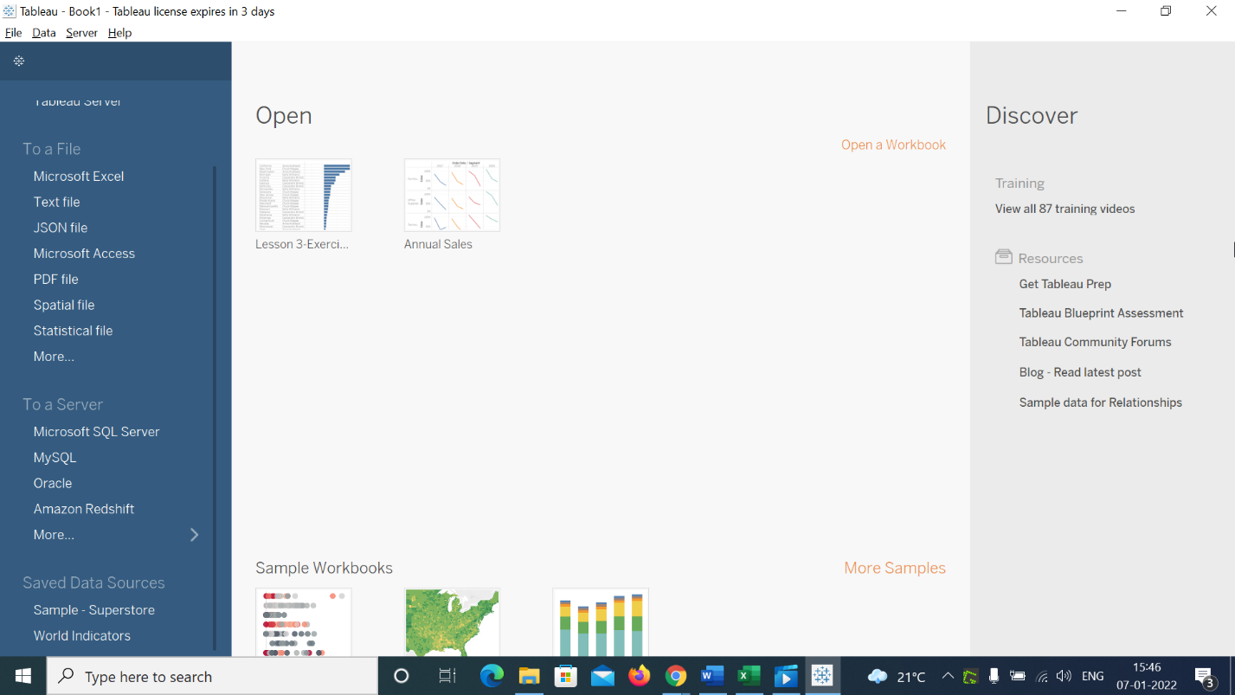

**3.** In the **Data pane**, under dimensions, locate **Category** and place it in the **Rows** shelf

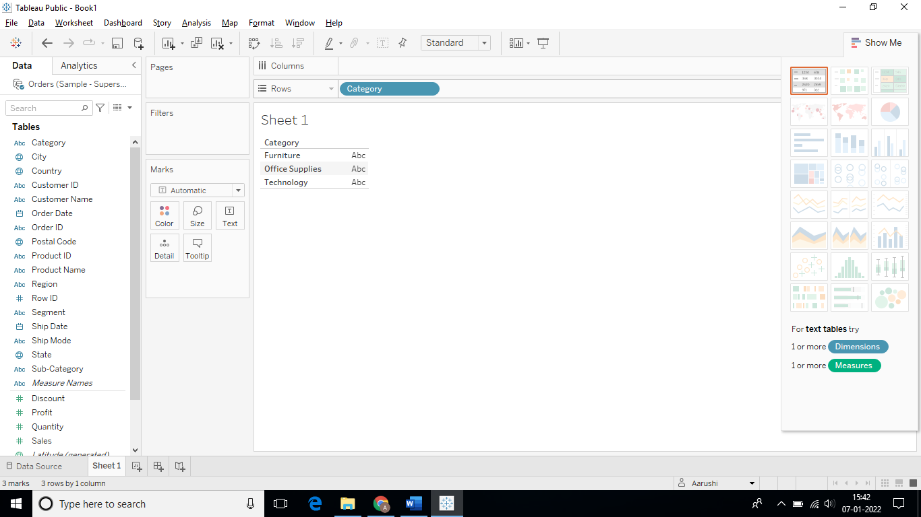

**4.** In the **Data pane**, under dimensions, locate **Order Date** and **Segment** and place them in the **Columns** shelf

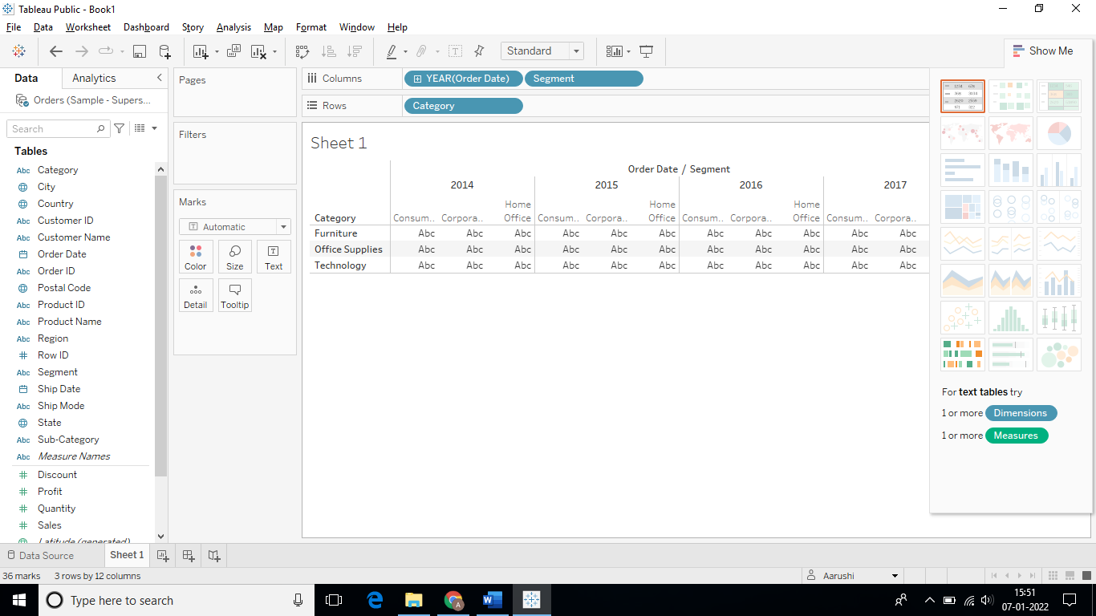

**5.** In the **Data pane**, under measures, locate **Sales** and place it in the rows shelf

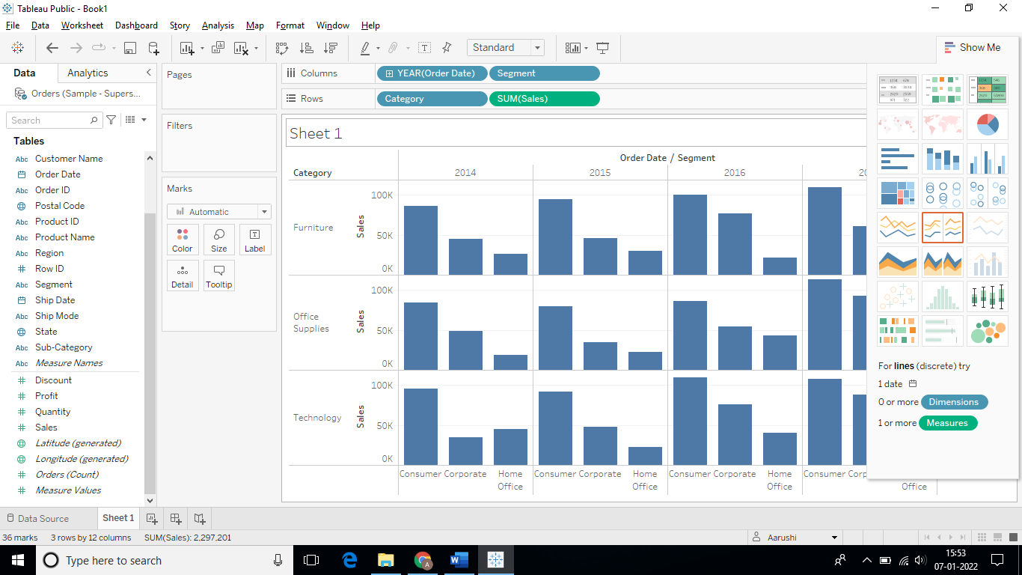

**6.** To change mark type, click on the drop-down in the marks card and select **Line**

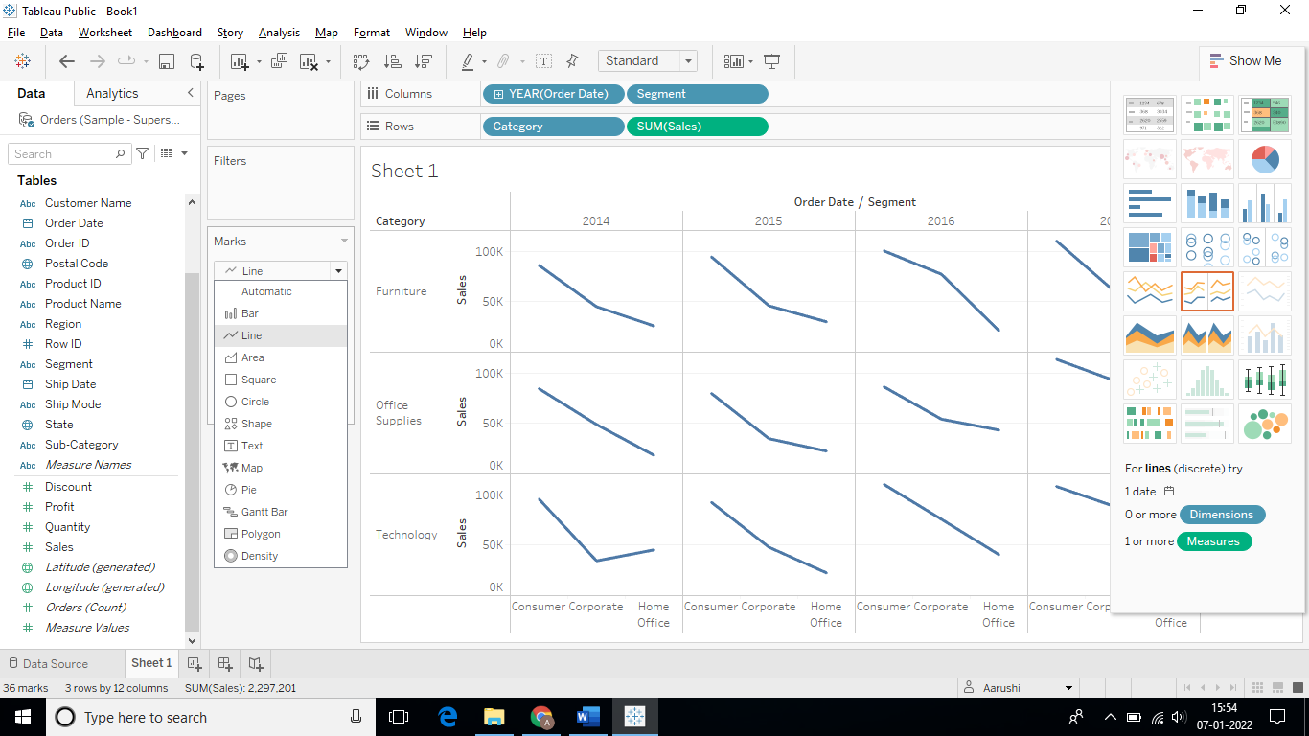

**7.** Drag and drop the **Order Date** in the color shelf in the marks card

The result should resemble the image below.

**8.** Rename the sheet as **Annual Sales**

**Answers:**

Based on the view, these are the answers to the questions in the problem statement:

* Which segment has the highest sales across all years? Answer: **Consumer**
* In which year and category were the home office sales greater than the corporate sales?

Answer: **2013, Technology**