**Lesson 6 Demo 01**

**Grouping, Alias, and Sets**

* Which are the bottom two products?
* What is the profit ratio for supplies?

**Overview:**

* Create a view with subcategories and sales
* Create a group called paper products, including envelopes, labels, and paper
* Create two sets to represent the top-two and bottom-two products
* Combine those sets and place them on color
* Label the view by profit ratio

The result should resemble the image given below:

**Detailed Instructions:**

1. On the home page, under **Connect**, under **To a file**, click **Microsoft Excel**

1. Browse and connect to the **Sample - Superstore** Excel file (NOTE: Provided in assisted practice)

1. Drag and drop **Orders** table on the canvas area

1. To create a view, in **Sheet 1**, drag **Sub-Category** to the **Rows** shelf and **Sales** to the **Columns** shelf

1. Holding the control key, select **Envelopes**, **Labels**, and **Paper** to **Sub-Categories**

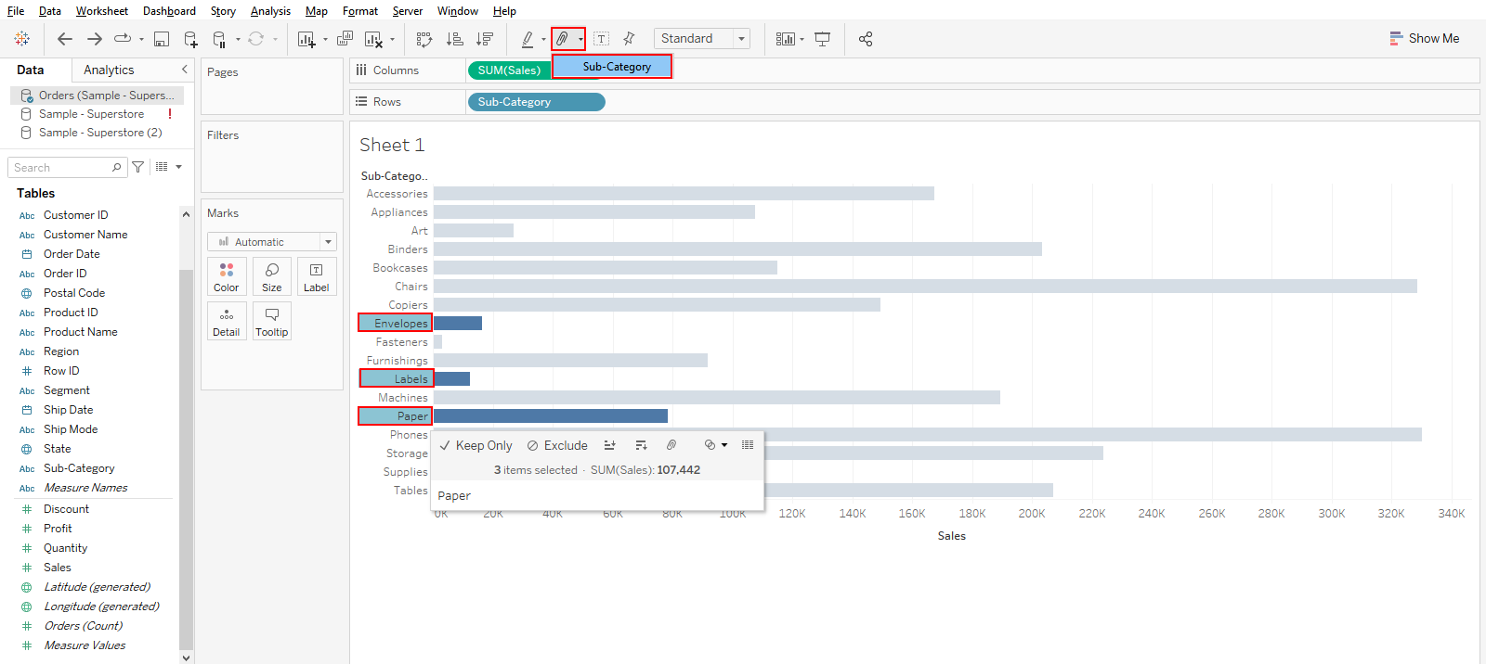

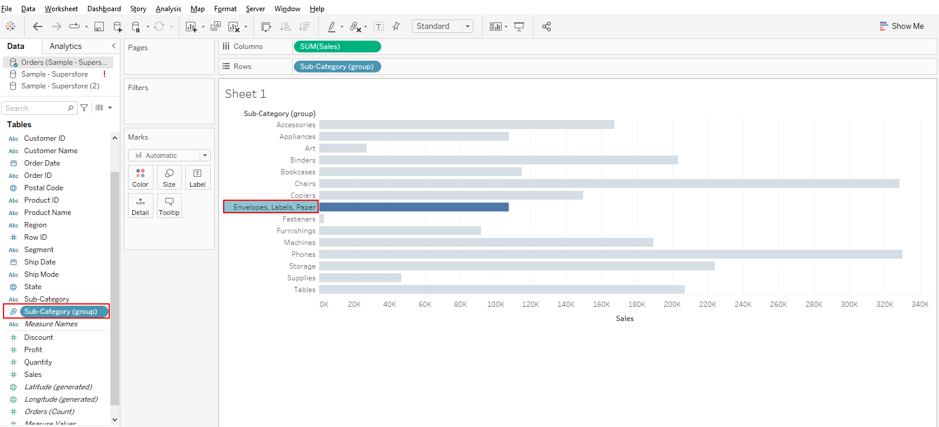

1. Right-click on the **Envelopes**, **Labels**, **Paper** field in the view, and select **Edit Alias**A picture containing chart

   Description automatically generated
2. Name the group as **Paper Products** and click **OK**

1. To create a set, right-click on the **Sub-Category (Group)** and select **Create** and **Set**

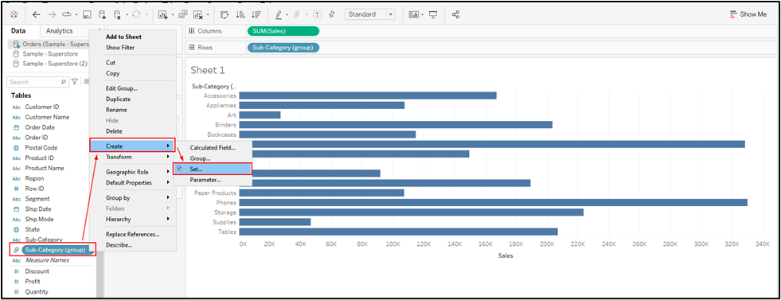

1. Enter the name **Top 2 Subcategories** and navigate to the **Top** tab

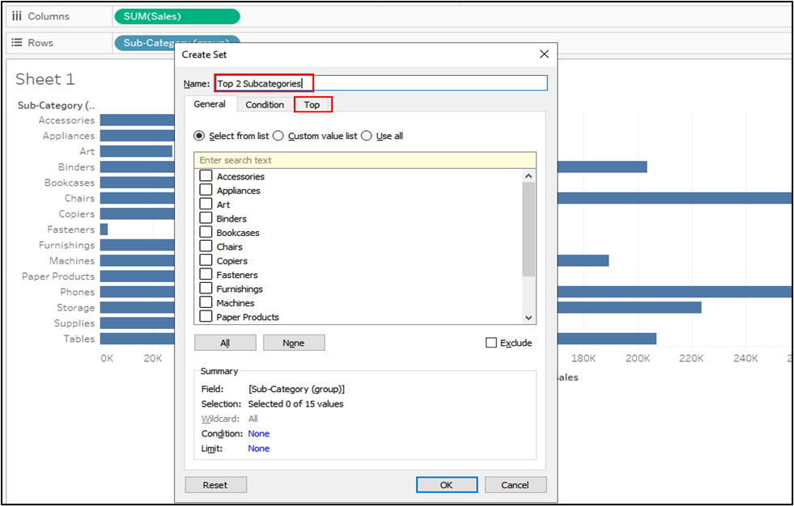

1. Select **By field**, select **Top**, and enter the value as **2**. Select **Sales** from the drop-down list and **Sum** as aggregation. Click **OK**

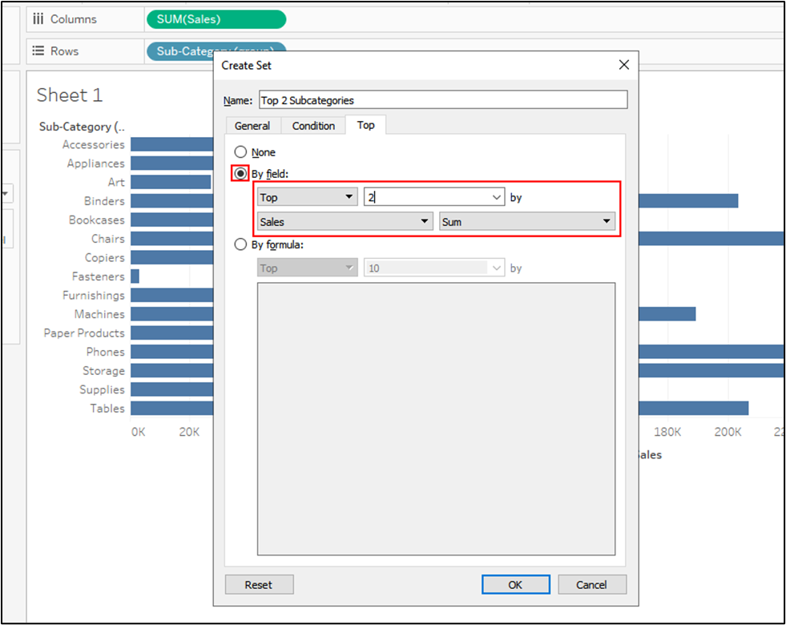

1. To create the bottom two set, repeat steps 9 to 11. Now, change from **Top** to **Bottom**

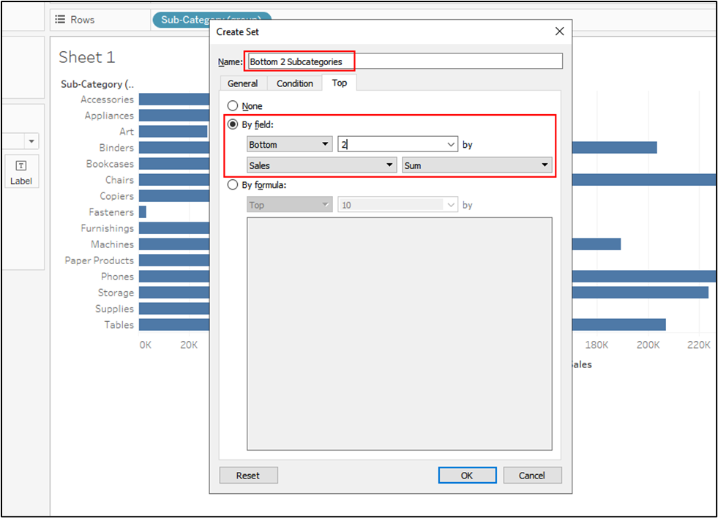

1. To combine these sets, under **Sets**, press CTRL and select these sets. Next, right-click and select **Create Combined Sets**

1. Enter the name **Top and Bottom**. Select the radio button and click **OK**

1. Drag this newly created set to **Color**

1. Create a **calculated field** by clicking the icon shown in the image. Write the name as **Profit Ratio** and formula:

**SUM([Profit])/SUM([Sales])**

1. Drag the **Profit Ratio** measure to the **Label** shelf

1. Rename the worksheet as **Sales by Sub-Category**

1. To do the formatting, right-click on **Profit Ratio**, and click on **Format**. Change it to a percentage in the pane

1. To change the **Format** of the x-axis, double-click on the x-axis

1. Select axis and go to Numbers. Select the currency and set the decimal places
2. Save the workbookA picture containing graphical user interface

   Description automatically generated

**Answers:**

Based on the view, these are the answers to the questions in the problem statement:

1. Which are the bottom two products based on Sales?

Answer: **Art and Fasteners**

1. What is the profit ratio for supplies?

Answer: **-3%**